

Torbay Local Heritage Grant Scheme 2026–2028

Writers, Artists & Musicians on the English Riviera: Local Heritage Grants

Background and Context
The initial round of Local Heritage Grant (LHG) Awards, delivered 2023-2025 with thanks to the Heritage Fund, led to improved confidence within Torbay communities, to design, develop, and deliver heritage projects for themselves. We want to continue to build ‘on the ground’ capacity to conserve and celebrate Torbay’s unique heritage. The ‘Writers, Artists & Musicians on the English Riviera’ topic expands a theme identified in the Torbay Heritage Strategy (Writers on the Riviera).
Heritage can be a powerful social process in the present, about the past, for the future. The scheme will enable successful applicants to design and deliver conservation and interpretation interventions across Torbay that conserve significant literary, artistic, and musical heritage of Torbay. Projects that respond to the theme whilst prioritising opportunities for communities to connect and improve physical and mental well-being will be favoured. For example, heritage walking trails, digital enhancement at heritage sites, commemorative installations or events designed to increase visibility of Torbay’s connections iconic writers, artists, and musicians.
The second scheme is made possible after Torbay Council secured £250,000 from The National Lottery Heritage Fund. The theme of these grants is ‘Writers, Artists & Musicians on the English Riviera’. It aims to celebrate Torbay’s rich literary, artistic and musical heritage and engage with local people about what makes Torbay special to them.

Local Heritage Grants
Torbay Council has been awarded a funding from the National Lottery Heritage Fund for another round of Local Heritage Grants, with three rounds of £50,000 secured to support community-led and locally-based heritage projects. Grants between £500 - £7,000 are available for new projects to be delivered in Torbay between May 2026 – January 2028.
The Torbay local heritage grant scheme will run between 2026 and 2027. Funding will be awarded in three rounds.
- Round 1: Opens 11 February and closes 30 April 2026 at 5pm
- Round 2: Open 1 June and closes 30 September 2026 at 5pm
- Round 3: Opens 1 February and closes 30 April 2027 at 5pm
All projects need to be delivered by January 2028.

How to apply
Applications for round 1 open on Wednesday 11 February 2026 and close on Thursday 30 April at 5pm.
To apply for a Local Heritage Grant, you will need to complete this application form.
If you have access needs that could be a barrier to applying and want to discuss this, please contact heritage.grants@torbay.gov.uk

Application Submission, Acceptance and Rejection
Applicants should submit their application electronically by email to:
heritage.grants@torbay.gov.uk
Torbay Council will accept fully completed Applications which have been submitted in accordance with the requirements of the application process. Torbay Council may at its absolute discretion may reject any Application where:
- submission was not made through heritage.grants@torbay.gov.uk
- the Applicant’s total cost exceeds the maximum Grant limit of £5,000 or £7,000 for capital costs, or is below the minimum of £500
- the Applicant has not accepted Torbay Council’s Terms and Conditions.
- the Applicant acts in any way improperly, including but not limited to canvassing, price fixing or inducements (which relate to offences under the Bribery Act 2010, Section 117 of the Local Government Act 1972 or any future legislation); or
- Torbay Council has become aware at any point that the Applicant has been afforded a competitive advantage or has a conflict of interest that cannot be rectified.
- it is considered by Torbay Council to be incomplete or vague;
- any of the information provided by an Applicant is found to be inaccurate or misleading;
- the Applicant has qualified the Application in any way; or
- the Application is in breach of any condition contained within it.

Assessment and Award
This funding is made possible by the National Lottery Heritage Fund. Applications received will be considered and assessed taking into account how the project seeks to address two or more of the National Lottery Heritage Fund’s (NHLF's) four core funding principles seen below. A full description of each of these principles can be found on the Heritage Fund website Investment principles | The National Lottery Heritage Fund;
- Saving heritage - Conserving and valuing heritage, for now and the future
- Protecting the environment - Supporting nature recovery and environmental sustainability.
- Inclusion, access and participation - Supporting greater inclusion, diversity, access and participation in heritage.
- Organisational sustainability - Strengthening heritage to be adaptive and financially resilient, contributing to communities and economies.
Applications submitted to the Torbay Local Heritage Grant Awards: Artists, Writers & Musicians on the English Riviera will also be assessed considering the following criteria;
- Fairly distributed among local community groups, following an open and transparent selection process
- Successful delivery of a range of local heritage projects across Torbay, engaging and led by diverse community groups of all ages and backgrounds
- Torbay residents and visitors will be better informed of Torbay’s rich heritage and will have a greater sense of local identity and pride in place
- Projects must be delivered in Torbay between May 2026 and completed by January 2028 – this includes completion of evaluation
- Projects should have a public facing element to be showcased during the programme year and/or at the festival in summer of 2027 and a celebration event in May 2028
- Project proposals must consider how outputs will be documented
In addition, we are keen to support projects that:
- Responding to the theme whilst prioritising opportunities for communities to connect and improve physical and mental well-being will be favoured
- Engage a greater diversity of communities, including children and young people
- Foster collaboration and partnership between organisations, community groups, and individual heritage/artist practitioners
- Are from organisations that haven’t previously successfully applied for Council or National Lottery Heritage Grant funding
Torbay Council will complete an assessment of Applications which meet all the mandatory requirements as set out within the documents.
Torbay Council is not bound to make any award of Grant.
On completion of the assessment process all Applicants will be notified of the Application outcome, whether this is to award or not to award the Grant.
We will aim to provide feedback for applications that are not recommended for funding, and where possible those applicants will be able to apply in a subsequent round.
Any group that is successfully awarded may not apply in a following round, although individuals may be involved in multiple projects. Projects that involve Council owned land will only be eligible if the project is wholly delivered by a community-led organisation.

Data Protection and access to information
Torbay Council will only use the information for the purpose of determining whether a grant will be made by Torbay Council. Applications and any other related information such as correspondence and details of payments made will be kept for eight years after the support has ended. Further information about how we process personal data and individual’s rights can be found on Torbay Council’s website www.torbay.gov.uk/dataprotection
Applicants must also be aware that any application received by Torbay Council is subject to the provisions of the Freedom of Information Act and therefore information submitted to Torbay Council along with any decision may be made public.

Notes for Completion
Applicants are required to complete in full the Application set out in the below section.
Please make sure you provide enough information to demonstrate you meet the grant requirements and that you do not exceed the word limit.
Before completing your application, please refer to the Local Heritage Grants Application Guidelines 2025-2028.
Please ensure that all questions are completed in full, and in the format requested. If the question does not apply to you, please state ‘N/A’. Should you need to provide additional information in response to the questions, please do so in the spaces provided.

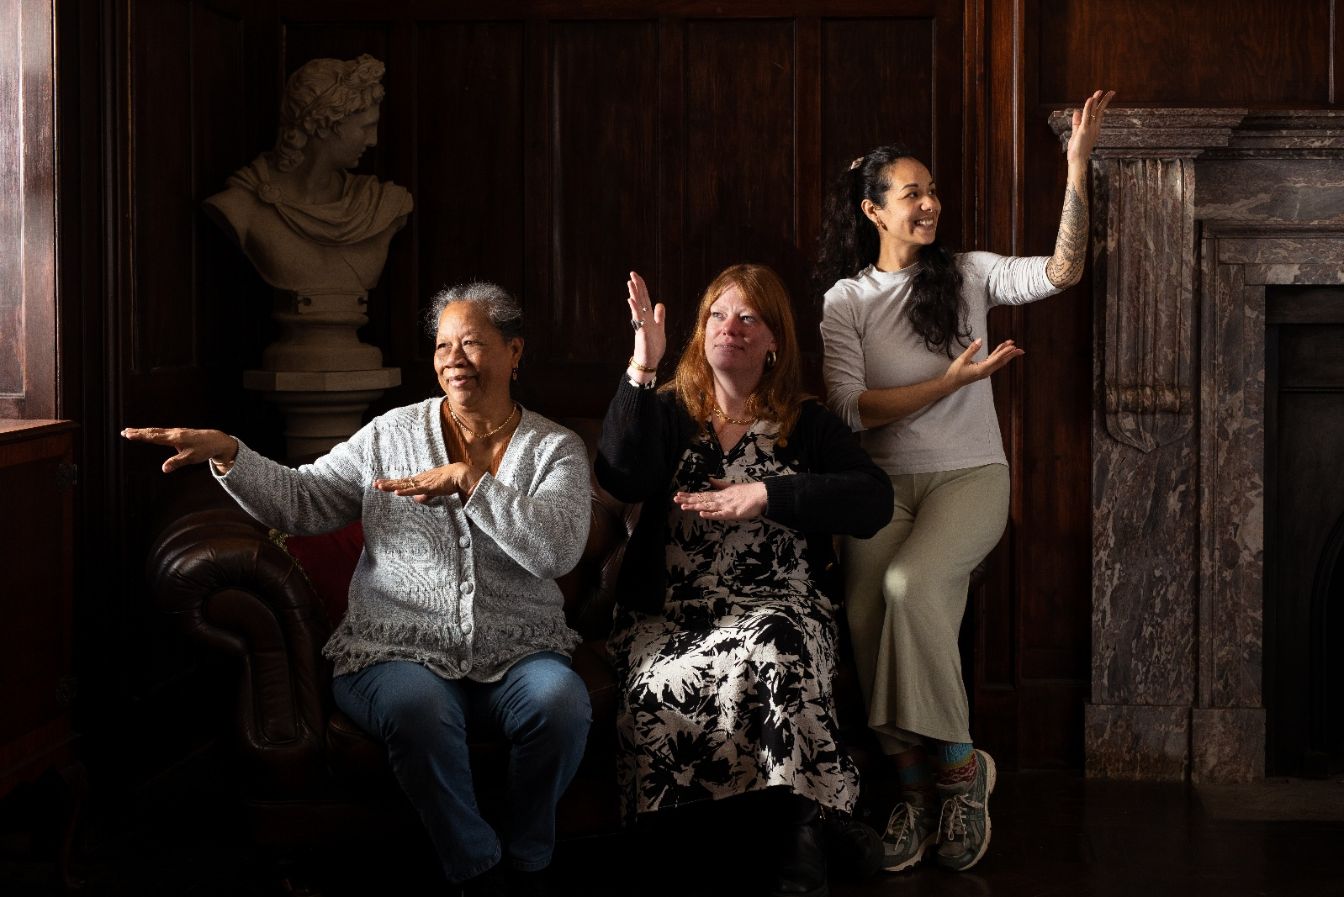
Photographer: Annemieke Goldswain Hein - project name: A tale of Two Fishing Communities: Connecting Brixham and Kiribati (funded through Torbay Local Heritage Awards, 2023-2025).

Application Form

Applicant Details
1. Applicant Details
Organisation / Group Name:
CIC or charity registration number (if applicable):
Tell us about your organisation (150 words):

Provide a brief overview of what your organisation does. If you are working in partnership with other organisations or individuals, please introduce everyone involved and briefly explain how you will work together.
Contact Person:
Role:
Address:
Email:
Phone:
Website / Social Media:

2. Project Overview
Project Title:
Start Date (dd/mm/yy):
End Date (dd/mm/yy):
Grant Amount Requested:

You can apply for between £500 and £5000 for activities, and for up to £7,000 for capital projects. Please state the total sum you are applying for.
Will your project cost more money than the funding you are requesting from us? (150 words)
Please tell us if you sought advice from us before you made this application:

3. Project Description
Describe your project and its local heritage focus (800 words):

Your answer will be evaluated against your ability to demonstrate and evidence how your proposed project, item or activity will involve people in heritage, and how it will meet the outcomes for this funding as seen below. Please tell us any social media handles or tags if you use these.

Remember to answer the Outcomes:

1.Saving heritage - Conserving and valuing heritage, for now and the future
2.Protecting the environment - Supporting nature recovery and environmental sustainability.
3.Inclusion, access and participation - Supporting greater inclusion, diversity, access and participation in heritage.
4. Organisational sustainability - Strengthening heritage to be adaptive and financially resilient, contributing to communities and economies

4. Target audience
You may only apply for this grant if it will be used to benefit people in Torbay. Please indicate which town your project will focus on? Who will benefit from your project / does your project have a target audience? How will you engage with them? (200 words)

5. How will you manage your project?
Tell us about the skills and experience of those who will lead the project. (200 words)

6. Project Plan
Please complete the project plan template below to include key activities, milestones and timescales and submit the plan as an attachment with the application form.

7. Project budget
Please complete the budget template below with a breakdown of how the grant will be spent and submit the budget as an attachment with the application form.

8. Supporting Information
Please provide partners, at least one letter of support, or other relevant details:

9. Declaration
Applicants are required to read this section thoroughly and confirm their acceptance of and compliance with the requirements of the Application process by providing their signature at the end of this section.

I / we confirm that:
- I / we have read, understand and will abide by the Guidance and Torbay Council’s Terms and Conditions of funding.
- The information supplied is accurate
- Any funds will be spent only on work, items and activities eligible for a Local Heritage Grant as set out in section A. Guidance and in accordance with the information provided within the Application
- I / we have not and will not canvass or solicit any Member, Officer or employee of the Authority in connection with the preparation, submission and evaluation of this Application or award or proposed award of the Agreement and that to the best of my knowledge and belief, no person employed by me/us or acting on my/our behalf has done or will do such an act
- I/ we have the full power and authority to enter into the Agreement and will, if requested, produce evidence of such to the Authority

I / we understand that:
- Applications not properly completed will be rejected as non-compliant.
- Torbay Council may check any of the information provided with other Council Services or organisations responsible for auditing or administering public funds and for the prevention and detection of fraud
- I / we may face prosecution if we have falsified information to obtain the grant

The grant must be repaid if I / we:
- have falsified my / our records to gain grant money
- received a grant in error

I confirm that the information provided is correct and that I agree to comply with the grant conditions.
Name:

Signature:

Date:

All applications will be checked for eligibility and passed to a decision panel for reviewing and scoring. A Grants Adviser will soon be appointed and available to support groups preparing their applications.
To find out more about the scheme and apply, visit the local heritage grant scheme webpage.
The closing date for this round of grant applications is Thursday 30 April at 5pm. Torbay’s local heritage grant scheme is made possible thanks to investment from The National Lottery Heritage Fund.
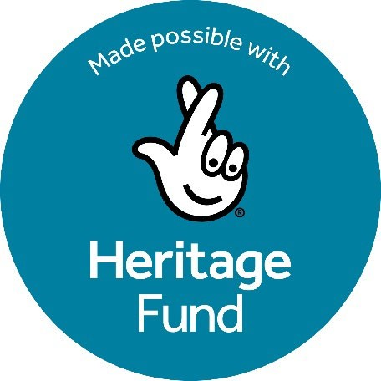
Using money raised by National Lottery players, The National Lottery Heritage Fund supports projects that connect people and communities with the UK’s heritage. The Community Heritage Grants are made possible with The National Lottery Heritage Fund.

