

Torbay Local Heritage Grant Scheme 2026–2028

Writers, Artists & Musicians on the English Riviera: Local Heritage Grants

Application Guidelines

Background and Context
The initial round of Local Heritage Grant (LHG) Awards, delivered 2023-2025 with thanks to the Heritage Fund, led to improved confidence within Torbay communities, to design, develop, and deliver heritage projects for themselves. We want to continue to build ‘on the ground’ capacity to conserve and celebrate Torbay’s unique heritage. The ‘Writers, Artists & Musicians on the English Riviera’ topic expands a theme identified in the Torbay Heritage Strategy (Writers on the Riviera).
Heritage can be a powerful social process in the present, about the past, for the future. The scheme will enable successful applicants to design and deliver conservation and interpretation interventions across Torbay that conserve significant literary, artistic, and musical heritage of Torbay. Projects that respond to the theme whilst prioritising opportunities for communities to connect and improve physical and mental well-being will be favoured. For example, heritage walking trails, digital enhancement at heritage sites, commemorative installations or events designed to increase visibility of Torbay’s connections iconic writers, artists, and musicians.
The second scheme is made possible after Torbay Council secured just under £250,000 from The National Lottery Heritage Fund. The theme of these grants is ‘Writers, Artists & Musicians on the English Riviera’. It aims to celebrate Torbay’s rich literary, artistic and musical heritage and engage with local people about what makes Torbay special to them.

Local Heritage Grants
Torbay Council has been awarded a funding from the National Lottery Heritage Fund for another round of Local Heritage Grants, with three rounds of £50,000 secured to support community-led and local heritage projects. Grants between £500 - £7,000 are available for new projects to be delivered in Torbay between May 2026 – January 2028.
The Torbay local heritage grant scheme will run between 2026 and 2027. Funding will be awarded in three rounds.
- Round 1: Opens 11 February and closes 30 April 2026 at 5pm
- Round 2: Open 1 June and closes 30 September 2026 at 5pm
- Round 3: Opens 1 February and closes 30 April 2027 at 5pm
All projects need to be delivered by January 2028.

What do we mean by heritage?
We use the National Lottery Heritage Fund definition.
“We don’t define heritage. We ask you to tell us what you think is important and should be preserved. From historic buildings, our industrial legacy and the natural environment, to collections, traditions, stories and more – heritage can be anything from the past that you value and want to pass on to future generations.”

Projects can include tangible heritage (such as buildings, parks, archives), intangible heritage (like oral histories, traditions, and celebrations) or natural heritage (such as green and blue spaces).

What type of projects are we looking to support?
Projects must be based in Torbay and involve and benefit local communities through public facing activity, events or participation.
This round of Local Heritage Grants invites local groups to think creatively about how to engage with residents and celebrate Torbay’s connections with iconic writers, artists, and musicians. This can be done through conservation, commemoration, trails, plaques, celebratory events with a clear heritage aspect, and other creative responses.

Examples of projects eligible for funding could include:
- heritage walking trails
- digital enhancement at existing heritage sites
- commemorative installations or events

Funding criteria
This funding is made possible by the National Lottery Heritage Fund. Applications received will be considered and assessed against how the project seeks to address two or more of the National Lottery Heritage Fund’s (NHLF's) four core funding principles seen below. A full description of each of these principles can be found on the Heritage Fund website Investment principles | The National Lottery Heritage Fund;
- Saving heritage - Conserving and valuing heritage, for now and the future
- Protecting the environment - Supporting nature recovery and environmental sustainability.
- Inclusion, access and participation - Supporting greater inclusion, diversity, access and participation in heritage.
- Organisational sustainability - Strengthening heritage to be adaptive and financially resilient, contributing to communities and economies.
Applications submitted to the Torbay Local Heritage Grant Awards: Artists, Writers & Musicians on the English Riviera will also be assessed considering the following criteria;
- Fairly distributed among local community groups, following an open and transparent selection process
- Successful delivery of a range of local heritage projects across Torbay, engaging and led by diverse community groups of all ages and backgrounds
- Torbay residents and visitors will be better informed of Torbay’s rich heritage and will have a greater sense of local identity and pride in place
- Projects must be delivered in Torbay between May 2026 and completed by January 2028 – this includes completion of evaluation
- Projects should have a public facing element to be showcased during the programme year and/or at the Showcase in summer of 2027 and in May 2028
- Project proposals must consider how outputs will be documented

In addition, we are keen to support projects that:
- Respond to the theme whilst prioritising opportunities for communities to connect and improve physical and mental well-being
- Engage a greater diversity of communities, including children and young people
- Foster collaboration and partnership between organisations, community groups, and individual heritage/artist practitioners
- From organisations that haven’t previously successfully applied for Council or National Lottery Heritage Grant funding, although previously successful groups are still eligible

Eligibility criteria
- Applications are encouraged from groups and organisations, whether or not they are constituted; for not-for-profit Voluntary, Community and Social Enterprise (VCSE) sector groups and organisations within Torbay; or a combination of groups working together. They should be representative of their local area.
- Applications may be considered by organisations that are based outside the area if the sole benefit of the project is for communities within Torbay.
- Eligible bodies may be but are not limited to:
- Youth groups
- Local heritage organisations, museums, and heritage societies
- Constituted Neighbourhood Committees, Residents Associations, Community Groups and Voluntary Organisations;
- Social Enterprises;
- Community Interest Companies;
- Community Benefit Societies; and
- Charities and trusts.

- Consideration will also be given to applicants who are sole traders and small businesses provided the project is entirely for the benefit of the local community and if they form a community group who would hold the ownership of heritage
- Grant funding cannot be used to subsidise a business's income or pay towards salary costs.
- Grant recipients will be expected to participate in evaluation of the grant scheme, which may involve responding to surveys or collecting information about their project to help us report to the National Lottery Heritage Fund.
- Projects which propose working with Council owned property are eligible if they are community-led, for public benefit, and only where the application is submitted with written permission from the Council (which must be sought prior to submission).

We cannot fund
- Profit-making or fundraising activities
- Acquisition of land, buildings or heritage items
- Activities that support or promote a particular political party, cause or religious agenda
- Project activities that are deemed the statutory responsibility of the council
- Ongoing support from the council once the project has ended
- Contingency costs, loans, endowments or interest or any budget deficit
- Retrospective payments for the project or purchases which have already taken place
- Costs that are already paid for by other income including applicant's own funds or any other funding
- VAT that you can reclaim
- Administration and/or research costs of preparing this application (e.g. paying someone to write an application for you)
- Any other non-project-specific costs

How to apply
Applications for round 1 open on Wednesday 11 February 2026 and close on Thursday 30 April at 5pm. Please submit your applications by emailing heritage.grants@torbay.gov.uk
To apply for a Local Heritage Grant, you will need to complete an application form.
If you have access needs that could be a barrier to applying and want to discuss this, please contact heritage.grants@torbay.gov.uk

How to complete the application form

You will be asked to provide contact details and organisation information, and to answer questions about your project. Please complete a Project Plan outlining key activities, milestones and timescales for your project as well as a budget document outlining the costs you would like us to fund.

If you have any questions about how to complete the application form, please contact heritage.grants@torbay.gov.uk

Supporting documents
As part of your application, you will need to provide the following additional documents:
- Your last submitted annual accounts or the past three months’ bank statements.
- A bank statement showing organisation name, address, sort code and account number
- Your organisation governing document (constitution, company articles of association for Community Interest Groups or Social Enterprises).
- If applicable to your organisation or project activity, attach your safeguarding policy or statement for working directly with vulnerable individuals or audiences.
- If applicable to your organisation or project activity, attach evidence of your Public Liability Insurance (usual standard up to £1m).
- Proof of ownership if your project involves work to land, buildings or heritage items (for example, deeds, leases or any information relating to mortgages).

Local Heritage Grant Panel Procedures
- Your application will be subject to an initial assessment to check that the eligibility criteria are met, using a yes/no system.
- You will be notified if your project does not pass this or if the Council needs further information to process it.
- All applications that fulfil the eligibility criteria will be put before the Local Heritage Grant Awards Panel, made up of Council staff, community and heritage sector representatives from the three towns of Torbay, and at least 3 people under the age of 30.
Before the panel takes place, panel members will receive a summary report of the applications received. The panel will assess each application against the Community Heritage Grants funding criteria.
The decisions that the panel can make are as follows:
- Reject application
- Make recommendations and suggest a resubmission (including, suggesting that groups with similar applications work together).
- Make an award but impose additional conditions to the standard grant conditions
- Make an award without additional conditions
- Offer a lower amount
On receipt of your application, the following stages will be followed:
Stage 1: The Local Heritage Selection Panel will meet and make a final decision on your application. You will be notified of the outcome of this decision in the first round by Friday 29 May 2026 and will be provided with feedback if unsuccessful.
Stage 2: The organisations successful in their application will need to sign a Grant Agreement.

How grant payments will be made
Torbay Council will make payment to successful Applicants in advance, in full.
Payment will be made automatically, following confirmation of a successful application, and on receipt of your signed Grant Fund Agreement Terms and Conditions.
Payment will be by BACS and remittance advices will be transmitted to the Provider by email (the Provider’s appropriate email address must be supplied).
Payment will be made directly to the awarded organisation. Once funding is approved and payments have been made, you may be asked to provide receipts or copy invoices to the value of the grant. Any unspent funds must be returned to the Council.

Monitoring and evaluation requirements
We aim for evaluation to be proportionate and not overly time consuming. All funded projects will:
- Collect basic data (e.g. number of participants, location, access needs)
- Document impact via one or more of the following:
  - photographs or short videos
  - audience or participant feedback (quotes, surveys, vox pops)
  - a short blog, report, or case study
- If appropriate, take part in a sharing and learning session to celebrate and reflect.
All projects must complete a Baseline Survey, Mid-way Monitoring Form and an End of Grant Report. Templates for these will be included with the confirmation of the grant for successful applicants.
We will require you to provide invoices and receipts for any assets worth over £500 acquired with the grant funding. You may also be asked to provide receipts or copy invoices to the full value of the grant.

What to expect once you have been awarded a grant
Funded projects will be supported with on-going project development and evaluation monitoring support throughout the project.

Funded projects are to be delivered, and the End of Grant Report submitted, before or by 31 January 2028.

Support and advice to applicants
If you have any queries about eligibility or making a submission, or if you have access needs that could be a barrier to participating or applying and want to discuss this, please contact heritage.grants@torbay.gov.uk .
From March 2026 we will release a series of workshops and mentoring sessions will be offered to give an overview of the grant context and criteria, offer networking opportunity, and give support with application development and writing.
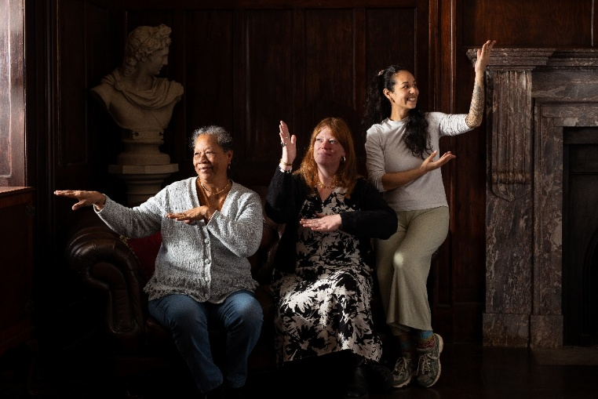
Photographer: Annemieke Goldswain Hein - project name: A tale of Two Fishing Communities: Connecting Brixham and Kiribati (funded through Torbay Local Heritage Awards, 2023-2025).

Timeline

Community Heritage Fund Launch  applications open | Wednesday 11 February 2026
Applications close | Thursday 30 April 2026, 5pm
Applicants informed of funding outcome | Friday 29 May 2026
Funded projects delivery period | May 2026 – January 2028
End of Grant Report deadline | Monday 31 January 2028

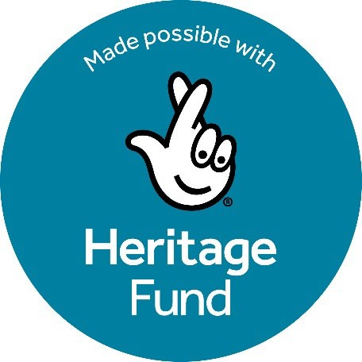

Using money raised by National Lottery players, The National Lottery Heritage Fund supports projects that connect people and communities with the UK’s heritage. The Community Heritage Grants are made possible with The National Lottery Heritage Fund.

