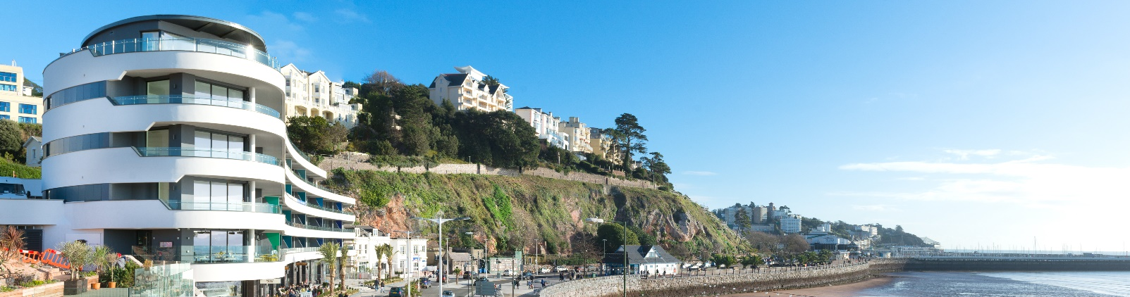
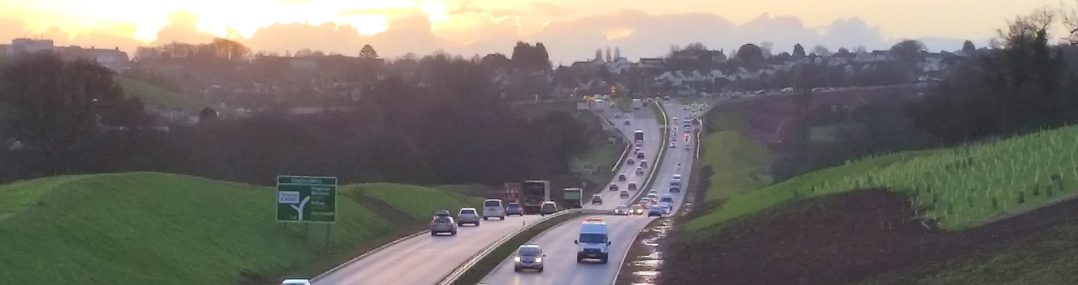
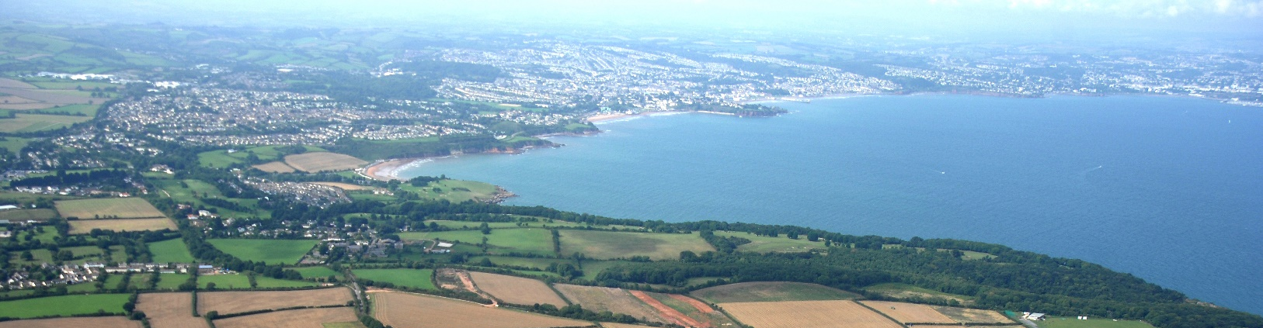

Sustainability Appraisal

Reasonable Alternatives
  - Housing Update: Growth Options
  - Consultation (Regulation 18)
  - January 2022

Contents
Introduction 3
Methodology 3
Assessment of Reasonable Alternatives 4
Options 1 and 2 4
Option 3 5
Option 4 and 5 5
The Local Plan Post 2030 6
Conclusions 7
Next steps 8

Introduction
The current document presents second stage of the Sustainability Appraisal (SA) of the Local Plan Review and update. Its role is to assist with the identification of the most appropriate option, in sustainability terms, to predict implications for sustainable development and put forward recommendations for improvement where necessary. An assessment of ‘reasonable’ alternatives is required to meet the requirement of Regulation 12 of the 2004 Strategic Environmental Assessment (SEA) Regulations and in doing so, identify and evaluate their sustainability implications.
Five growth options, based on the Housing and Employment Land Availability Assessment (HELAA), have been developed in the Issues and Options (Regulation 18 of the Local Planning Regulations 2012). The options set out different ways that the Local Plan could guide new housing sites and other infrastructure, in Torbay.
Option 1 Existing allocations plus densified urban clusters: No further greenfield allocation beyond already allocated or approved sites. This is estimated to provide between 190-250 dwellings a year.
Option 2 Limited further greenfield development: As per option 1 plus a limited number of greenfield sites deemed as having relatively minor constraints. This is estimated to provide between 250-300 dwellings a year. Option 2 “Business as usual”, represents building rates achieved since the beginning of the Local Plan period of 2012.
Option 3 As per option 2 plus one or two further urban extensions: Several possible “sub-options” for the location of the potential urban extension exist. However, further expansion at the west of Paignton appears to be the most likely candidate. This option is estimated to provide between 320-380 dwellings a year.
Option 4 All sites that have not been outright rejected by the HELAA: This includes sites which have significant environmental and deliverability constraints. This option could provide between 470-500 dwellings a year.
Option 5: Meeting full needs (as set down by the government standard method): To achieve a growth rate of around 600 dwellings per year, all sites including many rejected by the HELAA as unsuitable for development would need to be allocated.

Methodology
The SA of reasonable alternatives involves assessing the performance of each option against the SA framework. The appraisal is a qualitative exercise based on professional judgement taking into account the information gathered in the SA Scoping Report.

The magnitude of the impact of the different options on each objective is defined as significant positive benefit, some positive benefit, neutral or no link, significant negative impact, negative and uncertain impacts (see table 1). The SA should also consider the probability, duration, frequency and reversibility of the effects, including cumulative, secondary and synergistic effects whenever possible.

A significant effect arises as a result of a minor impact on a resource of international and national value or a major impact on a resource of local value. In addition, the accumulation of many non-significant effects on similar local resources may give rise to an overall significant effect. This approach to assessing and assigning significance to an environmental effect relies upon such factors as legislative requirements, guidelines, standards and codes of practice, consideration of the SA/SEA Regulations, the advice and views of statutory consultees and other interested parties and expert judgement.

Table 1: Effects of option on SA objectives
++ | Significantly positive | Option/policy/site would significantly help with achieving objective | Positive effect but consider whether effect can be enhanced
+ | Positive | Option/policy/site would help with achieving objective | Net positive effect but consider whether effect can be enhanced
? | Uncertain | More information needed | Where this will come from – who has it? What will be done about collecting it? When will it be collected?
0 | Neutral | Option/policy/site would neither help nor hinder the achievement of the objective | Option/policy or allocation likely to be acceptable; but would require intervention to realise positive effects
- | Negative | Option/policy/site would be in conflict with the objective. | Will require demonstrable levels of mitigation in order to make the option/policy/site acceptable.
-- | Significantly negative | Option/policy/site would be in conflict with the objective and unlikely to be acceptable. No evidence has been provided on potential mitigation. | Unlikely that adequate mitigation could be provided to make the site acceptable. Delete, reconsider or amend the option/policy or site

Assessment of Reasonable Alternatives
An assessment of options has been undertaken, with each option assessed against the sustainability objectives as set out in the Scoping Report. The assessment seeks to identify whether an option would contribute to, or conflict with, the achievement of sustainability objectives. Options were also being compared against each other. The outcome of this appraisal is set out in Appendix A and a summary below accompanied by visual illustration (Table 2).

Options 1 and 2
Overall, options 1 and 2 performed well against environmental objectives and relatively poorly across the range of social and economic sustainability objectives. Both options will steer development away from flood risk areas, areas of amenity and landscape value, biodiversity/geological sites, contaminated sites and other sensitive locations. They will direct growth towards main urban area of Torbay, which offer the highest level of services (e.g. education, leisure and retail) and thus should limit the overall need to travel. The two options, however, will not fit well with the growth aspirations (as outlined in the Torbay Local Plan) and could potentially undermine Torbay’s role in the region. On balance, option 2 would have slightly more long-term benefits.

These options would result in an undersupply against housing need, resulting in existing problems relating to the affordability of housing being exacerbated. Related to this, there may be a suppression of household formation as young adults are unable to afford to move out of the family home (potentially contributing to the existing trend of young people moving away from Torbay), and potentially giving rise to overcrowding with a negative impact on the aspirating to provide healthy and sustainable living environments. This could also increase the top-heavy age structure of Torbay.

Option 3
The supply of large numbers of new homes can often be best achieved through planning for larger scale development, such as new settlements or significant extensions to existing villages and towns, provided they are well located and designed, and supported by the necessary infrastructure and facilities. In essence, it would provide an opportunity to plan a vibrant and sustainable community from the outset.

Concentrating new homes in one or two urban extensions has both positive and negative impacts. On the one hand, a new urban extension would relieve pressure on existing infrastructure/services, offer employment opportunities, deliver a range of affordable homes and protect the character of existing settlements. On the other hand, a new urban extension would increase outward commuting, place pressure on the open countryside, biodiversity and infrastructure. Additionally, there would need to be market interest to deliver the level of services and facilities needed.

Option 4 and 5
Options 4 and 5 represent spreading growth across a larger number of settlements in less sustainable locations. This dispersed pattern is likely to improve the quality of housing and deliver affordable housing targets to address future needs. By their very nature, these options will have adverse impacts on the environment such as biodiversity, agriculture/soil quality, water resources and the character and appearance of the landscape, resulting from the loss of greenfield land and areas of amenity and landscape value. They are likely to exacerbate existing problems such long-distance to access jobs and services, greenhouse gas emissions, pollution level and flood risk.

Options 4 and 5 are likely to give rise to a broader range of adverse impacts than the other options, some of which may not be capable of mitigation. These options would clearly necessitate very significant investment in new infrastructure and physical improvements (e.g. extensive landscape buffers) in most parts of Torbay to accommodate the demand from the increase in households, workers and pupils in each community area. In many cases, new development would require very long lead-in times before it could be delivered.

Table 2: Summary of SA Alternative Options
SA Objectives | - Climate | - Natural resources | - Waste | - Biodiversity | - Heritage | - Landscape | - Travel | - Economy | 9. Poverty | 10. Land-use | 11. Crime | 12. Housing | 13. Health
Option 1
Option 2
Option 3
Option 4
Option 5

Key
++ | Significantly positive
+ | Positive
? | Uncertain
0 | Neutral
- | Negative
-- | Significantly negative

The Local Plan Post 2030
The Local Plan Growth Options Consultation’s first preference is to carry out a quick update of the Plan within the current timeframe of 2030, and the main SA reflects this approach. We are mindful of paragraph 33 of the NPPF that states that strategic policies should look ahead over a minimum of fifteen years. On this basis, it is necessary to consider the implications of rolling forward the Plan period to 2040, to ensure 15 years post-adoption plan period.

This would represent a significant change, that would add to Torbay housing needs requirement. The Growth Options document acknowledges that the supply of development land will fall off later in an extended plan period, as sites are built out. The housing deliverability is accordingly adjusted downwards to reflect these options.

With an extended Plan period, all options will have cumulative negative impact, sometimes significant, on many of the social and economic sustainability objectives. The undersupply of housing would worsen access affordable dwelling of mix sizes and types and exacerbate social deprivation and social exclusion. It would also have the potential to restrict long-term economic growth and prosperity and undermine regeneration efforts in Torbay. Such options will run counter to the principles of sustainable development.

The environmental impact will remain unchanged, particularly with respect to the dispersed growth options (option 4&5), that are allocating sites in environmentally sensitive locations. Some of the environmental objective for options 1, 2, &3 might have positive impact due to anticipated infrastructure improvement and ecological enhancement and habitat creation. Expected technological improvement could also contribution to combating the effects of climate change during the plan Period.

Table: Plan extended to 2040
SA Objectives | - Climate | - Resources | - Waste | - Biodiversity | - Heritage | - Landscape | - Travel | - Economy | 9. Poverty | 10. Land-use | 11. Crime | 12. Housing | 13. Health
Option 1
Option 2
Option 3
Option 4
Option 5

Conclusions
Torbay is physically constrained due to nature conservation interests and a lack of urban brownfield land opportunities. It would not be possible to meet the objectively identified needs in a way that maximises economic prosperity without compromising the environment. Future economic and population growth will generate more waste, increase greenhouse gas emissions and consumption of resources.

The assessment reveals that each option has sustainable merits and drawbacks. Option 1 and 2 would potentially widen the gap between rich and poor communities in terms of access to decent affordable homes, and offers little to support the resilience, strength and competitiveness of the local economy therefore unable to meet the Local Plan vision and objectives. The dispersed patterns (option 4 and 5) place significant pressure on the open countryside, biodiversity and infrastructure, even with mitigation in some cases. Option 3 scores relatively better than the other options as it would deliver development to enable contributions towards economic growth and community infrastructure, but not without environmental challenges. However, it will be possible to reduce, offset or avoid these adverse effects with appropriate mitigation.

Next steps
The next step in the development of the Sustainability Appraisal is to take on board the feedback from this consultation and update the report accordingly. Any significant changes made to the Issues and Options (Regulation 18) will be subject to further SA. The next stage of the Local Plan Update is (Regulation 19), will be accompanied by a Sustainability Appraisal Report.

Appendix A: Assessment of Alternative Growth Options
Sustainability objective | Growth Option |  |  |  |  | Comment
Sustainability objective | 1 | 2 | 3 | 4 | 5 | Comment
1. To reduce and manage the impacts of climate change | - | - | - | - - | - - | Housing delivery associated with all options will result in an increase in energy consumption. The greater the number of housing delivered, the higher the potential for negative impact on this objective. It is recognised that new development offers the best opportunity to integrate renewable energy into building design. However, the low growth scenarios (Option 1&2) are unlikely to reach the scale necessary for development of medium and large-scale renewable energy schemes, although opportunities may exist for small scale renewable schemes.  Option 1, 2&3 would steer development away from flood risk areas in contrast the high growth options (Option 4&5), several sites will have to be located within flood risk zone 3. This will increase the number of hard surfaces and place additional pressures on the surface water drainage system. In addition, these options could result in development in locations where services and jobs are less accessible. This would lead to an increase in transport and associated greenhouse gas emissions.
2. To improve water, air, soil quality and minimise noise levels | - | - | - | - | - | Whilst Option 1&2 will have the least implications for natural resources, they have been marked as negative because they will contribute to pollution and natural resource depletion to a certain level. It will also increase the risk of out commuting for work, further adding to air quality issues.  Development under all options will inevitably increase impermeable surfaces resulting in increased water run-off and potential pollution of water courses.  Existing policies in the Torbay Local Plan seek to ensure that new development will not result in, soil, water or air pollution.
3. To minimise waste and increase the recycling and reuse of waste materials | - | - | - | - | - | Waste arisings will inevitably increase due to the increase in Torbay’s households. The low level of growth will have the least implications for waste generation.  Existing policies in the Torbay Local Plan seek to ensure that new development will provide facilities to allow the recycling of materials. These policies will be taken forward into the Local Plan Review and thus the implementation of the existing policies will apply to all growth options.
4. To conserve, protect and enhance habitats  and species, and geodiversity | + | + | - | - - | - - | All the growth options have the potential to impact negatively on Torbay’s biodiversity assets in both the urban and countryside areas. The quantum together with location and design of the proposed growth areas will determine the nature of impact. However, as a general principle, the denser the housing development the less opportunities there are for incorporating biodiversity into the design.  Options 1& 2 offer the opportunity for significant ecological enhancement and habitat creation. Several site in options 3, 4 & 5 will lead to loss of agricultural land, greenfield land and land of ecological value.  The HELAA sites have undergone Habitats Regulations Assessment (HRA) screening to identify sites that are likely to have significant effect on the two European sites within Torbay i.e. the Lyme Bay and Torbay Marine SAC and South Hams SAC. All options will have likely significant effects on the two European sites. However, options 3, 4 and 5 would negatively affect the South Hams SAC more than option 1 and 2.  Local Plan Biodiversity and Geodiversity Policy (NC1) ensure the negative impacts of new development are avoided or mitigated.
5. To conserve, enhance and enjoy the historic environment. | - | - | - | - - | - - | All options will put pressure on heritage assets in Torbay and therefore will have the potential to result in negative impacts on the historic environment, including archaeological remains, and their settings. Options 4 and 5 will have significant negative impact on this objective due to intensity of site located within conservation areas and close to listed buildings.  Existing Local Plan Historic Environment Policy (HE1) seeks to ensure that new development does not detract from the character and heritage assets of the wider area.
6. To protect, enhance and manage the character and quality of the landscape, townscape and seascape | + | + | - | - - | - - | Impacts will depend on quantum of new land take together with the location and design of the proposed growth areas.  Options 1 & 2 will not have negative impact on this SA objective. Option 3 could require the development of more sites in sensitive landscapes areas.  Options 4 & 5 will have significant negative impact the AONB. There is potential for negative impact on the setting of the Maidencombe, Galmpton and Churston villages, by causing settlement Coalescence. This would  change the role and function of settlements which may impact on their identity and sense of place.  Existing Local Plan Policies Countryside, Coast and Greenspace (C1- C5) seek to ensure that new development does not result in an adverse effect on the landscape and townscape.
7. To reduce the need and desire to travel by car and support sustainable/active modes of travel | + | + | - | - | - | Growth options 1 and 2 offer the best opportunity to increase non-car travel and reducing the need for travel due to the focussing of new development in existing settlements were public transport, including opportunities for enhanced services, is available.  Growth option 4 and 5, by contrast, are less suited to reducing the need for travel due to the dispersed nature of the development, i.e. urban extensions away from existing public transport route.  Existing policies in the Torbay Local Plan seek to promote sustainable transport which, if implemented, will improve provision/investment in new or enhanced public transport in conjunction with the proposed residential development.
8. To support strong, diverse and sustainable economic growth | + | + | + | ++ | ++ | All Growth Options will indirectly improve economic growth in Torbay by providing employment in the housing building sector and within a mix of uses being brought forward in conjunction with the residential development.  Option 1, 2& 3 would provide minor improvement in viability of local businesses and commercial activities. Option 4 & 5 will bring opportunities for in-migration of population who may bring with them new employment opportunities and skills. This would help broaden the workforce, boost skills and reduce the output gap between Torbay and the rest of the region.
9. To reduce poverty and income inequality | - | - | + | - | - | Growth options 1 & 2 will exacerbate housing inequality and poverty. While growth options 3, 4 & 5 will provide greatest scope for New Homes Bonus and therefore benefit communities in Torbay. However, options 4 & 5 will raise concerns regarding over-intensive development and loss of cultural assets including space for cultural events.
10. To maximise the use of previously developed land/ buildings and encourage the efficient use of land | + | + | - | - - | - - | Growth Options 1 & 2 seek to focus new development on previously developed land and thus will contribute positively to maximising previously developed land and buildings.  Growth Option 3, which seeks to focus new development outside of existing settlements with one or two urban extensions west of Paignton, will include previously developed land but also greenfield land outside the settlement boundaries, however, this approach will ensure that land is used efficiently and thus represents a minor positive effect on this sustainability objective.  Growth Options 4 & 5 will focus new development both in and outside of existing settlement boundaries. These options, therefore, will have significant negative effect on this sustainability objective.
11. To promote safe communities and reduce fear of crime | ? | ? | ? | ? | ? | The extent to which crime reduction measures implemented in design depend on individual applications.  All the Residential Growth Options will have a neutral score on promoting safe communities and reducing the fear of crime at this stage.
12. To provide housing that meets the needs of existing and future residents | - | - | - | + | ++ | Growth Options 4 & 5 have the opportunity to deliver a range of housing types, including affordable housing. Option 5 will result in the delivery of the greatest number of affordable housing as required to meet the future demand for housing and therefore has the strongest positive impact on this objective.  Growth Options 1, 2 & 3 would deliver affordable housing below the assessed level of local housing requirement and it wouldn’t fit well with the long term growth aspirations. Moreover option 1&2 are likely to increased outward migration (particularly young people), and potential overcrowding.
13. To improve health and wellbeing and reduce health inequalities | + | + | + | + | + | Access to a decent and affordable housing is one of the wider determinants of health and therefore all options could have positive impacts on health. All options will  provide opportunities for regeneration of living environment within urban areas. They are likely to maintain access to recreational areas in the countryside and therefore increase opportunities for daily routine exercise through accessibility by walking and cycling as modes of transport.  Option 1, 2 & 3 will avoid town cramming and loss of urban open space. This will have a positive effect on this sustainability objective. The dispersed nature of Growth Options 4 and 5 have the potential to offer the opportunity to ‘design-in’ new indoor and outdoor leisure facilities and bring forward new or expanded health facilities. However,  the level of investment/resources for health and leisure related facilities will be spread more widely and thus will only have a minor positive effect on this sustainability objective.

Key:
++ | Significantly positive
+ | Positive
? | Uncertain
0 | Neutral
- | Negative
-- | Significantly negative

sustainability-appraisal-scoping-report.pdf (torbay.gov.uk)
NPPF (para.73)

