TORBAY AUTISM STRATEGY 2025 – 2028

Introduction
We are dedicated to enhancing the lives of Autistic individuals in Torbay. To achieve this, we've teamed up with members of the Autism Partnership Board to develop a meaningful strategy that outlines clear goals. The Board has chosen to align the Torbay Strategy with the National strategy for autistic children, young people, and adults for the period of 2021 to 2026. In addition to these discussions, we sought input from the community through surveys and consultation sessions that engaged carers and professionals in support services.
Our vision is to create a community in Torbay that is both understanding and inclusive. We are collaborating with the Torbay Autism Ambassadors to identify ways to dismantle existing barriers while highlighting the valuable contributions of autistic individuals. This strategy complements and supports various other initiatives across the Integrated Care systems, including the Adult Social Care Strategy and the Thriving Communities framework, where individuals can prosper.

About Autism
Autism is a lifelong, developmental condition that affects how people communicate and relate to other people, and how they experience the world around them. It is estimated that one in one hundred people in the UK are autistic. People’s strengths and challenges vary widely and how they experience the world and people around them can be quite different. It is important to treat each person individually and remember if you have met one autistic person, you have met one autistic person. While autism is not a learning disability, around 4 in 10 autistic people have a learning disability. Additionally, some individuals diagnosed with autism may also experience comorbid conditions such as ADHD, gastrointestinal conditions, mental health conditions such as OCD, depression and anxiety (list not exhaustive).
It is predicted that 451,698 adults (18+) in England have Autism Spectrum Condition (ASC), and this figure is predicted to rise to 488,185 by 2040.
As per the 2021 census, Torbay has a population of approximately 139,322. Data from POPPI and PANSI predicts that there are approximately 1,134 people in Torbay with ASC, however we are aware that official figures are difficult to establish as some people with ASC may not recognise themselves as being Autistic or come in to contact with adult social care services. There are many reasons for this, such as autistic people developing their own coping strategies to overcome day to day difficulties, misdiagnosis due to overlapping mental health problems and/or long waiting times for a diagnosis.

Myths and facts
Although over 700,000 people in the UK are autistic (more than 1 in 100 people), false and often negative perceptions about the condition are commonplace.
This lack of understanding can make it difficult for people on the autism spectrum to have their condition recognised and to access the support they need. Misconceptions can lead to some autistic people feeling isolated and alone. In extreme cases, it can also lead to abuse and bullying.
- Autism affects more than 1 in 100 people – fact. Over 700,000 people in UK are autistic, which means that 2.8m people have a relative on the autism spectrum.
- People tend to 'grow out' of autism in adulthood – myth. It is a lifelong condition – autistic children become autistic adults.
- Autism affects both boys and girls – fact. There is a popular misconception that autism is simply a male condition. This is false.
- Some autistic people do not speak – fact. Some autistic people are non-verbal and communicate through other means. However, autism is a spectrum condition, so everyone’s autism is different.
- Autism is a mental health problem – myth. Autism is a developmental disability. It is a difference in how your brain works. Autistic people can have good mental health, or experience mental health problems, just like anyone else.
- All autistic people are geniuses – myth. Just under half of all people with an autism diagnosis also have a learning disability. Others have an IQ in the average to above average range. 'Savant' abilities like extraordinary memory are rare.
- Everyone is a bit autistic – myth. While everyone might recognise some autistic traits or behaviours in people they know, to be diagnosed with autism, a person must consistently display behaviours across all the different areas of the condition. Just having a fondness for routines, a good memory or being shy does not make a person 'a bit autistic'.
- Autism is a learning disability – myth. A learning disability is a reduced intellectual ability and difficulty with everyday activities – for example household tasks, socialising or managing money – which affects someone for their whole life. Some autistic people also have a learning disability, but some do not.

Torbay Autism Partnership Board
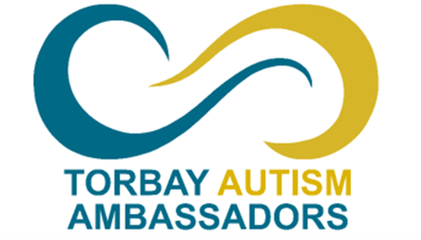
Torbay’s Autism Partnership Board was launched in November 2022 and members meet four times a year. Membership of the Board comprises of eight Autistic Ambassadors, two Family Carer Representatives, Torbay Council, Torbay & South Devon NHS Foundation Trust, adult social care providers, Devon & Cornwall Police and representatives from the voluntary sector. The role of the Board is to participate in, and influence decisions concerning the development of new services, review of existing services, policies and strategies and driving equality and justice for Autistic people in Torbay. More information about the Torbay Autism Partnership Board can be found here.

Torbay’s Autism Ambassadors have played a pivotal role in the development of the Torbay Autism Strategy. From setting the key priorities, providing feedback based on their own experiences with those priority areas, collaborating in engagement exercises, and ultimately giving the strategy the final sign-off. An action plan will be developed as a mechanism to deliver the key priorities from this strategy, and will be monitored by, and held accountable to the Autism Partnership Board.

National Strategy
Following the Think Autism Strategy (DHSC, 2014) published in 2014, The Department of Health and Social Care issued ‘Statutory guidance for Local Authorities and NHS organisations to support implementation of the Adult Autism Strategy’ (DHSC, 2015). The guidance states that there must be meaningful local autism partnership arrangements, which set a clear direction for improving services, and that the views, wishes, feeling and beliefs of people with autism and their carers should be listened to carefully, through a variety of methods such as autism partnership boards, consultation events or online consultation forms.

The 2009 Autism Act states that the Secretary of State must publish and keep under review a National Autism Strategy. In 2021, DHSC, the Department of Education and NHSE, published the National Strategy for Autistic Children, Young People and Adults (DHSE, 2021-2026). The purpose of the Strategy is to improve the lives of autistic people and their families and carers in England and to support them to lead fulfilling and happy lives. Following an initial meeting with Torbay’s Autism Ambassadors, they agreed that the priorities of the national strategy were relevant and reflective of the issues that autistic people in Torbay are facing, and that they should be mirrored for the Torbay Autism Strategy. The key national priority areas of the National Strategy are:
- Improving understanding and acceptance of autism within society
- Improving autistic people’s access to education, and supporting positive transitions into adulthood
- Supporting more autistic people into employment
- Tackling health and care inequalities for autistic people
- Building the right support in the community and supporting people in inpatient care
- Improving support within the criminal and youth justice systems

Local strategies are fundamental to setting out a clear vision and plan of how we want to support our local communities, whilst ensuring that resources are allocated effectively and gaps are addressed. Co-producing the strategy allows the community to have their say on issues important to them and the areas they feel need to be addressed. Co-production allows individuals to have their voice heard and encourage a collegiate approach to the formation of strategies.

Special Educational Needs and Disabilities (SEND)
The Torbay SEND Strategy and Torbay Adults Autism Strategy address different needs at various life stages. The SEND Strategy focuses on children, young people, and their families, while the Adults Autism Strategy addresses issues faced by Autistic Adults (18+). Despite these differences, Adult Social Care and Children’s Services will work together to ensure a smooth transition from childhood to adulthood, providing continuous support and resources.

The Torbay SEND strategy sets out a vision and direction of travel for children and young people 0 – 25 years, with Special Educational Needs and Disabilities (SEND) in Torbay. It is intended to cover the ‘local area’ of Torbay and can only be achieved through effective partnership between children, young people, parent and carers and our local system; the local authority, Integrated Care System (ICS) (health), public health, NHS England for specialist services, early years settings, schools, further education provisions and the voluntary and community sector.

A Shared Vision
- The shared vision for the SEND strategy was produced with representatives from across the local area. The shared vision is:
- SEND is everybody’s business - embedding the vision and values into the practice of everyone who works with children and families from 0-25 years.
- Identify and respond to needs early - in ways that value lived experience and expertise, offering personalised care and support.
- Deliver in the right place at the right time - always asking ‘so what difference are we making in the life of this child or young person?’
The vision for the SEND strategy will be delivered through five priority areas:
- Priority 1: SEND is everyone's business - embedding our values through education, health and social care, changing culture and reforming our workforce.
- Priority 2: Identify and act on children’s needs at the earliest opportunity, through valuing lived experience and expertise.
- Priority 3: Understand the needs of our children, young people and families and make sure joint commissioning supports service delivery and we make best use of all resources
- Priority 4: Make sure that all early years providers and mainstream educational settings support an inclusive approach to education
- Priority 5: Improve transition planning for young people moving into adulthood.
- To achieve this vision, young people, parents, carers, professionals and services across the local area have agreed to adopt a set of principles that have been set out in a partnership pledge. We know that the success of our strategy depends on cultural change. The commitments that we expect everyone to adopt and sign up to have been defined by our children and young people.

The full Torbay SEND Strategy 2023 – 2030 can be found here

Torbay Local Offer
The law says that every local authority must have a SEND Local Offer that provides information for and about services, processes and resources to support children and young people up to the age of 25 with special educational needs and disabilities (SEND), their parents or carers and the practitioners who support them - all in one place. Knowing what is out there gives you more choice and control over what support is right for you or your child.
The Torbay SEND Local Offer is part of the Family Hubs Torbay. Family Hubs are a new way of bringing together all the support a family may need and provides a welcoming space and a 'front door' for families from pregnancy through to young people turning 19 (or 25 if they experience SEND).
Visit the Torbay SEND Local Offer

Co-Production and Public Consultation
Our Torbay Autism Ambassadors have played an important part in the co-production of this strategy and will continue to monitor it throughout its lifespan to ensure that progress is being made.
In November 2024, a public online consultation was held in Torbay to collect valuable feedback on the strategy priorities while gaining insights into the experiences of local residents. This initiative was promptly followed by a working lunch with the Autism Ambassadors, facilitating a collaborative dialogue on autism-related issues. The analysis of the consultation responses identified key themes across each priority area, emphasising a need for enhanced autism awareness and understanding throughout the community. In April 2025, a subsequent strategy engagement session was organised for professionals who directly support autistic individuals or work in relevant organisations. This session aimed to strengthen connections among practitioners and to ensure that the collective knowledge and insights gained from both the public consultation and ongoing discussions are effectively integrated into the strategic initiatives, ultimately fostering a more inclusive environment for autistic individuals in Torbay.

Consultation Responses

What is your sex?
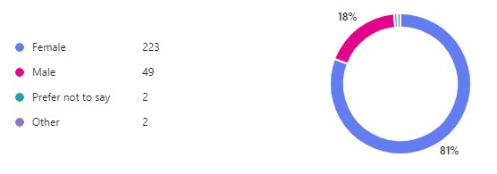
Which of the following age group applies to you?
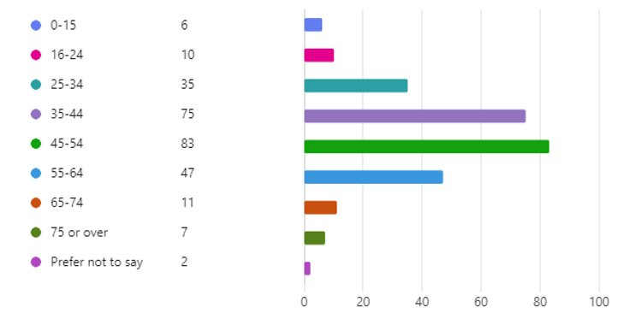
Which of the following best describes your ethnic background?
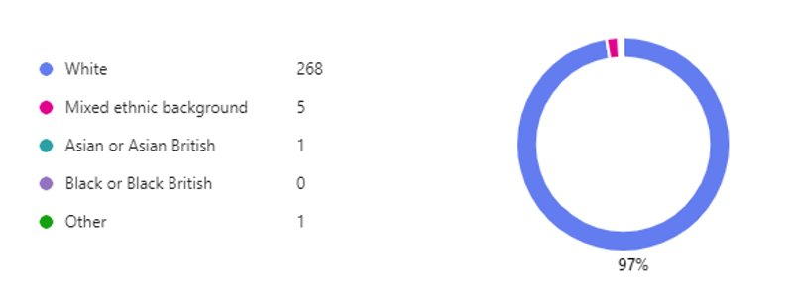
Do you identify as:
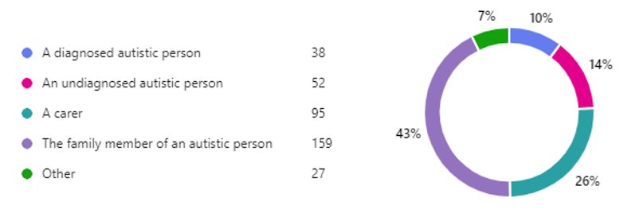
Do you consider yourself, or the autistic person you are related to or care for, to have a learning disability?​
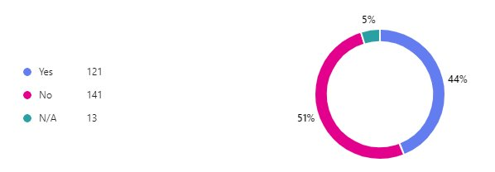

What do you think are the most important issues facing autistic people in Torbay today?
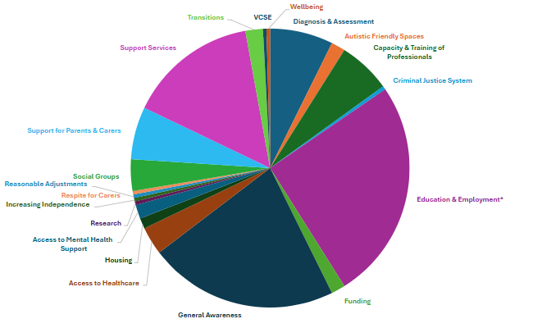

Out of 10, how would you rank Torbay residents’ understanding of autism?
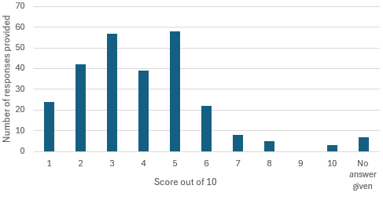
Based on the responses provided, the median score out of 10 is 2.8.

Our Key Priorities
Priority: Improving understanding and acceptance of autism within society
What we know
Our consultation revealed that although there is some awareness of autism in Torbay, there is still a significant opportunity to deepen understanding and promote better knowledge within both the community and local services.
Many individuals reported that both the general public and professionals often lack a proper understanding of autism. This includes misconceptions about autistic behaviours and needs. There are numerous accounts of people facing judgmental stares, rude comments, and even verbal abuse when autistic behaviours are displayed in public. Some have been accused of bad parenting or told that autism isn't a real condition, whilst also hearing the common misconception of "everyone is a bit autistic". Families often feel judged or stigmatised due to behaviours associated with autism, leading to social withdrawal and reluctance to seek help.
However, some positive experiences are noted, particularly with organisations and individuals who are understanding and accommodating. Examples include certain schools, community members who offer assistance during difficult moments, and local attractions and organisations.

‘I've heard various people say, "we're all on the spectrum". That one I hate as it really undermines and devalues the real struggles of autistic people.’

‘My experience has been varied - some people have an understanding of the condition and respond well. Others are judgemental and don't understand.’

Our goals are to:
- Enhance the public’s understanding of Autism and its diverse impacts on individuals.
- Work towards improving pre-conceived ideas about autism and addressing myths and misinformation.
- Promote the importance of making reasonable adjustments for everyone affected wherever possible.
- Raise awareness with the autistic community about what makes reasonable adjustments, reasonable.
- Improve access to community spaces that are friendly and accommodating for Autistic individuals.
- Ensure that relevant professionals receive Oliver McGowan training pertinent to their roles.
- Raise awareness about various communication methods that support individuals with Autism.
- Engage with local businesses and retailers to explore how we can work together to promote understanding.

Priority: Tackling health and care inequalities for autistic people
What we know
The findings from our consultations reveal a spectrum of experiences within the healthcare system, ranging from commendable to concerning. Positive feedback highlights instances where healthcare staff demonstrated knowledge, made necessary adjustments such as providing quiet rooms and modifying communication styles, and actively involving parents or caregivers when appropriate. However, some respondents indicated that the healthcare system has not been able to make essential accommodations for autistic individuals. Common issues include unsuitable physical environments, characterised by crowded waiting areas and overwhelming sensory inputs, as well as prolonged waiting periods and uncertainty regarding appointment schedules. Moreover, barriers to accessing healthcare services are prevalent. Many individuals report difficulties in navigating appointment systems, including complex online forms and inconsistent interactions over the phone. Additionally, our consultations identified a lack of adequate mental health support specifically tailored to the needs of autistic individuals, coupled with confusion surrounding the process of obtaining appropriate services.
These findings underscore the need for enhanced training, increased awareness, and the implementation of strategies among healthcare professionals in Torbay who engage with autistic individuals. The nature of these professional interactions has a significant impact on the well-being of autistic individuals and their families, thus illustrating the importance of addressing both positive and negative experiences within healthcare settings.

‘Access to quiet areas is very limited. Some healthcare workers are not up to date on autism training’

Our goals are to:
- Continue to support the roll out of the Oliver McGowan Training
- Support the roll out of the Reasonable Adjustment Digital Flag
- Raise awareness of reasonable adjustment in healthcare settings.
- Raise awareness of the challenges with Communication during appointments and how to support people effectively.
- Advocate for the use of easy-read appointment letters where required.
- Continue to promote the principles within the Triangle of Care initiative (a partnership between professionals, the person being cared for and the Carer).
- Increase awareness of the Torbay health passport.
- Improved information and advice on how to access appropriate mental health support for autistic individuals.
- Raise awareness about co-morbidities, and how Autism links with other health issues
- Maintain knowledge and awareness of our local LeDer (Learning from lives and deaths – People with a learning disability and autistic people) Review findings and learning.

Priority: Supporting more autistic people into employment
What we know
Contributing meaningfully through work, enjoying one's job, and feeling a sense of worth are important. However, the latest official statistics show that only around 3 in 10 working age autistic disabled people are in employment, compared with around 5 in 10 for all disabled people and 8 in 10 for non-disabled people (DWP, 2024).
Autistic people face the largest pay gap of all disability groups, receiving a third less than non-disabled people on average. Autistic graduates are twice as likely to be unemployed after 15 months as non-disabled graduates, with only 36% finding full time work in this period. Autistic graduates are most likely to be overqualified for the job they have, most likely to be on zero-hours contracts, and least likely to be in a permanent role (DWP, 2024).
Our consultation findings highlight the importance of understanding and accommodating employers or managers. Individuals reported experiences of employers lacking understanding of autism and mental health, instances of bullying and discrimination, isolation from colleagues and feelings of overwhelm and burnout.
Supportive workplaces that acknowledge disabilities and make reasonable adjustments contribute significantly to positive experiences. Workplaces that have a good understanding of autism and other disabilities create a more inclusive environment; this includes colleagues who are knowledgeable and show good attitudes toward neurodiversity.
Torbay currently funds

‘My work life is managed well by a supportive family and colleagues who understand my needs’
‘My daughter is missing out in huge elements of her education and is unlikely to gain any qualifications. She is concerned that this will be a major barrier to employment and independence in the future.’

Our goals are to:
- Strengthen partnerships with employers in Torbay to foster collaboration.
- Encourage local businesses to participate in autism-related events and training to enhance their expertise.
- Support and encourage more employers to offer work experience and work trials.
- Support and champion autistic friendly employers and businesses
- Cultivate connections with Disability Employment Advisors.
- Collaborate with local job centres to raise awareness and understanding of autism among staff working with autistic individuals.
- Raise awareness of reasonable adjustments to employers and promote toolkits and resources that can assist with implementing them.
- Promote information and resources available for employers, unemployed autistic people and autistic employees.
- Explore, support and raise awareness of local employment and skills support programmes, including those aimed at building self-esteem and confidence.
Priority: Building the right support in the community and supporting people in inpatient care

What we know
The consultation revealed several gaps in support for autistic individuals, such as peer support among autistic people and practical assistance when individuals require help navigating systems and accessing mainstream services.
To address these issues, it is important to create environments where autistic people feel secure and accepted. This includes developing autism-friendly public spaces and community hubs. Additionally, organizing social activities and groups can help reduce isolation and promote engagement within the community. Improved access to information, guidance, and signposting is essential to ensure that autistic individuals can readily discover the support available to them.
In July 2025, The Brook Inpatient Unit at Langdon Hospital, Dawlish opened. The Brook unit is a 10-bed acute admission unit for those with a mental health condition and learning disability and/or who are autistic. The Torbay Autism Partnership Board have been kept informed of progress of the build and given the opportunity to visit the unit prior to opening.

“There is a lack of support and groups for autistic adults - support is not just needed for autistic children. Autistic children become autistic adults and still need support.”

Our goals are to:
- Enhance the accuracy of information and data collection, so that commissioners can analyse local trends and make well-informed commissioning decisions for the autistic community in Torbay.
- Bridge the social support/peer support gap for autistic adults, ensuring they receive the assistance they need.
- Improve accessibility to information, advice and signposting to support services for autistic individuals and their family carers in Torbay.
- Explore the potential for creating an accessible hub where autistic individuals can connect within their local communities. This hub could serve as a supportive space for socializing, participating in activities, obtaining practical assistance, accessing peer support, and finding valuable information and advice.
- Develop and maintain links between the Torbay Autism Partnership Board and local inpatient units and their outreach services.
- Continue to maintain links with Adult Autism and ADHD Service (DAANA) and Devon Adult Autism Intervention Team.

Priority: Improving support within the criminal and youth justice systems
What we know
People with Autism are heavily represented in both the prison and probation population and amongst victims of crime. Our consultation results provided a varied response when it came to interactions with the police. Some individuals report positive experiences, highlighting police support during crises such as suicidal incidents, however others recount negative experiences, noting a lack of understanding and inappropriate handling of situations involving autistic individuals.
There is a recurring concern that police and justice system staff are not adequately trained to recognize and interact with neurodiverse individuals, and that misinterpretation of behaviours associated with autism often leads to unjust treatment or escalation of situations.

“The Police were brilliant during a suicidal incident.”
“Local police lack understanding of autism and additional needs”

Our goals are to:
- Emphasise the necessity for specialised training for all criminal and justice system personnel on neurodiversity.
- Advocate for collaborative approaches that involve families and professionals to support affected individuals better.
- Ensure there is consistent representation from Devon & Cornwall Police and Probation services to the Torbay Autism Partnership Board.
- Work with Devon & Cornwall Police and Probation services to raise awareness within the organisations and collaborate on new and existing ideas and initiatives.

Priority: Improving autistic peoples access to education and support positive transitions into adulthood
What we know
Many respondents to our consultation noted the knock-on effect of the lack of support during early education and a lack of adequate support and preparation from professionals in preparing autistic people for adulthood. Services and guidance that should assist with transitions are often absent or insufficient and feedback indicated that ineffective communication between parents, carers and professionals such as educators, social workers, and healthcare providers can hamper the development of effective transition plans.
Autistic individuals and their families often feel ignored or invisible within the system, leading to worries about their future and what will become of them without proper support.
Of the 1716 Education Health and Care Plans (EHCP) maintained by Torbay (up to 31st May 2025), 535 children and young people are identified as having an autism as their primary need. Torbay Adult Social Care and Torbay Children’s Services will work together to ensure a smooth transition from childhood to adulthood, providing continuous support and resources.

“There is inadequate support for higher education and autistic adults trying to access education”
“My daughter was failed by mainstream schools and there are no appropriate specialist provisions. They are unlikely to be able to gain any qualifications due to lack of professional expertise and the appropriate schools and provisions. My daughter’s mental health is also deteriorating due to this failure”

Our goals are to:
- Continue to maintain links between children’s services and adult social services to promote smooth transitions into adulthood.
- Explore and promote local skills programmes.
- Effective multi-agency early identification and pathways for support ensure that early and timely help addresses needs well.
- Transition plans will focus on opportunities, experience and skill development to build confidence, self advocacy and informed choice
- Ensure there is support available for those who do not meet the threshold of holding an EHCP or have a diagnosis.

Help and Support signposting
Our Autism Partnership Board is highlighting the services available to autistic adults and their carers in Torbay. You can find out more information here.

Are you are experiencing mental health distress? Or maybe you are worried about someone else’s emotional state. There are many organisations that can help and support you. Find out who to contact and what help is available on the Devon Partnership Trust website

