Cabinet’s Response to Consultation
  - February 2026

Budget 2026-2027

Statement from the Leader of the Council and Cabinet Member for Finance
In accordance with the Council’s Constitution, the Cabinet is proposing a balanced net Revenue Budget of £205.334million for 2026/2027 and a Capital Investment Plan of £126.865 million for the period up to 2028/29, for the Council’s consideration. As we said when we launched the consultation, our approach in proposing this budget continues to be one of focusing on the ongoing revenue pressures, delivering against our financial sustainability plans and our Capital Investment Plan. As always, we want to ensure we concentrate on the things that residents have told us matter to them.
We’d like to thank everyone who took the time to provide feedback on the draft proposals, whether by completing the questionnaire or engaging with us through our social media channels. We are also grateful to the Overview and Scrutiny Board for the time it dedicated to reviewing our proposals and for endorsing the suggestions we brought forward.
This year, the Government decided to provide local authorities with a three-year settlement, which is a welcome position as it offers certainty for medium-term planning. This allows us to make decisions in the overall context for the three-year period. Just before Christmas, Government shared with us the proposed settlement for Torbay. Whilst the financial position for year one (2026/27) of the settlement is reasonable, their proposal would have resulted in a significant funding gap of almost £20 million across years two and three. Between Christmas and February, we engaged extensively with multiple Government departments to make the case that the settlement did not adequately reflect the needs of our residents in Torbay.
On 9 February 2026, the Government confirmed the final settlement, and that they have reconsidered elements of this. As a result, comparably we are now in a slightly improved position over the three-year period than we had originally feared, with an estimated funding gap of £12 million. During the engagement with Government on the budget, it was made clear that they expect Councils to apply the full Council Tax increase available to them, which is 4.99%. If Councils did not do this then there was a risk to receiving government funding. Therefore, whilst our proposals for consultation set out our plan to limit any increase in Council tax to a maximum of 4.75%, the Government’s expectation has left us with no option but to proceed with a 4.99% increase to optimise our funding.
We recognise that this places additional pressure on residents, and while our flexibility in this area is extremely limited, we will continue to do everything possible to manage and mitigate the impact. This includes changes to our Council Tax Support Scheme to support families, which has already been approved at our Council meeting in December.
Whilst we are pleased that the budget reductions are not as severe as originally planned by Government, the level of savings required are very significant in years two and three. It is essential therefore that we manage our finances even more prudently and responsibly so as to minimise the impact of the required reductions in future years. We are proposing to allocate additional monies received for this year on a one-off basis only, meaning that it can be used to contribute to required savings next year. In respect of the one-off allocations, it is also important that these are used sensibly to ensure that the Council is in the best possible position to meet future challenges. We are therefore proposing to:
- Allocate £400,000 to fund transformation activity to sustainably reduce the Council’s budget in future years, and
- Allocate £1.7 million to create a Higher Needs Block reserve, to fund the required 10% Council contribution arising from Dedicated Schools Grant national policy changes.
We believe that this combination of approaches puts the Council in the best possible position to face the challenges arising from the funding settlement.
Within the consultation responses, we were pleased to see overwhelming support for continuing with our flagship programmes, Operation Brighter Bay and Operation Town Centres. Many of you told us you have already seen a marked improvement because of Operation Brighter Bay. At the same time, you asked that going forward we place a stronger emphasis on residential areas, not just our well-known visitor hotspots. We have listened carefully to this feedback and will be ensuring that Operation Brighter Bay delivers more visible improvements in neighbourhoods across our communities.
The Council faces significant uncertainty in respect of the delivery of adult social care. Whilst we hope that these services will continue to be delivered by Torbay and South Devon NHS Foundation Trust, we recognise that significant transformation activity needs to take place to reduce costs. We are proposing to establish a new adult social care reserve and allocate £730,000 to it in the 2026/27 financial year to fund transformation activity, and to start to develop funding solutions for future years.
Despite the significant challenges in today’s financial environment and the continued rise in costs, we have maintained a steady and responsible position as a Council, carefully managing your money. We are continuing with our ambitious regeneration plans, while also making sure that the everyday services you rightly expect and rely on remain in place. We are clear-eyed about the financial pressures ahead, but by taking prudent and sensible decisions in year one, we are putting ourselves in a stronger position and helping to smooth the path for future years.

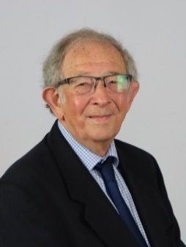
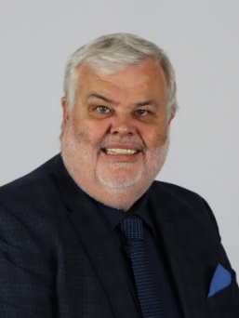

Councillor David Thomas Councillor Alan Tyerman
Leader of Torbay Council Cabinet Member for Housing and Finance

Appendix 1 – Cabinet’s response to the recommendations of the Overview and Scrutiny Board
Recommendations from the Overview and Scrutiny Board | Cabinet’s Response
- Any additional money received in the final Government Financial Settlement be used for an adult social care transformation reserve and that all appropriate steps be taken to work with the Government to secure additional funding to help deliver this. | Cabinet is proposing to allocate additional monies as follows to address the full range of risks facing the Council;  - Creation of an Adult Social Care reserve, allocating revenue funding of £730,000,  - Creation of a Higher Needs Block reserve, allocating on a one-off basis £1.7m to fund the Council’s required contribution,  - Allocation of £400,000 on a one off basis to fund transformation activity to reduce revenue expenditure in future years.
- The Panel acknowledge the Cabinet’s intention to increase the Council Tax by 4.99% in recognition of the impact on the Council’s funding in 2027/2028 and 2028/2029; and | Cabinet is proposing to raise Council Tax by 4.99% in light of the Government’s clear expectation and risk to other funding were the Council not to do so.
- Cabinet, Directors and the Members of Parliament be recommended to continue to take all appropriate steps to provide evidence and put the Council’s case forward that the Fair Funding Formula does not recognise Torbay’s deprivation and the impact that it will have moving forward | This was undertaken and Cabinet hope this contributed to the slightly improved position we now face.

