
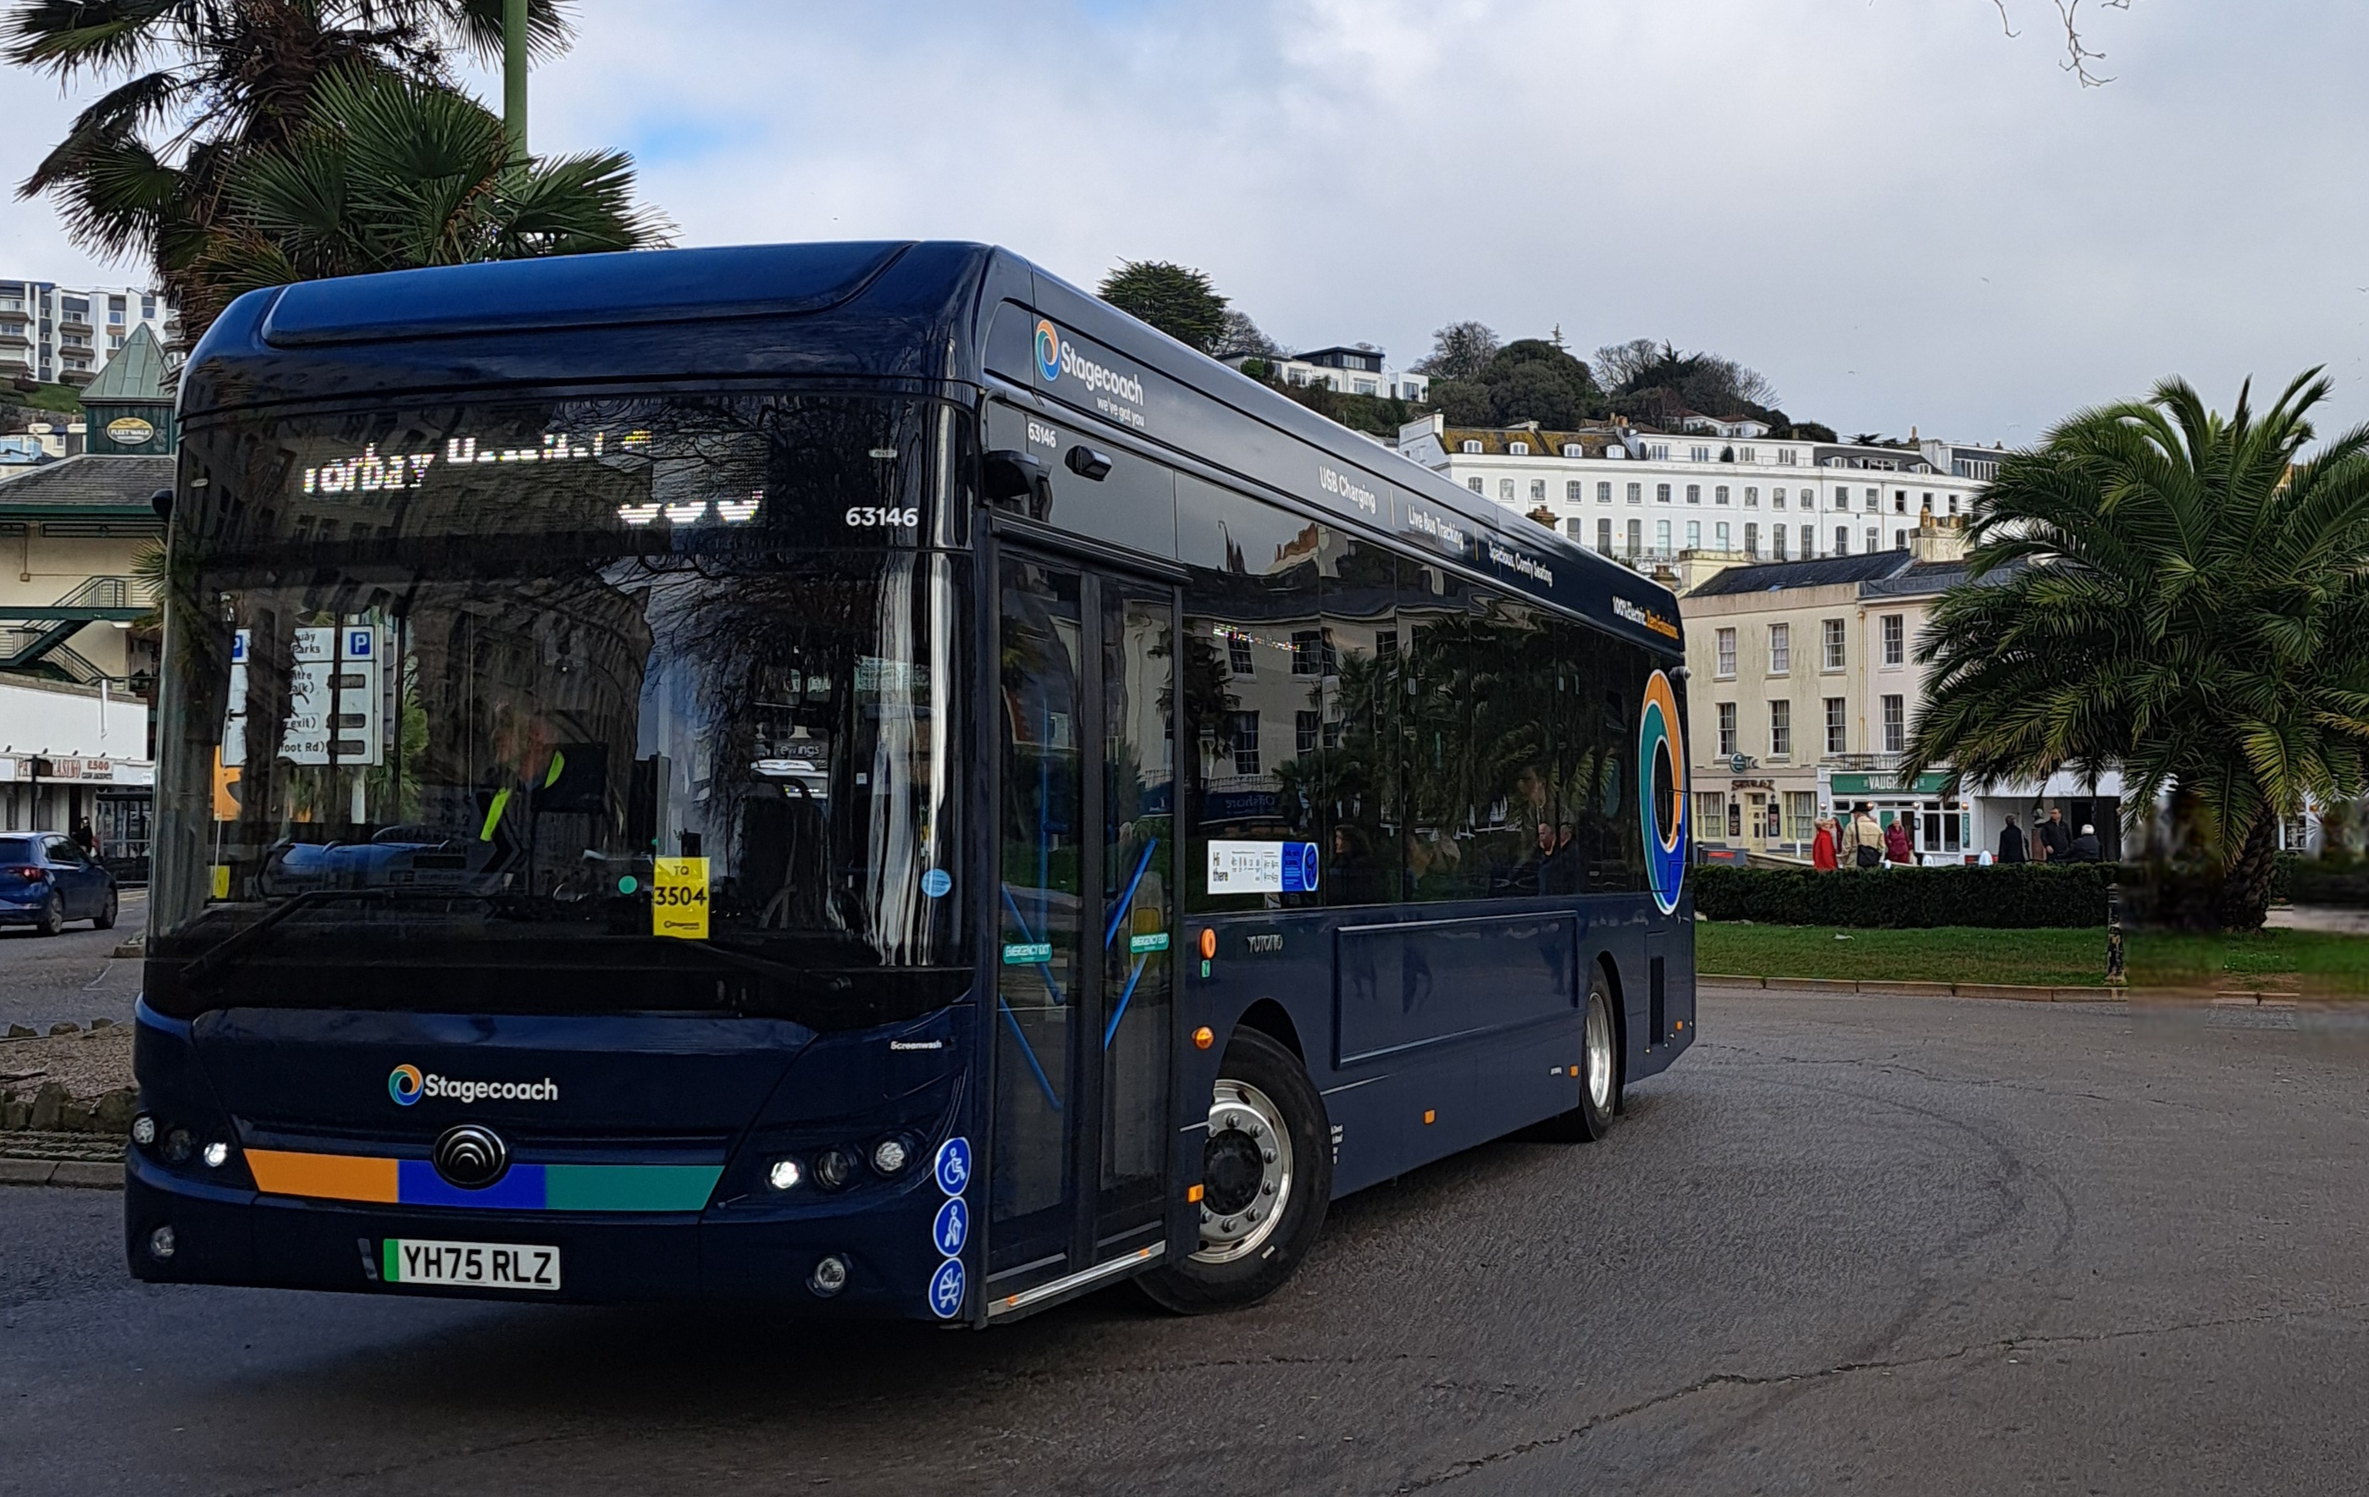

Companion Bus Pass application form (Torbay)
Devon and Torbay Combined County Authority (DTCCA) Companion Bus Pass application form for holders of a valid National Bus Pass

Introduction
You must live in Torbay to use this application form. If you live in the Devon County Council area, please visit devon.gov.uk/nationalbuspass.
You can use this pass if you live the Devon County Council and Torbay Council areas. To apply as a Torbay resident, you need to:
- live in Torbay
- already have a National Bus Pass issued by Torbay Council
- be secondary school age or over
- have a severe disability which makes it difficult for you to use the bus alone
All information provided below should be for the National Bus Pass holder, not the travel companion. The holder of that pass will, if approved, be issued with a Companion Pass.

Data protection
How the information you provide will be used
The information you have provided on this form will be used to deal with your request by the relevant department. We may pass your details on to contracted third party service providers. We will store a copy of your completed request as a backup for 12 months.
If you would like to know more about how we use your information and how you can exercise your information rights please see our privacy notice
If you wish at any time to access your personal information, or to have your data deleted from our database, please contact the Information Governance Team by email at infocompliance@torbay.gov.uk or by phone on 01803 201201.
I have read and understood the Data Privacy Statement and agree that Torbay Council may process the data I provide for the purposes detailed above, and in accordance with all applicable legislation.
☐ Yes, I agree

Your details
Please complete all sections of the form. All information provided should be for the National Bus Pass holder, not the travel companion.
This application form is only for holders of a National Bus Pass issued by Torbay Council.
Please confirm you live in Torbay and have a National Bus Pass. If not, please contact your local authority.

☐ Yes, I am a Torbay resident with Torbay issued National Bus Pass

Full Name:

Date of Birth:

Address:

Postcode:

Telephone Number:

Email Address:

National Bus Pass Number:

Eligibility
You must also provide proof that you live in Torbay. This must be dated within the last 12 months. This can be any of the following with your name and address:
☐ Rental agreement;
☐ Council Tax bill;
☐ Utility bill;
☐ Driving licence;
☐ NHS medical card/printed prescription
To be eligible you must also provide one of the following to support your application:
☐ Disability Living Allowance with higher rate mobility component together with higher rate care component.
☐ Letter on headed paper from a medical professional confirming a medical condition that that prevents you from travelling alone. For example uncontrolled epilepsy or a severe mental disorder.
☐ War pension with mobility supplement award letter.
☐ Letter from Children’s or Adult services confirming you are:
  - registered as blind or
  - registered with a learning disability and unable to travel alone.
☐ Personal Independence Payment combining at least 2 of the following activities:
- 8 points (or more) for 'moving around';
- 10 or 12 points for 'planning and following a journey'; 8 points for 'communicating';
- 8 points for 'reading';
- 8 points for 'mixing with other people'

☐ Other (please give details in the box below)

Personal Statement
Please use the box below to explain why you need a companion to help you travel by bus. Please note that companion passes are not issued for travel training.

Declaration
I want to receive a Torbay Council Companion Pass, issued due to my disability. I understand that I must use the Companion Pass together with my National Bus Pass. I declare that I am eligible and will follow the conditions of the scheme. I understand that these conditions may change. All my personal details in this application form are correct. I will return the companion pass if I move out of the Torbay Council area or if I no longer qualify for this pass for another reason. I also consent that Torbay Council can ask for more evidence if they need it to approve this application.

Signed: _____________________________________ Date: _____________________
Once you have completed your application form, please put the application form and supporting photocopied documentation in an envelope. You can send it by post to:
Torbay Council, Concessionary Fares
Community & Customer Services
Lower Ground Floor, Town Hall
Torquay, TQ1 3DR

You can also take the envelope to your local library and post in the internal post box.
You must send your own photocopies of original documents together with this application. Please note, we cannot accept responsibility for original documents we receive.

National Bus Passes and Companion Passes for Torbay residents are administered by Torbay Council on behalf of the Devon and Torbay Combined County Authority.
For more information, please visit www.torbay.gov.uk/bus-pass or contact the team on the following details:
Email: buspass@​torbay.gov.uk
Telephone: 01803 207766
Address: Concessionary Fares team, Torbay Council, Town Hall, Torquay, TQ1 3DR

