
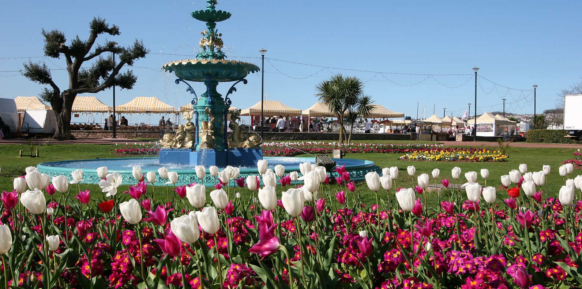

Biodiversity Duty Report
Jan 2026 to Jan 2031
Contents
Chapter 1. Policies, Objectives and Actions to meet our Biodiversity Duty 6
Chapter 2. Future actions to fulfil our biodiversity duty over the next 5 years 14
Chapter 3. Biodiversity Duty for Local Planning Authorities and Biodiversity Net Gain 16
This chapter includes LPA actions related to BNG as well as other planning actions to conserve and enhance biodiversity in more detail. 16
Background for BNG requirements 16
BNG related actions 17
On-going and future planning actions for biodiversity: 18
Other Local Planning Authority actions: 19
Ecological Advice 19
Ecological data 19
Torbay Development Plan 19
Monitoring Contributions 21
For countryside, landscape, ecology, biodiversity, and geodiversity: 23
Climate Change, Flooding and Water Management 23
Other LPA initiatives: The Berry Head Management Plan 24
Chapter 4. Information about our authority and how we can affect biodiversity 25
Torbay’s Natural Environment: 25
Actions to support our internationally important Special Areas of Conservation 25
Torbay Community 27
Chapter 5. How we have considered other strategies and how our policies, objectives and actions have helped the environment 28
The Devon Local Nature Partnership 28
Devon Local Nature Recovery Strategy – a joint strategy for Devon, Plymouth and Torbay 28
Devon Tree and Woodland Strategy 29
The South Devon National Landscape and Management Plan 30
Tor Bay Harbour Authority: 31
The Devon and Torbay Combined County Authority 31
Chapter 6. How we’ve raised awareness and educated the community 32
Staff training and awareness: 32
Chapter 7. Monitoring and Evaluation actions 32
Chapter 8. Biodiversity highlights and challenges 34
This section includes some example positive actions and initiatives: 34
Miyawaki Forests 34
Improved LED street lighting 34

Background and legal context
The Biodiversity Duty Report 2026 responds to the enhanced statutory biodiversity duty placed on public authorities from January 2023. The duty requires the conservation and enhancement of biodiversity and the publication of a plan and report in line with the Environment Act 2021. The report sets out how the Council will meet these legal requirements, and demonstrates how biodiversity considerations are embedded across Council policies, plans and service delivery. A draft report was published in March 2026 and approved by Cabinet on 14th April 2026.
The Environmental Improvement Plan (EIP23), published in January 2023, sets out government plans for significantly improving the natural environment. By 2030, the government has committed to; halt the decline in species abundance & protect 30% of UK land. By 2042, the government has committed to:
- increase species abundance by at least 10% from 2030, surpassing 2022 levels.
- restore or create at least 500,000 ha of a range of wildlife rich habitats.
- reduce the risk of species extinction.
- restore 75% of our one million hectares of terrestrial and freshwater protected sites to favourable condition, securing their wildlife value for the long term.
The Environment Act 2021 also introduces the strengthened ‘biodiversity duty’, such that public authorities who operate in England must consider what they can do to conserve and enhance biodiversity in England. This means that public authorities must:
- Consider what can be done to conserve and enhance biodiversity.
- Agree policies and specific objectives based on those considerations.
- Act to deliver those policies and achieve objectives
Local authorities (excluding parish councils) must also write and publish a biodiversity report. For local authorities and local planning authorities, the end date of the first reporting period should be no later than 1 January 2026. After this, the end date of each reporting period must be within 5 years of the end date of the previous reporting period. Council’s must publish all reports within 12 weeks of the reporting period end date.
By law, the biodiversity report must include: a summary of the action taken to comply with the biodiversity duty:
- the policies and objectives set to meet our biodiversity duty.
- the actions completed, either alone or in partnership with others, which benefit biodiversity.
- Explain how the LA has taken account of local nature recovery strategies, protected site strategies and species conservation strategies.
- Set out how it plans to comply with the biodiversity duty in the next reporting period (five years)
- Set out the actions The Council has carried out to meet biodiversity net gain obligations.
- Provide details of biodiversity net gains resulting, or expected to result, from biodiversity gain plans Torbay Council have approved.
- Detail how it plans to meet biodiversity net gain obligations in the next reporting period.
- Any other information considered appropriate

Policies, Objectives and Actions to meet our Biodiversity Duty
  - As set out above, the Environment Act 2021 requires all public authorities to consider what they can do to conserve and enhance biodiversity. This report communicates how Torbay Council has complied with the ‘biodiversity duty’ between the 1st January 2024 and the 31st December 2025 and the future actions identified to be delivered between January 2026 and January 2031. This first chapter sets out how the Council’s existing policies and strategies contribute towards meeting the strengthened Biodiversity Duty.
  - Torbay Council is a unitary authority responsible for delivering a range of public services to residents and businesses in Torbay, with a Vision for ‘…a healthy, happy and prosperous Torbay.’ Our strategic themes are: Community and People; Pride in Place and Economic Growth.
  - Our core functions include: education, social services, housing, waste management, planning, environmental health and public health; and Tor Bay Harbour Authority. To a greater or lesser degree, these various functions provide opportunities to benefit biodiversity.
  - This current report should build on the ‘first consideration’ of what action the Council has corporately made for biodiversity from 1st January 2024. This was largely embedded within the Council’s Climate Change Action Plan 2024-2026, the Torbay Local Plan (2012-2030), the Community and Corporate Plan and other Council framework documents listed below:
- Community and Corporate Plan - Torbay Council
- Torbay Council Climate Change Action Plan - Torbay Council
- Greener Way for Our Bay - Torbay Council
- Council Business Plan 2024/27 - Torbay Council - Priority P4: Protect and enhance our lived, built and natural environments, including our green spaces & Priority P3: Maximise heritage and cultural opportunities for the enjoyment and benefit of residents and visitors
- Devon, Plymouth and Torbay Local Nature Recovery Strategy
  - This section of the Biodiversity Duty Report therefore draws from various strategies, policies and procedures with service level contributions.
  - Table 1 below, includes some examples of Torbay Council policies and objectives in our Policy Framework Documents including the Climate Action Plan. It lists how their identified actions align with the Biodiversity Duty Requirements, and those actions that have been delivered between January 2024 and January 2026.
Table 1 Example Torbay Council Policies and Objectives and how their identified actions align with the Biodiversity Duty Requirements, and those actions that have been delivered between January 2024 and January 2026
Policies and Objectives | Summary | Actions identified | Actions which have been delivered
Torbay Council Community and Corporate Plan 2023-2043 | Commits the Council “to protect and enhance our natural environment” and “work in partnership to address the climate emergency and create a sustainable future”  This document recognises the importance of protecting and enhancing Torbay’s natural environment through the Council’s mission and approach.  Wider corporate policy framework and other strategies (such as the Local Plan below) contributes to the delivery of the Corporate Plan and includes detailed actions. | Corporate Priority Protect and enhance our lived, built and natural environments, including our green spaces. | See below – actions to deliver improvements in the natural environment more specifically delivered through the strategies below
Torbay Council Climate Change Action Plan 2024-2026 | This Action Plan primarily focuses on what the Council will do reduce it’s own carbon dioxide emissions.  It has been developed by many officers from across the Council, SWISCo and Torbay Harbour Authority, with support from members, and focusses on the areas of the Council where most carbon emissions arise from. These include the operation of our estate, fleet and business travel. As a wholly owned company of the Council, who deliver a range of services for the Council, actions that relate to SWISCo are also included in this action plan. | Install new streetlighting control system and full LED rollout to cut energy and carbon.  Carry out whole building decarbonisation assessments for 10 worst performing buildings.  Introduce a new climate & environment impact assessment tool for all council construction project  Develop actions to reduce carbon from staff business travel, including replacing grey fleet use  Refresh the Environment & Carbon Neutral Policy | Council have approved a new streetlighting control management system. Street lighting upgrades to LEDs to reduce energy use has been rolled out. The installation of a control management system and more energy efficient lighting will deliver significant carbon savings.  Between 1st April 2019 – 31 March 2025 consumption reduced by 50% from 4,912,041kwh to 2,437,007kwh. The reduction in energy consumption can be attributed partly to the replacement of over 60% of the council’s streetlight inventory from Holophane lanterns to more energy efficient LED. This resulted in carbon emissions reducing from 903 tonnes to 505 tonnes, a 44% reduction.  Purchase of three electric fleet vehicles
Torbay Council Environment and Carbon Neutral Policy | Sets out how Torbay Council will change the way it works to minimise environmental impacts and achieve its climate commitments. It applies to all Council employees, SWISCo, and all commissioned services | Reduce carbon emissions  Protect and enhance the natural environment (embedding the NERC duty into corporate policy)  Build climate resilience  Measure and report progress | Policy adopted in 2023 and implemented from then onwards.  All staff must support and deliver this policy wherever possible in their job roles.  Line managers are expected to challenge their teams and individuals to ensure this policy is adhered to
Greener Way For Our Bay (GWFOB) Framework  2024 - 2027 | Forms Torbay’s wider climate and nature recovery framework and GWFOB identifies nature-based actions among its ten priority areas for climate and nature recovery | Greener Way For Our Bay Framework sets out ten priority objectives. Of these, three directly relate to conserving and enhancing biodiversity, and two indirectly support biodiversity through climate adaptation and nature based action | New Draft Local Plan out for public consultation including net zero and climate resilient design and construction standards  10 climate related community engagement sessions to bolster awareness and more local action  Range of climate action and support for schools including the commencement of two new Miyawaki forests, three rainwater gardens and classroom activities. All of which also help reduce localised flooding
SWISCo Business Plan 2024-2029 | Sets out the mission, objectives, and operational priorities for SWISCo as Torbay Council’s wholly owned company | Commitment to maximising biodiversity and carbon sequestration opportunities (OB6)  Biodiversity centred- Park Management Plans (PG1)  Deliver an inclusive Green Infrastructure strategy. (Tree and woodland strategy and Open Spaces Strategy). (PG3) | In 2024/25, SWISCo recycled over 700 tonnes of seaweed into compost for community use. Commercial recycling rose to 20.5%.  SWISCo achieved EA permit compliance across all sites and advanced feasibility work on a new Waste Transfer Station, which will improve environmental compliance and expand reuse and recycling capacity.  Reducing emissions through implementation of electric street sweepers and barrows. Secured council approval to implement dynamic LED street lighting
Torbay Local Plan 2012 – 2030 (adopted) | Sets out the strategic planning framework for how Torbay will grow, change, and protect its natural and built environment up to 2030 | - Protect and enhance Torbay’s countryside, landscape and natural environment through designated areas (Countryside Areas, Urban Landscape Protection Areas, Undeveloped Coast).  - Safeguard heritage and nature conservation, including Conservation Areas and European Protected Sites.  - Allocate land for Country Parks and green infrastructure, supporting biodiversity and access to nature.  - Manage development to minimise environmental damage and ensure resilience to climate change. | Continued protection of designated Countryside Areas, Urban Landscape Protection Areas, and the Undeveloped Coast through development management decisions.  Delivery of biodiversity‑related planning obligations through the Local Plan’s evidence base (e.g., HRA requirements, mitigation for European Sites)  Delivery of development which incorporates biodiversity enhancements, mitigation and provision of open spaces for public use.  Support for nature conservation measures in identified sites including Berry Head & South Hams SAC (as part of Local Plan HRA updates)
Green Infrastructure Delivery Plan 2010 | The Vision for Torbay’s Green Infrastructure Delivery Plan is: “To build a sustainable Torbay for the future that protects and enhances the health and beauty of our natural environment, serves the needs of local people and supports economic development” | The strategic aims of the Plan are to: Enhance biodiversity and landscape character; Improve economic prosperity and support regeneration of the Bay; Benefit people and create healthy communities; Adapt to climate change; Support a low carbon economy; Safeguard ecosystem services | Target BL15. Ensure biodiversity standards e.g. provision for urban biodiversity are set out in developer guidance and validation documents:  Updated Planning department’s Local Validation List to require all development proposals to submit the “Torbay Wildlife and Geology Checklist”
Devon, Plymouth and Torbay Local Nature Recovery Strategy | A statutory strategy for Devon, Plymouth and Torbay required under the Environment Act 2021. It sets out local biodiversity priorities, a mapped network of important habitats, and agreed actions to support nature’s recovery across the whole county. Final publication expected in March 2026. | Make space for wildlife everywhere: provide shelter, nesting sites and food  Delight in the unruly!  Reduce emissions and adapt to climate change  Look after Devon’s soils  Control invasive species  Minimise light pollution  Minimise pollution and biocides  Minimise recreational disturbance and litter | Cabinet (17th February 2026) provided consent for DCC to publish the Devon Local Nature Recovery Strategy.
Devon Tree and Woodland Strategy | A county‑wide strategy (covering Devon, Plymouth and Torbay) that sets out a long‑term plan to protect, expand, improve and manage Devon’s trees, hedges and woodlands up to 2050. | Increase canopy cover by 4ha per year in Torbay to reach 2050 canopy cover target  Expand, protect, improve and restore woodland habitats, including Devon’s temperate rainforest, orchards, hedgerows and ancient woodlands.  Enhance woodland resilience to climate change (warmer, wetter winters; hotter, drier summers) | Strategy adopted region-wide—Torbay now working with partners to determine its specific contributions toward tree-cover expansion.  Existing Torbay tree-planting programmes (e.g., via Plymouth and South Devon Community Forest, community planting schemes) already contributing towards the Strategy target of increasing tree cover
Devon Biodiversity Net Gain Strategic approach | Biodiversity Net Gain (BNG) became mandatory in England on 12 February 2024. BNG is a requirement under the Environment Act 2021, which amended the Town and Country Planning Act 1990. It mandates that developers must leave biodiversity in a measurably better state than before development, with a minimum 10% net gain in biodiversity value | Cross boundary BNG working group to ensure consistency throughout Devon.  Updates to internal processes and development management  Identification of potential habitat creation opportunities | A dedicated BNG officer.  Regular BNG group meetings.  The Council contribute to a joint Devon-wide BNG guidance website for developers, landowners interested in providing BNG  This guidance aligns with the Council’s updated validation checks. Officers received several training sessions since early 2024 covering legal frameworks, planning roles, and BNG metrics.  To assist with the delivery of BNG conditions and support BNG delivery through development.  Torbay Council is investigating the possibility of habitat banking on its land and looking at sites for their potential to provide offsite BNG units.
Municipal Waste / Resource Management Strategy (2020-2023) -out of date but still applicable | The Torbay Resources and Waste Strategy seeks to support a path towards carbon neutrality by 2050 and to consider the amount of embedded carbon in the materials that are collected for recycling and the environmental benefit of recycling. | Prioritising waste prevention, reuse, and recycling, reducing ecological pressures  Protecting the natural environment through improved waste systems  Eliminating landfill impacts through Zero Waste to Landfill achievement  Strengthening environmental enforcement to safeguard habitats  Supporting climate mitigation  Reducing pollution, littering, and fly tipping that harm wildlife  Educating residents and businesses on sustainable behaviours | Yearly increases in annual recycling rate (0.5% increase in 2024/25 compared to the previous year) and garden waste subscriptions
Torbay Port and Harbour Masterplan (addendum) 2019-2024 | The Masterplan (2013) provides a long term framework for the sustainable development and management of Tor Bay Harbour and the harbours at Brixham, Paignton and Torquay, informing future land use-, marine activity, and environmental stewardship.  Port area includes environmental designations, supporting the protection of marine and coastal biodiversity | Ongoing efforts to minimise the impact of human activity on Tor Bay’s natural environment – while also allowing, where possible, for those activities to take place. The Harbour Authority have been closely involved in several Bay-wide initiatives to improve sustainability.  Highlights environmental measures to ensure the Harbour Authority makes a positive contribution to the environment and amenity, including sustainable harbour management.  Commits to sustainable management of maritime activities, including fishing, eco-tourism, and marine businesses, which supports healthy ecosystems | Partnership working with marine stakeholders has supported local biodiversity initiatives, including eco‑mooring and anchoring improvements (e.g., Advanced Mooring Systems deployed with partners in Torbay), reducing physical seabed damage.  Sensitive Habitat Marker Buoys and Voluntary No‑Anchor Zones implemented in seagrass areas, protecting key marine habitats such as seagrass meadows and seahorse habitat.
Torbay Council Local Flood Risk Management Strategy 2015 | This LFRMS highlights the steps that are to be taken to improve knowledge of flood risk within Torbay, to work with other FRMA’s and the public towards reducing the risks whilst aiming to balance the need of communities, the economy and the environment. | To take a more sustainable approach to flood risk management at a catchment level; considering natural land use management techniques, such as managing flood plains and restoring wetlands and upland woodlands.  SuDs are also an opportunity to ensure that amenity and biodiversity are considered with the same importance as managing volumes of water | Implementation of the Torbay SUDS Design Guide suds-design-guide-version-20_sept22.pdf that support sustainable drainage methods that protect natural flow regimes and can provide a natural habitat for wildlife

Future actions to fulfil our biodiversity duty over the next 5 years
  - This Chapter seeks to demonstrate how we incorporate biodiversity considerations into our functions and deliver the Community and Corporate Plan’s mission to ‘protect and enhance our (built and) natural environment’ and ‘address the climate emergency so as to create a sustainable future’. This will primarily be driven through our policy framework documents including the Torbay Local Plan and the Council’s Climate Change Action Plan (CCAP) 2024-2026.
  - Our Council Business Plan is the delivery plan for our Community and Corporate Plan. Whilst the Community and Corporate Plan sets the council’s vision, objectives and priorities for the next twenty years, the Council Business Plan is a more focussed delivery plan of what the Council will undertake through until 2027.
  - Under the Pride in Place theme, the Council seeks to celebrate and protect the places that make Torbay special, maximising the cultural, heritage and event opportunities for our residents and visitors alike. Working in partnership we will continue to address the climate emergency, so as to create a sustainable future. A priority under this theme includes: Protect and enhance our lived, built and natural environments, including our green spaces (P5).
  - Another key strategy includes the ‘A Greener Way For Our Bay’ which is Torbay Climate Partnership’s framework and action plan that aims to reduce the Bay’s carbon emissions and prepare for a changing climate. It proposes a 10 key actions two of which are particularly related to the Biodiversity Duty copied below:
  - Enjoy and protect our marine and natural environment - projects include a new comprehensive plan to restore and protect natural habitats within Torbay and projects to help our local sea grass thrive
  - Work with nature and the local community to prepare for a changing climate - While reducing carbon emissions is essential, Torbay's plan also includes adaptation measures to prepare for climate impacts. This involves assessing risks to public health, infrastructure, and biodiversity, and helping us to prepare and be more resilient
  - We seek to embed good ecological practices within our strategies, business plans and services plans; and will also continue to use our influence to motivate others to take action for biodiversity. We have identified key future projects and actions to further biodiversity interests in the next reporting period, as set out in Table 2 below.

Table 2: Example Torbay Council future actions identified to be delivered between January 2026 and January 2031

Action | Service Area Responsible | Estimated Delivery Timeframe
Allocate additional resource to lead on strategic environmental matters and compliance with the Environment Act 2021 (subject to leadership approval). | Place Strategy | 12–18 months
Identify how the NERC Duty should feed into Torbay Council service plans and SWISCo. Business Plan | Corporate Strategy / All Service Leads | 6–12 months
Embed the NERC Duty into each Torbay Council service plan (subject to leadership approval) | Corporate Strategy / Senior Leadership | 12–24 months, then ongoing
Identify how the NERC Duty should feed into the SWISCo Business Plan | SWISCo | 6–12 months
Embed the NERC Duty into the SWISCo Business Plan and Service Level Agreement with Torbay Council (subject to leadership approval) | SWISCo/Senior Leadership | 12–24 months, then ongoing
Strategic overview of the actions that Torbay Council can take to help deliver the Devon LNRS | Pride in Place /SWISCo | 6-12 months, then ongoing
Act on LNRS proposals by creating or improving habitat on land we manage | Place Strategy / SWISCo/ Estates | ongoing
Develop Parks Improvement Strategies including biodiversity actions (incorporating the Devon LNRS) | SWISCo | 12–24 months
Continue developing a Green & Blue Infrastructure (GBI) Strategy | Spatial Planning / SWISCo / Torbay Heritage Places / Public Health | 36-48 months
Investigate creation of a Habitat Bank and habitat banking potential/opportunities on Council land (SWISCo Business Plan) | Spatial Planning / SWISCo / Finance / Estates | 24 months
Produce and begin delivery of Management Plans for all for all Council owned and managed SSSIs | SWISCo / Spatial Planning / Geopark / Estates | 12–36 months
Produce Management Plans for all Council-owned and managed County Wildlife Sites | SWISCo / Spatial Planning / Estates | 12–48 months
Develop and deliver the Berry Head Management Plan (restoring SSSI features) | SWISCo / Spatial Planning / Estates | 6 months for plan; multi year delivery
Scale up tree planting, woodland creation, street tree planting and park greening (via the Plymouth and South Devon Community Forest) | SWISCo / Strategic Planning | Multi-year delivery commencing in 2026/2027
Include a new section on the NERC Duty and how the Council can take action to preserve and enhance biodiversity within the iLearn climate change training | Corporate Training / HR / Strategic Planning | 6–12 months
Finalise a system for monitoring Biodiversity Gains approved through the planning system | Planning / Business Support | 6-12 months

Biodiversity Duty for Local Planning Authorities and Biodiversity Net Gain

This chapter includes LPA actions related to BNG as well as other planning actions to conserve and enhance biodiversity in more detail.

  - By law, LPAs must include the following Biodiversity Net Gain (BNG) information to fulfil their biodiversity reporting duty
  - The actions they’ve carried out to meet BNG obligations
  - Details of BNG resulting, or expected to result, from biodiversity gain plans that have been approved
  - How they plan to meet BNG obligations in the next reporting period

Background for BNG requirements
  - The Environment Act 2021 and associated regulations amend the Town and Country Planning Act 1990 (TCPA) to make BNG a mandatory condition of planning permission. Major TCPA development has been subject to mandatory BNG since 12 February 2024, and all other TCPA development has been subject to BNG from 2 April 2024 (subject to exemptions).
  - Relevant developments need to demonstrate that proposals can deliver a minimum 10% uplift in biodiversity value, when compared to the pre-development biodiversity value of the application site. Uplift is calculated using the statutory biodiversity metric. Development cannot commence until BNG has been demonstrated.
  - Developers will need to submit a biodiversity gain plan (BGP) to the local planning authority for approval, after the grant of planning permission. The BGP document will evidence what measures are being provided to achieve the required uplift in biodiversity value. Under the Environment Act 2021, only three measures are permitted to deliver BNG:
- Onsite habitat enhancements;
- Registered offsite biodiversity gain; and
- Purchase of statutory biodiversity credits.
  - If development is subject to the biodiversity net gain requirement, the application must include information:
- as set out in Article 7 of The Town and Country Planning (Development Management Procedure) (England) Order 2015, and
- in the Torbay Council local validation list
  - Where the improvement to biodiversity is on site, the Council will expect:
- it will be in place for a minimum of 30 years, and
- it will be monitored over this time
  - It is likely we will use planning conditions or a legal agreement to make sure this is the case. We will also have to provide a report on the status of biodiversity net gain within Torbay at least every five years.

BNG related actions
  - From 12 February 2024, the Local Planning Authority (LPA) has been applying a mandatory Biodiversity Net Gain Pre-Commencement Condition to all relevant (except exempted) planning applications coming forward. This data has been captured and entered into the corporate planning software (Uniform). Planning applications must provide the relevant information set out in the Torbay Council local validation list.
  - A completed Devon Biodiversity Net Gain Statement for Validation should include:
- The steps taken to minimise adverse biodiversity impacts in line with the mitigation hierarchy
- The proposed approach to enhancing biodiversity on site (including how the applicant has followed the sequential approach and a justification as to why the proposed approach is the most appropriate);
- Any proposed off site biodiversity enhancement (including the use of biodiversity units and/or national credits) that have been planned or arranged for the development
  - The LPA has provided online advice and, through the BNG Steering Group worked with officers from other local authorities and Devon County Council (DCC) to provide The Devon Biodiversity Net Gain Guidance Note. This Guidance Note provides advice on calculating and delivering biodiversity net and delivering BNG across all Devon LPAs. It aims to ensure a consistent and efficient approach to Net Gain across Devon. It is relevant for all those involved. This includes the Devon Biodiversity Net Gain Map which can be used to find registered Habitat Banks, those who plan to register as a Habitat Bank and those interested in delivering BNG on their land.
  - The BNG Steering Group and DCC Ecologists (through our Service Level Agreement) have facilitated Biodiversity Net Gain Training Events and Webinars for Torbay Council Planning Officers.
  - The LPA has commissioned Devon County Council (Principal Ecologist) to assist in the inspection of BNG eligible planning applications to review the BNG metrics and provide recommendations. The ecologist has provided comment on behalf of the LPA and 5 Biodiversity Net Gain Plans (in the last two years). See table 3 below.
  - Torbay Council Planning Authority will enter any Section 106 Agreements on the Torbay Exacom webpages where these are used to secure onsite delivery of BNG. At time of writing, Torbay Council has determined a total of 17 BNG‑applicable planning applications and 5 planning applications have had the mandatory BNG Condition applied for on-site BNG.
Table 3 In terms of Biodiversity Gain Plans (BGPs) our records show:
Planning Reference | On/Off Site | Net Gain in habitat units as a percentage
P/2024/0626 BNG (BGP) condition discharged | On-site | Area habitat biodiversity units 0.14  Area habitat biodiversity units + 35.56% change
P/2024/0879 BNG (BGP) condition discharged | On-site | Area habitat biodiversity units +0.0330  Area habitat biodiversity units +12.33% change  Hedgerow biodiversity units +0.0025  Hedgerow biodiversity units +11.54% change
P/2025/0622 BNG (BGP) condition discharged | On-site | Area habitat biodiversity units +0.01  Area habitat biodiversity units +13.35% change
P/2025/0061 BNG (BGP) condition discharged | On- site | Area habitat biodiversity units 0.02.  Area habitat biodiversity units +16.60 % change
P/2024/0532 BNG (BGP) condition discharged | On- site | Area habitat biodiversity units 2.1808  Area habitat biodiversity units +41.51 % change

On-going and future planning actions for biodiversity:
  - In the next reporting period, we aim to continue to support applicants through the planning system through the provision of expert advice from our commissioned ecologists and the systems and process that we have put in place to record and report on BNG.
  - It is expected that many more Biodiversity Gain Plans will be approved by the Planning team from January 2026 onwards, (with the assistance of the specialist ecological advice from DCC colleagues) and the associated delivery of the net gain.
  - The Council has initiated exploratory work to establish the viability of potential Habitat Bank land within its ownership. This included commissioning of a limited number of ecological reports to provide the Baseline Biodiversity Net Gain Assessments and recommendations exploring options to enhance certain landholdings, in order to potentially deliver Biodiversity Units. This work will be reviewed and the scoping for potential Habitat Bank land on Torbay Council assets will continue, initially, at an internal officer level.

Other Local Planning Authority actions:

Ecological Advice
  - Torbay Council has a service level agreement with Devon County Council Ecology Team to provide advice and scrutiny on Planning Applications beyond the BNG element. The service agreement outlines the ecological and biodiversity support that Devon County Council (DCC) will provide to Torbay Council across various planning stages. This includes strategic advice during policy and guidance development, pre-application ecological and Biodiversity Net Gain (BNG) input, validation list support, and detailed assessments of ecological reports and BNG metrics during application determination.
  - Devon County Council can also offer recommendations on planning applications. Post-determination, DCC will review evidence for discharging ecological conditions, monitor BNG compliance through site visits and reports, and advise on enforcement actions where necessary (subject to a fee schedule).

Ecological data
  - Torbay Council has a Service Level Agreement with Devon Biodiversity Records Centre (DBRC) which includes the provision of periodic updates to ecological data GIS layers and, more detailed County Wildlife Site Assessments where sites are owned by the Local Authority. DBRC plays a key role in providing local ecological data for the County as a whole. It holds valuable information on designated sites, including local wildlife areas, as well as records of protected, rare, and invasive species and habitats. This data is gathered through collaborative partnerships with various non-governmental organisations and the Devon Wildlife Trust.

Torbay Development Plan
  - In December 2015, we adopted our Local Plan 2012-2030 – ‘A landscape for success’. Alongside Neighbourhood Plans, this Plan provides the basis for planning decisions within Torbay.
  - This covers the spatial strategy and strategic delivery objectives. It covers all three towns, Torquay, Paignton and Brixham. It works alongside policies for managing change and development in the Bay. The Plan allocates areas for:
- investment in tourism
- future growth areas for housing and employment
- proposed Country Parks
- existing and proposed shopping centres and transport hubs
  - 3.22 It works with the Countryside Area, Urban Landscape Protection Areas and Undeveloped Coast. It also includes information and policies about things such as:
- waste and minerals
- showing sites for potential housing and or employment development
- heritage and nature conservation information such as Conservation Areas and European protected sites
- landscape and environment designations such as SDNL (AONB)
  - The Adopted Local Pan has five key Aspirations but two clear aims related to the conservation and enhancement of biodiversity and natural environment. (see Aspiration 3, and Policies SS8 and SS9 and Aspiration 5), in recognition of the environmental, social and economic value of those assets. Specific policies, covering the natural environment, green infrastructure and historic environment, promote protection and improvement of the environment.
  - Aspiration 3: Protect and enhance a superb natural and built environment.
To conserve and enhance the richness and diversity of the built, historic, marine and natural environments, which provide Torbay with its unique setting and important economic benefits. This will be achieved by meeting the following objectives:
- To safeguard heritage assets including those at risk in a manner appropriate to their significance, having regard to their ability to deliver economic regeneration, express local identity, reveal social histories and narratives and increase the connection of communities with place.
- To ensure new development makes a positive contribution to local character and identity, including the wider landscape character, river corridors, open spaces, country parks and natural areas, and setting of proposals.
- To avoid mediocre design by the application of clear design standards, including the use of Torbay’s Design Review Panel to maintain quality development that is well integrated in its surroundings and responds successfully to local character.
- To require conversions and extensions to positively enhance the existing building, especially in Conservation Areas, removing unsympathetic extensions and rectifying poor quality alterations where necessary.
- To safeguard existing and maximise opportunities for biodiversity enhancement in and around developments to deliver a net gain for biodiversity.
- To encourage the re-use of empty homes and businesses, including bringing back historic buildings into beneficial use.
- To make the most of the English Riviera’s status as the world’s first internationally recognised Urban Geopark in recognition of its geological, historical and cultural heritage and sustainable tourism value.
  - Aspiration 5: Respond to climate change:
To ensure the use of energy and natural resources, the sensitivity of the natural environment and public health needs are taken into consideration when planning new development. This will be achieved through meeting the following objectives:
- To support the development of ‘green collar’ businesses in the Bay.
- To promote the installation of low carbon and renewable technologies.
- To improve the energy efficiency of developments to reduce the reliance on fossil fuels and the impact of rising utility bills on poverty.
- To help deliver ‘invest-and-save’ projects to allow scarce resources to be channelled to the most productive use.
- To become resilient and adaptable to climate change.
- To minimise flood risk to new and existing development by incorporating climate change factors such as run-off, sea level rise, increased storminess and unpredictable weather.
- To recognise the multiple benefits provided by open spaces, biodiversity, green infrastructure such as green corridors/wedges, rural landscapes, beaches and the Bay itself, having regard to their statutory significance and value to the community over the lifetime of development.
- To minimise the generation of household, business and construction waste and reduce its negative impacts upon the environment by focusing on the prevention, re-use and recycling of waste as set out in the waste hierarchy and prevent pollution.

Monitoring Contributions
  - The existing Local plan is accompanied by Supplementary Planning Documents (SPD) including the Planning Contributions and Affordable Housing SPD (planning-contributions-spd_2022.pdf) Section 2.5 deals with biodiversity and mitigation of development impacts upon it. The SPD provides a greater level of detail support the relevant Torbay Local Plan 2012-30 Policies, particularly SS8 and NC1. It sets out detailed sections on the following habitats and species, which must be addressed as “site delivery matters” when considering development proposals :
2.7 Greater Horseshoe Bats (HRA issue)
2.8 Recreational Impacts on Berry Head to Sharkham Point (HRA Issue)
2.9 Impacts on Coastal and Marine Habitats and Species (HRA and National Nature Reserve issue)
2.10 Cirl Buntings
2.11 Protected species- locally important sites for biodiversity and geodiversity.
2.12 Offsite habitat compensation (Biodiversity offsetting. Now partly superseded by Biodiversity Net Gain requirements)
  - Section 2.16 of the SPD seeks monitoring contributions. The latest (2022) version of the SPD makes these a “site deliverability matter” including for Ecological Mitigation works. The starting figure is £4,800 (index linked) for a development of 100 dwellings. The notes in Table 2.4 state that:
Ecological Mitigation Works. £4,800: Based on 2 full days data assessment and/or site visit per annum for years 1, 3, 5, 10, 15, 20, 25 and 30, charged at £300 per day. Cost is per development site. This figure would be typical of a large major development (e.g., 100 dwellings) requiring significant ecological monitoring. The figure will be adjusted upwards or downwards according to the complexity of the ecological mitigation and the level of monitoring required.
2.16.3 Monitoring of Ecological Mitigation. The effectiveness of ecological mitigation relies on appropriate monitoring. Where mitigation measures or compensation land are necessary in order to address the ecological impacts of a development and to secure a net gain in biodiversity (as sought by Local Plan Policy NC1), the Council will also seek a monitoring contribution to enable a suitably qualified ecologist to ensure that the mitigation measures or compensation land have been implemented appropriately and are being maintained effectively, and to identify any remedial works where necessary.
2.16.4 The monitoring contribution sought will be proportionate to the nature of the ecological mitigation measures required, and the level of monitoring need that they give rise to. It is anticipated that many ecological mitigation measures would give rise to a need for two full days of monitoring per annum, carried out on years 1, 3, 5, 10, 15, 20, 25 and 30 of the development. Charged at a rate of £300 per day (as at May 2022), this results in a total monitoring contribution of £4,800. The level of monitoring required will depend on the complexity and extent of the ecological mitigation, and the monitoring contribution sought will be increased accordingly on a case by case basis.
  - CIL may also, in principle, be used to monitor ecological mitigation, although the Council has generally sought to target CIL to the delivery of infrastructure including green infrastructure rather than monitoring.
  - The emerging Torbay Local Plan 2025-2045 plan also includes policies which seek to protect and enhance our natural environment and build resilience and sustainability in the context of climate change key issues are set out below:

For countryside, landscape, ecology, biodiversity, and geodiversity:
- Policies for the protection South Devon National Landscape (formerly AONB) in the South of Torbay.
- Policies for the protection and enhancement of South Hams Special Area of Conservation (SAC) at Berry Head and the surrounding countryside which is important for Greater Horseshoe Bats (sustenance zone) and the Berry Head calcareous grassland 8 km ‘zone of influence’. Which is also indicates the need for Suitable Alternative Natural Greenspace (SANG) and active management and dog-friendly facilities to reduce recreational pressure on Berry Head grassland.
  - Delivery of homes/holiday accommodation in south Torbay requires a positive strategy to manage impacts on South Hams SAC. This is a critical soundness measure for the Local Plan.

Climate Change, Flooding and Water Management
- Net Zero & Climate Change Strategy All new homes built after Plan adoption must produce 75% fewer carbon emissions than 2013 Building Regulations. Policies to embedded carbon in existing buildings, and guidance on Heritage, and Climate Change
- Torbay is a Critical Drainage Area. There is a legacy of shared sewers creates flooding and water management issues which raises Habitats Regulations concerns due to combined sewer overflows into Marine SAC. (note the importance of the evidence base Strategic Flood Risk Assessment and Water Cycle Study). The Infrastructure Delivery Plan will include costed flood mitigation measures. In addition to physical infrastructure, policies need to deliver reduced water run-off through Sustainable Drainage & Marine Protection measures.
  - The Local Plan will need to set out s106 and CIL funding mechanisms for biodiversity mitigation. It will not be possible to introduce or prepare new Supplementary Planning Documents after June 2026 (due to change in plan making Regulations as part of the LURA Act). Updated contributions policies will therefore need to be embedded in the new Local Plan.
  - The emerging Torbay Local Plan 2025-2045 plan is accompanied by a wide evidence base that together provide valuable data on our natural environment its resilience and capacity to support growth. The following studies to support the development of the above-mentioned planning policies and particularly assist with the assessment of our natural environment:
These include:
- Agricultural Land Survey - A Strategic Study of the Best and Most Versatile Land
- Required for Housing and Employment
- Strategic Landscape Study, comprising four related studies. The other studies are: Landscape Sensitivity Assessment (in two parts); Open Space Review (in three parts) and Review of Valued Landscapes.
- Wildlife screening assessment
- Assessment of Sewer Capacity Study*
- Water Cycle Study*
- Strategic Flood Risk Assessment Update (currently in draft)*
- Infrastructure Delivery Plan (to be prepared)*
*These studies will be particularly relevant to ensure no changes to water quality (which can have an adverse effect on the integrity of the Lyme Bay and Torbay Marine Special Area of Conservation (SAC)) as a result of additional growth proposed in the emerging Plan. It will be necessary to consider the effectiveness of any adopted mitigation measures and whether any additional measures may be required.

Other LPA initiatives: The Berry Head Management Plan
  - Berry Head is designated as a Site of Special Scientific Interest (designated 1952) and forms part of the Berry Head to Sharkham Point National Nature Reserve (designated 2001) and part of the South Hams Special Area of Conservation (SAC) (designated 2005) under the European Habitats Directive. The site is also designated as a regionally important geological site (RIGS), a Country Park and lies within the South Devon National Landscape (AONB).
  - The Strategic Planning Team has commissioned (2026) the preparation of a comprehensive 10 year management plan for Berry Head NNR, to ensure its long-term conservation and sustainable use.
  - The site is of cultural, natural and historical significance due to its:
- Habitats of European importance: including calcareous grassland, heathland, vegetated sea cliffs and caves, which support a suite of nationally rare and scarce plants and diverse invertebrates;
- Iconic wildlife colonies: including protected and declining Greater Horseshoe Bats Rhinolophus ferrumequinum and Red-listed Guillemots Uria aalge
- Imposing Napoleonic Forts: dating from 1975-1807 and built from stone quarried on site. The two forts are considered to be some of the best-preserved remains of this period in Britain.
- Recreational opportunities: the site is used for a range of activities including walking, dog walking, wildlife appreciation, sea angling, and general enjoyment of the outstanding views and scenery
- Geological interest: dramatic and important features associated with Middle Devonian stratigraphy and sedimentology are revealed by the vertical faces of the quarries and the sea cliffs
  - The Berry Head Management Plan will be developed with key stakeholders (including Natural England), public engagement and should be completed in the spring/summer 2026 so that it can inform the Regulation 19 version of the Torbay Local Plan 2025-2045.

Information about our authority and how we can affect biodiversity

Torbay’s Natural Environment:
  - Torbay has a natural environment of international importance in terms of its biodiversity, geodiversity and landscape beauty. There is a high concentration of designated conservation sites, including two European Special Areas of Conservation, a National Nature Reserve and a number of Sites of Special Scientific Interest.
  - Torbay’s natural environment is of great importance for its own sake, but also of considerable value as a tourist attraction. The English Riviera was one of the first urban Global Geoparks designated by UNESCO, recognising Torbay’s varied and internationally significant geology across a range of geological periods. The south of the Bay is part of the South Devon National Landscape (Area of Outstanding Natural Beauty). The Council is committed to promoting sustainable development which protects and enhances the natural environment and helps to restore degraded assets.

Actions to support our internationally important Special Areas of Conservation
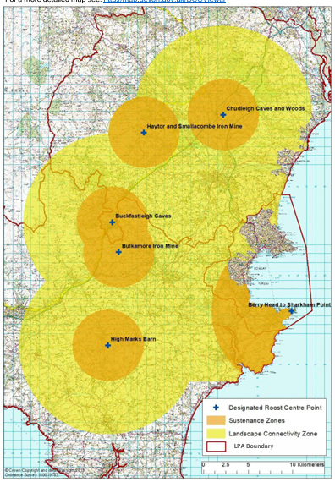
  - The South Hams SAC is situated in Devon on the south coast of England and covers an area of 129.53ha. The site is divided into 5 separate sites, including the Berry Head- Sharkham Point SSSI component, adjacent to the town of Brixham. It is considered to include one of the best areas of European dry heath and semi-natural dry grasslands and scrubland facies in the UK. It also supports a number of rare and scarce vascular plants typical of the oceanic southern temperate and Mediterranean-Atlantic elements of the British flora. The South Hams SAC is thought to hold the largest population of greater horseshoe bat (Rhinolophus ferrumequinum) in the UK . Vulnerabilities of the bat population arise through disturbance to the cave systems, disused quarries and mine-shafts used by the bats as a result of public access and recreational activities. The vulnerabilities of the bat population are not limited to within the SAC itself; disturbance and damage to wider countryside feeding and commuting routes Figure 1), such as agriculturally unimproved grassland, woodlands and hedgerows, can also have a detrimental impact on the population.
Figure 1
  - The Lyme Bay and Torbay Marine SAC site lies off the south coast counties of Dorset and Devon (Figure 2). The site comprises two sections, Lyme Bay Reefs and Mackerel Cove to Dartmouth Reefs and Sea Caves travelling from east to west respectively. It covers 31,248 ha and includes 14,289 ha of reef and at least 85 caves. The Lyme Bay and Torbay SAC has been identified by Natural England as one of the best examples of the range and diversity of bedrock reef, stony reef, and sea caves in the UK for protection under the Habitats Directive. It is estimated to contribute 0.9 percent of the UK’s total reef resource to the Natura 2000 network.
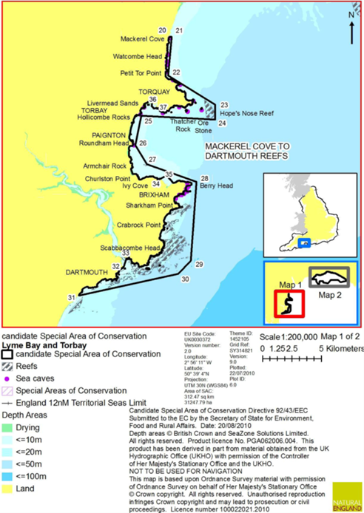
  - Torbay Council officers have been party to the South Hams SAC Steering Group for Greater Horseshoe Bats (The Steering Group includes the other local authorities affected: Dartmoor National Park Authority, Devon County Council, Teignbridge District Council, South Hams District Council, Torbay Council and Natural England). Together, the Steering Group has produced Greater Horseshoe Bats, South Hams SAC, HRA Guidance. This document is aimed at those preparing and validating planning applications in the South Devon area which may impact on the South Hams SAC population of greater horseshoe bats. It provides advice on which applications may have a likely significant effect on the SAC greater horseshoe bat population. It also provides advice on the information that applicants may need to submit with a planning application in order for the LPA to undertake an HRA.
  - The cirl bunting is a UK priority species of principal importance under Section 41 of the Natural Environment and Rural Communities (NERC) Act 2006. These species were identified as requiring action under the UK Biodiversity Action Plan and remain conservation priorities.
Figure 2
  - Torbay is important for Cirl Buntings and the Council has prepared, in partnership with Devon County Council, Teignbridge District Council, Torbay Council and the RSPB, a Wildlife and development guidance note for Cirl Buntings to help anyone (e.g. developers, agents, consultants, Local Planning Authorities) considering built developments that may affect cirl buntings in Devon.
  - These birds need a mixed farmland landscape to flourish and in particular the retention of suitable nesting sites (traditionally managed hedgerows and scrub and sources of both summer (for breeding: tussocky pasture on which to forage for invertebrates to feed young ) and winter food (a source of small seeds over the winter, ideally arable weeds within an over-winter stubble following harvest of a low input spring barley crop).
  - This Guidance also has wider benefits for the natural environment - preserving a network of suitable habitats isn’t just good for cirl buntings. It also preserves the characteristic Devon landscape and benefits a number of other priority species and habitats such as bats, dormouse, wildflowers, arable plants and hedgerows.

Torbay Community
  - The Office for National Statistics estimates that Torbay has 139,485 people living in our area in approximately 63,000 households. The overall population in Torbay has grown by 4.9% in 2023 since 2013, this compares to 7% growth across England. 27% of our population is over 65 years of age which is set to increase to 34% during the next 20 years.
  - Torbay offers an inspiring coastal, maritime and landscape setting. Kown as the English Riviera it has a strong history of being a premier coastal resort, with a tourism sector that supports local and regional businesses.

How we have considered other strategies and how our policies, objectives and actions have helped the environment

The Devon Local Nature Partnership
  - Devon Local Nature Partnership (LNP) was established in 2012. It is a voluntary strategic collaboration of a huge range of organisations, groups and individuals committed to working together to restore and enhance the natural environment Torbay Council officers are on the LNP Working Group which co-ordinates Natural Devon’s routine activity, progresses the initiatives and provides a link between the Forum and Board members.
  - The LNP has three key goals:
1. Deliver a Nature Recovery Network – Protect and restore a network of wildlife rich habitats and natural systems across the county in towns, villages, rural areas and at sea.
2. Respond to the Climate Emergency – Use natural solutions to capture carbon and increase our resilience to climate change and flooding.
3. Connect people and nature – Support communities and businesses to value, enhance and connect with the natural environment which underpins our health, wellbeing and economy.
  - These goals are closely related to the production of a Local Nature Recovery Strategy.

Devon Local Nature Recovery Strategy – a joint strategy for Devon, Plymouth and Torbay
  - Local Nature Recovery Strategies (LNRS) are a new approach to setting priorities for nature at a local level in England. They are a statutory requirement, defined in Sections 104 to 106 of the Environment Act 2021. More information can be found at Defra regulations and guidance summary document.
  - The County Council is the appointed Responsible Authority to lead the statutory Devon Local Nature Recovery Strategy (LNRS), covering Devon and the areas of Plymouth City Council and Torbay Council. This identifies the priorities for habitats and species, the actions needed to achieve these priorities and a map that shows where actions are most needed to reverse the decline of wildlife.
  - The LNRS has been developed in collaboration with a wide range of partners and wildlife experts under the umbrella of the Devon Local Nature Partnership. This has included discussion through LNP networks including farming, communities, education and health and collaborating with the ‘Supporting Authorities’ These are the Local District Authorities, including, the two National Parks of Dartmoor and Exmoor, as well as Natural England. LNRSs must be produced in collaboration with SAs and all other relevant stakeholders. A Supporting Authorities Officer Group was set up and Torbay Council officers were part of the meetings held regularly throughout the preparation of the LNRS.
  - Torbay Council has been involved in the development of the LNRS through the Devon LNP . In it’s role as supporting Authority, Torbay Council provided consent for the Devon Local Nature Recovery Strategy (LNRS) to be published (cabinet Decision 17th February 2026). At the time of writing formal publication is expected imminently (following the approval by all Supporting Authorities).
  - The Devon-wide LNRS will provide local planning authorities and developers with information to enhance the planning system, including the delivery of Biodiversity Net Gain requirements, and investment in our urban green spaces. It will guide public and private investment, including through the new Environmental Land Management Schemes (ELMS). It will support communities and businesses in their actions to protect and enhance Devon’s land and marine environments, and the benefits we gain from them, such as health, access and learning.
  - The Devon LNRS is hosted on the LNRS Viewer that allows everyone to explore the spatial priorities and opportunities identified in the Devon Local Nature Recovery Strategy. This includes the statutory Local Habitat Map which shows where actions are most needed. These High Opportunity Areas will help to direct BNG as action is incentivised in these areas. The Viewer also shows Species Opportunity Areas and brings together lots of other Useful Layers in one place.
  - A delivery map was launched on the LNRS Viewer in October 2025, so that anyone taking action for biodiversity can add their contribution – even in their own garden. In the first three months, as of December 2025, 21 delivery projects had been added to the map.
  - The Country Council will continue to work with Partners to deliver and monitor the Strategy under the umbrella of the Local Nature Partnership.

Devon Tree and Woodland Strategy
  - A significant partnership achievement has been the publication of the Devon Tree and Woodland Strategy. Through the strategy countywide tree planting has taken place, delivering tens of thousands of new trees annually through multiple funding schemes, including the Treescapes Fund and Saving Devon’s Treescapes.
  - The Council partnered with other local authorities the Woodland Trust, Forestry Commission, Devon Wildlife Trust and other stakeholder organisations in steering the creation of the Devon Tree and Woodland Strategy for the Local Nature Partnership. The strategy, published in April 2024, sets out priorities and actions for the delivery of an additional 3000ha of woodland and trees in Devon by 2030, to help achieve an increase in the county's tree cover from 14% to 16.5% by 2050, meeting the UK's national targets as set with the England Tree Action Plan. Devon Tree and Woodland Strategy DTWS_Full-Mar 2024 Accessible Version & DTWS Summary Apr 2024 Accessible Version

The South Devon National Landscape and Management Plan
  - The SDNL Partnership Committee provides a strategic lead in the protection, conservation and enhancement of the South Devon National Landscape (AONB) and consists of 18 representatives including the local authorities, Natural England, Environment Agency, Historic England locan organisations and community representatives. The South Devon National Landscape Management Plan is a statutory document that seeks to ensure that the South Devon Area of Outstanding Natural Beauty is conserved, managed and enhanced to support and benefit present and future generations. It also serves the purpose of a plan for the South Devon Heritage Coast which shares many of its special qualities. The current plan (April 2019 to March 2024) has been formally adopted by the Local Planning Authorities : South Hams District Council, Devon County Council, Torbay Council and Plymouth City Council.
  - The Plan contains policies support partners by driving sustainable development whilst conserving and enhancing the natural beauty and special qualities. The Management Plan includes key policy objectives: To conserve and enhance the biodiversity and geological assets so that they are bigger, better and more connected in the landscape and to support the sustainable management of natural resources. For Strategic Planning and Development Management, the Management Plan is a material consideration in the plan making and decision-taking process. The Management Plan includes a Planning Guidance Annexe which forms an integral and important part of the Management Plan.
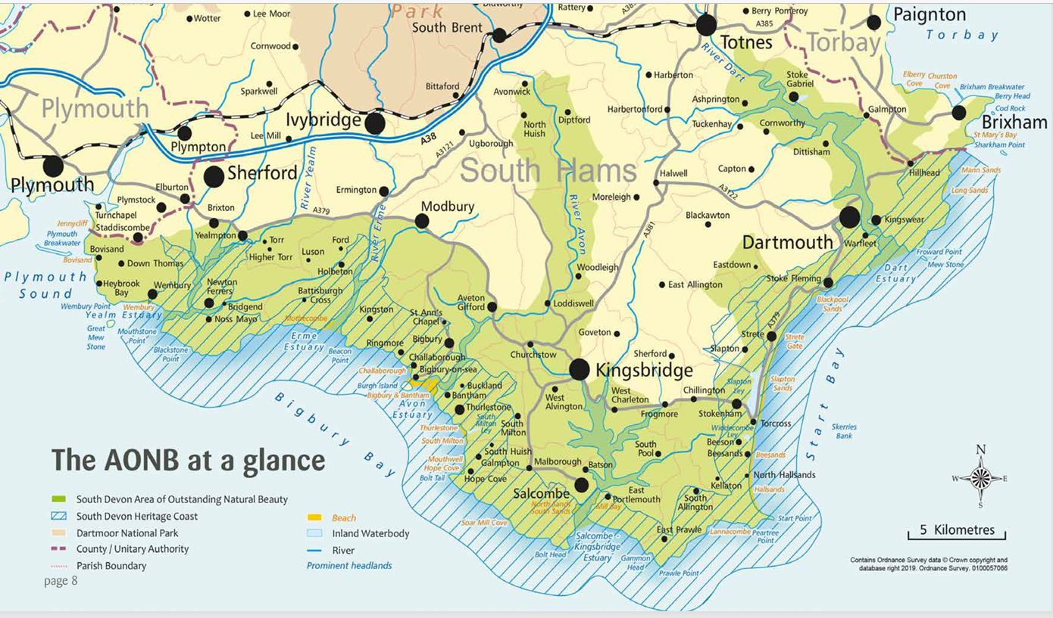
Figure 3

Tor Bay Harbour Authority:
  - The Port Masterplan for Tor Bay Harbour acts as a framework document to set the scene for the future of the port and to ensure sustainable development. It highlights environmental measures to ensure that the Harbour Authority makes a positive contribution to the environment and amenity.
  - As part of ongoing efforts to minimise the impact of human activity on Tor Bay’s natural environment – while also allowing, where possible, for those activities to take place - the Harbour Authority have been closely involved in several Bay-wide initiatives to improve sustainability. These have included monitoring the recently introduced Torbay inshore Marine Conservation Zone; working alongside Living Coasts and others by contributing to the design and installation of experimental eco moorings to hopefully reduce scouring of the seabed caused by mooring and anchor chains; and working with the Community Seagrass Initiative and Fishing for Litter projects, among others.

The Devon and Torbay Combined County Authority
  - The Devon and Torbay Combined County Authority is a legally recognised, single body. Our Combined County Authority looks at issues that affect the whole area and includes responsibility for strategic transport -The Devon and Torbay Local Transport Plan 4 (LTP4) is the strategic document that sets out the priorities for transport across the county between 2025 and 2040. Two of the six objectives set out below will also closely align to objectives in the emerging Green and Blue Infrastructure Strategy and our Climate Change Action Plan. The Local Transport Plan is therefore an additional document that has influence on these goals. The LTP is also a material consideration in planning matters:
  - The Place to be naturally active: Enabling people to be more active with improved public health outcomes by expanding the multi-use trail network, delivering a network of quiet lanes and improving facilities and safety in urban areas
  - Decarbonisation: Reaching net zero carbon emissions by 2050, and a 50% reduction against 2010 levels by 2030, by reducing the need to travel, increasing digital access and shifting trips to sustainable transport and fuels

How we’ve raised awareness and educated the community
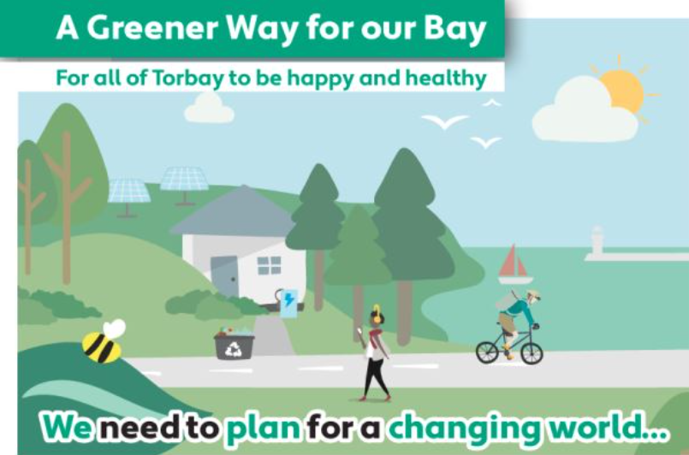
  - The Council has carried out various engagement events and consultations related to it’s numerous strategies and action plans.
Figure 4
  - A key example would be ‘A Greener Way for Our Bay’ which proposes ten key things to help reduce Torbay’s carbon emissions. One of these key aims is ‘Ensure the community is at the heart of local action’ by engaging with community, schools and businesses to raise awareness and promote: saving energy, reducing waste, growing food, protecting and enhancing the natural world as well as encouraging walking and cycling.
  - The Greener Way For Our Bay Framework and Action Plan was developed following two public consultations, a series of climate conversations and a comprehensive engagement programme in 2023 and 2024. The Climate Change Partnership consulted on the Plan through three surveys and a range of engagement events. During the consultation, 1,263 people were engaged by Tonic Creatives on behalf of the Partnership. In the most recent round of surveys, more than 600 people responded.

Staff training and awareness:
  - The Council has an internal staff training and awareness system. This now includes a Climate Change Module on iLearn system. As identified in Table 2, the Council will seek to add an additional section relating to the biodiversity duty within this module.

Monitoring and Evaluation actions
  - The Council’s Overview and Scrutiny Board is a committee of councillors that can hold the Council’s decision-makers and partners to account and improve services for the people of Torbay. Overview and Scrutiny acts as the Council’s watchdog – monitoring and challenging decisions taken by the Leader and other decision makers. To help improve services overview and scrutiny also reviews existing policies, procedures, and practices.
  - The Council Business Plan sets out, against each theme of the Community and Corporate Plan (Community and People, Pride in Place and Economic Growth), the priority actions and milestones for delivering those actions. The Council produces a Quarterly Performance Report using various performance indicators, to inform and update Councillors on performance against the three themes of the Community and Corporate Plan. This will be one way in which actions, such as those within the Climate Change Action Plan, the Torbay Carbon Neutral Plan, will be monitored and measured.
  - This includes the Council Climate Action Officers Group to assess and discuss progress on identified Actions. The Greener Way for Our Bay the Action Plan is reviewed annually.
  - There are various monitoring mechanisms for the numerous corporate strategies and plans containing objectives for the natural environment. One key Evaluation and monitoring method is the Sustainability Appraisal and Habitats Regulations Assessment, which accompany the adopted The Torbay Local Plan 2012-2930. The SA has also been published alongside the consultation Local Plan Update (2025–2045) Evidence Base and Monitoring and an HRA will be produced for the Submission version.
The SA includes a specific sustainability objective for biodiversity, flora and fauna:
To conserve, protect and enhance habitats and species, and geodiversity
  - Ecological Footprint
  - Condition and number of nationally or locally designated sites
  - Amount of green infrastructure delivered
  - Number and condition of global, national and local geological designated sites
  - Percentage of major developments generating overall biodiversity enhancement
  - Number of planning approvals that generated any adverse impacts on sites Biodiversity, flora and fauna
  - Hectares of biodiversity habitat delivered through strategic site allocations
  - The effectiveness of ecological mitigation relies on appropriate monitoring. The Adopted Torbay Local Plan is also accompanied by Supplementary Planning Documents and the Planning Contributions and Affordable Housing Supplementary Planning Document (SPD) (detailed in Chapter 3 paragraphs 3.26 to 3.28 above), specifically includes a section on biodiversity and mitigation of development. In addition, it sets out the need for ongoing assessments and associated monitoring contributions for relevant ecological mitigation works for years 1, 3, 5, 10, 15, 20, 25 and 30 of a development.

Biodiversity highlights and challenges

This section includes some example positive actions and initiatives:

Miyawaki Forests
  - The tree planting at Watcombe Primary School, Torquay is currently the first of two Miyawaki Forests for Torbay.
  - Torbay Council, SWISCo, the Environment Agency and Department for Environment, Food and Rural Affairs (Defra) planted a Miyawaki Forest with 700 trees, which will trial this nature-based solution’s ability to reduce flooding and support wider work to address climate change. It forms part of the Devon County Council Devon Resilience Innovation Project (DRIP) funded by Defra. The tree planting at Watcombe Primary School, Torquay is currently the first of two Miyawaki Forests for Torbay.
  - A Miyawaki Forest is a very dense planting (3-5 trees per sqm) that recreates the conditions of a natural clearing in a forest and can result in much faster growth rate (5-10x faster or 1m per year on average) as the trees compete with each other for nutrients and light.
  - Around 20 different tree species are being randomly planted to mimic the canopy layers in a natural woodland, which will help increase biodiversity as well as capturing carbon. SWISCo are leading on the planting but school pupils have also joined in.
  - Miyawaki Forests aim to:
- Increase biodiversity, capture carbon, improve air quality, support more wildlife
- adapt to climate change
- show how practical actions can improve resilience to flooding

Improved LED street lighting
  - Improved LED street lighting which will significantly improve the energy efficiency of our streetlights and lower our carbon emissions, and importantly, also save money in the long term, saving thousands of pounds over its lifetime.
  - As a result of the changes to streetlighting, it will be centrally controlled and upgrade the rest of our streetlights to LED Holophane Lanterns and to procure Telensa’s Control Management System (CMS). This means more than 3,000 of the Bay’s street lights will be upgraded and centrally controlled.
  - The proposed new streetlighting scheme will be fantastic for Torbay with the ability to vary the brightness of the lights in all areas enabling us to be more responsive, will be better for the environment, and also save both energy and costs in the long term. The new lighting will also help address anti-social behaviour and reduce the impact on our biodiversity across the Bay from artificial streetlighting. This is just one the projects under our Climate Change Action Plan that Torbay will benefit from.

Adult Social Care Strategy; Community Engagement and Empowerment Strategy; Corporate Asset Management Plan; Corporate Capital Strategy; Corporate Parenting Strategy; Community and Corporate Plan; Domestic Abuse and Sexual Violence Strategy; Economic Growth Strategy; Housing Strategy; Gambling Act Policy/Statement of Principles; Joint Health and Wellbeing Strategy; Licensing Policy; Local Transport Plan; Development Plan; Strategic Agreement between Torbay Council, One Devon Integrated Care Board and Torbay and South Devon NHS Foundation Trust; Treasury Management Strategy; and Resource Management and Waste Strategy.
https://www.torbay.gov.uk/council/policies/planning-policies/evidence-base-and-monitoring-2025-2045/

