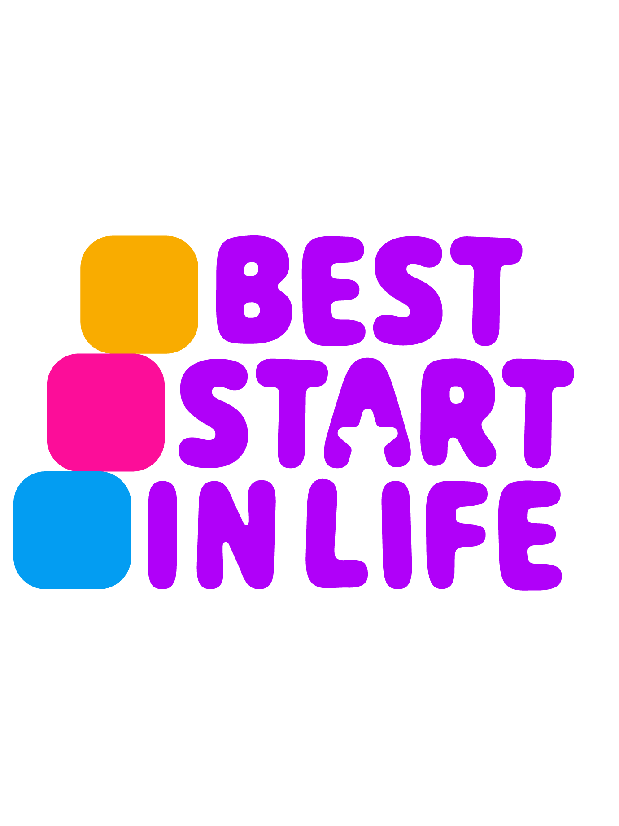
Torbay’s Local Plan

Best Start local plan for Torbay

Contents
1. Vision and Approach 4
Vision and approach 4
2. Early Child Development: Targets, Tracking and Current Position 5
Targets 5
Current position 6
How children’s progress will be tracked 7
3. Case for Action 10
Demographics 10
Existing services 12
Summary of key strengths 12
Summary of key gaps 13
4. Best Start in Life Services – Early Child Development 15
Home Learning Environment interventions 15
Parenting interventions 17
Early Childhood Education and Care access and quality 19
Transition to school and Reception year 20
SEND support 21
Early child development gaps, actions & impact 23
5. Best Start in Life Services – Healthy Babies and Wider Maternal Health 31
Infant feeding 31
Perinatal Infant Mental Health and Parent Infant Relationship 33
Healthy Babies gaps, actions & impact 37
Wider maternal and early years health services 39
6. Best Start in Life - System enablers 41
Best Start Family Hubs 41
Workforce capacity and capabilities 42
Family involvement 43
Monitoring, evaluation and learning 44
System enablers gaps, actions & impact 46
Accountability and governance 50
Funding 50

1. Vision and Approach

Vision and approach
Our vision is that every child in Torbay has the best possible start in life, where they can grow up safe, happy, healthy, learning well, and connected to a strong community.

Together with families and partners across all sectors, we are committed to closing gaps in early development and ensuring that more children are ready for school and confident to learn. We will achieve this by delivering joined up, preventative, and relationship-based support from pregnancy to age five.

By understanding where the gaps are, we will remove barriers, strengthen early identification of need, and offer support to families at the earliest opportunity, including those who feel un-heard and underrepresented. Together, we will create the conditions where every child can thrive, develop with confidence, and be ready for school and lifelong learning.

2. Early Child Development: Targets, Tracking and Current Position

Targets
Torbay’s target is that by 2028, 77.8% of children overall and 61.6% of children accessing Free School Meals (FSM) reach a Good Level of Development (GLD) by the end of Early Years Foundation Stage (EYFS), or age five. This equates to 101 additional children achieving GLD overall and 23 additional children achieving GLD on Free School Meals (FSM) by 2028, see table one below.

Table 1: Torbay’s GLD Targets 2024 - 2028
Year | All Children reaching GLD |  | FSM Children reaching GLD target
 | Percentage | Number | Percentage | Number
2024/2025* | 68.5% | 749 | 50.7% | 109
2025/2026 | 71% | 776 | 55% | 118
2026/2027 | 74% | 809 | 58% | 125
2027/2028 | 78% | 850 | 62% | 132
* 2024/2025 figures represent actual performance, not targets

Table two shows the projected number of children not expected to reach a GLD over the next three years, based on Torbay’s falling birth rate. It compares outcomes if performance stays at the current 68.5% rate with Torbay meeting its yearly targets. Children in the second column represent those most likely to require targeted support, identified through Torbay’s data on groups least likely to achieve a GLD.

Table two: Projected number of Torbay children not expected to achieve a GLD by the end of EYFS.
Year | No of children not expected to reach a GLD based on current achievement rate of 68.5% | No of children not expected to reach a GLD based Torbay meeting the yearly set targets
2025/2026 | 330 | 304
2026/2027 | 320 | 264
2027/2028 | 307 | 216

Current position
By reviewing the Early Learning Goals (ELGs) which are the individual measures that contribute to GLD, a more granular understanding of those areas where Torbay has a good foundation as well as where greater focus is needed (fig. 1).
Torbay’s strongest areas are in comprehension, word reading and speaking, which sit at or above national levels. The greatest gaps are in fine motor skills, managing self, number, listening and attention, and early maths related goals. These domains require focused improvement to accelerate progress towards GLD targets.
Figure one: Percentage of pupils reaching each early learning goal (ELG) in Torbay compared with national averages for the 2024 to 2025 academic year
. 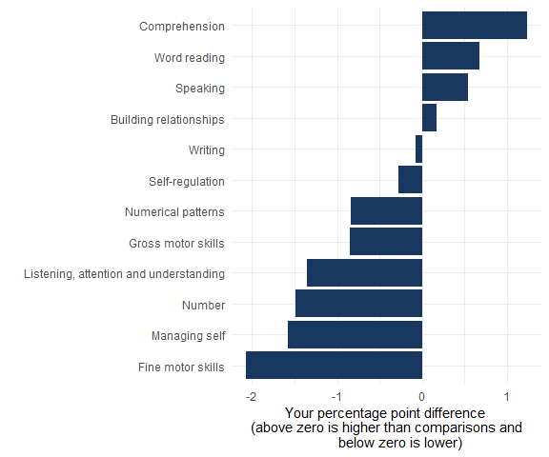

Source: Early Years Foundation Stage Profile 2024/25 results for your local authority and national 2024/25 data from the DfE
Different groups of children in Torbay achieve a GLD at different rates. Boys, children with an Education, Health and Care Plan (EHCP), and children with no identified special educational needs perform slightly above national averages, despite these groups typically performing less well nationally. Children who speak English as an Additional Language (EAL) show the largest gaps compared with their peers and remain well below national levels, highlighting the need for focused attention. Children eligible for free school meals (FSM) also continue to fall slightly behind.
Ages and Stages Questionnaires (ASQ3), used at the Health Visitor led 2.3 year developmental review, show that although Torbay achieves very high coverage, (98.6% of children received an ASQ3), outcomes across all five developmental domains are below national levels.
Torbay records children who score in the “grey” band just below the expected level as not meeting expectations. Nationally, however, children scoring in the grey band are generally classified as meeting the expected level. This difference in reporting means Torbay appears to perform significantly below national averages. In practice, though, children in Torbay who fall within the grey band or lower are provided with additional intervention.
Table three: ASQ-3 data for Torbay and England 2024 - 2025
Year 2024/2025 | All Children reaching ASQ-3
Development Area | Torbay % at or above expected level | England % | Difference (Torbay Vs England)
Overall (all five areas) | 70.7% | 81.4% | -10.7 pp
Communication | 82.9% | 87.5% | -4.6 pp
Gross Motor | 86.8% | 93.6% | -6.8 pp
Fine Motor | 84.6% | 93.7% | -9.1 pp
Problem-Solving | 87.9% | 93.0% | -5.1 pp
Personal-Social | 84.0% | 92.3% | -7.7 pp

Data analysis of GLD outcomes at both ward level and individual school level make it clear where the children who are not reaching their developmental milestones live in Torbay and which settings they will attend. This enables support to be targeted with much greater precision.

How children’s progress will be tracked
The table below sets out how Torbay will systematically track children from birth to age five to monitor progress toward GLD targets. It shows the key data sources used at each stage, who holds that data, how it will be gathered and interpreted, and how the information will trigger targeted interventions.
Table four: Tracking mechanisms for children at risk of not achieving GLD
Stage of tracking | What data is used | Who holds the data | How data is collected, collated and analysed
Early Identification (Ages 0–4) | - 1 and 2.3 year Health Visitor development reviews:  - Ages and Stages Questionnaires (ASQ) assessing across five domains.  - Early Language Identification Measure (ELIM),  - Section 23 Notifications.  - Targeted Groups of Children:  - Funded 2 Year Olds.  - Early Years Pupil Premium.  - Disadvantage funding.  - SEND. | - Public Health Nursing teams.  - Early Years settings.  - Local Authority.  - Family Hubs. | - Shared from Public Health Nursing into Early Years Panels.  - LA collates ASQ, ELIM, S23 and vulnerability indicators.  - Analysed to spot children at risk of not achieving GLD.  - Multi-agency use via a shared dashboard and reporting to the BSiL Board and operational workstreams.
Pre-school | - EYPP take up.  - Funded Two Year olds.  - Section 23 Notifications.  - Targeted Groups of Children:  - Early Years Pupil Premium.  - Disadvantage funding.  - Boys.  - Summer Born cohorts.  - EAL.  - Children performing below expected levels of development from observations. | - Early Years Providers.  - Local Authority.  - Family Hubs.  - Public Health Nurses.  - Early Help. | - Locally coproduced data collection system.  - Local Authority combines Early Years Pupil Premium, EAL, S23 and observation data with ward level deprivation and population profiles to identify -localities with higher risk.  - Multi-agency review via shared dashboard and Early Years Panels.
Reception Baseline & In year EYFS Checks | - Baseline assessments.  - Targeted Groups of Children:  - Free School Meals.  - Children from areas of deprivation.  - Boys.  - Summer Born cohorts.  - EAL.  - Children performing below expected levels of development from observations. | - Schools. | - Data analysed at school level to identify children not on track for GLD and monitor -in year- progress.  - Shared across services through the Local Authority dashboard and EYFS forums.
End of Reception Year | - Early Years Foundation Stage Profile. | - Schools.  - Local Authority.  - Department of Education (DfE). | - Statutory EYFS returns submitted by schools, collated by Local Authority and DfE.  - GLD and ELG level gaps analysed to inform targeted support.  - Reported through Local Authority dashboards and EYFS Forum's for systemwide action.

3. Case for Action

Demographics
Around 139,500 people live in Torbay, and children make up an important part of the population. Table five shows the breakdown by educational life-stage for Torbay.
Table five: Torbay’s profile of children and young people under the age of 18
School age | Years of age | Number
Pre-school age | 0-4 | 5, 389
Primary school age | 5-10 | 8,456
Secondary school age | 11-16 | 9,395
Further education age | 17-18 | 2,988
Source: the Office of National Statistics (ONS) mid-year population estimates for 2024
Deprivation is a feature of Torbay’s local context. The English Indices of Deprivation 2025 contains information around local authority deprivation. This shows that Torbay was ranked as the 39th most deprived upper tier local authority out of 153 in England (Based on rank of average rank). Approximately 26% of Torbay’s population live in areas amongst the 20% most deprived in England.
In relation to income deprivation, Torbay is ranked as 51st most deprived out of 153 upper tier local authorities. Within this, there is a measure of ‘Income Deprivation affecting Children’ in which Torbay is ranked as 52nd most deprived out of 153 upper tier local authorities and the most deprived in the South West. This measures the proportion of children aged under 16 who are living in income deprived families. In Torbay, this equates to 41% of children. There are significant differences between areas as shown by the map below with the percentage of children living in income deprived areas ranging from 11% to 80% (Fig 2).

Figure two: Income Deprivation Affecting Children Index: Map showing children living in income deprived families, Torbay, 2025
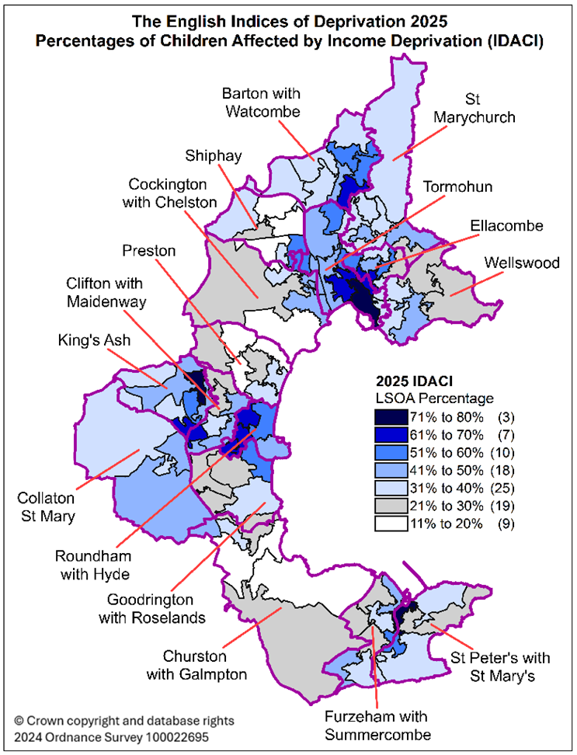
Educational and developmental needs are a significant part of Torbay’s local context, with around three in every hundred children having Special Educational Needs and high numbers of referrals into children’s social care, reflecting the complex and varied challenges many families experience.
For some, family life in Torbay is also shaped by further challenges. High levels of mental health need, homelessness and economic vulnerability affect household stability and can impact children’s early experiences and outcomes. Furthermore, some early health concerns appear very young; more than a quarter of five-year-olds have visible dental decay and almost a quarter of children aged four to five are already overweight or obese. These early challenges can shape a child’s development and future health.

Existing services
Following the receipt of Family Hubs and Start for Life funding in 2022, a broad and diverse network of services that support children and families across the early years has been developed and implemented. These services span home learning, parenting, early education and childcare (ECEC), health, community engagement, and early help.

They are delivered collaboratively by Torbay Local Authority, Torbay and South Devon NHS Foundation Trust (TSDFT), Action for Children and early years settings. The diagram below maps the current support and activities against the locally adapted
Every Child Matters outcome framework, covering Safe, Happy, Healthy, Learning and Community domains.

Figure three: Torbay early childhood development support and activities mapped to the Every Child Matters framework
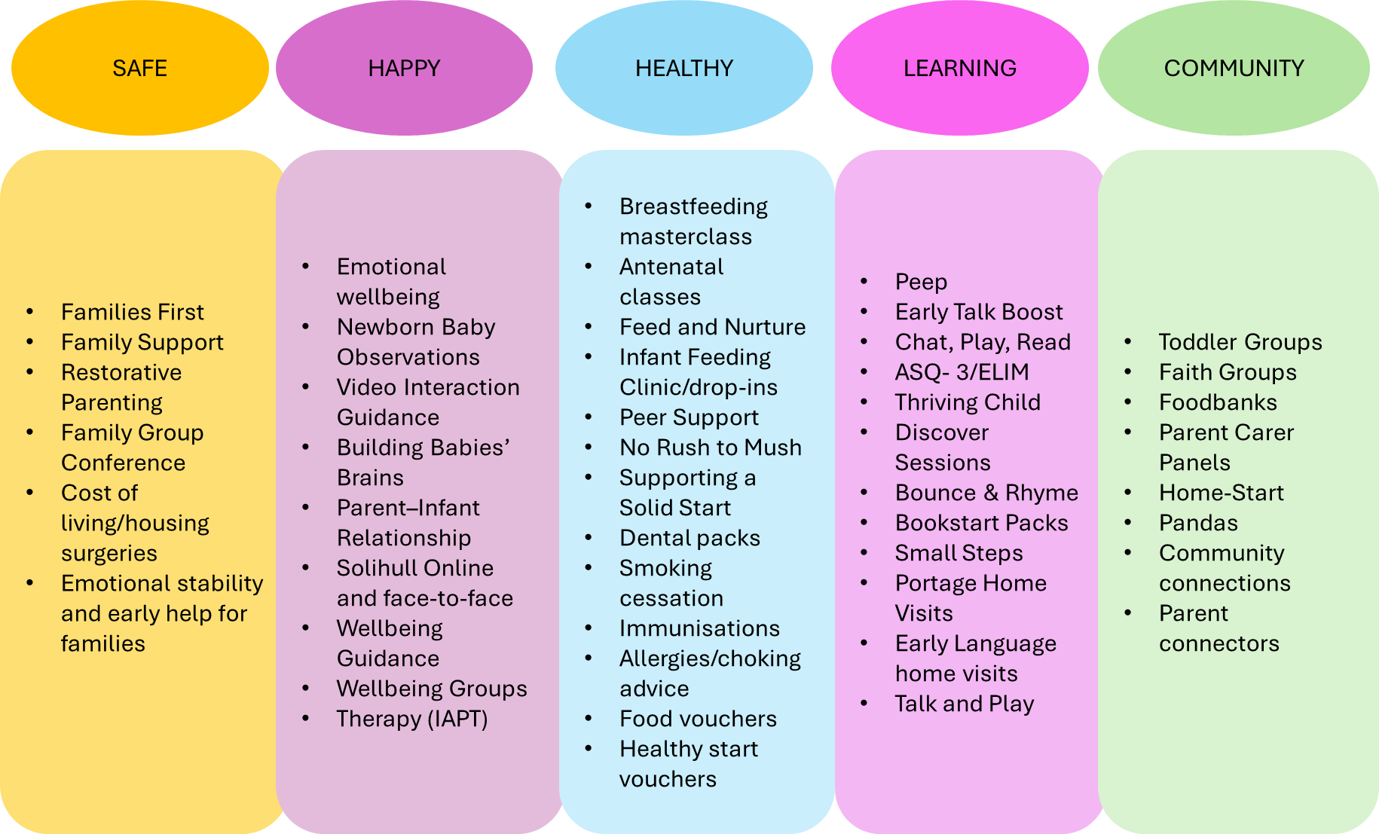

Summary of key strengths
Torbay’s early years system has developed into a collaborative and well-integrated partnership, with strong alignment between the Local Authority, Public Health Nursing, Torbay and South Devon NHS Foundation Trust (TSDFT), Early Years providers and the voluntary and community sector. This joined up approach is one of the system’s most prominent strengths, creating a coherent offer for families from pregnancy to age five and ensuring children receive timely, coordinated support rather than isolated interventions. Key contributions to this include:
- The Family Hubs model, which has been central to this transformation. Co-location of services, consistent pathways and shared values have created a system that families experience as supportive, relational and accessible.
- A high-quality Early Years sector, with 98% of inspected providers rated Good or Outstanding and consistently high take- up of funded entitlements, meaning most children access high- -quality provision early in life.
- Strong health visiting coverage, with 98.6% of children receiving their ASQ3 assessment, enabling almost universal early identification of need.
- Growing capability in data interpretation and use, allowing partners to better understand children’s development and target support more effectively.
- Improved data sharing across partners, supported by pathways such as the Early Years Development Pathway, which align assessment information to strengthen early identification and reduce duplication.
- A wide range of evidence-based interventions, including PEEP, Solihull, Early Talk Boost, Incredible Years, Triple P and Video Interaction Guidance (VIG), all contributing to improvements in communication, early relationships- and parental confidence.
- Strong Perinatal Infant Mental Health and infant feeding support, with breastfeeding rates rising to 58% at 6–8 weeks and Public Health Nursing achieving UNICEF Baby Friendly Initiative (BFI) Gold accreditation.

Summary of key gaps
Despite strong foundations, Torbay continues to face several systemwide gaps that limit progress in early child development and constrain the pace at which inequalities can be reduced. While services are increasingly coordinated, outcomes show that some groups of children are still not benefiting fully from the local offer, and areas of inconsistency across practice, pathways and engagement exist. These gaps highlight the need for greater reach, stronger alignment and more targeted use of evidence-based approaches. Key challenges include:
- Persistent inequalities in early child development, with disadvantaged children, those eligible for FSM, children with English as an Additional Language, boys and summer born children achieving lower outcomes across the Early Learning Goals (ELGs) that contribute to GLD.
- Underperformance in key developmental areas, particularly fine motor skills, early maths, self-regulation, listening and attention, and managing self, all of which significantly influence whether children achieve a GLD.
- Inconsistent engagement from priority families, including young parents and families with EAL, who are not routinely accessing HLE, parenting or Healthy Babies interventions despite being most likely to benefit.
- Limited capacity to deliver evidence-based interventions at scale, affecting reach and reducing the system’s ability to intervene early and consistently for children identified as at risk.
- Variation in approaches to school readiness and transitions, with no single standardised transition process or shared understanding of school readiness expectations across settings, schools and professionals.
- SEND pathways that are not uniformly understood, leading to variation in early identification, differing interpretations of Ordinarily Available Provision, and inconsistent referral routes across partners.
- Gaps in data and digital integration, particularly around tracking children’s development between the 2.3-year ASQ review and school entry, and continued reliance on manual data collation across multiple systems.
- Under-representation of priority cohorts in co-production and parent voice activity, alongside inconsistent “you said, we did” feedback loops, meaning lived experience is not always fully embedded in service development.

4. Best Start in Life Services – Early Child Development
This section examines Torbay’s Early Child Development system, which includes the Home Learning Environment (HLE), Parenting Programmes, Early Years Access and Childcare Provision, Transition to School and Reception year and SEND provision. It outlines what is currently in place within each component of the system and concludes with a summary of the identified gaps, the actions that will address these gaps, and the impact this will have on child development.

Home Learning Environment interventions

Current situation
Since receiving Family Hubs funding in 2022, the HLE offer has continued to evolve, extending across Public Health Nursing, Early Years, Family Hubs, the NHS, and local community and voluntary sector partners. In response to the developmental challenges faced by children in Torbay, including a marked rise between 2020 and 2025 in Education, Health and Care Plan (EHCP) applications for children aged five to ten, see figures four and five, an Early Years Pathway was developed and implemented. This pathway ensures that children’s needs are identified as early as possible and that a strong, coordinated package of support is delivered consistently across the Early Years sector.

Figure four: Number of EHCPs – Torbay  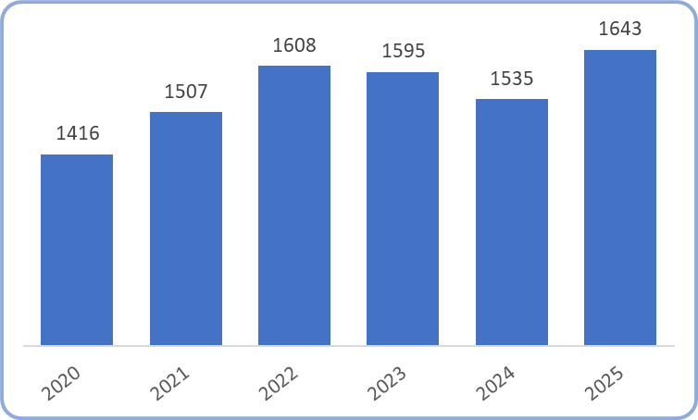 | Figure five: EHCPs by age - Torbay  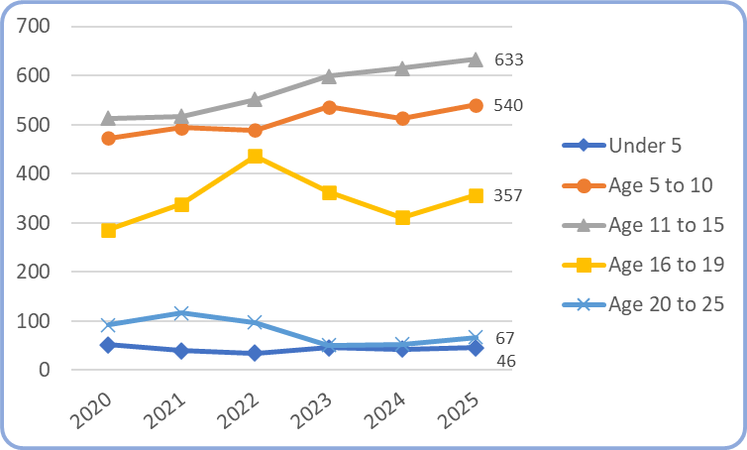

What’s in place
Torbay is embedding its HLE approach through consistent, evidence based key messages focused on Chat, Play, Read, using a ‘pass it on’ model. Training, resources and locally tailored messages have been developed and shared with key professionals and partners through training sessions and networks, who then cascade these messages to families across the area. Additional physical and digital resources are also available to support direct communication with families.

Diagram three below illustrates a targeted early identification and support pathway within the Best Start Family Hubs framework, structured around three key developmental stages: 1 year, 2.3 years, and 4 years. Across all stages, the approach is underpinned by consistent messaging promoting Chat, Play, Read, and the importance of the Home Learning Environment.

Figure six: Early Identification of Need – targeted support
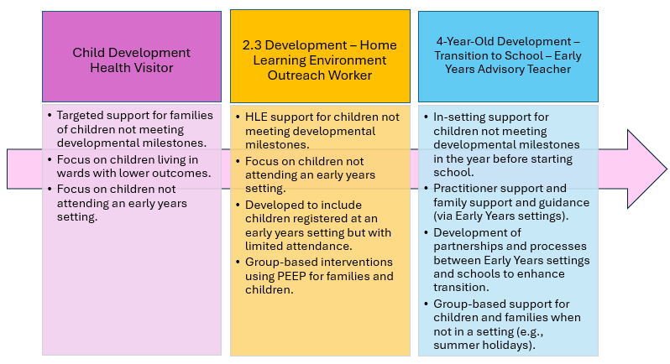

The Child Development Health Visitor provides targeted support for families where children are not expected to meet their 1-year and 2.3-year developmental milestones. The role focuses on children living in areas with lower outcomes and on those not attending an Early Years setting, ensuring they are identified early and referred into the Early Years Pathway.

The HLE Outreach Worker delivers targeted support for children who are not meeting developmental milestones at their 2.3 ASQ3 assessment, particularly those not attending an Early Years setting or attending with limited consistency. The role strengthens practitioner understanding of the importance of the home learning environment and delivers PEEP- based- group interventions and Chat, Play, Read support for families.

The Early Years Advisory Teacher provides insetting support for children who are not meeting developmental milestones in the year before school. The role focuses on practitioner guidance, strengthening partnerships between Early Years settings and schools, and supporting high- quality transitions. Additional group- based- work is offered during periods when children are not in a setting, such as the summer holidays, ensuring continued access to developmentally supportive activities.

HLE services have been developed based on identified needs of children and their families. Through the Home Visiting service, it was established that many families were experiencing levels of anxiety on leaving the home which was stopping them accessing the wider support offer of the Family Hubs. In response these families were invited to smaller, evidenced based PEEP workshops delivered by the HLE Outreach worker. These sessions help families build confidence, develop relationships with peers, and connect with staff and volunteers. Workshops focus on supporting parent–child communication and interaction and are offered weekly in Family Hubs and community venues.

A comprehensive suite of training and resources has been created to reinforce Torbay’s Chat, Play, Read messaging. Practitioners across Public Health Nursing, Action for Children, Early Years settings and libraries have received training, and a dedicated section of the Family Hub website promotes these resources to families. Targeted engagement has taken place in areas of higher deprivation, including attendance at community led coffee mornings in local venues, schools and Early Years settings.

A collaborative programme involving Public Health Nursing and Early Years providers led to the development of a local Early Years Development Pathway, incorporating both the ASQ3 assessment at the 2.3 year development review and the Progress Check at age two. This pathway strengthens early identification of need and ensures coordinated support for children and families, including interventions delivered in Early Years settings and the home.

Across the Family Hub network, a range of groups, including Thriving Child and Little Explorers, offer opportunities for children and families to engage in activities that support child development. These groups also provide advice and guidance on supporting learning within the home environment.

One-on-one Talk and Play Sessions offer tailored advice to families on supporting their child’s communication and language development. Referral pathways between these sessions and PEEP groups ensure families continue to receive appropriate support once individual sessions have ended.

Parenting interventions

Current situation
Torbay’s Family Hubs parenting programme has been operational since the introduction of Family Hubs funding in 2022 and is now a well-established part of the early years system. The programme is built around Early Help principles, offering timely, accessible support to families and helping to prevent challenges from escalating. Parenting support is delivered through a coordinated partnership of

services working across Family Hubs, early years settings and health and community providers, ensuring families receive help that is consistent and tailored to their needs.
The programme places strong emphasis on building parental confidence, strengthening parent–child relationships and supporting positive home environments that contribute to early development and improved long-term outcomes. A wide range of DfE approved evidence-based interventions (EBIs) are available, reflecting the diverse needs of families across Torbay, from universal guidance for all parents, to more targeted and intensive support for families experiencing additional challenges.

What’s in place
Torbay delivers a wide range of parenting support spanning pregnancy, the early years and middle childhood, with coordination improving as the system continues to develop. Support begins in the antenatal period through Solihull Antenatal groups, followed by postnatal Solihull groups delivered both in Family Hubs and community settings.
Parents can access a full suite of online Solihull courses and bitesize videos through the Family Hub website, providing flexible support alongside in person group delivery.
A newly appointed Parenting Lead within Public Health Nursing is helping to strengthen coordination and ensure families are consistently linked to appropriate parenting pathways and are supported specifically with child development.
Portage delivers weekly Small Steps sessions for children with emerging developmental needs, while PEEP groups and Family Wellbeing activities support early learning, relationships and parental confidence.
Community outreach events across early years settings, Family Hubs and wider settings promote Early Help, Solihull and other parenting offers, helping parents understand available support and how to access it.
Reducing Parental Conflict sessions and programmes such as Standing Tall offer further support for families experiencing relationship difficulties or requiring additional help to maintain a stable and nurturing home environment.
Across all ages, Torbay provides targeted one-to-one interventions through Early Help and Family Support pathways, including Triple P Baby, Video Interaction Guidance, Incredible Years Pre-School and one-to-one Solihull parenting. These EBIs allow practitioners to tailor support to families who require more intensive or therapeutic help, ensuring a continuum from universal advice through to structured relational interventions. Parenting support is matched to need through the Family Help Panel, helping reduce duplication and ensuring families receive timely, appropriate support.

An annual programme of Solihull training and facilitator development maintains delivery capacity across the workforce, enabling consistent, evidence informed practice.

Early Childhood Education and Care access and quality

Current situation
Currently 98% of Torbay’s Early Years Providers who have received a graded inspection from Ofsted are Good or Outstanding. This means that most early years children are accessing their funded entitlements in high quality early years provision.

The most recent Early Years Sufficiency Survey showed that across Torbay there is a 94% occupancy rate for early years places. This indicates that there is some capacity within the system, but some families may find it difficult to access provision in the areas or days/times they require. Further analysis shows that occupancy rates vary between wards ranging from 76% occupancy to 100% occupancy.

The most recent data shows that 77.1% of targeted two-year-olds are taking up a funded place, this is in line with the DfE locally set target of 77.1% take up. 95.1% of 3 & 4-year-olds are taking up their funded entitlements, in comparison to 93.1% nationally.

What’s in place
An annual sufficiency survey is carried out and collects a snapshot of place availability within all Early Years Settings. This is broken down by age ranges. The report also seeks to capture parent/carer feedback on childcare availability in Torbay. The report also details quality of provision, sustainability and specific support for children with SEND.

Through both the School Based Nursery Grant and the Early Years Capital Expansion, 12 projects have been supported locally. Once all are completed this will generate approximately 110 additional places. Ongoing engagement with the School Based Nursery Programme has resulted in an additional bid for Phase 2, with support advice and guidance provided to the school to complete their application. This bid will increase sufficiency of places for 2-year-old children in an area of high disadvantage.

The Home Learning Environment and Early Years Team offer advice, support and guidance to all Early Years Provision in the form of visits, training and forums/networks. Support visits are planned to offer advice and guidance to on developing practice and improving outcomes for targeted groups of children (EYPP, funded wo years olds). Bespoke in-house training is offered to support current priorities within individual settings e.g. Maths Development

Links with the Southwest Stronger Practice Hubs provide a suite of training opportunities that Early Years settings can engage in. Localised specific work from the Advisory Team have resulted in the establishment of a joint Childminding Network with the Stronger Practice Hub that supports peer on peer development and ideas to develop practice.

The Early Language Consultant is Early Talk Boost trained, supporting settings to embed evidenced based interventions within provision. Currently 60% of Early Years settings are trained in Early Talk Boost, with a further 15% using an alternative evidence-based intervention. Early Talk Training is also being offered to settings to allow them to offer further Early Communication support to families. There is increasing attendance at a termly Early Communication Network, where delivery is supported by a range of professional, including Speech and Language Therapy. This provides opportunities to hear key messages and develop practice.

Transition to school and Reception year

Current situation
Transition processes in Torbay are grounded in the locally developed Transition Commitment which identifies transitions ongoing processes rather than a single moment in time. It also recognises the uniqueness of all children and the different levels of support that children and their families may need.

However, there is currently no standardised process for Transitions within Torbay with schools and settings. Each have their own working practices and associated documentation for supporting transitions.

What’s in place
The local Transition Commitment was developed in partnership with Early Years Settings, Schools, Public Health Nursing and Action for Children. A dedicated page on the Home Learning Environment and Early Years website holds key documents and an online video explaining the commitment and how the timelines for transition can be used to support varying levels of need.

Using the nationally published Ready Reception document, a localised and co-produced document is being developed to look at the key skills identified within it and how these may translate into the different age ranges. The aim of this document is to support early years practitioners to work with families in understanding typical child development at key milestones (1 year, 2 years and 3 years) and what skills children may require when transitioning to the next stage of their learning and development.

Schools in Torbay are currently developing a strategy to support a Cradle to Carer approach across Torbay. This is part of national RISE programme (Regional Improvement for Standards and Excellence). Supported by the Reach Foundation part of the current vision for this piece of work is that "Every child and young person in Torbay deserves the opportunity to thrive from birth to adulthood and to achieve long-term economic mobility”. A key area of focus for this work is school readiness and looking at themes for development, including the 1001 Critical Days, High Quality Provision and Transitions. All areas that are fully reflected in the Best Start for Life Plan and can enhance and develop partnership working. Within Torbay the RISE programme is also running a Transition strand of work. This is currently focussed on Transition from Year 6 to Year 7, with planned expansion into Transition into Primary School.

SEND support

Current situation
Torbay’s SEND landscape in the early years presents a varied picture. The number of EHCPs has increased significantly since 2020 in Torbay (Fig 2). The rise in rates since 2020 is lower (16%) than those of Torbay’s statistical neighbours (54%). All except the Under 5 and 20 to 25 age groups have seen significant rises in the numbers of EHCP since 2020. Early educational outcomes begin to diverge once SEND is identified: in 2025, 26.3% of children receiving SEN Support achieved a GLD, which aligns broadly with national averages, while 4.5% of children with an EHCP achieved GLD, a figure that exceeds the national average.

What’s in place
Torbay has a Portage Service as part of the HLE and Early Years Team. The service is registered with the National Portage Association (NPA) and is a five-star accredited educational support service for pre-school children with the most severe and complex developmental needs. Delivery is through regular visits to family’s homes where teaching strategies are offered to parents to support their children. The Portage team also run a Facebook group within excess of 150 members where families can access further support until the end of their child’s first year at school. The team also liaise with health professionals and early years settings to ensure that children’s needs are met and provide modelling and advice to staff.

The Portage Service also runs Small Steps groups that are accessible to any pre-school child displaying additional needs. At these sessions, 1-1 support, modelling and advice is provided. These take place weekly throughout the year, at all Family Hubs and community locations. Furthermore, the Portage team, provide workshops each term at each venue on developing independence skills, total communication and supporting play and interaction.

Referral pathways have been defined and updated to ensure that families have access to the most appropriate service at the right time. This ensures families do not

have multiple referrals, reducing the impact on waiting lists and the number of different waiting lists families are sat on.

There is an established Section 23 Notifications process in place, that includes a half termly multi-disciplinary meeting to discuss notifications received and ensure children are receiving appropriate support and interventions. This needs to be enhanced further by ensuring more referrals are received from wider health services at the earliest opportunity.

Early Years settings in Torbay can access support, advice and guidance from the Home Learning Environment and Early Years Team to support children with identified need. Regular SENCO Forums and an Autism Network provide opportunities to share the latest key messages, provide strategies for support and ongoing professional development for practitioners. These sessions are regularly attended by a wide range of professionals who have specialism in their given areas.

The Torbay Early Years Graduated Approach Toolkit (TEYGAT) provides a one-stop-shop, for all Early Years providers to promote inclusive practice and support the additional needs of early years children at a targeted level. It highlights the importance of a quality adaptive response, which addresses the needs of all children. It supports practitioners working with children to identify strategies and appropriate resources to meet need. A current review of the toolkit is underway, with the support of the Council for Disabled Children, this will include input from families, providers and a range of professionals with the aim of developing a localised response to Ordinarily Available Provision (OAP).

Torbay was successful in its application to be part of the Comic Relief funded Dingleys Promise Training. This has proved 10 high quality online training modules to support the development of SEND practice across Torbay. This training is available across the Early Years Workforce, including partners within the Family Hubs and Parent/Carers. Completion of training allows for settings to apply for a Mark of Achievement to show inclusive practice. There are currently 15 out of 45 settings in Torbay who have achieved this.

Monthly allocation meetings, which are multi-disciplinary, to discuss and priorities Educational Psychology referrals, ensure timely access to support and early identification of children who may require specialist support.

Early child development gaps, actions & impact
Table six: Home Learning Environment gaps, actions and impact
Gaps | Actions | Impact
Children identified early as being at risk of not achieving a GLD are not consistently accessing timely and targeted support, particularly in the developmental areas where Torbay underperforms most (see figure one) | - Use integrated data to identify which children are least likely to achieve ASQ3 milestones, and in which developmental areas, and provide targeted support from the one- year- development review onwards.  - Strengthen targeted outreach pathways from the 2–2½ year ASQ3 review so that children identified as “at risk” receive automatic, proactive offers into evidence- -based interventions.  - Use data (ASQ3, EYFS profiles, HLE markers, ward- -level insights) to identify communities, settings and cohorts most at risk.  - Target Home Learning Environment (HLE) programmes and outreach to families most likely to benefit, including FSM, children with EAL, boys, and summer -born children.  - Delivering evidence-based support by working with all Early Years providers to focus support on the ELGs most associated with GLD underperformance (e.g., communication & language; PSED; early maths; fine motor skills).  - Strengthen consistent follow--up and monitoring for children who do not engage in early support offers.  - Strengthen the Section 23 Notification Process, across partners, to ensure early identification of need and appropriate support is in place. | - Increased engagement in GLD support from families identified as “at risk” at 2–2½ years, with a higher proportion accessing targeted intervention before age 3.  - Increased GLD attainment, especially among those identified as “at risk” at 2–2½ years.  - Improved developmental progress at ages 3–4, particularly in ELGs linked to GLD gaps:  - Listening & Attention  - Self‑Regulation  - Fine Motor  - Numbers and number patterns  - Reduction in GLD inequalities by narrowing gaps for:  - Children in receipt of FSM children,  - Children with EAL, boys, and  - Summer‑born children.
Offers not consistently developed to meet families’ need in relation to access and delivery | - Development of consistent cross- organisation ‘parent voice’ systems to inform service provision.  - Coproduction with families to best meet needs.  - Development of a localised Chat, Play, Read Campaign, co-produced with families, that encompasses messages based on local need.  - Development of a localised early maths campaign, co-produced with families, that encompasses messages based on local need.  - Developing culturally and linguistically accessible support for EAL families. | - Increase in the % of families accessing early support  - Increased GLD attainment, especially among those identified as “at risk” at 2–2½ years.  - Improved developmental progress at ages 3–4, particularly in ELGs linked to GLD gaps:  - Listening & Attention  - Self‑Regulation  - Fine Motor  - Numbers and number patterns  - Reduction in GLD inequalities by narrowing gaps for:  - Children in receipt of FSM children,  - Children with EAL, boys, and  - Summer‑born children.  - Increase in the % of families reporting that they understand the key messages associated with Chat, Play, Read  - Increase in the % of families reporting that they understand the key messages associated numbers and numerical patterns
Insufficient capacity to deliver evidence-based interventions | - Development of numbers of practitioners trained to deliver PEEP and HLE interventions.  - Expansion of Evidenced Based Interventions into community venues and early years settings  - Expansion of the Chat, Play, Read programme.  - Expansion of the Early Maths programme. | - Increase in the number of families and children engaged in and successfully completing each programme.  - Increased GLD attainment, especially among those identified as “at risk” at 2–2½ years.  - Improved developmental progress at ages 3–4, particularly in ELGs linked to GLD gaps:  - Listening & Attention  - Self‑Regulation  - Fine Motor  - Numbers and number patterns  - Reduction in GLD inequalities by narrowing gaps for:  - Children in receipt of FSM children,  - Children with EAL, boys, and  - Summer‑born children.
Table seven: Parenting gaps, actions and impact
Gaps | Actions | Impact
Parents of 3–4-year-olds who would benefit most from early support are not consistently being targeted. | - Develop a pathway using data (ASQ3, EYFS profiles, HLE markers, ward- -level insights) to identify communities, settings and cohorts most at risk.  - Target Parenting EBIs and outreach to families most likely to benefit, including FSM, children with EAL, boys, and summer -born children. | - Increase in the % of families accessing early support  - Increase in the number of families and children engaged in and successfully completing each programme.  - Increased GLD attainment, especially among those identified as “at risk” at 2–2½ years.  - Improved developmental progress at ages 3–4, particularly in ELGs linked to GLD gaps:  - Listening & Attention  - Self‑Regulation  - Fine Motor  - Numbers and number patterns  - Reduction in GLD inequalities by narrowing gaps for:  - Children in receipt of FSM children,  - Children with EAL,  - Boys, and  - Summer‑born children.
Parenting support is not yet fully aligned with the Early Years Pathway or the Home Learning Environment (HLE) offer. | - Integrate parenting support into the Early Years Pathway  - Establish shared referral and triage process that links HLE activities, Family Hubs, Public Health Nursing with parenting programmes, ensuring any child flagged for HLE support triggers a parenting offer.  - Align Health Visitors, Early Years Practitioners, Family Hub teams and Parent Connectors so they provide consistent guidance on parenting and HLE together, reinforcing the same key early development messages.  - Introduce shared tracking to identify families receiving HLE support but not currently linked to parenting interventions, enabling targeted follow up-. | - Increase in the % of families accessing early support  - Increase in the number of families and children engaged in and successfully completing each programme.  - Increased GLD attainment, especially among those identified as “at risk” at 2–2½ years.  - Improved developmental progress at ages 3–4, particularly in ELGs linked to GLD gaps:  - Listening & Attention  - Self‑Regulation  - Fine Motor  - Numbers and number patterns  - Reduction in GLD inequalities by narrowing gaps for:  - Children in receipt of FSM children,  - Children with EAL,  - Boys, and  - Summer‑born children.
Insufficient capacity to deliver evidence-based interventions | - Development of numbers of practitioners trained to deliver Parenting EBIs  - Expansion of Evidenced Based Interventions into community venues and early years settings | - Increase in the number of families and children engaged in and successfully completing each programme.  - Increased GLD attainment, especially among those identified as “at risk” at 2–2½ years.  - Improved developmental progress at ages 3–4, particularly in ELGs linked to GLD gaps:  - Listening & Attention  - Self‑Regulation  - Fine Motor  - Numbers and number patterns  - Reduction in GLD inequalities by narrowing gaps for:  - Children in receipt of FSM children,  - Children with EAL, boys, and  - Summer‑born children.

Table eight: ECEC access and quality gaps, actions and impact
Gaps | Actions | Impact
Parental engagement in local sufficiency planning. | - Co-produce parental engagement mechanisms to support local knowledge of how parents choose and access childcare | - Increased take up of Early Years funded places:  - Targeted Funded 2 Year olds  - EYPP  - Universal 3&4 Year Funding  - Increased access to high quality early years provision
Insufficient real-time understanding of childcare place availability-. | - Move to more frequent sufficiency reporting. | - Increased take up of Early Years funded places:  - Targeted Funded 2 Year olds  - EYPP  - Universal 3&4 Year Funding  - Increased access to high quality early years provision
Limited local area data available on the attainment and progress of children after their ASQ 2.3 and prior to their Early Years Foundation Stage Profile Assessment | - Development a localised data collection model that improves the understanding of children’s progress towards GLD between 2.3 years and 4 years of age  - Targeted support for those in greatest need for support. | - Progress of children’s GLD attainment between the ages of 2.3 and 4 years of age.  - Increase in the number of children achieving a GLD.

Table nine: Transition to school gaps, actions and impact
Gaps | Actions | Impact
No shared local understanding of school readiness:  - for families  - for Professional  - for Early Years Providers  - for Schools | - Co-produce and communicate a shared understanding of School Readiness across Torbay. | - Increase in the % of children at achieving age related expectations.
There is not a single standardised transition process embedded across all Early Years providers and schools | - Co-produce a localised and consistent Transition Process that meets the needs of children, families, early years settings and schools.  - Targeted support for identified groups | - Increase in the number of providers using the Transition Process  - Increase in the % of children at achieving age related expectations.
A local model for moderation of EYFS Assessment judgements | - Develop ‘moderation’ process to allow for reflective discussion that support understandings and shared agreement on age related expectations linked to assessments. | - Increase in the number of practitioners engaged in the local moderation process.

Table ten: SEND gaps, actions and impact
Gaps | Actions | Measure of progress
A consistent shared understanding of the mechanisms for early SEND referral routes with the local area partnership. | - Embed agreed pathways and train all professionals to ensure this is fully understood across all local area partners.  - Monitor compliance with, and instances of dispute resolution instances to demonstrate understanding. | - Increased accuracy of referrals made for SEND support.  - % reduction in GLD inequalities gap  - Reduced delays in children and their families in accessing the right support.
Accurate data on take up of full early years entitlements for children with SEND | - Development of sufficiency data collections to ensure information captures % of children with SEND accessing full early years entitlements. | - Increased take up of the full Early Years entitlement for children with SEND.  - % reduction in GLD inequalities gap
A shared, consistent understanding of what Ordinary Available Provision means and how this is embedded in practice. | - Development of Ordinary Available Provision Document to support the local areas knowledge around inclusive practice and how this is delivered within the local system. | - Improved inclusion practice in settings and schools  - Increased take up of the full Early Years entitlement for children with SEND.  - OAP strategies are evidenced through individual support plans

5. Best Start in Life Services – Healthy Babies and Wider Maternal Health

This section outlines Torbay’s health provision from the antenatal period to age 2½, including the Healthy Babies programme. It summarises current support across Infant Feeding and Perinatal & Infant Mental Health (PNIMH), describing what is in place and consolidating the gaps, actions and measures of progress. It also provides an overview of the wider maternal health offer that helps give babies the best start in life.

Although these interventions do not directly determine whether a child achieves a GLD, they play a crucial role in shaping the health, relationships and early environments that underpin children’s cognitive, social and emotional development, and therefore influence their readiness to learn. The actions in this section focus specifically on Infant Feeding and PNIMH because they address the foundational health and relational conditions that support early child development and create the circumstances in which more children can progress towards achieving a GLD.

Since 2022, Torbay has delivered Infant Feeding and PNIMH, Parent Infant Relationship (PIR) programmes through Family Hubs Start for Life investment, now collectively known as Healthy Babies. These programmes work in partnership to strengthen early relationships, promote infant wellbeing and ensure families receive high-quality support throughout pregnancy and the first 1,001 days. By supporting secure attachment, parental mental health, early nutrition and responsive caregiving, key drivers of child development, the Healthy Babies offer contributes to the foundational conditions that enable more children to move towards achieving a GLD. With three further years of secured funding, Torbay is well-positioned to continue integrating feeding, bonding, emotional wellbeing and early development within a single, coordinated vision.

Infant feeding

Current situation
Positive infant feeding experiences help strengthen early bonding and support secure attachment, giving babies a strong emotional foundation from the very beginning. Breast milk provides additional benefits, offering optimal nutrition, supporting immune development and contributing to improved health and developmental outcomes throughout childhood.

Infant feeding support in Torbay is about making sure that every woman feels supported to feed her baby in the way that is right for her, with a strong commitment to prioritising breastfeeding for those who choose it. Many women stop breastfeeding earlier than they had hoped, and one in ten stops before they feel ready, underlining the importance of providing consistent, compassionate support throughout the early weeks and beyond.

In Torbay, breastfeeding rates at six to eight weeks have continued to improve, rising from 39% in 2016/17 to 58% in 2026, bringing local performance broadly in line with the national average.

In 2023, Torbay’s Public Health Nurses were awarded the UNICEF Baby Friendly Initiative (BFI) Gold Award, reflecting their sustained commitment to delivering high-quality, compassionate infant feeding support. Action for Children has Level 2 accreditation, working towards level 3 assessment in 2026, demonstrating strong foundations are in place to support families.

What’s in place
The infant feeding support system spans maternity services, public health nursing, the community and voluntary sector and the wider community, ensuring families receive coordinated support from pregnancy through the early months of parenthood.

Regarding breastfeeding, antenatal breastfeeding masterclasses are delivered in all Family Hubs and at Torbay and South Devon hospital, through education classes with sessions on breastfeeding and parent infant relationships. These are available both face-to-face and digitally, scheduled at times that suit working families and those with other childcare commitments. In- person- sessions take place in Family Hubs, and feedback from attendees is consistently positive.

Continuity of support is maintained through the One Feed at a Time messaging which provides practical, timely and compassionate support, including access to help around the clock and support delivered in ways that suit each family’s circumstances.

Breastfeeding specialist clinics run from all Family Hubs and selected community venues. Appointments can be booked directly or made through referral from health professionals. Drop in sessions are also available for families who prefer flexible, on- the- d-ay support. Both approaches are well publicised and well attended. The support offer includes access to breast pumps, ensuring families who need additional support to establish or maintain breastfeeding can access equipment quickly and with appropriate guidance.

Twenty four- hour- digital and remote breastfeeding support is available through both maternity and health visiting services, promoted across websites, social media and at hospital/midwifery discharge.

A comprehensive peer support programme is in place, offering group -based infant feeding support for new mothers. An enhanced peer support pathway is available for families identified as having additional vulnerabilities, providing proactive contact from immediately after birth through to the New Birth Visit. This programme is based on an evidence informed- model, with outcomes showing that all mothers who started the programme breastfeeding were still feeding at the end of the intervention.

Additionally, all Family Hubs operate a breastfeeding friendly policy and include designated spaces where babies can be fed in privacy and comfort, with support available if required-. These facilities are widely promoted so families know they can access a welcoming place to feed their baby. Breast feeding friendly spaces are also in Paignton and Brixham libraries.

Torbay’s breastfeeding friendly business scheme continues to grow, with updated resources for participating organisations and a map locator on the Family Hub website to help families find supportive venues. A promotional video featuring parents and local businesses showcases- the scheme and encourages wider involvement.

Feed and Nurture groups run as rolling programmes across all Family Hubs, offering practical infant feeding and early nurturing support in a welcoming environment. For weaning, No Rush to Mush sessions give parents clear, evidence based- guidance as they move into introducing solids. Community based training through the Nurture Network further extends support by building the skills and confidence of volunteers and practitioners, helping ensure consistent, nurturing- and responsive feeding messages are shared with families across a wider range of community settings.

Regular service monitoring is carried out through digital surveys and ongoing parent feedback. This provides a consistent picture of how families experience the infant feeding offer, with feedback routinely highlighting the responsiveness, compassion and practical value of the support provided.

Perinatal Infant Mental Health and Parent Infant Relationship

Current situation
National data shows that perinatal mental health difficulties affect around one in five women during pregnancy or in the two years after birth, with up to 27% of new

and expectant mothers experiencing a mental health condition, and 40% of maternal deaths within a year of birth linked to mental health- -related causes such as suicide and substance misuse. Fathers are also affected, with up to 1 in 10 experiencing perinatal depression or anxiety, often under-diagnosed. Parental mental health difficulties are known to impact early bonding, interaction and infant development.

Positive parental bonding plays a crucial role in supporting a baby’s early emotional development, helping to build secure attachments that lay the foundation for lifelong wellbeing. Strong early relationships are consistently associated with improved cognitive, social and behavioural outcomes for children, demonstrating the powerful impact that nurturing, responsive parenting can have on long-term development.

Torbay’s mild to moderate PNIMH programme, led by Public Health Nurses and supported by Action for Children, has developed significantly since receiving Start for Life funding. The programme aims to support families experiencing low to moderate mental health difficulties and parent-infant attachment concerns identified both antenatally and postnatally.

What’s in place
The PNIMH offer provides holistic, whole family support delivered in the home, in community settings and, crucially, in the places where families feel most comfortable and where their needs are best met. The focus is on strengthening early relationships, supporting parental emotional wellbeing and promoting positive -parent-infant- interaction.

The Parent and Infant Wellbeing service delivers a broad range of interventions tailored to individual family needs. This work is underpinned by strong connections across health visiting, Family Hubs, early years providers and wider community partners, with ongoing efforts to strengthen alignment with maternity services, voluntary sector organisations and NHS mental health teams.

A core part of the programme focuses on strengthening early relationships and supporting parents to understand and respond to their baby’s cues. Baby massage sessions provide guided opportunities for bonding, relaxation and early communication, helping parents develop confidence in soothing, touch and reading their baby’s signals.

Newborn Behaviour Observations (NBOs) deepen this understanding further, offering early insights into how babies communicate through movement, behaviour and responses, and supporting parents to develop sensitive, attuned caregiving.

Wellbeing sessions for mothers and fathers provide structured time for parents to focus on their own mental health, explore strategies for managing emotional demands and build peer support networks. These sessions help normalise the challenges of the perinatal period and give parents space to reflect, connect and access early emotional support.

More targeted intervention is available for families where early relational concerns are emerging. Parent–infant relationship support offers focused work to strengthen emotional connection, build secure attachment and help parents feel better equipped to meet their baby’s needs. Specialist perinatal mental health and emotional wellbeing interventions are available for parents’ experiencing anxiety, low mood or more complex mental health needs, ensuring that timely support is accessible when families require it.

Video Interaction Guidance (VIG) is available to help parents reflect on positive moments of interaction and build confidence in relational skills. Additional evidence informed approaches, such as parenting support for young parents and programmes including Triple P Baby and single- session- interventions, enhance the range of support available across the early months.

From Spring 2026, all families open to a Care Plan, along with targeted young parents, will be routinely offered Newborn Baby Interactions (NBO) and Video Interaction Guidance (VIG) as part of their early support pathway. This will help strengthen early attachment, deepen parents’ understanding of their baby’s cues and promote secure early relationships at the earliest opportunity.

Support from the Specialist Practitioner for Parent and Infant Mental Health will continue and be strengthened through increased supervision capacity, ensuring that practitioners are confident, well supported and able to deliver safe, evidence informed- relational work with families.

In September 2026, the Leeds Early Attachment Observation (LEAO) tool will be introduced into the 6–8 week review delivered by Health Visitors. This will strengthen early identification of any parent–infant relational concerns by including an observation of the baby’s experience. Early recognition will allow for quicker access to support, ensuring families receive the right help at the right time and strengthening pathways into specialist PNIMH and wider early years services.

Workforce development forms an important pillar of the PNIMH offer. Practitioners receive reflective supervision from specialist clinicians, helping them work safely and confidently with families experiencing a range of emotional and relational challenges. Ongoing workforce training, delivered by specialist practitioners within the parent and infant wellbeing team, supports a shared understanding of early

relational health, infant development and perinatal mental health across all agencies. This ensures consistent, evidence informed- practice and strengthens the quality and coherence of the support families receive.

Additional resources such as the Dad Pad app help ensure that fathers have access to practical guidance and emotional support tailored to their needs, further strengthening inclusivity and the whole family- approach.

Healthy Babies gaps, actions & impact
Table 11: Infant feeding gaps, actions and impact
Gaps | Actions | Impact
Limited engagement with families on barriers to breastfeeding and accessing feeding support, including lower uptake among families from Torbay’s most deprived areas, EAL families and young parents. | - Co-design and deliver targeted support.  - Strengthen accessible and culturally appropriate communication.  - Expand delivery by partnering with key community organisations. | - Increased attendance at support sessions from targeted populations.  - Increased breastfeeding rates amongst targeted populations.
Breastfeeding data across services including maternity, health visiting and action for children is not aligned, with gaps in understanding initiation rates and drop-off rates. | - Ensure EPIC reports initiation rates for Torbay specifically.  - Develop a shared method for analysing and addressing drop-off patterns. | - Improved accuracy and consistency of data across services.  - Better understanding of why and where drop-off occurs.  - Increase in breastfeeding rates through earlier and coordinated intervention.
Antenatal and breastfeeding sessions are not consistently accessible, relevant or tailored to Torbay’s most deprived areas, young parents and those with EAL. | - Co‑design antenatal sessions with representation from targeted groups.  - Develop sessions specifically tailored to priority cohorts. | - Increase in numbers of targeted populations attending feeding support.  - Increased breastfeeding rates amongst targeted populations.

Table 12: Perinatal Mental Health and Parent Infant Relationships gaps, actions and impact
Gaps | Actions | Impact
PNIMH Peer support is under-developed | - Co-design a peer support programme with parents, community groups and practitioners.  - Develop clear referral pathways from midwifery, health visiting and Family Hubs into peer support.  - Sustainably recruit and train volunteers with lived experience to provide safe, structured support. | - Increased number of parents accessing, engaging and benefitting from peer-led emotional support.  - Improved early development outcomes for children contributing to GLD attainment.
Young parents are not routinely offered a tailored parent infant relationship or PNMH offer | - Co-design and implement dedicated Parent Infant Relationship (PIR) and PNMH support specifically for young parents.  - Embed offers within Family Hubs, schools/colleges, and youth-focused settings.  - Strengthen referral pathways between maternity, health visiting, early help and youth services | - Increased number of young parents accessing, engaging and benefitting from PIR and PNMH support.  - Improved early development outcomes for children of young parents, contributing to GLD attainment.
The Healthy Babies PNIMH programme is not yet connected or aligned with the NHS Perinatal Mental Health Team’s pathways. | - Establish a shared PNIMH pathway between Healthy Babies and the NHS PMIMH team. | - Increased numbers of parents accessing, engaging and benefiting from support.  - Improved early development outcomes for children contributing to GLD attainment.

Wider maternal and early years health services
Torbay’s wider maternal and early years public health interventions provide the foundations that enable children to thrive and move towards a GLD. These interventions sit alongside the Healthy Babies programme and address the broader social and health inequalities shaping the early experiences of Torbay families. By focusing on immunisations, nutrition, oral health, smoke-free homes and targeted support for young parents, the system works to reduce entrenched patterns of disadvantage seen across parts of Torbay, particularly within our most deprived communities, and helps create more equitable starting points for children from birth.
Healthy eating and nutrition programmes play a vital role in supporting early growth, concentration and the ability of Torbay children to engage fully in early learning. With clear links between food insecurity, low income and excess weight in several Torbay communities, initiatives such as NCMP follow up, access to Veg Power programmes and consistent nutrition guidance for early years settings provide practical, accessible support to families. These activities help children develop positive eating habits and support their physical and cognitive development, while offering additional benefits to families living in areas where healthier food choices may be limited.
Vaccination uptake forms an important part of Torbay’s wider maternal and early years public health approach, helping protect children from preventable illness and across many Early Years vaccinations, with two reaching the World Health Organisation/UK target of 95% coverage and the majority sitting within the amber range, generally above national averages. While some vaccines, such as the second dose of Measles Mumps & Rubella (MMR) and the DTaP/IPV booster for Diphtheria, Tetanus, Pertussis & Polio at age five, remain below the 90% threshold, local uptake is still higher than the England average, reflecting the impact of coordinated work across public health, immunisation providers and primary care. Targeted action, such as focused MMR campaigns in areas of deprivation, enhanced accuracy of vaccination records, and engagement with Early Years setting helps strengthen vaccine confidence and ensures children are protected early.
Torbay’s focus on oral health is also crucial in supporting early development. Local data shows dental decay in young children remains significantly higher than national and regional averages, highlighting the need for preventative action across the Bay. The expansion of supervised toothbrushing into Torbay’s schools and nurseries, early prevention through First Dental Steps and targeted oral health education delivered in local settings all help children avoid dental pain and disrupted sleep, issues that can affect behaviour, communication and school readiness. These interventions are particularly important for Torbay’s most disadvantaged areas, where dental decay is most concentrated.

Tobacco dependency support further contributes to healthier early development in Torbay by reducing the risks associated with smoking during pregnancy and in early childhood. While Torbay has successfully brought smoking at time of delivery closer to the England average, early pregnancy smoking remains a challenge locally, especially within communities experiencing higher deprivation. Torbay’s tobacco support system, including Baby Clear, Carbon Monoxide (CO) testing, and the national pregnancy incentive scheme, helps reduce exposure to tobacco smoke and supports healthier pregnancies, improved birth outcomes and safer home environments for infants.
Support for teenage and young parents addresses another inequality within Torbay. Teenage conception rates remain higher than national averages in key wards, and the impact on young parents and their children is reflected in poorer infant health, higher smoking rates, lower breastfeeding rates and greater socioeconomic instability. Torbay’s targeted interventions, from housing support and safeguarding pathways to sexual health provision and youth focused relationships education, aim to reduce these risks and provide young parents with the stability, confidence and practical support needed to nurture their children. This has direct benefits for early attachment, parental wellbeing and children’s developmental outcomes.

6. Best Start in Life - System enablers
This section outlines the system enablers that underpin the child development system, focusing on the Best Start Family Hubs network, the workforce and its capacity to deliver the ways in which families are involved in decision making- and share their views on child development. It identifies key gaps across each area, setting out priority actions, and describing the impact these actions are expected to achieve. It concludes with the governance arrangements that ensure accountability, and the financial and funding structures that support delivery.

Best Start Family Hubs

Current situation
In 2022, Torbay was awarded Department for Education funding to establish and develop Family Hubs, becoming one of only seventy-four Local Authorities selected nationally. This investment has enabled Torbay to transform the way families access support, strengthening the ability to deliver targeted support to those who need it most. By bringing key services under one umbrella and ensuring shared ways of working, the hubs provide a central point for infant feeding support, parenting programmes, early language development, family relationships, mental health and wider wellbeing.

Torbay’s Family Hubs model places an emphasis on accessibility, offering both face-to-face and digital support, flexible drop- in sessions and a welcoming environment where families can access information, advice and specialist help. This integrated model supports Early Help, strengthening prevention, improving continuity of care- and ensuring families receive he right support at the right time.

What’s in place
Torbay has three Family Hubs, one located in each of the three towns that make up the area: Torquay, Paignton and Brixham. The Family Hubs have enabled Torbay to develop an early child development offer that is not only geographically well distributed but also strongly integrated across workforces. Services that once operated separately now work together around families, creating smooth pathways and more consistent support from pregnancy through early childhood.

A key strength of Torbay’s model is the co-location of services within the Hubs. Midwives, Health Visitors, Early Years teams, Early Help, Public Health Practitioners, Speech and Language Therapists and voluntary sector partners are all based on site with surgeries delivering support around cost-of-living including housing and benefits. As a result, families experience a joined up and coordinated offer rather than multiple disconnected contacts, with clearer communication, quicker referrals and a more holistic approach- to meeting their needs.

A blend of child development face-to-face, in- home, remote and digital support is offered so that families can access services in a way that works best for them. This flexibility helps ensure that families with different circumstances, preferences or barriers can still receive timely and appropriate help-.

A peripatetic offer is also being developed to extend child development support into the wider community. This includes taking services into places where families spend their time, such as libraries, primary schools and Early Years settings. Strengthening these links will help broaden the reach and make support visible and accessible beyond the main Hub sites.

Referral pathways across the system are strong and increasingly integrated. Simple, clear referral and booking processes, both digital and in person, allow families and professionals to navigate support easily and ensure no one falls between services.

Torbay has invested in establishing a collaborative and trustworthy offer for families. Feedback often reflects that families do not distinguish between organisations but instead see the workforce as a single, unified team. This culture has been developed through strong working relationships, open dialogue and shared values across teams, helping ensure that families receive a seamless and supportive experience at every point of contact.

Workforce capacity and capabilities

Current situation
Torbay’s early years and Family Hubs workforce is broad, skilled and multi‑disciplinary. It encompasses professionals working across health, early education, family support, community development and specialist early years roles. It includes practitioners delivering universal services, targeted early help, and specialist interventions, supported by roles focused on coordination, quality assurance, workforce development and operational management. Working across settings and in people’s homes, the workforce ensures families receive timely, consistent and relational support.

A significant proportion of the workforce delivers direct, face‑to‑face support with families, including practitioners focused on early years development, family support, community outreach and system navigation. These roles are complemented by those providing business, administrative and operational support, which are essential to maintaining service continuity and ensuring the system functions efficiently.

What we have in place
The integrated workforce is a core strength of the local system, enabling coordinated support across maternity, health visiting, early years education, community venues, and targeted family support pathways.

Specialist expertise strengthens the universal and targeted offer. The workforce includes specialist practitioners with advanced skills in areas such as infant feeding, perinatal and infant mental health, emotional wellbeing, parenting support, early communication and language development, and child development. These roles help ensure evidence‑informed practice is embedded across Torbay’s Family Hubs and Early Years system.

Workforce capacity has been enhanced through investment in roles such as practice leads, early development specialists, community‑based family practitioners, and navigators who support families to engage with services. These roles help extend reach, particularly for families who may face barriers to accessing more formal services.

Collaboration is a key feature of the workforce model. Cross‑sector communication, joint planning forums, shared learning opportunities and aligned service approaches support consistent messaging and coordinated support for families. These structures enable practitioners from different organisations to work together with shared purpose and accountability.

Training and workforce development are supported through a blend of in‑house expertise, specialist practitioners, peer learning networks and external training partners. The local offer includes programmes such as Chat, Play, Read, Nurture Network, infant feeding training, and structured development pathways across the Early Years workforce.

Family involvement

Current situation
Family involvement is an established and valued part of Torbay’s early years system. Families regularly share their views through a mix of digital, in person and thematic engagement, and these insights increasingly shape how Family Hub services are delivered. Parents are becoming more confident in taking part in discussions about support, contributing to local learning, and participating in community- led- activity. The workforce is experienced in building relationships with families, helping ensure that lived experience is recognised as an essential driver of Best Start in Life improvement.

What’s in place
Torbay has a structured and varied approach to gathering insight and feedback from families, with multiple mechanisms designed to capture feedback across different points in a family’s journey. A quarterly thematic cycle guides deeper engagement on priority topics such as the home learning environment, infant feeding, parenting and emotional wellbeing. Additional ad hoc insight is gathered on inclusivity, child development, safety and the day-to-day- experience of using Family Hubs.

A wide range of tools support this activity. Social media, QR codes, digital surveys and brief questions through the Family Hub sign in- app enable families to provide quick feedback. Chromebooks and mobile devices help staff collect digital feedback directly in community venues, reducing barriers for families who may not have reliable access to technology at home.

The family involvement model is strengthened by trusted relationships. Practitioners, community champions and parent connectors engage families and support conversations with those who may be less likely to participate in formal feedback processes.

Parents are also taking more active roles within Family Hubs. Peer led groups and parent- initiated- activities, such as loneliness support groups and informal peer networks are also becoming more common and contribute to a strong sense of shared ownership. Torbay also gathers insight through learning partnerships and research activity, including work on relationships, wellbeing and financial resilience, and through regional maternity and neonatal networks.

Monitoring, evaluation and learning

Current situation
Part of the success of Torbay’s Family Hubs programme can be attributed to the improvements made in data sharing across the local system. Stronger collaboration between services has enabled timelier and more coordinated support for families, while also reducing duplication. Clear data sharing arrangements set out defined roles and responsibilities from the outset, ensuring that each partner understands their function within the wider system and that information is handled safely and consistently.

As collaboration across the Early Years system has strengthened, shared data is increasingly used to inform strategic planning, helping services identify what is working well, where gaps exist, and how different communities across Torbay experience early years support.

What’s in place
Torbay has a system in place to ensure all BSiL services have a mechanism to gather parent carer feedback with sign in- data, surveys and participation tracking helping to measure service reach and effectiveness.

Early education data, such as attendance patterns, speech and language information and participation in early learning activities adds insight into children’s progress. Feedback and outcomes from parents and carers are collected before and after interventions, supported by parent panels, group discussions and tailored feedback tools mapped to recognised outcomes frameworks.

Contact information is updated regularly to ensure effective communication with families. Families are registered at their first point of contact with the Family Hub, either in person, online or via outreach. Each service interaction is recorded through the sign in system and shared across eStart and Public Health Nursing systems.

A comprehensive system is in place to draw data together from different IT and case management- systems, allowing information from multiple early years services to be viewed and interpreted as a cohesive picture.

A wide range of early years data is routinely collected to provide a clear picture of communities and service use. Demographic information is collected consistently, including age, gender, ethnicity, household composition, socio-economic indicators and languages spoken at home. In addition, service access, health and development data, early education participation and parent carer feedback are all collected and monitored.

Health Visitor mandated contacts from pregnancy to the 2.3-year review provide reliable touchpoints for understanding family circumstances and emerging needs. Health and development data includes ASQ-3. Early Language Identification Measure (ELIM) results, and referrals to specialist services.

Data is collected by service leads across commissioned services and the Local Authority, submitted and quality assured- by Business Intelligence before final sign-off by senior leaders. A repeatable quarterly reporting cycle is embedded within a Corporate Reporting Framework.

The move to the single ‘EPIC’ case management system from April 2026 will support more consistent case recording and provide practitioners with a unified view of each family’s journey.

System enablers gaps, actions & impact
Table 13: Best Start Family Hubs gaps, actions & impact
Gaps | Actions | Impact
Families who do not routinely access Best Start Family Hub services including families from Torbay’s most derived areas, young parents and families with EAL. | - Codesign targeted outreach using cultural, linguistic and community l-ed insights.  - Targeted outreach to connects families to EYFS aligned- developmental support including Chat, Play, Read, Numbers, Fine and Gross Motor Skills. | - Increase in the % of families accessing early support.  - Increase in the number of families and children engaged in and successfully completing programmes.  - Increased GLD attainment.  - Reduction in GLD inequalities.
The current ‘spoke’ offer is under-developed, limiting access through community settings. | - Expand spoke delivery by increasing provision in libraries, primary schools, Early Years settings, community centres, and voluntary sector- venues.  - Embed early development EBIs into the spoke offer. | - More families accessing early development support closer to home.  - Increase in the number of families and children engaged in and successfully completing programmes.  - Increased GLD attainment.  - Reduction in GLD inequalities.

Table 14: Workforce capacity and capabilities gaps, actions and impact
Gaps | Actions | Impact
Current workforce is not fully aligned to delivering EBIs to meet the GLD targets | - Strengthen the Community Champion and Parent Connector roles to support the government approved HLE and Parenting EBIs.  - Embed child development aligned messages at all universal and targeted contacts. | - Increase in the number of families and children engaged in and successfully completing EBIs.  - Increased GLD attainment.  - Reduction in GLD inequalities.
Workforce training for government approved EBIs supporting child development is inconsistent | - Develop a workforce training offer for government approved EBIs. | - Increase in the number of staff trained in delivering EBIs.  - Increase in the number of families and children engaged in and successfully completing EBIs.  - Increased GLD attainment.  - Reduction in GLD inequalities.

Table 15: Family involvement gaps, actions and impact
Gaps | Actions | Impact
Priority families are under-represented on parent carer panels. | - Actively recruit parent carers from priority cohorts. | - Increased representation of families in parent carer panels from priority cohorts.  - Broader range of lived experience influencing child development support pathway  - Improved early years decision making- that reflects diverse needs, supporting progress toward GLD.
Co-production of services does not fully involve the groups least represented in services including families from Torbay’s most deprived areas, families with EAL and young parents. | - Increase involvement of priority cohorts through Community Champions and Parent Connectors.  - Develop flexible, accessible co-production activities that fit families’ needs. | - Increase in the number of co-produced provisions, specifically from priority cohorts.  - Services are better aligned with the needs of diverse families, improving engagement in early learning activities that support GLD.
Parent-led quality assurance is underdeveloped. | - Develop and implement a parent led- quality assurance model.  - Embed findings into continuous improvement cycles. | - Increase in the number of parent led- quality assurance activities.  - Stronger, real time- insight into family experience across Family Hub services.  - Improved quality, responsiveness and equity of early years services, strengthening conditions for early development and GLD outcomes.

Table 16: Data, monitoring and learning gaps, actions and impact
Gaps | Actions | Impact
Limited analytical capacity restricts the ability to turn data into actionable insight. | - Build analytical capacity across teams to translate insight into early intervention.  - Develop an integrated early years Power BI dashboard to support real time- analysis. | - Improved ability to identify trends, inequalities and emerging needs.  - Increase in the number of families accessing support earlier, strengthening pathways towards GLD.  - Increased GLD attainment.  - Reduction in GLD inequalities.
Multiple digital systems require manual collation, limiting efficiency. | - Implement EPIC and create a shared early years data model for automated flows.  - Align digital systems to track developmental progress, service use and outcomes. | - More reliable and consistent data across partners.  - Improved real‑time monitoring of early years activity.  - Improved ability to intervene early where children may fall behind GLD domains.  - Increased GLD attainment.  - Reduction in GLD inequalities.
Parent feedback is collected but not consistently acted on. | - Embed routine feedback loops across all workstreams.  - Use insight to refine early development messaging, access routes and service design and delivery. | - Clearer demonstration of how parent voice shapes decisions and services.  - Increased trust and engagement from families.  - More responsive services tailored to family‑identified priorities.

Accountability and governance
Torbay’s governance structure provides a strong foundation for oversight and accountability, ensuring that work to improve outcomes for children and families is well coordinated and aligned across the system. A Best Start in Life (BSiL) Board has been operational since October 2026 and provides strategic leadership for the programme, supporting collective progress towards achieving Torbay’s targeted GLD outcomes.
The governance arrangements promote multiagency ownership, shared responsibility and system-wide improvement. They also ensure that evidence, insight and lived experience shape decision making and that services remain focused on delivering high quality, equitable support across the early years system. Figure 6 illustrates how governance is organised across Torbay’s Best Start in Life programme.
Figure 6: Torbay’s Best Start in Life Governance Structure
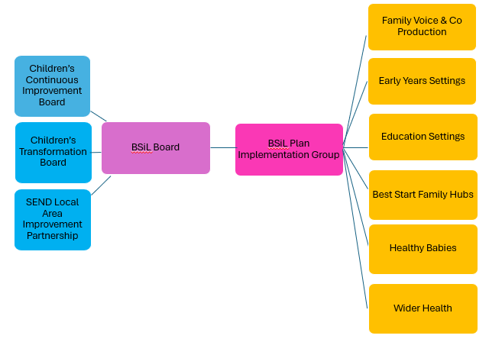

Funding
The available resources, including the Best Start in Life and Healthy Babies grants, the Public Health Ringfenced Grant, and Local Authority resource are being aligned to support the effective delivery of the BSiL Plan.

Best Start funding will be prioritised to support the delivery of EBIs for 3- and 4-year-olds, increasing reach among priority cohorts, addressing inequalities in GLD attainment, and contributing to overall improvements in GLD outcomes.
Best Start Family Hubs and Healthy Babies funding will be distributed between 2026 and 2029 in line with Department for Education allocation guidance and the percentage breakdown outlined in Table Three.
Table 17: Best Start Family Hubs and Healthy Babies grant allocation
Strand | % | How resource will be spent
Best Start Family Hubs  delivery grant - programme | 25% | Supporting strategic oversight and strengthening family involvement to ensure services remain on track and are equipped to contribute towards meeting GLD targets.
Best Start Family Hubs  delivery grant - capital | 6% | Maintaining and enhancing Family Hubs and spoke sites so they offer a welcoming, accessible environment for families.
Parenting support | 12% | Increasing and expanding delivery of EBIs that equip parents and caregivers with the skills, knowledge and confidence to positively influence their child’s development at ages 3 and 4, supporting readiness for school.
Home Learning Environment Support | 10% | Increasing and expanding HLE‑focused EBIs to help parents and carers use practical strategies and activities that strengthen the quality of learning interactions in the home.
Perinatal Mental Health and Parent Infant Relationships | 29% | Continuing to provide tailored and targeted support for families including partners and co-parents on mild to- -moderate perinatal mental health needs and parent–infant relationship support, contributing to early development and positive GLD outcomes.
Infant Feeding support | 17% | Continuing to offer tailored and targeted breastfeeding and infant feeding support, enabling families to make informed feeding choices while optimising breastfeeding, strengthening early attachment and supporting child development towards GLD.
Healthy Babies offers and Parent Carer Panels | 2% | Promoting the Healthy Babies offer widely and expanding the Parent Carer Panel approach to ensure representation from priority cohorts.

