Heritage Impact Assessment: Coppice Hotel
HELAA2021 Ref: | 24T004
Site Address: | Coppice Hotel, Barrington Road, Torquay
Site Area (ha): | 0.1
Site Yield: | 12
HIA Assessment

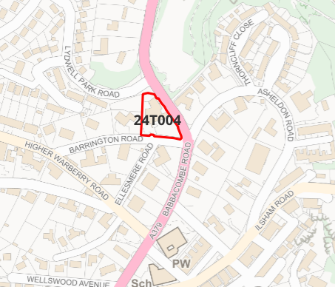
Site overview and heritage context:
The site is on the eastern boundary Warberries Conservation Area and adjacent to Lincombes Conservation Area. It occupies a prominent corner position between Barrington Road and Babbacombe Road and sits on an elevated position above the main road. Much of the site is somewhat screened from the road by a wall and mature vegetation, but the hotel building itself is clearly visible in several views from the two Conservation Areas.
The site was previously in use as a hotel but is now closed, and the building is derelict following a fire in January 2024. The current status of the building is uncertain, but it appears to be quite badly damaged by the fire and reports suggest up to 70% of material has been lost.
The Warberries Conservation Area Appraisal identifies this building as one of a key group of 12 villas that retain a good amount of historic material: ‘all have hipped roofs carried on deep bracketed eaves; other features include full height canted bays, balustrading, rustication, and flat, segmental or semi-circular arched openings with keyblocks. Coppice has a very attractive 3-storey belvedere with twin round-headed windows and flanking pilasters, and chimneys seemingly rising from the window openings! However, a large flat roof extension on the west considerably dims the charm of the original building’.

Planning History:

Heritage Asset Affected by Allocation | Designation | Contributing Elements to Significance | Impact of Development on Significance | Mitigation Measures for any Identified Harm /Opportunities to Enhance Significance | Impact on Significance with Mitigation in place
Warberries Conservation Area  Lincombes Conservation Area  (E of site)  Kent’s Cavern (SE of site)  Parish Church of St Matthias (S of site) | Conservation Area  Conservation Area  Scheduled Monument  GII* Listed Building | The Conservation Area is characterised by its development of large, detached Victorian villas set in spacious gardens, many of which adopt the Italianate style associated with Torquay’s status as a fashionable resort town. The Coppice Hotel site fits this trend of development, and is identified in the Conservation Area Appraisal as a key building.  In spite of some unsympathetic extensions and alterations associated with its use as a hotel, the site in its pre-fire form contributed positively to the character of the Conservation Area. Fire damage has greatly compromised the historic fabric of the building, but sympathetic rebuilding and removal of detrimental elements no longer necessary for hotel use would enable it to once again contribute positively to the significance of the Conservation Area.  In spite of some unsympathetic extensions and alterations associated with its use as a hotel, the site in its pre-fire form contributed positively to the significance of the Conservation Area.  Kent’s Cavern is a large cave with two entrances opening halfway up Lincombe hill. It holds what are by far the most important known extant Palaeolithic cave deposits in Britain and also provides in situ stratified deposits extending from the Palaeolithic to the Iron Age as well as later occupation evidence.  C19 church designed by A Salvin. The Coppice Hotel site is not visible from the Church, but is located on the same stretch of road and thus may be considered to be within its setting. In its pre-fire form, the site had a neutral contribution to the significance. The fire damage has cause the site to negatively impact the significance of nearby heritage assets. | The proposed yield of 12 could be achieved through the sensitive rebuilding of the site which would result in a positive impact to the significance of this asset.  The proposed yield of 12 could be achieved through the sensitive rebuilding of the site which would result in a positive impact to the significance of this asset.  The Caverns have no line of sight to the Coppice Hotel site, and its impact upon the setting of the Caverns is neutral.  The proposed yield of 12 could be achieved through the sensitive rebuilding of the site which would result in a neutral impact to the significance of this asset. | Opportunity to enhance significance through sensitive rebuilding of the site and removal of detrimental elements no longer necessary for hotel use.  Opportunity to enhance significance through sensitive rebuilding of the site and removal of detrimental elements no longer necessary for hotel use.  N/A  Opportunity to enhance significance through sensitive rebuilding of the site and removal of detrimental elements no longer necessary for hotel use. | Positive  Positive  Neutral  Neutral

