HIGHWAYS, FLEET AND TRANSPORT



Delivering Services for and on behalf of



STREET WORKS LICENCE PROCEDURE
SECTION 50
NEW ROADS AND STREET WORKS ACT 1991

INDEX

Part 1 | Notes for Guidance for Applicants | Form SWL 1
Part 2 | Street Works Licence Application | Form SWL 2
Part 3 | Registration of Works | Form SWL3
Part 4 | Statutory Undertakers Declaration | Form SWL 4
Part 5 | Controlled Waste Transfer Note | Form SWL 5
Part 6 | Traffic Application Form | Form SWL 6
Part 7 | Temporary Prohibition of Traffic  Torbay Council  Town Hall  Castle Circus  Torquay  TQ1 3DR | Form SWL 7

Part 1 Notes for Guidance for Applicants Form SWL 1

- The person granted a Street Works Licence, becomes an Undertaker for the purposes of the New Roads and Street Works Act 1991, and therefore attracts the relevant duties and responsibilities imposed by the Act and associated Secondary Legislation and Codes of Practice.

- Financial penalties will be imposed by the Street Authority against the licence holder for non-compliance with the relevant statutory duties or licence conditions. Applicants should note that this liability cannot be delegated to any other person or organisation.

- The requirement to obtain a Street Works Licence applies to any person or organisation (other than a Statutory Body) who wishes to place, retain and thereafter inspect, maintain, adjust, repair, alter or renew apparatus, or change its position or remove it from the highway.

- The term apparatus includes drains, ducts sewer pipes, water and gas pipes.

- Form SWL 2 must be completed by the applicant for authorisation to place and retain apparatus or to work on existing apparatus in the highway and this must be submitted to the Street Authority with:

  - A copy of a scale plan of the proposed location of the relevant apparatus marked by a red broken line.
  - Proof of contractors Public Liability Insurance. This must provide a minimum £5 million cover and be maintained from the commencement of the works on the highway, up to completion and acceptance by the Street Authority of the permanent reinstatement.
  - Proof of contractors Supervisors and Operatives accreditation with SCOTVEC in Street Works to City & Guilds standard.
  - Completed Declaration Form (Statutory Undertakers Declaration/Requirements).

- Payment of £755.30 is required to place and retain new apparatus in the public highway.

  - £297.55 Administration fee (non-refundable)
  - £257.70 Capitalised fee in lieu of annual charge
  - £200.05 Inspection fee
  - Cheques to be made to Torbay Council and sent to the address above or payment can be taken over the phone by telephoning 01803 207960 option 1.

6.1 Payment of £369.00 is required to work on existing apparatus in the public highway.

  - £168.95 Administration fee (non-refundable)
  - £200.05 Inspection fee
  - Cheques to be made to Torbay Council and sent to the address above or payment can be taken over the phone by telephoning 01803 207960 option 1.

- A Street Works or consent to work on existing apparatus in the highway, will only be granted to the owner(s) of apparatus or their Successor in Title. Owners should note their statutory duty to secure that the apparatus is properly maintained at all times.

- In order for Torbay Council (Street Authority) to comply with its statutory duty, all applications must be submitted at least ONE MONTH in advance of commencement of the proposed works. The application form must be signed by the owner of the apparatus.
- Applicants should note that special conditions may be imposed by the Street Authority as below:

  - To minimise the inconvenience to persons using the street, having regard to people with disability in particular.
  - For traffic sensitive streets, streets with special engineering difficulties and protected streets.

NB The applicant must strictly adhere to these conditions.

- The Duty of Care: Controlled Waste Transfer Note must be completed where any waste from the excavation has to be disposed of. A copy of the completed form must be retained by the Licence Holder with a copy given to the person accepting the waste.

- The Licensee must give SEVEN DAYS advance notice of the intended starting date to the Street Authority.

- The Licensee must permit the Street Authority to monitor their performance throughout all stages of street works. These are signing, guarding, excavation and interim reinstatement, within 1 month of permanent reinstatement and during the one month preceding the end of the guarantee period. (This period will begin from the date the Street Authority is notified of the permanent reinstatement).

- The Licensee must inform the Street Authority of the completion of the reinstatement by the end of the following working day, stating whether it is interim or permanent. Prior notification must be given to the Street Authority if an interim reinstatement is to be carried out. Any interim reinstatement must be made permanent within 6 months.

- The Licensee must notify the Street Authority within 7 days of completion of the works and clearing the site.

- Where the apparatus in respect of which an application for a Street Works Licence is made to the Street Authority is to be placed or retained on a line crossing the street, and not along the line of the street, a person aggrieved by:

  - The refusal of the Authority to grant a licence
  - The refusal to grant a licence except on terms prohibiting its assignment or
  - Any terms or conditions of the licence granted

may appeal to the Secretary of State.

- The Licensee shall indemnify the Street Authority against any claims in respect of injury, damage or loss arising out of:

  - The placing or presence in the street of apparatus to which the licence relates to
  - The execution by any person of any works authorised by the licence and the former licensee shall indemnify the Street Authority against any claim in respect of injury, damage or loss rising out of the execution by the Authority or the licensee of any works under paragraph 7.

- The licence hereby granted shall remain in force until withdrawn by the Street Authority under Schedule 3 of the New Roads and Street Works Act 1991 or surrendered to the Street Authority by the Licensee.

- The Street Authority may, under schedule 3 paragraph 6, withdraw the licence having given proper notice if:

  - The Licensee fails to comply with any provision of this part or any condition of the licence
  - The Street Authority considers the withdrawal of the licence as necessary for the purpose of the exercise of its function as Street Authority
  - If the Authority becomes aware that the Licensee:
    - Has ceased to use or has abandoned the apparatus, or intends to do so
    - Has parted or intends to part with interest in the apparatus in a case where assignment of the licence is prohibited

- Where a licence expires or is withdrawn or surrendered, the Street Authority:

  - May remove the apparatus to which the licence relates or alter it in such manner as they think fit and reinstate, the street and may recover from the former Licensee the expenses incurred by them in doing so.
  - If satisfied that the former Licensee can, within such reasonable time as they may specify, remove the apparatus or alter it in such a manner as they may require and reinstate the street, they may authorise to do so at the former Licensee’s expense. A further licence will be required for such works.

- Any licence issued under this procedure by the Street Authority must not be construed as conferring any right for the applicant to make any connection to a sewer, drain, pipe, or other apparatus.

- The licence does not confer any right on the Licensee, as against the owners of land which the highway is situated, to use the land. The Licensee must make their own arrangements with such owners in cases where their consent is needed.

- In this licence the terms ‘Licensee’ shall include the Successor in Title – Personal Representative – Receiver – Liquidator or Trustee of the Licensee.
‘Highway’ shall include and apply to each and every Highway, when more than one Highway is specified in section 2 of Form SWL 2 here to.

Part 2 Street Works Licence Application Form SWL 2
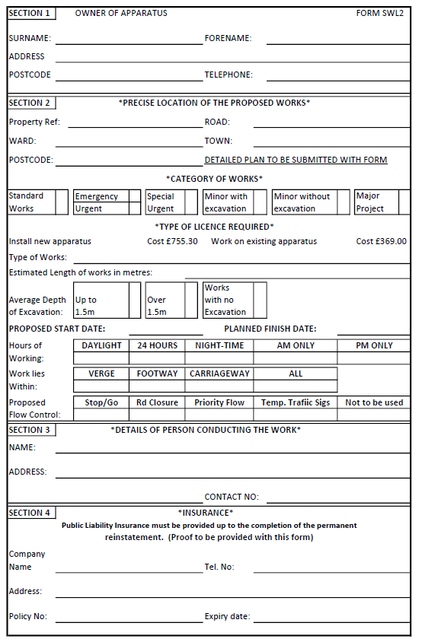
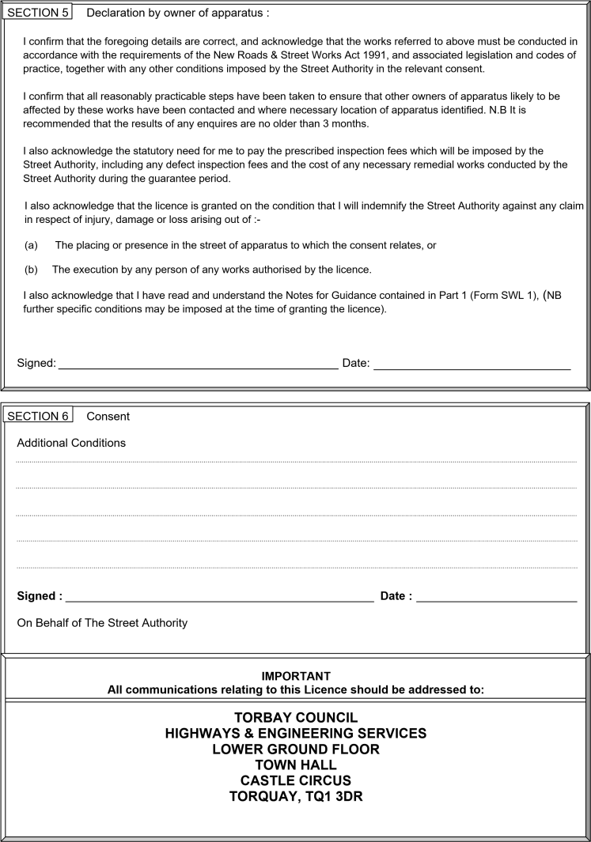

Part 3 Registration of Works Form SWL 3
New Roads and Street Works Act 1991
 |  | Has part N been sent? |  |  |  | ☐ YES ☐ NO
 |  | Part R2 |  | Give number of R2 continuation sheets:
 |  | REFERENCE No. |  |  |  |  |  |  | Part of
 |  | RECIPIENT’S  CROSS REF No. |  |  |  |  |  |  | Part of
 |  | REFERENCE No. |  |  |  |  |  |  | Part of
FROM |  | ORIGINATOR’S CROSS REF No. |  |  |  |  |  |  | Part of
 |  | ALL WORKS ON THIS NOTICE COMPLETE? |  |  |  | ☐ YES ☐ NO
 |  | (If yes above, no. of actual inspection units)
No. of boreholes/core drills plugged

Date
LOCATION
Description or house name/number

Street name

Local area name

District Postcode

DESCRIPTION OF WORKS (inc. construction methods, if known)

COMMENTS (traffic management or other)
REINSTATEMENT CLOSING DIMENSIONS & LOCATION |  |  |  |  |  |  |  | GUARANTEE START DATE
Item | Location | Length | Width |  | C,F,V |  | +1.5 | Interim |  | Permanent
Part 4 Statutory Undertakers Declaration FORM SWL 4

To comply with Section 69 of the Act where street works are likely to affect another person’s apparatus in the street, applicants must take all reasonably practicable steps:

- to give the person to whom the apparatus belongs reasonable facilities for monitoring the execution of the works, and
- to comply with any requirement made by them which is

All Statutory Undertakers must therefore be contacted before the commencement of any work. Space is provided below for them to indicate their requirements (if any) and these conditions, complete with endorsements, should be presented with your application form.

STATUTORY UNDERTAKERS’ RESPONSE

Western Power Distribution
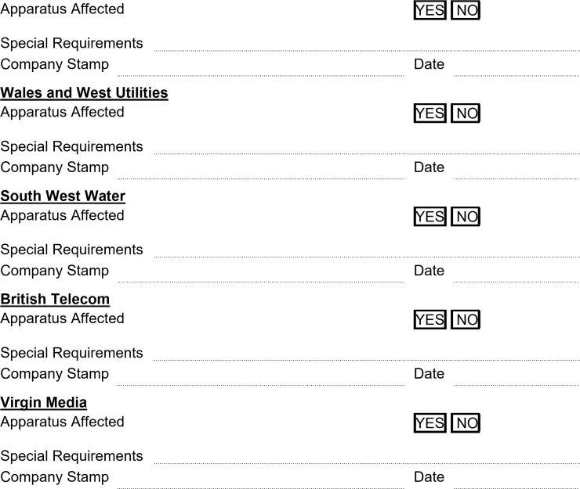

Part 5 Controlled Waste Transfer Note FORM SWL 5

Section A - Description of Waste

- Please describe the waste being transferred.

__________________________________________________________________________________________________________

- How is the waste contained?

__________________________________________________________________________________________________________

- What is the quantity of waste? (Number of sacks, weight, etc.)

__________________________________________________________________________________________________________

Section B - Current holder of the waste
Full Name (BLOCK CAPITALS):

__________________________________________________________________________________________________________

Name and address of company:

__________________________________________________________________________________________________________

__________________________________________________________________________________________________________

Which of the following are you? (Please put an ‘X’ in one or more boxes)
☐ Holder of waste disposal ☐ Registered waste carrier
☐ Producer of the waste ☐ Waste collection authority
☐ Importer of the waste ☐ Waste disposal authority (Scotland only)
☐ Exempt from requirement to have a waste disposal or waste management licence (give reason below)

__________________________________________________________________________________________________________________
☐ Exempt from requirement to register (give reason below)

_________________________________________________________________________________________________________________

Registration/licence number: _______________________________ Issued by: ______________________________________ Section C - Person collecting the waste
Full Name (BLOCK CAPITALS):

__________________________________________________________________________________________________________

Name and address of company:

__________________________________________________________________________________________________________

__________________________________________________________________________________________________________

Which of the following are you? (Please put an ‘X’ in one or more boxes)
☐ Waste collection authority  ☐ Holder of waste disposal/management licence  ☐ Exempt from requirement to register (give | ☐ Registered waste carrier  ☐ Exporter  ☐ Waste disposal authority (Scotland only)
reason below)

__________________________________________________________________________________________________________________

Registration/licence number: _______________________________ Issued by: ______________________________________

Section D – Details of Waste Transfer
Address of place of transfer/collection point:
__________________________________________________________________________________________________________________
Date of transfer: Time(s) of transfer:
_____________________________________________________ _____________________________________________________
(For multiple consignments, give ‘between’ dates)

Name and address of broker who arranged this waste transfer (if applicable):

__________________________________________________________________________________________________________________

Signed: ________________________________ Representing: __________________________________________________________

Full Name: (BLOCK CAPITALS) __________________________________________________________________________________

Part 6 Traffic Application Form FORM SWL 6

V2 To Place Portable Traffic Signals in the Public Highway
Section 53, Traffic Signs Regulations and General Directions 2002
☐ Application for Revised Dates ☐ Re-submitted Application
TO: (Street Authority name) |  | Statutory Undertaker applying: |  | (logo)
 |  | OFFICER NAME:
 |  | ADDRESS:
Phone: |  | Phone:
Fax: |  | Fax:
Email: |  | EToN REF:
Immediate Works? | ☐ Yes ☐ No | Planned Works? | ☐ Yes ☐ No

LOCATION DETAILS

ROAD NUMBER (A & B Only): | LOCATION:
STREET NAME  or USRN/S: | TOWN:
GRID REF - EASTING: | GRID REF - NORTHING:

SITE SETUP

Does this site contain a junction?  Comments: | ☐ Yes ☐ No
Does this affect permanent signals or pedestrian crossing?  Comments: | ☐ Yes ☐ No
Has the Highway Authority been contacted to agree switching / bagging these lights off?  Comments: | ☐ Yes ☐ No
Will there be an effect on other matters? (E.g. trams, bus lanes, bus stops, pedestrian crossing points, parking bays) Comments: | ☐ Yes ☐ No
Number of signal heads: | ☐ 2 ☐ 3 ☐ 4

WORK DETAILS
START DATE: | FINISH DATE: |  | Days in use (working days):
TIMING OF TRAFFIC LIGHT USE - tick applicable boxes and/or enter details
☐ 24 hrs ☐ Weekday  ☐ Night (19:00 - 07:00) ☐ Weekends  ☐ Peak (09:30 – 15:30) ☐ Other |  | Comments/Details:
Have unsocial working hours been confirmed with relevant Environment Health departments? ☐ Yes ☐ No
WORKS DESCRIPTION:

EMERGENCY/OUT OF HOURS CONTACT – For Traffic Management / Signal Failure

NAME: | ORGANISATION: | TEL.:

DECLARATION

I have completed ALL the above sections, have read, understood and agree to the Notes on Portable Traffic Signals and have provided any additional information as required. I understand that incomplete Applications will be refused and will notify the Street Authority if any change is made to the date or time given on this Application. I understand that as part of this agreement, it is a mandatory condition to have stop/go boards available on site whilst works are ongoing in case of signal failure. I also confirm that the maximum site length will be no more than 300m. I understand that the individual authority may impose a charge for turning of any permanent signals to help me facilitate my works. I confirm that 1 scale site plan (minimal requirement) has been attached to this application. I confirm that any unsocial working hours have been agreed with the relevant Environmental Health Departments.
NAME: | DATE:

STREET AUTHORITY COMMENTS

Response | ☐ Authorised ☐ Not authorised
Comments:

NAME: |  | DATE: |  | TEL.:

Guidance Notes

Method of sending
All applications must be sent by email in the first instance. Other methods of sending (e.g. fax, post) must be agreed with the Street Authority first.

The Local Authority must publish the contact that applications should be sent to and the preferred method of sending on the SWHAUC website.

Application Durations Planned Works:
Minor / Standard Applications 10 working days
Major works 1 calendar month

Immediate Works:
Urgent / Emergency: As soon as reasonably practicable

N.B. Late applications may result in the EToN notice & application form for TTLs being rejected and the works requested needing to be replanned.

Location Details
Road Number: Only required if this is an A or B route.
Street / USRN: One or both is acceptable. Must correspond with EToN Notice.
Town: Must correspond with EToN Notice.
Grid reference: Must be 12 figures minimum. Centre point of site should be used.

Site Set Up
Permanent signals / Must be checked and any special requirements to manage the junction noted Crossing / Junctions: at this stage on the application. (E.G. Permanent signal heads to be switched
off.)
Site length: Agreement is required for sites over 300m by the Street Authority so this must be highlighted. 500M is the maximum length allowed.
Signal heads: Only 1 application will be accepted per street and per set of signals. E.g. If moving from 2 to 3-way signals, 2 applications must be sent together.
Site Plans: 1 is the minimum requirement. The street map must be to an appropriate scale and indicate the start / finish of the shuttle lane. If this changes whilst works are ongoing on site, the works promoter must undertake a risk assessment and log all justifications for slight amendments on an audit document. If the changes are significant e.g. 2-way to 3-way, affecting another street, then approval from the street authority is required.
Please consider and advise if the TTL’s affect other factors of the highway.
The other matters? comments box is an opportunity to confirm what planning has been taken to reduce the impact of the TTL’s.

Work Details
Start / Finish Date: | To represent actual days on site. N.B. Must correspond with the EToN Notice and be a reasonable duration to avoid challenge by the street authority. N.B. By ‘correspond’ the dates may not reflect the exact dates on the EToN notice but should be within the EToN dates e.g. EToN Dates 1-10/3/11. TTL dates 510/3/11.
Days in Use: | Must indicate the number of working days the TTL’s are in use on the highway. (N.B. Working days means Monday – Friday excluding bank holidays).
Works description: | Must be in layman’s terms (i.e. no technical jargon) and must justify the duration of any work requested, e.g. New Water 150mm diameter supply main 100m long and 5 connections. Must be in laymen’s terms as per the EToN Technical Specification.
Timings of traffic | Must reflect the intention of when the lights will be operational. This must
lights: | not just reflect the times that the applicant intends to be working on the site.
Environment Health: This box requires the applicant to consider any additional impact on the local community due to the works, (e.g. Noise) if works are proposed for unsocial hours. The comments box allows the applicant to advise the street authority of any action taken to help plan the works. (e.g. EA / District council contacted, and noise control measures A & B will be imposed / not residential – no action necessary).
Emergency/out of hours contact – This must be a number that can be contacted 24/7 in case of management concerns or signal failure. This cannot be an individual’s mobile.

Street Authority Comments - This box must be blank on submission of the application.
Authorisation is only given if the form is returned to the applicant with ‘authorisation’ and relevant conditions attached in this section of the form.

Part 7 Temporary Prohibition of Traffic FORM SWL 7

Delivering Services for an on
behalf of

REQUEST FOR TEMPORARY PROHIBITION OF TRAFFIC

Applications must be received 3 months before the anticipated start date of the closure and be submitted with a plan/sketch of the exact location of the area/section of road affected.

This application is to be completed by the applicant or nominated contractor and emailed to streetworks@torbay.gov.uk or posted to Street Works Co-ordinator, Highways Management, Lower Ground Floor, Town Hall, Torquay, TQ1 3DR.

Please note: A five-day consultation period will be undertaken before approval. Approval of this application does not affect any other statutory obligations.

ROAD NAME:
SECTION/LOCATION OF WORKS:
TOWN:
START DATE:
COMPLETION DATE:
TIMING OF CLOSURE: | FROM: |  |  | TO: |  | ☐ All day
REASON FOR CLOSURE:
CLOSURE REQUIRED: PLEASE TICK |  |  | ☐ Full closure ☐ Lane closure
DIRECTION OF CLOSURE:
CONTACT NAME:
ORGANISATION NAME:
CONTACT PHONE NUMBER (DAY):
24 HOUR CONTACT PHONE NUMBER:
CONTACT ADDRESS/BILLING ADDRESS:
EMAIL ADDRESS:
OTHER INFORMATION:
TORBAY COUNCIL TO PROVIDE SIGNING SCHEDULE? | ☐ Yes (PLEASE NOTE AN ADDITIONAL FEE APPLIES) ☐ No
DECLARATION

I agree that I or my nominated contractor will be responsible for:

- Providing, placing and maintaining all road closed and diversion signs indicated in correspondence or plan.
- Giving advanced warning to residents/businesses affected by the closure and ensure access is maintained to their satisfaction.
- Ensuring removal of said signs on completion of work.
- Providing signs in accordance with Traffic Sign Manual, with a 24-hour contact telephone number on advanced warning signs.
- Reopening road as soon as works are complete and informing the Street Works Co-Ordinator if timings are different from those requested.
- Public Liability Insurance cover over 5 million pounds sterling (£5,000,000 GBP).
- Valid and correct accreditation to place out road signs and diversion signage.

I understand that I will be liable for Torbay Council’s costs incurred in connection with the closure which are payable in advance.

2024/25 Charges  Temporary Traffic Notice (emergency works only)  Temporary Traffic Order (planned works) |  |  |  | £ 348.71  £ 1772.99
The provision of mandatory advisory signing of the closure is my responsibility and is not included in the fees payable as stated above.

I confirm that consultation will be undertaken prior to the closure with the residents, local businesses, schools, etc. of effected streets, advanced notice boards will be placed out on the effected street 7 days prior to the road closure date and information will be published in the local newspaper as appropriate.

SIGNED: |  | DATED:
Office Use Only: The above application has been received, and the following traffic management is proposed:
Consultation: Please supply any comments within 5 days of receipt
☐ Police ☐ Fire ☐ Ambulance ☐ Public Transport ☐ Other
Street Works Co-Ordinator:

