

Delivering Torbay Council's Embodied

Carbon Policy
CENTRE FOR ENERGY AND THE ENVIRONMENT
Internal Document 1089
August 2025

 | Author(s): | D Lash
 | Report number: | Internal Document 1089
 | Publication date: | 1st August 2025
 | Revision number: | 2

Management Summary
The Centre for Energy and the Environment at the University of Exeter was commissioned by Torbay Council to consider the implications of its proposed Embodied Carbon policy in its draft updated Local Plan 2026 – 2040. This report outlines the steps that would be necessary to meet the policy and discusses potential cost implications.

Background
Embodied carbon from the construction and refurbishment of buildings currently makes up 20% of UK built environment emissions. As operational emissions from buildings continue to reduce, embodied emissions will make up a greater proportion of a building’s total carbon emission. Work carried out for the Royal Institution of Chartered Surveyors suggests that embodied carbon currently makes up between 35% and 51% of a building’s lifetime emissions, rising to 70% as operational energy decarbonises [1]. Torbay Council (TC) is updating its Local Plan with a targeted adoption date of April 2027. The draft plan sets out policies for how development will be managed in the district up to 2040. Appendix 2 of the draft plan includes the following draft wording for an Embodied Carbon policy:
All new development will be expected to demonstrate how they will minimise embodied carbon emissions.
Proposals for major development will be required to include an embodied carbon assessment as part of the Energy and Climate Change Statement. This assessment must use a nationally recognised embodied carbon assessment methodology and demonstrate actions taken to reduce embodied carbon emissions.
All applications must demonstrate how these requirements are to be met in an Energy and Climate Change Statement.
A Supplementary Planning Document will be developed to support meeting all requirements of this policy.

The Centre for Energy and the Environment (CEE) at the University of Exeter (UoE) was commissioned by TC to consider the implications of this policy.

Meeting the Policy

Background
Buildings contribute to climate change through emissions of greenhouse gases resulting from the materials, construction, and use over their entire life. This is known as a building’s Whole Life Carbon (WLC) emissions. In the built environment, WLC is composed of (i) operational carbon and (ii) embodied carbon. Operational carbon encompasses the emissions associated with the energy used to operate a building such as heating, hot water, ventilation, and lighting; and is regulated under Part L of the Building Regulations [2]. Embodied carbon emissions are those associated with the materials used, construction, maintenance, demolition, and waste disposal of the asset [3]. These are accurately represented in BS EN 15978-1 [4], where the different lifecycle stages are defined in four modules which are subsequently broken down into further stages (see Figure 1).
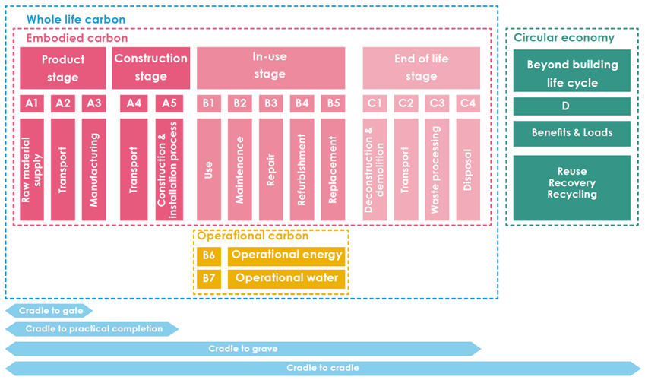
Figure 1: Lifecycle stages defined by BS EN 15978-1[4]
Module A covers ‘Upfront’ emissions associated with the production and construction stages. Module B covers the in-use stage and includes the embodied carbon arising from maintenance activities, and the operational carbon from energy and water use. Module C covers the End-of-Life emissions arising from the demolition and waste processing. Together, emissions from modules A, B, and C (excluding Operational Carbon stages B6 and B7) make up Embodied Carbon.
Module D covers impacts beyond the building life cycle. It can be thought of – in combination with modules C1 and C3 – as the Circular Economy module. It quantifies the potential future carbon benefits or burdens from current design decisions. It includes the impacts of carbon sequestration, and it should be reported separately as it is not included within targets for ‘Upfront’ or ‘Whole Life Carbon’.
LETI has developed a letter rating system for four building archetypes to provide alignment in embodied carbon measurements and comparisons [5] (Figure 2). The current average design is stated to achieve an E rating, whereas the proposed best practice LETI 2020 Design Target achieves a C rating. With the Design Target 2030 achieving an A rating. The RIBA 2030 Climate Challenge [6] built performance target aligns with these ratings as a B rating. While these ratings are targets rather than limits, they are representative of those that exemplary developments should follow if net zero is to be achieved in the building sector.
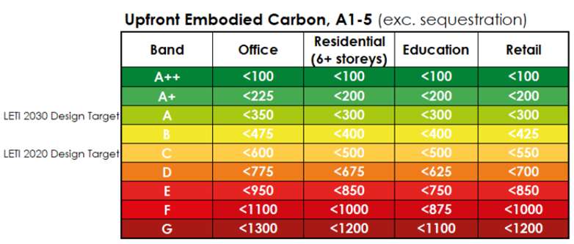
Figure 2. Upfront Embodied Carbon Target Alignments values in kgCO2/m² for different developments from LETI [5]

Undertaking an Embodied Carbon Assessment
Major development will be required to include an embodied carbon assessment that uses a nationally recognised embodied carbon assessment methodology.
- Standard: Embodied carbon calculation approaches should conform with BS EN 15978-1.
- Methodology: RICS Professional Standard: Whole Life Carbon assessment for the built environment 2nd edition [7] provides the most nationally consistent and up-to-date standard for embodied carbon assessments.
- Data sources: Valid data sources for embodied carbon factors include but are not limited to verified Type III Environmental Product Declarations (EPDs), proprietary data verified and peer-reviewed to conform with ISO 14067 or PAS 2050:2011, the University of Bath ICE Database, RICS Professional Standard default values, or manual calculations using the ‘RICS Methodology to calculate embodied carbon of materials’ [8].
- Data quality: Data must conform with data quality standards ISO 14064-1, ISO 14064-2, The Greenhouse Gas (GHG) Protocol Scope 3, PAS 2080:2016 Carbon management in infrastructure. All data must be third party verified and should reflect the geographical location of the project.
- Study Periods: Assessments should have a ‘cradle to grave’ reference study period i.e. Stages A to C. Operational Carbon stages B6 and B7 are not needed to establish Embodied Carbon, though it is recommended they are included to enable Whole Life Carbon emissions to be calculated.
- Scope: Embodied carbon assessment should cover all items listed in the project’s Bill of Quantities, cost plan, or other design information. All building elements should be covered, including Facilitating Works, Substructure, Superstructure, Finishes, Fixed Furniture and Equipment (FF&E) (non-fixed excluded), Building Services, Prefabricated Buildings, Works to Existing Building, and External Works. At least 95% of the cost allocated to each building element category should be accounted for in the assessment.
- Software tools: BIM based tools offering integration of embodied carbon assessments with the design processes are recommended for ease. Several commercial tools are available. There are also freely available tools such as The Structural carbon tool – Version 2 by IStructE.
- Units: As a minimum for the development, Embodied Carbon should be reported in standard units (overall tCO₂e and kg CO₂e/m² of gross internal area [GIA]), with a preference for also breaking down these overall numbers into building types.
- Reporting: Reporting forms should be consistent with the calculation method used. Both LETI and RICS provide analogous reporting templates that are standardised and widely used.
- Time of assessment: RICS recommends for the assessment to take place before the commencement of the technical design, during the concept design phase (RIBA Stage 3), as decisions are more influential at this stage. A post-construction assessment is also recommended (though not a requirement of TC’s policy) to represent the ‘as built’ carbon budget. Interim assessments can be carried out according to the nature of each project.
Developers should provide valid justification should they decide to take on an alternative approach. It is encouraged for all developers to submit embodied carbon assessments to the Built Environment Carbon Database (BECD) as it will help build knowledge on reducing embodied carbon emissions and maximise reporting consistency. Further guidance on assessing embodied carbon can be found at LETI Embodied Carbon Primer [9], RICS Professional Standard: Whole Life Carbon assessment for the built environment 2nd edition [7], UKGBC Embodied Carbon Scope 3 Measurement and Reporting [10], and PAS 2080 framework (2016 Carbon management in infrastructure) [11].

Demonstrating Actions Taken to Reduce Embodied Carbon Emissions
As part of the assessment described in the previous section, major development will be required to include actions taken to reduce embodied carbon emissions. Reducing embodied carbon is a broad challenge that can take numerous approaches. LETI establishes a recommended hierarchy to follow when reducing the embodied carbon of each building element [12]:
- Build less
- Build light
- Build wise
- Build low carbon
- Build for the future
- Build collaboratively
These steps prioritise circularity by building less and building wisely by reusing existing infrastructure, reviewing structural loadings, reducing material quantities, reviewing material efficiency, and ensuring material longevity. If all possible material reductions have been applied, then the next step is to reduce the use of high embodied carbon materials, particularly in the ‘big ticket’ building elements that provide the greatest carbon reduction opportunities e.g., foundations, upper floors, or framing. Finally, designing for durability, flexibility, and easy disassembly ensures circular economy at the end of life of a building and allows for embodied carbon reductions in future builds.
There are many ways in which embodied carbon can be reduced at each stage in the hierarchy. The LETI Embodied Carbon Primer [9] provides a comprehensive list of ‘rules of thumb’ that outline the most common ways of maximising opportunities for low carbon design. Common ways of mitigating embodied carbon include using recycled materials, using cement replacement mixes, using renewable elements such as timber or earth, using lime render and mineral wool in the façade, using refrigerants with low GWP and leakage, or preserving/re-using existing superstructures, among many others [9].
To demonstrate that adequate steps have been taken to reduce embodied carbon emissions, developers should adopt the following three-step process:
- Create an initial baseline embodied carbon assessment based on common practice assumptions. This allows for identification of the ‘big ticket’ building elements that have the most embodied carbon reduction potential.
- Apply an embodied carbon reduction strategy to each element, implementing best practice reduction measures.
- Carry out an optimised embodied carbon assessment illustrating the percentage reduction achieved and the measures implemented to do so.
The outcomes of this three-step process can be evidenced in a single report. Alternative demonstrations of active efforts to reduce embodied emissions must provide thorough explanations of the methodology used and must be accompanied by a quantitative assessment of the reduction achieved.
A potential Embodied Carbon Delivery Checklist is provided in Appendix A.

Cost of the Embodied Carbon Policy

Cost of Assessment
Major development will be required to include an embodied carbon assessment. The Church of England [13]states that the cost of a whole life embodied carbon assessment varies depending on the size and complexity of a building and detail of the assessment. It estimates that for a detailed RICS method compliant assessment, a specialist would expect to take 5 to 20 days to complete the assessment for many building projects, dependent upon the size and complexity of the project. Based on this and an average consultancy rate of £550/day, this results in a cost range of £2,750 to £11,000 with an average of £6,875. The cost uplift per dwelling based on a 76 m² terrace/semi-detached house is shown in Table 1. There is no requirement for an assessment for minor development, and therefore no additional cost for development at that scale.
Table 1: Cost range of Embodied carbon assessment for various development sizes per dwelling and per m² of floor area based on a terrace/semi-detached house
Scenario | 10 | 50 | 100 | 200 | 10 | 50 | 100 | 200
 | Cost per dwelling |  |  |  | Cost per m²
Lower | £275 | £55 | £28 | £14 | £3.62 | £0.72 | £0.36 | £0.18
Average | £688 | £138 | £69 | £34 | £9.05 | £1.81 | £0.90 | £0.45
Upper | £1,100 | £220 | £110 | £55 | £14.47 | £2.89 | £1.45 | £0.72

Cost of Reducing Embodied Carbon
TC’s policy does not mandate a quantified embodied carbon target. Rather, all new development will be expected to demonstrate how they will minimise embodied carbon emissions. As such this could be achieved qualitatively at no additional cost. For example, carbon reduction strategies that are based on simplifying designs, standardisation, reducing waste, or reusing existing elements are all compatible with cost reduction. The South West Net Zero Hub has stated that significant reductions in embodied carbon can be achieved at no net additional cost [1]. WSP produced a report [14] investigating embodied carbon for the West of England Combined Authority. Within it, cost uplifts to achieve LETI WLC ratings as shown in Figure 2 for four building typologies were estimated as follows:
- Semi-detached house: A rating of up to C was possible with no additional cost. There was a 3% cost uplift to achieve a B rating, and a 15% uplift to achieve an A rating.
- Apartment block: A rating of up to B was possible with no additional cost. There was a 9% cost uplift to achieve an A rating.
- Office: A rating of up to B was possible with no additional cost. There was a 16% cost uplift to achieve an A rating.
- School: A rating of up to C was possible with no additional cost. There was a 9% cost uplift to achieve a B rating, and a 15% uplift to achieve an A rating.
Given that typical performance is stated to correspond to a rating of E, this is consistent with significant reductions in embodied emissions being possible at little to no cost, for a range of building types.

Conclusion
This report outlined Torbay Council’s embodied carbon policy. This requires major developments to undertake an embodied carbon assessment that conforms to BS EN 15978-1 by following the RICS Professional Standard: Whole Life Carbon assessment for the built environment 2nd edition. The assessment should consider upfront, in-use (excluding operational energy and water) and end of life emissions (i.e. Modules A – C), and be undertaken at RIBA Stage 3. Applicants should demonstrate by modelling baseline and subsequent improved designs how embodied carbon has been reduced. A typical building achieves an embodied carbon rating of E on a scale of A to G (where A is lowest emissions). Prior work for a range of building types has estimated that achieving a rating of C (or B for some building typologies) is possible with no additional cost. The average cost of the assessment itself was estimated here to be £688 for a small development (10 dwellings) dropping to £34 for a large development (200 dwellings).

References
[1] South West Net Zero Hub, Net Zero New Buildings: Evidence and guidance to inform Planning Policy, 2021.
[2] Department for Levelling Up Housing and Communities (DLUHC), The Building Regulations 2010, Approved Document L, Conservation of fuel and power, Volume 1: Dwellings, 2022. www.gov.uk/guidance/building-regulations-.
[3] ARUP, London Borough of Tower Hamlets Net Zero Carbon Policy Evidence Base Research Report, 2023. https://talk.towerhamlets.gov.uk/17424/widgets/50365/documents.
[4] BS EN 15978-1 Sustainability of construction works - Methodology for the assessment of performance of buildings. - Part 1: Environmental Performance , n.d.
[5] LETI, Embodied Carbon Target Alignment, 2021. https://www.leti.uk/carbonalignment.
[6] RIBA, RIBA 2030 Climate Challenge Version 2, 2021. https://www.architecture.com/about/policy/climate-action/2030-climate-challenge.
[7] RICS, RICS Professional Standard: Whole Life Carbon assessment for the built environment 2nd edition, 2nd ed., 2023. https://www.rics.org/profession-standards/rics-standards-and-guidance/sector-standards/construction-standards/whole-life-carbon-assessment.
[8] RICS, Methodology to calculate embodied carbon of materials, 2012.
[9] LETI, LETI Embodied Carbon Primer, 2020. https://www.leti.uk/ecp.
[10] A. Benstead, C. Wilde, UKGBC Embodied Carbon Scope 3 Measurement and Reporting, 2024. https://ukgbc.org/resources/embodied-carbon-scope-3-measurement-and-reporting/.
[11] Construction Leadership Council, Guidance Document for PAS 2080, 2016.
[12] LETI, LETI Embodied Carbon One Pager, 2021. https://www.leti.uk/publications.
[13] Church Buildings Council, Reducing Embodied Carbon, A Guide to Reducing the Embodied Carbon of Church Building Projects, 2023.
[14] WSP, Evidence Base for West of England Net Zero Building Policy: Embodied Carbon, 2021.

Appendix A: Potential Embodied Carbon Delivery Checklist
Task | Completed | Notes
EMBODIED CARBON ASSESSMENT
- Has an embodied carbon assessment been submitted with the application?
If not, application should not be validated
- Has the assessment been completed by a suitably qualified assessor?
- Does the assessment method conform to BS EN 15978-1?
e.g., RICS or London Plan Guidance (see report for guidance on appropriate methodology, data sources, data quality, scope, software tools, reporting, etc.)
DEMONSTRATING ADEQUATE STEPS TAKEN TO REDUCE EMBODIED CARBON
- Has a clear report providing quantitative demonstration of embodied carbon reduction efforts been submitted?
- Does this report include a baseline and optimised assessment?
If not, is there an alternative methodology thoroughly explained and accompanied by data illustrating carbon reductions
- Are the following emission reduction measures covered:
- Reuse of buildings
- Efficient building design (e.g., considers spatial efficiency, reuses/renovates existing structures, reviews loadings, reduces material quantities, considers material efficiency and longevity)
- Low carbon material (Prioritises the use of low-carbon, renewable, bio-based, locally sourced and reused/recycled materials from responsible sources)
- Reusability of material for future builds (e.g., designed for easy disassembly, durable and flexible materials that can be used at end-of-life)
The suitably qualified assessor undertaking the embodied carbon assessment will be able to advise further on what steps are most suitable for reducing impact for the specific development proposed
- Does the report include an approach to monitor and ensure the constructed building achieves the estimated embodied carbon?

Embodied Carbon | UKGBC
Note Part L covers regulated emissions only, for example from fixed building services such as heating and lighting. Some unregulated uses for example appliance equipment use or catering are not covered by regulations.
https://www.becd.co.uk/ (accessed 27/6/25)
The median Principal Engineer daily rate in the UK is £550, according to job vacancies posted in the 6 months leading up to 27 June 2025. https://www.itjobswatch.co.uk/

