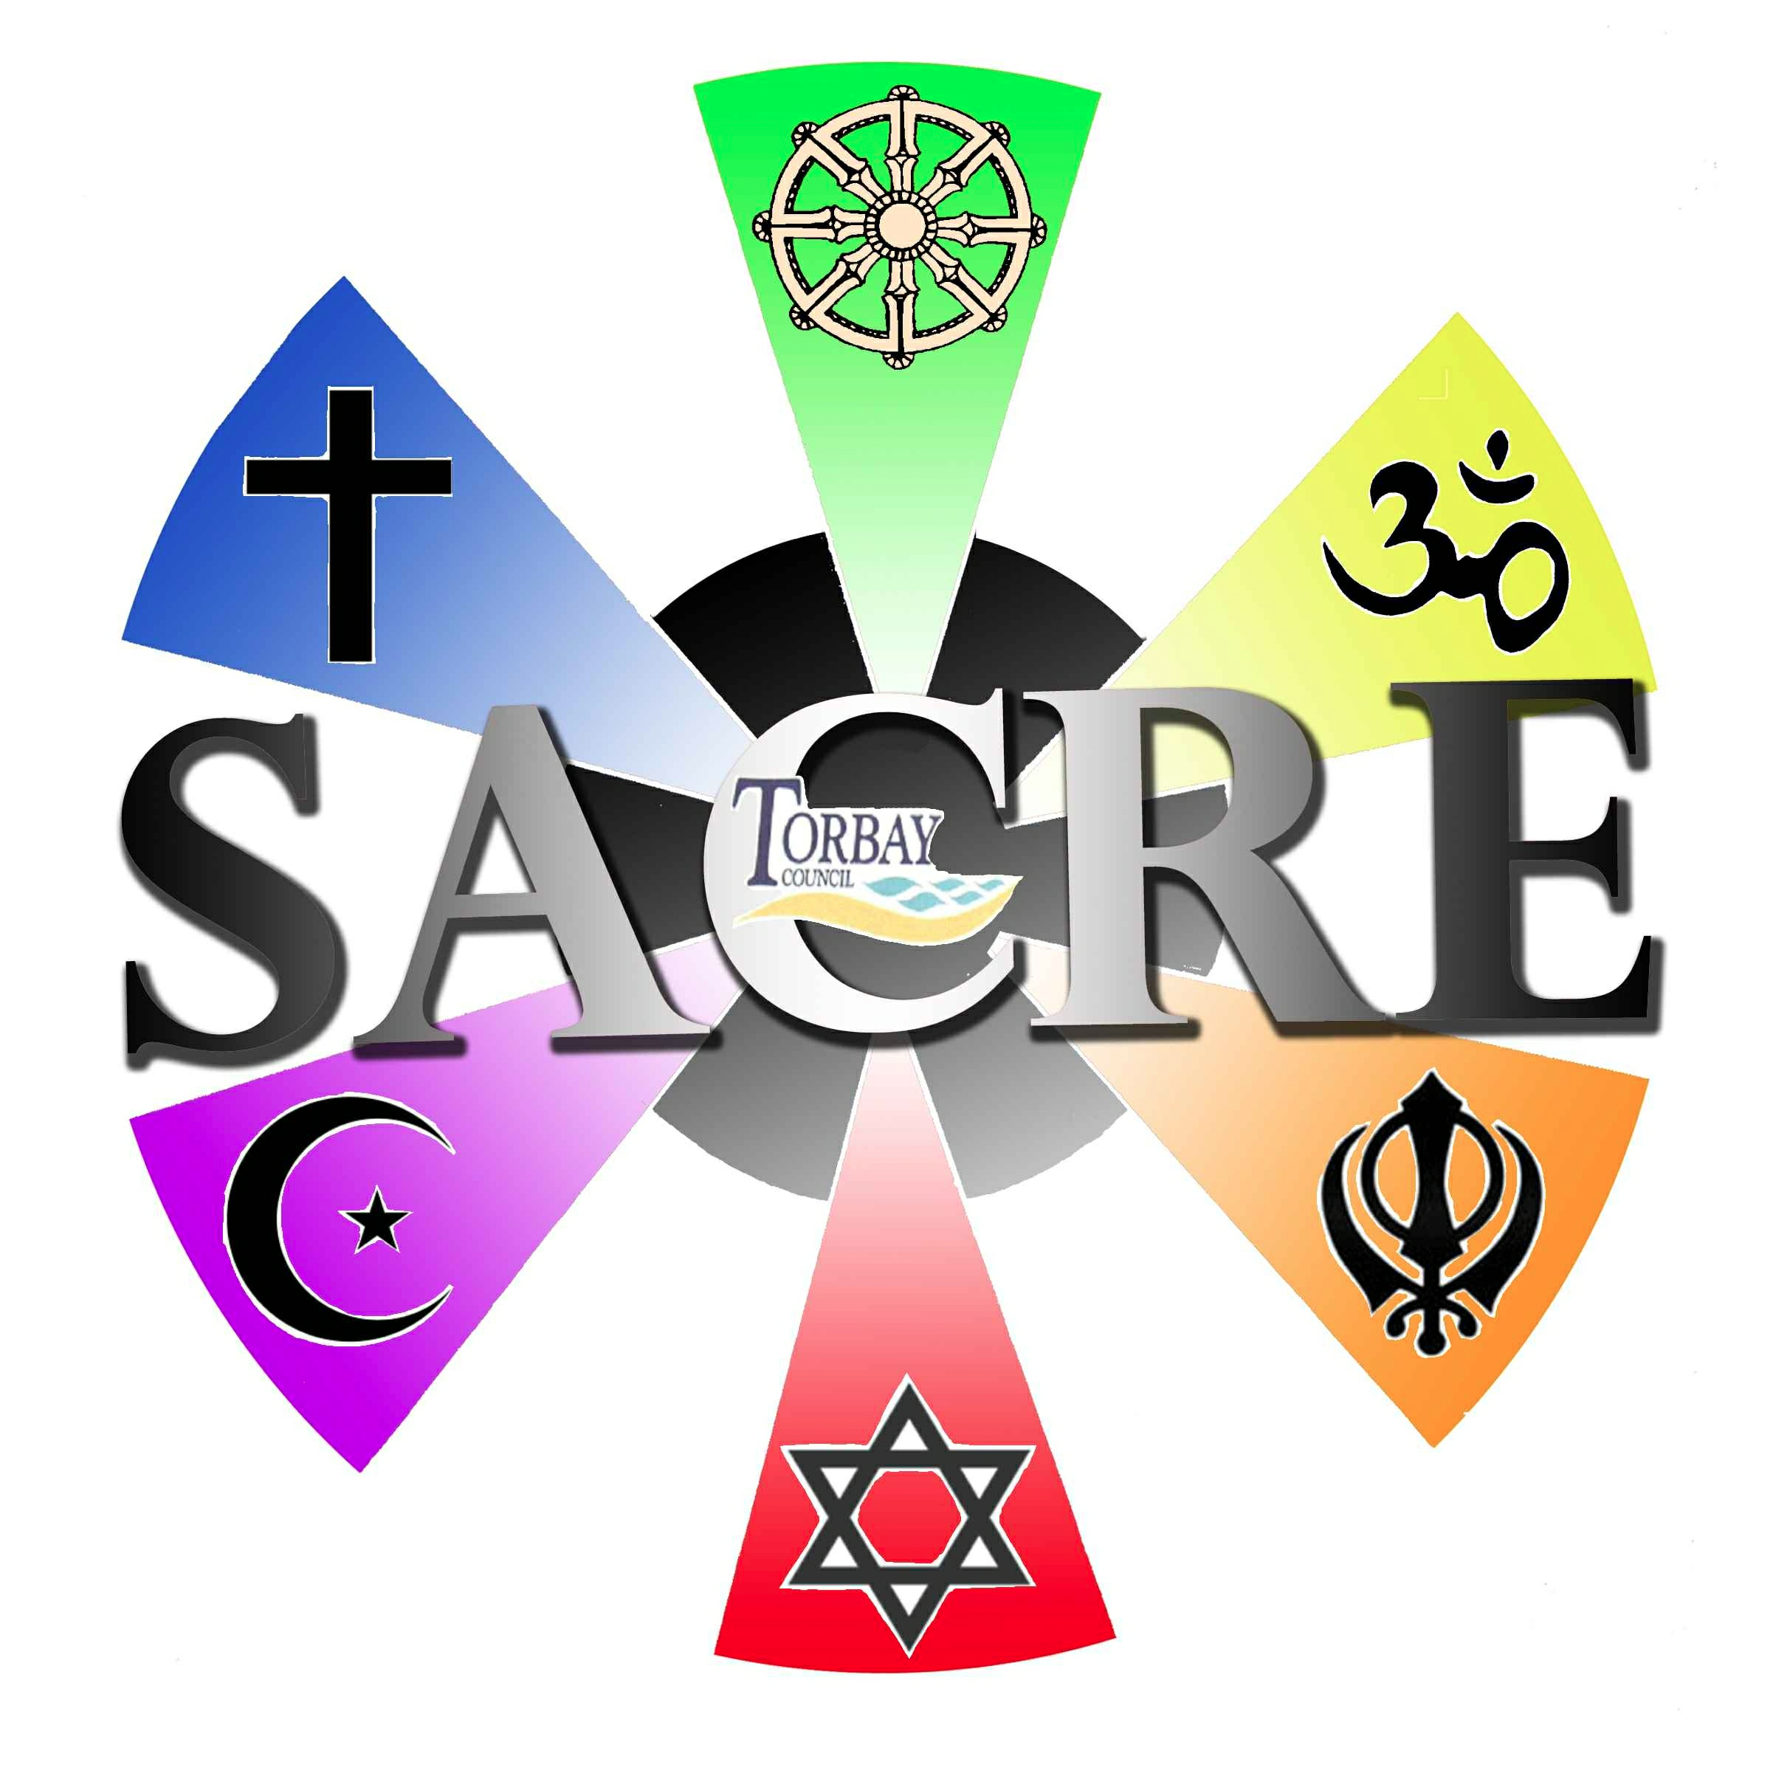

Torbay SACRE Agenda 30th June 2017
9.30 am – 11.30 am
Town Hall, Castle Circus, Torquay TQ1 3DR

- Welcome and apologies

- Minutes of the meeting of 1 February 2017

- Matters arising from the minutes

- Correspondence with the Chair of SACRE

- Public questions. One public question has been notified to the Adviser:

I should appreciate SACRE’s insight on a concern I have had for many a year. My attention was focused on it again when I read in the Herald Express of ‘Torbay’s successful Christian Youth Trust’ – LINX now celebrating its 20th anniversary in Torbay. I was present 20 years ago at its inauguration in my church – Central Church, Torquay. I was horrified at the implication then that RE teachers were finding it difficult to cope, especially with sensitive issues and the answer lay with LINX! Indeed I was much angered by it. At the time, I got in touch with the LEA as well as the Methodist Circuit minister. Neither could see the danger for state non-religious schools.

What educational right have they to exercise ‘schools based ministry’ in 9 secondary schools in Torbay?

- SACRE Development Planning

- Recent national events and their impact on RE and collective worship

- Torbay LTLRE Hub (oral report by the Chair)

- Torbay based Farmington Fellowship Update Report (oral report by the Chair)

- Inter Faith Week 2017

- Future of advice to Torbay SACRE (oral report)

