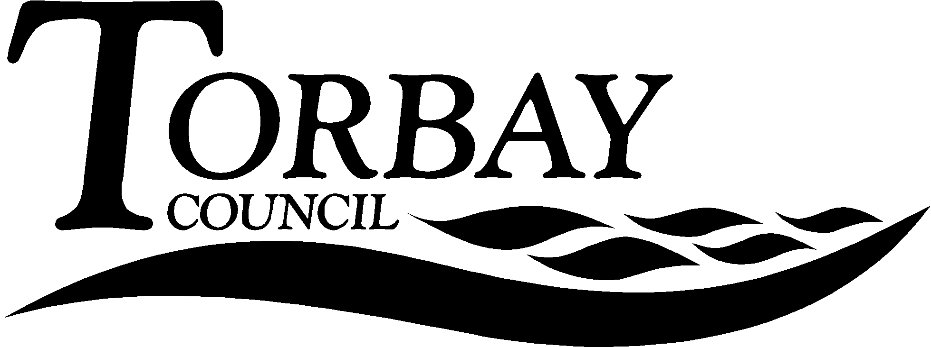

Title: | Recent national events and their impact on RE and collective worship
This report relates to
Wards Affected: | All
To: | SACRE |  | On: | 30 June 2017
Contact Officer: | David Hampshire
Telephone: | 07855 235865
E.mail: | hampshireeducational@outlook.com

1. Key points and Summary

1.1 The purpose of this report is to reflect on the recent events nationally and to explore their implications for religious education and collective worship.

2. Introduction

2.1 During 2017 there have been a number of terrorist attacks and incidents of extreme violence that have had a significant impact on our national life. These were the Westminster Bridge attack of the 22 March, the Manchester Arena attack on the 22 May, the London Bridge and Borough Market attack on 3 June and the Finsbury Park attack on 19 June. These have all been associated with Muslims in some way, either as perceived perpetrators or as victims.

2.2 As a result of these attacks there has been an heightened security effort, especially in major cities and events which are high profile. The situation has led to statements from Muslim leaders and has brought out shows of solidarity for victims from Muslim communities. In terms of the Finsbury Park attack, which was clearly aimed at Muslims, there has been a show of solidarity with Muslims there and further afield. What is clear is that many people are feeling more exposed to danger than since the time of the 7/7 bombings or the IRA terror campaigns of the 1970s and 1980s.

2.3 The result of these recent events has been to galvanise cross community support and inter faith activity. This can be seen from the collated statements gathered by the Inter Faith Network for the UK (IFN), as well as statements that it has also published on-line (see: https://www.interfaith.org.uk/news/statements-and-messages for IFN’s responses and https://www.interfaith.org.uk/news/statement for the statements of other bodies).

2.4 There are a number of implications for schools. Firstly, there have been reports nationally on an increase in Islamophobic attacks (see: https://tellmamauk.org/). Secondly, how is the teaching of Islam affected by these events, which see Muslims portrayed as perpetrators or victims of atrocities? And, thirdly, how are these events reflected upon during collective workshop?

2.5 There are a number of priorities that emerge out of these questions. Firstly, is there evidence that Islamophobic incidents have increased in Torbay? Has this been an issue for schools? Secondly, has there been in an increase in withdrawal from RE as a result of these events? How are schools managing this if so? Thirdly, what are the resources available to schools to commemorate these events appropriately so that pupils themselves do not become anxious?

2.6 SACRE may wish to note that some schools have cancelled trips to London as a result of these events as a result of parental pressure around the country.

3.0 Recommendation

  - That SACRE consider producing guidance on how to respond to religiously motivated incidents that have a significant impact on communities locally, regionally and nationally and that it does so in collaboration with other SACREs in the South West.
  - That SACRE consider this guidance at its next meeting so that it can be put on Torbay SACRE’s webpage for schools to access as a resource that is reviewed and updated annually, or as necessary.
  - That SACRE ask the local authority and the Devon and Cornwall Police to update it at its next meeting to see if the events noted in the report led to spikes in Islamophobic incidents and their reporting in Torbay, and what the response of the local authority and police was to these locally.

Corrine Guntrip
Chair of SACRE

Appendices

None

Documents available in members’ rooms

Background Papers: None

