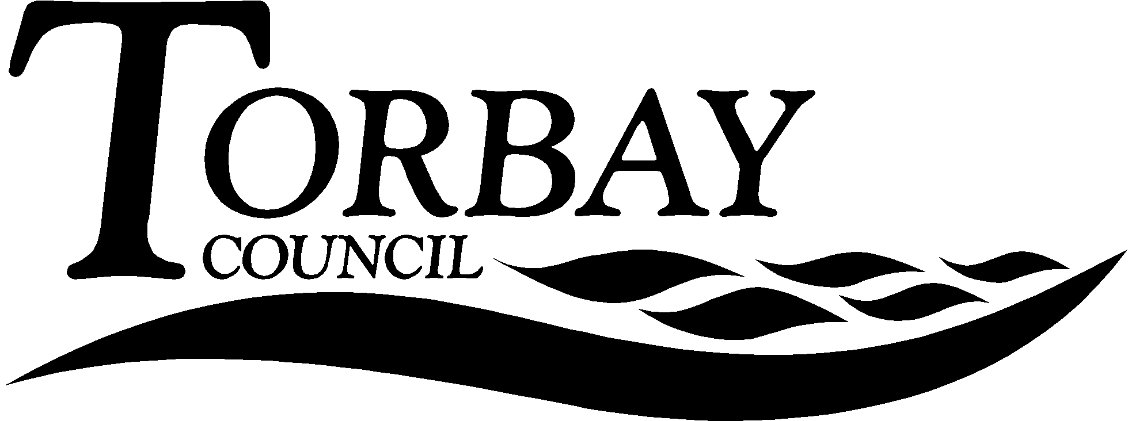

Title: | inter Faith Week 2017
This report relates to national Inter Faith Week 2017, which was established in 2009 by the Inter Faith Network for the UK, and promoting the Week amongst Torbay’s schools.
Wards Affected: | All
To: | SACRE |  | On: | 30 June 2017
Contact Officer: | David Hampshire
Telephone: | 07855 235865
E.mail: | hampshireeducational@outlook.com

1. Key points and Summary

1.1 The purpose of this report is to update SACRE on Inter Faith Week 2017 and to promote it amongst Torbay’s schools. The Week runs from 12 – 19 November 2017.

2. Introduction

2.1 In 2016 there were over 600 events nationally for Inter Faith Week. These events ranged from civic events to smaller community events, some involved large businesses and universities and others small rural schools. In the part Torbay’s Interfaith Forum has been involved in planning and hosting events across the Bay area.

2.2 The Inter Faith Network provides and number of resources for communities, including schools, to help them plan events for the week. These can be found at https://www.interfaithweek.org/resources. Particularly useful is the Inter Faith Week Toolkit (Appendix 1), which can be downloaded from the link in the report.

2.3 Events are registered, at no cost, on the Inter Faith Week website and schools, as well as others, can download promotional materials for their events, such as formatted documents and logos.

3.0 Recommendation

  - That SACRE write to all schools to encourage them to put on one event during Inter Faith Week and to register it on the Inter Faith Week Website.
  - That SACRE ask the local authority to put the Inter Faith Week Toolkit on SACRE’s webpage for schools to download.

Corrine Guntrip
Chair of SACRE

Appendices

Documents available in members’ rooms

Background Papers:

