Teresa Buckley
Governance Team Leader/Health & Safety Co-ordinator
Governance Support Team
Torbay Council,
Town Hall
Torquay
TQ1 3DR

13 June 2017

Dear Teresa,

ELECTORAL REVIEW OF TORBAY: WARDING ARRANGEMENTS

The purpose of this letter is to formally announce the start of the first consultation stage on warding patterns in the electoral review of Torbay Council.

Enclosed is a copy of a letter sent to Steve Parrock formally notifying your Council of the start of the consultation, together with:

- a copy of the news release announcing the start of the consultation stage.
- 20 A4 posters

Please feel free to contact me should you have any questions. We will be happy to assist with technical aspects of your warding scheme, if you require, either in person, via email or telephone. This is an open offer.

Any representations should be made to the Commission by 14 August 2017. Representations should be made through http://consultation.lgbce.org.uk, by email to reviews@lgbce.org.uk or in writing to this address:

Review Officer (Torbay)
Local Government Boundary Commission for England
14th Floor Millbank Tower,
Millbank
London
SW1P 4QP

If you have any queries, please feel free to contact me.

Yours sincerely
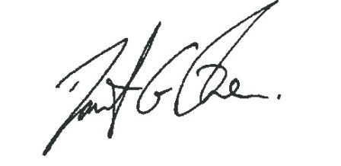
David Owen
Review Officer
reviews@lgbce.org.uk
0330 500 1277

