Torbay Public Health Lifestyle Services Questionnaire
7 November – 16 December 2016
Summary of responses

Overview
This survey was carried out as part of the Council consultation on budget proposals. It was open from 7 November – 16 December 2016.
There were 199 responses to the survey. 68% of respondents were female, 52% were current or previous users of the Torbay Lifestyles Service, and 19% were healthcare professionals working within Torbay.
The first section of the survey asked for views on the proposed service reduction. Responses to this section of the survey were included in the main Budget 2017/18 Consultation Report January 2017 and are not repeated here.
The second section asked for people’s experiences of using services to help with health risk behaviours (stopping smoking, losing weight, eating more healthily, taking more exercise, improving emotional health and resilience). Responses to this part of the survey are below.
Thank you to all who responded to the survey. The results will be used to inform the future development of services in Torbay.

EXPERIENCE OF USING SERVICES TO HELP TACKLE HEALTH RISK BEHAVIOURS
What have you used a service to help you with?
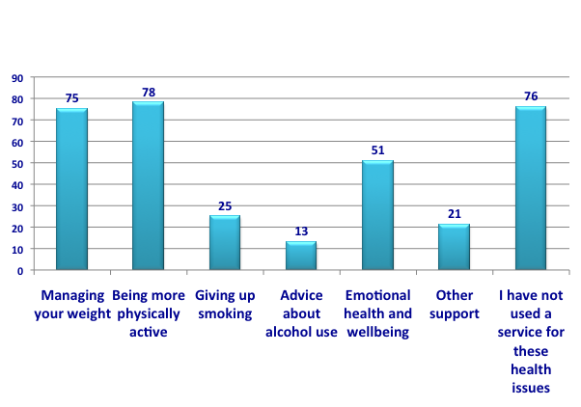

How did you access the service?
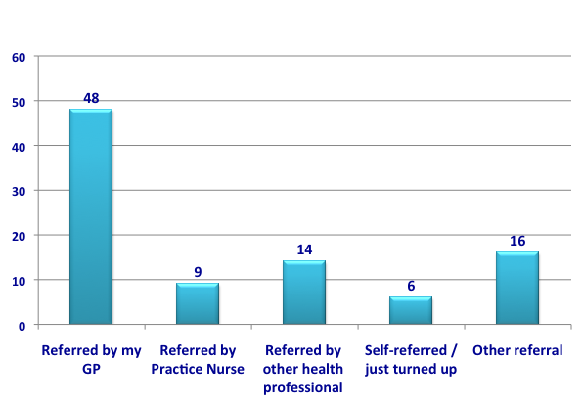

Do you have any comments about accessing services?
Positives
- It was easy and straightforward to access
- The team were really supportive
- The service is welcoming and people do not feel put under pressure
- You can just turn up
- The service is run at user-friendly times for those who work
Negatives
- More awareness for the service needs to be raised
- The waiting list for the gym was lengthy
- Could not get an appointment to help quit smoking
- Should not need to go through the same questions with the GP and then the service
- The Leisure Centre no longer offers evening sessions

Why did you access support at that time?
- Illness or new diagnosis - heart problems, osteoarthritis, diabetes, cancer, post traumatic stress
- To build up strength or prevent future health problems – avoid a knee replacement, avoid needing a wheelchair
- Needed support with full time carer role
- Recommended by a professional – GP, practice nurse
- Recommended by a friend or colleague
- Personal motivation – wanted to stop smoking, lose weight, feel healthier
- Cost and availability - the service was free and available

Did you complete the full course?
YES 87%
NO 13%

If not, why didn’t you didn't continue to attend?

- Work or family commitments
- Alternative - went to another gym
- Felt better and didn’t need to continue

What did you like about the service(s) you used?

- Individual support – one to one, tailor made, personal, focused on me
- The staff – friendly, knowledgeable, flexible, encouraging, non-judgmental, confidential
- Support of a peer group & the opportunity to meet other people
- Access – local, free, just turn up
- The results – improved my life, improved my mood, got me out of myself, produced great results, gained fitness, felt better

Was there anything about the service(s) which you feel could have been improved?

- Follow up - would have liked long-term support beyond the fixed course
- Access – longer opening hours, more days or times during the week, shorter waiting times
- Easier referral route
- More advertising to make people aware of the service
- More small groups and one-to-one sessions, more guidance on setting achievable goals

Where would like to access INFORMATION about healthy lifestyles?

- GP surgery
- On-line
- Pharmacy
- Place of work
- Other health or care settings
  - Midwife/Antenatal appointments
  - Children’s Centres
  - GP Clinics, home visits
  - Chiropractors, Chiropodists
  - Drop-in centres
  - A dedicated centre i.e. a health style hub within the velopark
- Community settings
  - Schools & Colleges
  - Health & Leisure Centres
  - Community Centres & community newsletters
  - Car parks & Toilets
  - Libraries, Citizens Advice Bureaux, Voluntary agencies
  - Council facilities
  - Supermarket notice boards, Bus billboards
  - Replace public adverts such as KFC with health lifestyle advice
- Information within the council tax post
- Media / technology
  - Local media (radio, newspaper and TV advertising)
  - Social media, smart phone app, Email
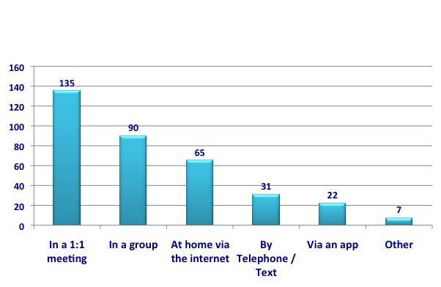
How would you prefer to receive SUPPORT with living a healthier lifestyle?

Comments

- It has to be on a 1:1 basis
- Online support is not enough to support behaviour change
- Some signposting to begin with as a first step for everyone, then more individualised support if required after this
- Ongoing support after the group sessions have finished
- The support needs to be tailored to the problem and the individual
- Text services are helpful to back up messages and motivate behaviour change
- People don’t want to spend any longer on their computer screens, they need to get out, meet new people, lose weight and get advice from other humans about mental and physical health issues.
- Information online can be confusing and inaccurate
- Face to face interactions are better, questions can be answered immediately
- In a group you get the help and support of other people around you
Has anything stopped you from accessing a service in the past?

- Problems with the referral
- Work commitments
- Caring responsibilities
- Poor health, disability
- Access, location - unable to travel / housebound, sessions were fully booked
- Awareness – didn’t know about the service
- Personal - lack of motivation, not accepting that I had a problem, denial

If you made a change in the past (eg. lost weight, walked more, took up cycling, made healthier meals) what motivated you to do it?

- Advice or support from a professional
- Prompting or support from family or friends
- Personal motivation
- Support from a peer group
- An upcoming event (eg. a wedding)
- Illness or being diagnosed with an illness
- Wanting to feel and look better and healthier
- For the future benefits – living longer, having a more active retirement, wanting to watch grandchildren grow up
- Finding that exercise or eating more healthily or giving up smoking made them feel better
- Life change (pregnancy, new baby, new relationship)
- See the impact of health problems/improved health in other people
- Having free, local access to health facilities

What is important to you about any type of support you or your family may receive?

- The personal approach - speaking to and having the support of an actual person
- Setting small goals
- Peer support group for motivation
- Easy access to dedicated professionals
- That it is delivered by the same person/people each time
- Evidence based, trained healthcare professionals
- Confidentiality, a supportive and non-judgmental approach
- Learning from others who are in a similar position
- Follow up on progress
- The whole family being engaged – it is difficult to eat healthily/give up alcohol/smoking if others in your family don’t change
- To feel I am speaking to someone who is real and in front of me and cares.

Do you have any other comments?

- There is plenty of information out there. Sometimes you need to be pointed in the right direction
- Signposting by other professional and organisations is vital as people will often need support and encouragement to make the first move
- It’s not information that people need, it is support
- Support needs to be specialised and tailored to support complex behaviour change, no one size fits all approach
- It is great to have all this information on line to supplement rather than take the place of face to face intervention. However people can not be motivated by a website like they can be face to face
- Whilst accessing information online is easy, actually being able to see someone, to talk things through and get more individualised support with change, is much more likely to result in change
- People have to really want to make changes in their current lifestyles. All the information in the world is useless if the person does not bother to follow through
- There is a big difference between knowing and doing. Most people know what behaviour is best for their health, but making changes and maintaining them is more challenging. Individual or group support with this is invaluable
- My GP & Practice Nurse… are the ones I trust to know what I am able to achieve… Very few people are motivated enough to seek out this sort of support for themselves - it HAS to be linked to the NHS in some way
- A wide variety of exercise options and locations for those in rural areas or who don't drive need to be offered

…………………………………………………..

Thank you to all who responded. The results of this survey will be used to inform the development of services for people in Torbay.

…………………………………………………..

