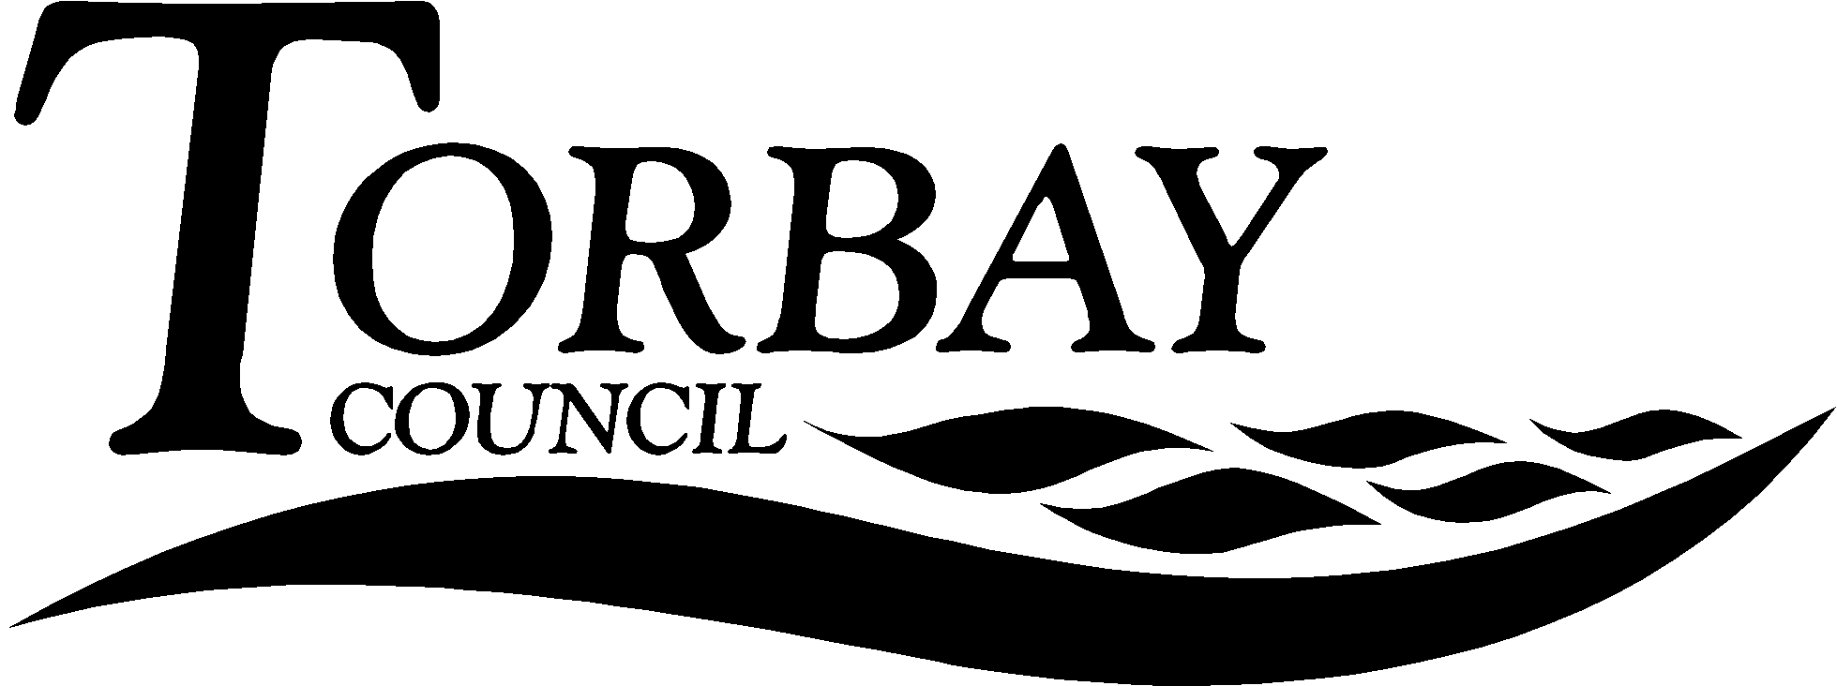

 | Title: RE Commission Response of Torbay SACRE
This report relates to the RE Council’s Commission on Religious Education in England. It looks at the call for evidence, which has a closing date of 13th February 2017 by 9 am. It encourages SACRE to make a response to the Commission before the closing date.
Wards Affected: |  | All
To: |  | SACRE | Date 1st February 2017
Contact Officer: |  | RE Adviser
Telephone: |  | 07855 235865
E.mail: |  | hampshireeducational@outlook.com

1. Key points and Summary

  - The purpose of this report is enable SACRE to make a formal response to the RE Council’s Commission on RE in England. There are two ways of making a response, either on-line or a written submission. This report recommends the use of the on-line consultation format. It also recognises that SACRE members and others can also make individual responses.

2. Introduction

2.1 SACRE received its first report on the Commission for RE in June 2016. SACRE resolved to participate in any consultation undertaken by the commission and wrote to the Commission inviting it to visit the South West as part of its evidence gathering. No response was received as to the request.

2.2 The Commission was appointed in the autumn term of 2016 and now has its own dedicated website, where full details of its staff, commissioners and its current work can be found, see: http://www.commissiononre.org.uk. The call for evidence was issued before the end of the Autumn term but its closing date is before the end of the Spring Half Term, thus causing some problems for some SACREs. Nevertheless, Torbay SACRE is in a strong position to complete the on-line call for evidence, of which a pdf version is attached as the Appendix to this report (see: http://www.commissiononre.org.uk/wp-content/uploads/2016/12/Call-for-evidence.pdf).

2.3 Members of SACRE can, of course, submit their own evidence and members of the National Association of RE Teachers (NATRE) have been encouraged to. SACRE members should be aware that at least one of the Commissioners has been public about their own position on matters relating to the definition of RE and to the state of SACRE’s on Twitter and may wish to take this matter up with the Commission in relation to impartiality and prejudice.

3.0 Recommendation

  - That SACRE complete the on-line consultation on the RE Council’s Commission on RE in England’s website.

  - That SACRE encourage others to complete that same consultation by 13th February 2017, by 9 am on that date.

Andrew Strachan
Chair of SACRE

Appendices

Commission on Religious Education Call for Evidence (pdf. version of the on-line form)

Documents available in members’ rooms

Background Papers:

Religious Education in English Schools, Department for Education 2010
Torbay Agreed Syllabus 2015

