ROAD CASUALTY
REDUCTION REPORT 2015

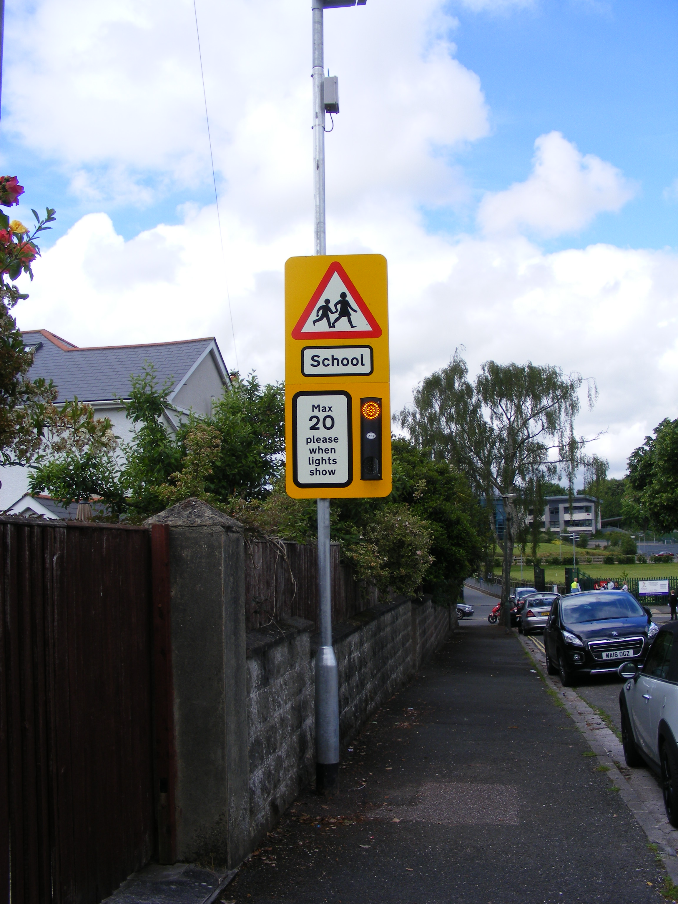



Community & Customer Services

Lower Ground Floor

Town Hall
Torquay
TQ1 3DR

- INTRODUCTION

  - This report highlights the road casualty and collision data for the Torbay area during the calendar year 2015. Torbay Council’s proposals for improving road safety for the next year are identified in the Torbay Council Road Safety Strategy 2012 - 2020, however, this report highlights in more detail the activities for 2016.

2 TORBAY’S TARGETS

2.1 In March 2000 the Government announced new targets for reducing casualties nationally. The targets are the percentage reductions to be achieved by 2010 compared with the average results for the base years, 1994 – 1998. The targets set by the Government were as follows:

- 40% reduction in the number of people killed or seriously injured in road crashes/collisions;

- 50% reduction in the number of children killed or seriously injured;

- 10% reduction in the slight casualty rate, expressed as the number of people slightly injured.

2.2 In 2011 and for the years ahead, it is the intention for the development and implementation of local road safety strategies to enhance road safety delivery by focussing on casualty reduction with objectives and targets to support that aim and programmes planned to achieve that, thus improving casualty reduction.

The development of a local road safety strategy is included within the new Local Transport Plan 3 (2012 – 2020), to ensure greater reductions in road casualties locally by:
- Encouraging better and co-ordinated working between local authorities and their partners;
- Enabling local authorities to consider their future priorities;
- Involving and informing the public.

Road Safety is of paramount importance to both the Council and the residents it serves. Road safety issues are wide ranging and sometimes complex, but the Council has a good record in improving road safety for all transport users. A mixture of education, encouragement, enforcement and engineering alongside evaluation will be used to further improve the safety of all road users.

An evidence based approach to road safety education and engineering will be used in Torbay to identify and target investment where it is most needed. This will be led by the new Road Safety Plan, which was approved by members of the Transport Working Party at their meeting on 25th April 2013. The new Road Safety Plan reflects local road safety requirements, taking into account the most up-to-date Government recommendations, guidance, targets and strategy.

Unlike in the period up to 2010, the Department for Transport (DfT) have not set any targets for us to compare our results against.

However the Dft published its Strategic Framework for Road Safety (May 2011) which is designed to help Government, local organisations and citizens to monitor the progress in improving road safety.

The DfT have identified 6 key indicators which relate to road deaths and will measure the key outcomes of the strategy at national level. These are:

- Number of road deaths (and rate per billion vehicle miles)
- Rate of motorcyclist deaths per billion vehicle miles
- Rate of car occupant deaths per billion vehicle miles
- Rate of pedal cyclist deaths per billion vehicle miles
- Rate of pedestrian deaths per billion miles walked
- Number of deaths resulting from collisions involving drivers under 25.

At a local level, such as here in Torbay, the number of road deaths is small and subject to fluctuation. For this reason the DfT propose the following as key indicators:

- Number of killed or seriously injured casualties
- Rate of killed or seriously injured casualties per million people
- Rate of killed or seriously injured casualties per billion vehicle miles

The progress will be reported annually, with details published in ‘Reported Road Casualties Great Britain’.

This will enable local authorities to consider their future priorities, whilst involving and informing the public of what action is taken.

Here in Torbay, we will also to continue to report casualty figures each year as part of the Road Casualty Reduction Report and the figures for the following categories can be found displayed in section 3 of this report.

- Fatal
- Killed and seriously injured
- Killed and seriously injured (0 – 15 years-old)
- Slightly injured
- Slightly injured (0 – 15 years old)

3 CASUALTY AND COLLISION DATA

3.1 The graphs below outline the road casualty and collision data for the years 1998 to 2015 compared against the government targets (where applicable).

3.2 Fatalities

Fig 1 shows the number of fatalities that have occurred within Torbay
We are pleased to report that the results show no fatalities on Torbay roads in 2015, which is a decrease on the previous year. The average figures remain at a consistent overall level, since the 1998 to 2010 targets were introduced.

Torbay Council continues to work from very low base figures and continues to have one of the safest road networks within the South West. The authority benchmarks with other highway authorities and the number of road traffic casualties expressed as a percentage of the population is amongst the lowest in the south west.

3.3. Killed and Seriously Injured (KSI’s) (all age groups)

Fig 2 shows the number of people killed or seriously injured within Torbay.

For the second year in succession there has been a reduction of the numbers of killed and seriously injured, the results for 2015 show there has been a 9% decrease in the number of killed and seriously injured since last year.

Torbay Council continues to work from very low base figures and significant reductions can be very hard to identify, further details on reviewing collision cluster sites are included in section 5.3.

3.4 Killed and seriously injured (0 – 15 age group)

Fig 3 shows the number of 0-15’s killed or seriously injured within
The results show there has been no change in the number of killed and seriously injured casualties (0-15 age group) over the past year, remaining at 3 casualties.

Analysis shows that all of these casualties were pedestrians.

Continued targeting of road safety education to this age group will take place as part of our ‘Learn to Live’ and teenage road safety weeks.

Bikeability training will continue, whilst a successful bid to the Department for Transport (DfT) has recently accessed additional funding, allowing the authority to undertake Schools Action Travel planning. This has included the preparation of school maps showing 5 minute and 10 minute walk zones, scooter training and the provision of scooter pods at schools for storage; as well as the setting up of a number of ‘Park ‘n Stride’ schemes for schools (e.g. Cockington, Curledge, Roselands and Upton St James schools).

3.5 Slight Injuries

Fig 4 shows the slight injuries for all ages and the 0-15’s within Torbay
All ages
The results show slight injury casualties up slightly by 4% to 334, however our figures continue to show a downward trend from the 1988 baseline of 445, with a current reduction of 25%.

Children (0-15 age group)
There has been a 4% decrease in child slights for 2015 and provisional analysis shows that 43% of these casualties were pedestrians, 18% front seat passengers, 35% rear seat passengers and 4% cyclists.

4 PLANNED ROAD SAFETY CAMPAIGNS 2015

4.1 A list of the road safety campaigns which will be undertaken by the Road Safety Team during 2016 will be published on the website. Wherever possible, the local media (newspaper, radio and TV) will assist and are key to getting the message across to the target audience. The team continue to have a good working relationship with the media and enjoy a high profile, with positive stories being run and picked up by both local and national newspapers and television.

Road safety education will continue to be delivered in accordance with the Road Safety Strategy 2012/2020. However, collision data for the last three years is currently being analysed to establish the road users most at risk in relation to age and sex so that campaigns can be tailored to this priority. The budget for road safety education for 2016/17 is £15,500.

5 PLANNED EXPENDITURE OF FUNDING FOR ROAD SAFETY INITIATIVES

5.1 Contained within the Local Transport Plan 2011 – 2016 are the budgets for carrying out all Road Safety initiatives. This information is shown under the following headings:

Road safety initiatives (Safer routes)

The budget will be agreed as part of the Council’s Capital Budget setting process for 2016/17.

TRAFFIC ACTION ZONE

The Local Transport Plan 3 (2011 – 2016) has identified the continued provision of funding from the capital programme for Traffic Action Zones.

The objective of the projects was to enable communities to become involved with the re-design of their streets to reduce vehicle speeds and provide safer / better access to the schools and other facilities within the TAZ.

The Coombe Pafford and Hele Traffic Action Zone was implemented during 2013/2014 and there has been no funding identified for Traffic Actions Zones in either the 2014 / 2015, 2015 / 2016 or 2016 / 2017 financial years.

  - ROAD SAFETY INITIATIVES

With the implementation of various road safety schemes over the thirteen years since Torbay became a unitary authority, there are now very few obvious ‘traditional’ collision cluster areas which can be identified. This means that the law of diminishing returns applies to any schemes implemented. However, engineering measures are an important part of the Council’s strategy in reducing collisions. The Council will continue with its Safer Journeys programme and will carry out a review of accidents to identify any linear routes which have a higher than normal collision record. Further details of the engineering measures to be carried out in 2016/17 will be presented to the Transport Working Party in the Road Safety Initiatives Report.

5.4 PENINSULAR ROAD SAFETY PARTNERSHIP

Torbay Council continues to work closely with the Police to ensure enforcement is a key activity in road casualty reduction. The Council also works with the Peninsular Road Safety Partnership (formerly known as the Devon and Cornwall Safety Camera Partnership) to use camera enforcement and education to reduce speeds and red light violation.

Once again there will be decreased funding for the operation of Safety Cameras in 2016/17, however the operation and enforcement of the fixed safety camera sites within Torbay will continue.

The authority will continue to work closely with the partnership to ensure that mobile safety camera activity is targeted at those locations where speed related problems continue in an effort to increase the visibility of enforcement.

Brixham continues to operate a Community Speed Watch initiative which works in partnership with, and uses the combined efforts of, the local residents and is supported by both the Police and the Peninsular Road Safety Partnership.

Community Speed Watch is a scheme to help people reduce speeding traffic though their community. The scheme enables volunteers to work within their community to raise awareness of the dangers of speeding and to help control the problem locally. The use of the radar devices to record vehicle speeds will not lead to prosecution; drivers will get a letter from the police instead, but will help to underline the community’s commitment to reducing speed.

