TORBAY LOCAL PLAN
A landscape for success
The Plan for Torbay – 2012 to 2032 and beyond
PROPOSED SUBMISSION PLAN (FEBRUARY 2014)

SUMMARY OF SUSTAINABILITY APPRAISAL OF PROPOSED ADDITIONAL SITES WITH POTENTIAL FOR DEVELOPMENT TO BE INCLUDED AS PROPOSED MAIN MODIFICATIONS TO THE LOCAL PLAN

Torbay Council - February 2015
Contents
Summary of Sustainability Appraisal of Proposed Additional Sites 3
1. Land South of White Rock (Future Growth Area) Paignton 3
2. Sladnor Park, Torquay (SHLAA Site No.13037) 4
3. Victoria Car Park, Paignton (SHLAA Site No.T787) 5
4. Station Lane/Great Western Car Park, Paignton (SHLAA Site No. H1:014) 6
5. The Terrace Car Park, Torquay (SHLAA Site No. HC090) 6
6. Lower Union Lane Car Park and Temperance Street Car Park, Torquay (SHLAA Site Nos. T782, 13228 and TM003) 6
7. Paignton Harbour Car Park, Paignton (SHLAA Site No. T857) 7
8. Churchward Road Car Park, Paignton (SHLAA Site No. HC232) 8
9. Preston Gardens Car Park, Paignton (SHLAA Site No. HC239) 8
10. Sheddon Hill Car Park, Torquay (SHLAA Site No. HC076) 8
11. Brunswick Square Car Park, Torquay (SHLAA Site No. HC105) 9
12. Meadfoot Road Car Park, Torquay (SHLAA Site No. HC156) 9
13. Chilcote Close Car Park, Torquay (SHLAA Site No. HC062) 10
14. Steps Cross Playing Field, Torquay 10
15. Shoalstone Overflow Car Park, Brixham (SHLAA Site No. T816) 11
16. St Mary’s Road, Brixham 12
17. Town Hall Car Park, Torquay (SHLAA Site No. TM001) 12
Maps showing the Location of Proposed Additional Sites with Potential for Development 14

Summary of Sustainability Appraisal of Proposed Additional Sites

Land South of White Rock (Future Growth Area) Paignton
The site could provide approximately 355 new homes that can incorporate a mix of dwelling types and tenures to encourage mixed communities as well as providing a range of facilities locally. Development on greenfield sites should be capable of meeting requirements for affordable housing provision and is likely to reduce poverty. There is also an opportunity to design out crime within residential and employment layouts. The site will provide infrastructure including green infrastructure and could encourage healthier lifestyles through well designed urban environments that encourage cycling and walking.

Development of the site could provide short-term construction jobs. The area is connected by public transport and within close proximity to other key services, and therefore could reduce the need to travel by car. Any education facilities required to serve this new housing could be provided within the wider Strategic Delivery Area.

Development of the site will involve loss of greenfield land. It could also result in loss of large areas of Grade 1, 2 and 3a agricultural land (excellent, very good and good).The whole area is within cirl bunting 2km foraging/feeding zone and the south west part is within 250m buffer zone. It is also within a greater horseshoe bat sustenance zone. Manor Farm LWS is adjacent to the south west edge of the site and protected species have been recorded within the site.

The site lies within AGLV and it is highly sensitive to change, although parts of the southern area are slightly less sensitive due to visual contaminant. Most of the site is open to views from the South Devon AONB to the west and south. The site is not within a flood risk area; however Galmpton Watercourse (main river) is adjacent to the southern edge of the site. The predominant historic character of the area is post-medieval enclosures, Barton fields and modern enclosures adapting medieval fields.

Overall energy use will increase through growth, however new development offers the opportunity to incorporate extensive energy efficiency and micro renewable measures. To be effective in the longer term micro renewable measures will need to be designed at neighbourhood scale. There are some potentially substantial pressures on water resources, although there is potential to mitigate by designing in water efficiency measures. Waste creation will increase overall with an increase in households but new development should provide the opportunity to design in resource efficiency measures. Development of the area could cause light pollution.

Recommendations
- GHB survey will be required and mitigation measures to reduce negative impact on bats should be implemented;
- A survey would be required to ascertain the presence of cirl buntings and to inform suitable mitigations;
- High quality agricultural land should be excluded from the development site;
- Proposed development should be achieved through a combination of careful sitting with strong screen planting and the reinforcement of existing field hedgerow boundaries;
- Development and associated infrastructure should not increase run off to Galmpton watercourse. Introduction of SUDS in new development should help to minimise the risk of flooding.

Sladnor Park, Torquay (SHLAA Site No.13037)
The site could provide approximately 25 new homes that can incorporate a mix of dwelling types and tenures to encourage mixed communities as well as providing a range of facilities locally. However, introduction of this number of dwellings would result in loss of greenfield land and could increase the need to travel. Development of the sites should be capable of meeting requirements for affordable housing provision and could provide short-term construction jobs and infrastructure, including green infrastructure.

There is an end of a greater horseshoe bat flyway at the north of the site and the whole site lies within a 2km cirl bunting buffer zone. Part of the site is designated as CWS.

The site lies within an area classified as AGLV and Coastal Preservation Area. It is considered to be of high sensitive landscape value, the eastern part of which is more sensitive due to its relationship to the Coastal Plateau. There is a small area of flood risk to the east of the site and therefore development of the site could potentially contribute to surface water flooding.

Recommendations
- Development and associated infrastructure should not increase runoff;
- Introduction of SUDS in new development should help to minimise the risk of flooding;
- A survey would be required to ascertain the presence of bats and cirl bunting and inform suitable mitigation measures and other biodiversity enhancements;
- Any changes to the landscape should be only limited in nature, and strictly controlled to ensure that the secluded character of the area and setting of the area is not harmed. Infilling should be resisted;
- Measures to prevent water pollution should be implemented.

Victoria Car Park, Paignton (SHLAA Site No.T787)
The site could achieve 60 dwellings. It should be capable of meeting requirements for affordable housing provision. It could provide a mix of residential and commercial development and therefore would create permanent job opportunities. However, the site is located in a Core Tourism Investment Area.

The site is fairly accessible and could encourage healthier lifestyles through well designed urban environments that encourage cycling and walking. Any education facilities required to serve this new housing could be provided within the wider Strategic Delivery Area.

The site is brownfield land within the urban area and therefore would not negatively affect biodiversity. However, it is located within a flood risk area.

Recommendations
- Development and associated infrastructure should not increase risk of flooding;
- Introduction of SUDS in new development should help to minimise the risk of flooding;
- Measures to prevent water pollution should be implemented.

Station Lane/Great Western Car Park, Paignton (SHLAA Site No. H1:014)
The site could achieve up to 35 high density developments. It should be capable of meeting requirements for affordable housing provision and could provide short-term construction jobs. The site is fairly accessible and could encourage healthier lifestyles through well designed urban environments that encourage cycling and walking. Any education facilities required to serve this new housing could be provided within the wider strategic delivery area.

The site is brownfield land within the urban area and therefore would not negatively affect biodiversity. However, it is adjacent to a flood risk area.

Recommendations
- Development and associated infrastructure should not increase risk of flooding;
- Introduction of SUDS in new development should help to minimise the risk of flooding;
- Measures to prevent water pollution should be implemented.

The Terrace Car Park, Torquay (SHLAA Site No. HC090)
The site could provide approximately 20 homes with a mix of other uses. It would meet the requirement for affordable housing provision as well as a range of local facilities and will create permanent job opportunities. It could also encourage healthier lifestyles through well designed urban environments that encourage cycling and walking. The site is well connected by public transport and other key services, and therefore could reduce the need to travel by car. Development of the site will involve redevelopment of a brownfield land and therefore will not negatively affect biodiversity or sensitive landscapes.

Recommendations
- Measures to prevent water pollution should be implemented.

Lower Union Lane Car Park and Temperance Street Car Park, Torquay (SHLAA Site Nos. T782, 13228 and TM003)
Town centre site with good service and local amenities, suitable for high density development. The site could provide approximately 100 homes with a mix of other uses. It would meet the requirement for affordable housing provision as well as a range of local facilities and will create permanent job opportunities. It could also encourage healthier lifestyles through well designed urban environments that encourage cycling and walking. The site is well connected by public transport and other key services, and therefore could reduce the need to travel by car.

Development of the site will involve redevelopment of a brownfield land and therefore will not negatively affect biodiversity or sensitive landscape. Some part of the site is within a flood risk area.

Recommendations
- Measures to prevent water pollution should be implemented.
- Introduction of SUDS in new development should help to minimise the risk of flooding.

Paignton Harbour Car Park, Paignton (SHLAA Site No. T857)
The site could achieve up to 50 residential units in a high density development. It should be capable of meeting requirements for affordable housing provision and could provide short-term construction jobs. However, the site is located within a Core Tourism Investment Area.

The site is fairly accessible and could encourage healthier lifestyles through well designed urban environments that encourage cycling and walking. Any education facilities required to serve this new housing could be provided within the wider strategic delivery area.

The site is brownfield land within the urban area and therefore would not negatively affect biodiversity. The site is adjacent to Paignton Harbour and Roundham Head SSSI and also adjacent to a flood risk area.

Recommendations
- Development and associated infrastructure should not increase risk of flooding;
- Introduction of SUDS in new development should help to minimise the risk of flooding;
- Measures to prevent water pollution should be implemented.

Churchward Road Car Park, Paignton (SHLAA Site No. HC232)
The site could achieve up to15 residential units in a high density developments. It should be capable of meeting requirements for affordable housing provision and could provide short-term construction jobs. The site is fairly accessible and could encourage healthier lifestyles through well designed urban environments that encourage cycling and walking. Any education facilities required to serve this new housing could be provided within the wider Strategic Delivery Area.

The site is brownfield land within the urban area and therefore would not negatively affect biodiversity. However, it is located within a flood risk area.

Recommendations
- Development and associated infrastructure should not increase risk of flooding;
- Introduction of SUDS in new development should help to minimise the risk of flooding;
- Measures to prevent water pollution should be implemented.

Preston Gardens Car Park, Paignton (SHLAA Site No. HC239)
The site is brownfield land within the urban area The site lies within a walking distance from a local centre and therefore would not negatively affect biodiversity. However, it is located within flood risk area and close to Occombe Valley watercourse. Increased hard surface in the area could increase the risk of flooding.

Recommendations
- Development and associated infrastructure should not increase runoff to watercourse;
- Introduction of SUDS in new development should help to minimise the risk of flooding;
- Measures to prevent water pollution should be implemented.

Sheddon Hill Car Park, Torquay (SHLAA Site No. HC076)
The site will provide approximately 50 homes. It would meet the requirement for affordable housing provision as well as a range of local facilities. It could also encourage healthier lifestyles through well designed urban environments that encourage cycling and walking. The site is well connected by public transport and other key services, and therefore could reduce the need to travel by car.

Development of the site will involve redevelopment of brownfield land and therefore will not negatively affect biodiversity or sensitive landscape. There is a flood risk area in close proximity to the south and south west of the site. Introduction of SUDS in new development should help to minimise the risk of flooding.

Recommendations
- Measures to prevent water pollution should be implemented.

Brunswick Square Car Park, Torquay (SHLAA Site No. HC105)
The site is an important car park for local businesses with good service and local amenities, suitable for high density development. The site will provide approximately 30 homes. It would meet the requirement for affordable housing provision. It could also encourage healthier lifestyles through well designed urban environments that encourage cycling and walking. The site is well connected by public transport and other key services, and therefore could reduce the need to travel by car.

Development of the site will involve redevelopment of brownfield land and therefore will not negatively affect biodiversity or sensitive landscape. The eastern part of the site is adjacent to flood risk zone and therefore Introduction of SUDS in new development should help to minimise the risk of flooding.

Recommendations
- Measures to prevent water pollution should be implemented.
- Introduction of SUDS in new development should help to minimise the risk of flooding.

Meadfoot Road Car Park, Torquay (SHLAA Site No. HC156)
The site will provide approximately 20 homes. It would meet the requirement for affordable housing provision as well as a range of local facilities. It could also encourage healthier lifestyles through well designed urban environments that encourage cycling and walking. The site is well connected by public transport and other key services, and therefore could reduce the need to travel by car.
Development of the site will involve redevelopment of brownfield land and therefore will not negatively affect biodiversity or sensitive landscape. There is a flood risk area in close proximity to the north of the site. Introduction of SUDS in new development should help to minimise the risk of flooding.

Recommendations
- Measures to prevent water pollution should be implemented.

Chilcote Close Car Park, Torquay (SHLAA Site No. HC062)
The site would provide approximately 10 new homes that can incorporate a mix of dwelling types and tenures to encourage mixed communities. However it is unlikely to meet the requirements for affordable housing provision and could provide short-term construction jobs.

The site should provide infrastructure including green infrastructure and could encourage healthier lifestyles through well designed urban environments that encourage cycling and walking. Any education facilities required to serve this new housing could be provided within the wider strategic delivery. The site is within a close proximity to key services and therefore could reduce the need to travel by car.

The site is brownfield land within the built up area. Development is unlikely to cause adverse impact on biodiversity or landscape.

Recommendations
- Measures to prevent water pollution should be implemented.

Steps Cross Playing Field, Torquay
The site will provide approximately 70 new homes that can incorporate a mix of dwelling types and tenures to encourage mixed communities as well as providing a range of facilities locally. Development on greenfield sites should be capable of meeting requirements for affordable housing provision and could provide short-term construction jobs. The site should provide infrastructure including green infrastructure. Development of the site would reduce the amount of playing field available in the area. Any education facilities required to serve this new housing could be provided within the Wider Strategic Delivery Area. Development of greenfield land could increase the need to travel, however the site is well connected by public transport and other key services, and therefore could reduce the need to travel by car.

The whole site lies within a 2km cirl bunting foraging/feeding zone. Development of the site will involve loss of greenfield land that is designated in the Local Plan (Policy C5) as an ULPA. River Fleet (ordinary watercourse) runs to the west of the site and therefore development could potentially contribute to surface water flooding.

Recommendations
- Development and associated infrastructure should not increase runoff to River Fleet;
- Introduction of SUDS in new development should help to minimise the risk of flooding;
- A survey would be required to ascertain the presence of cirl bunting and inform suitable mitigation measures and other biodiversity enhancement.

Shoalstone Overflow Car Park, Brixham (SHLAA Site No. T816)
The site could achieve up to 6 dwellings. It is unlikely to meet the requirements for affordable housing provision and could provide short-term construction jobs. The site is fairly accessible and should provide infrastructure and could encourage healthier lifestyles through well designed urban environments that encourage cycling and walking. Any education facilities required to serve this new housing could be provided within the wider Strategic Delivery Area.

The site is brownfield land within the urban area, however the site is within a GHB sustenance zone and adjacent to Berry Head SAC and Berry Head Farm OSWI. The site is within flood risk area.

Recommendations
- GHB survey will be required.
- Development of the site should not compromise the adjacent historic site.
- Development and associated infrastructure should not increase risk of flooding;
- Introduction of SUDS in new development should help to minimise the risk of flooding;
- Measures to prevent water pollution should be implemented.

St Mary’s Road, Brixham
The site will provide approximately 50 new homes that can incorporate a mix of dwelling types and tenures to encourage mixed communities as well as providing a range of facilities locally. Development of the site should be capable of meeting requirements for affordable housing provision and could provide short-term construction jobs. The site should provide infrastructure including green infrastructure and could encourage healthier lifestyles through well designed urban environments that encourage cycling and walking. Any education facilities required to serve this new housing could be provided within the wider Strategic Delivery Area. Although the site is within a close proximity to the southern edge Brixham; access to the site is restricted.

The site lies in an area with multiple environmental constraints. It lies within South Devon AONB, a GHB sustenance zone and flyways, the site whole lies within 2km cirl bunting buffer zone. Development of the site will involve loss camping site. Any change or development would be highly visible from the surrounding area. Generally the site considered to be highly sensitive. The site itself is not located in a surface water flood risk area.

Recommendations
- GHB survey would be required;
- A survey would be required to ascertain the presence of cirl bunting and inform suitable mitigation measures.

Town Hall Car Park, Torquay (SHLAA Site No. TM001)
Town centre site with good service and local amenities, suitable for high density development. The site could provide approximately 50 dwellings with a mix of other uses. It would meet the requirement for affordable housing provision as well as a range of local facilities and will create permanent job opportunities. It could also encourage healthier lifestyles through well designed urban environments that encourage cycling and walking. The site is well connected by public transport and other key services, and therefore could reduce the need to travel by car.

Development of the site will involve redevelopment of a brownfield land and therefore will not negatively affect biodiversity or sensitive landscape. Most of the site is within a flood risk area.

Recommendations
- Measures to prevent water pollution should be implemented.
- Introduction of SUDS in new development should help to minimise the risk of flooding

Maps showing the Location of Proposed Additional Sites with Potential for Development
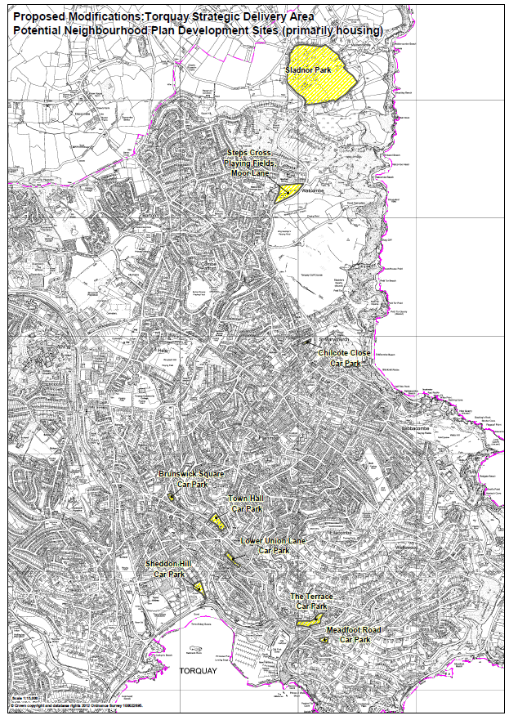
Figure 1: Torquay Sites

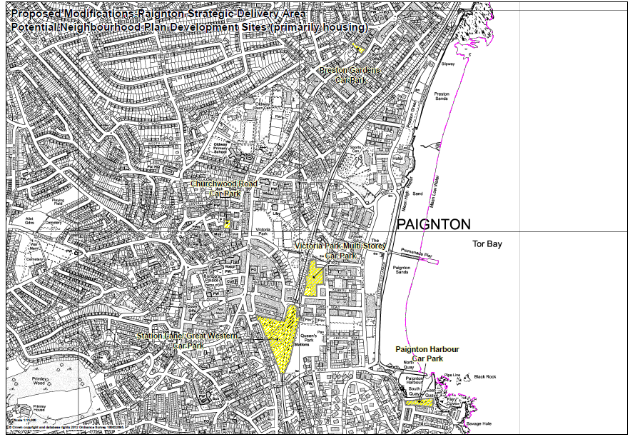

Figure 2: Paignton Sites
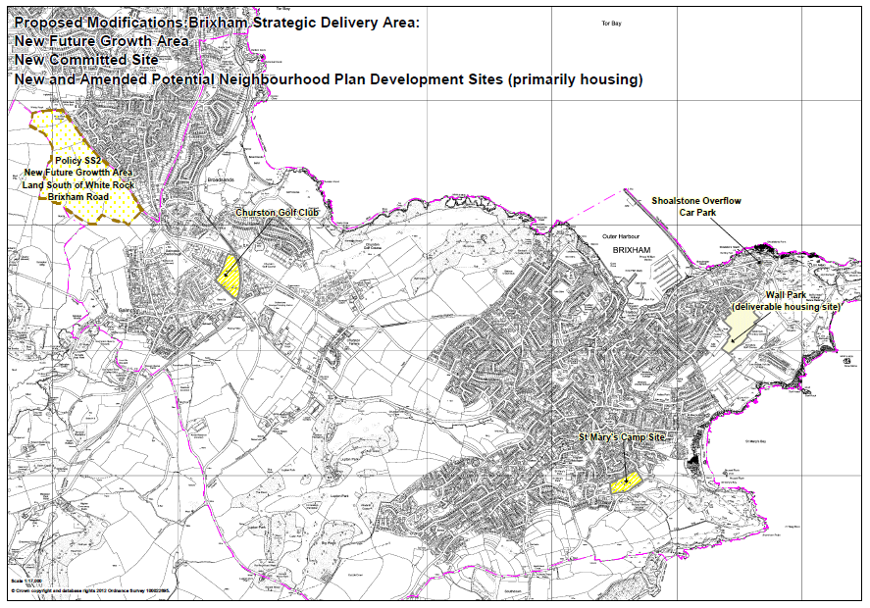
Figure 3: Brixham Sites

