 | Please reply to: Anne-Marie-Bond  Executive Head – Corporate & Business
 | Services, Town Hall, Castle Circus,
 | Torquay, TQ1 3DS
Mr & Mrs Penner  11 Sandringham Drive  Paignton  Devon  TQ3 1HU | My ref:
 | Your ref:
 | Telephone: | 01803 207160
 | Fax:
 | E-mail: | Anne-marie.bond@torbay.gov.uk
 | Date: | 16 September 2016

To request a copy in another format or language phone 01803 208973

Dear Mr & Mrs Penner

Re: Covenant Petition - 9 Sandringham Drive, Paignton

I write in response to your petition submitted to Governance Support in relation to the covenants on the Land Registry title of 9 Sandringham Drive. I apologise for the delay in responding to you.

The Council and the TDA is aware the matter in question is a contentious issue locally, to the extent that it was discussed at a recent Strategic Land Task Group meeting attended by senior officers of the Council, TDA and Councillors, including the Executive Lead for Business Services. At that meeting instruction was issued to the TDA to seek further legal advice with regard to releasing the covenant. This advice has now been obtained.

After due consideration of this advice, the Council has decided on this occasion not to take any action with the covenant either to enforce or release, on the title of 9 Sandringham Drive. This is primarily because i) planning permission for the development has been granted, and (ii) the Council believes it is not wholly within their gift to release the covenant, and (iii) the Council cannot see any grounds on which the proposed development is contrary to the wider public interest.

Clearly this decision will not affect your ability to obtain your own independent advice in this matter.

Yours sincerely
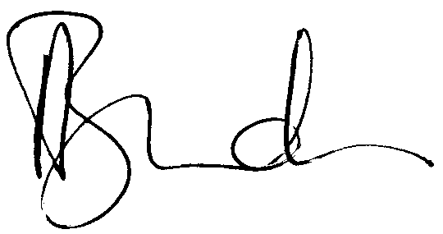

Anne-Marie Bond
Assistant Director – Corporate & Business Services

Cc Human Resources

