How to Apply for a Private Hire Vehicle and Operators Licence

1
To start, please log onto the web address – www.torbay.gov.uk/taxis then select the ‘Licensing Public Registers’ tab.

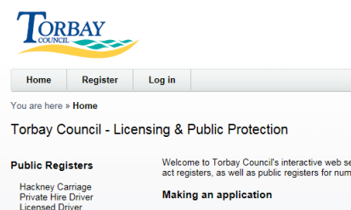
2
Next, Log into your online account using your registered email address and password.

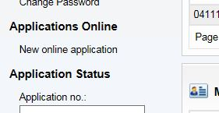
To make an application, click ‘NEW ONLINE APPLICATION’.
3

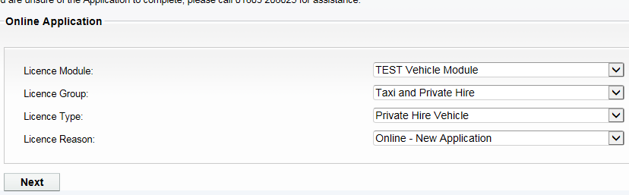
Now select the following options:-
Licence Module = VEHICLE MODULE
Licence Group = TAXI & PRIVATE HIRE
Licence Type = PRIVATE HIRE VEHICLE
Licence Reason = ONLINE – NEW APPLICATION
4

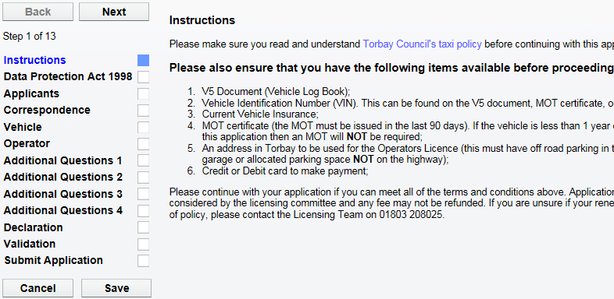
5
When you have the documents ready, click ‘NEXT’.
Please read the instructions of what you will need to complete this application.

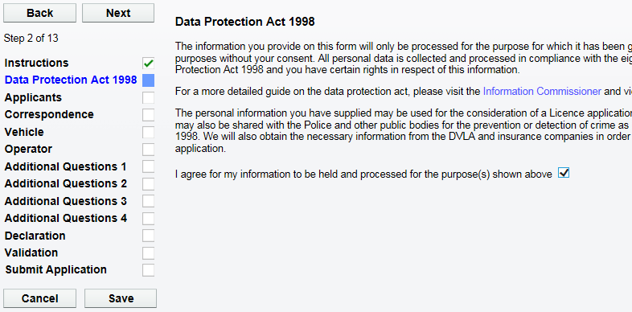
6
Please now agree to the Data Protection agreement by ticking this box.
Now click ‘NEXT’ to proceed.

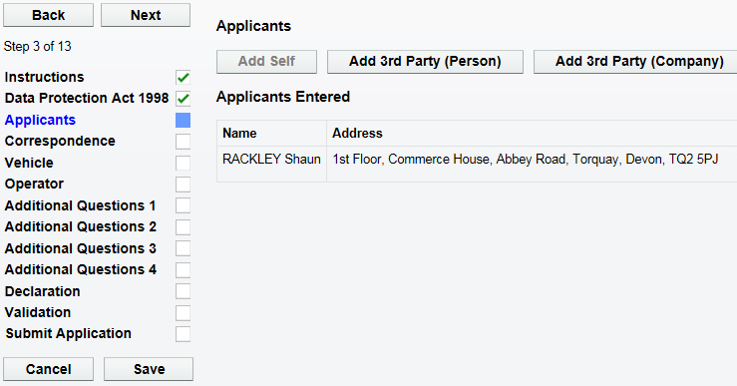
7
Now you will find your personal details. DO NOT change these.
Now click ‘NEXT’ to proceed.

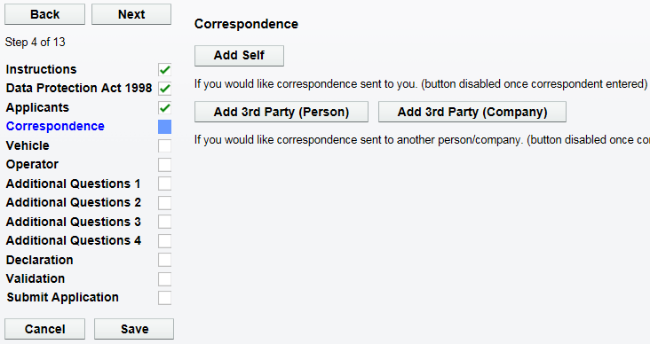
Next click ‘ADD SELF’ to add your correspondence details.

8
Now click ‘NEXT’ to proceed.

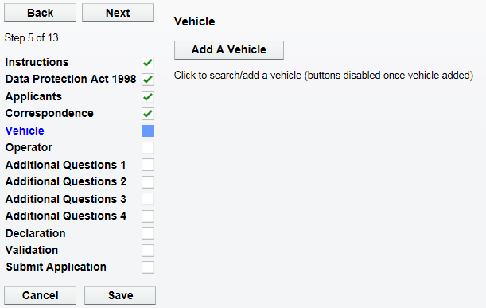
9
Now click ‘ADD A VEHICLE’ to add the NEW vehicle.

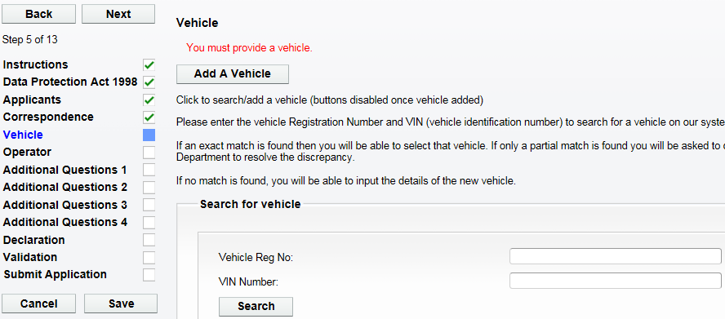
10
Next, add the NEW vehicle Registration Number and VIN Number in these boxes.
Now click ‘SEARCH’.

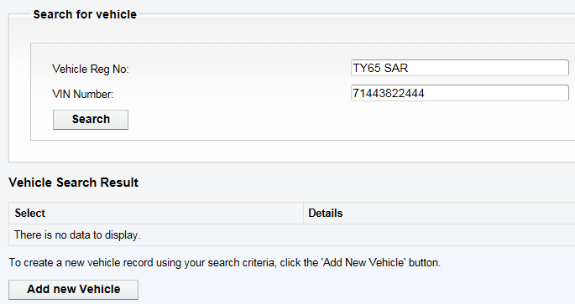
11
After entering the Vehicle Registration Number and VIN Number, You will either find the vehicle on our database, or have to create a new vehicle.

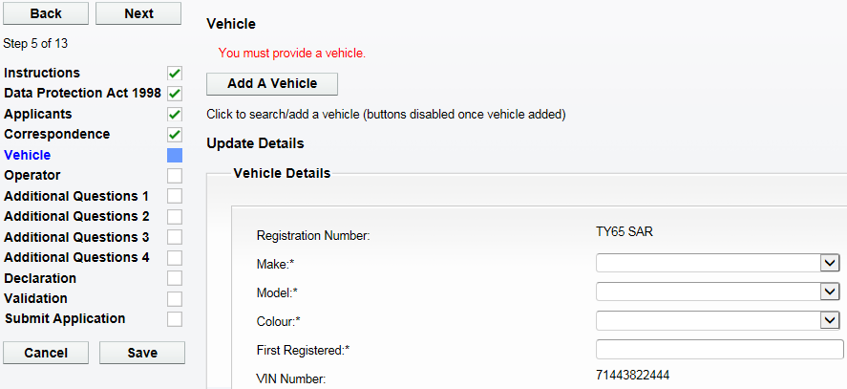
If creating a new vehicle, enter all the NEW vehicle details here.
12
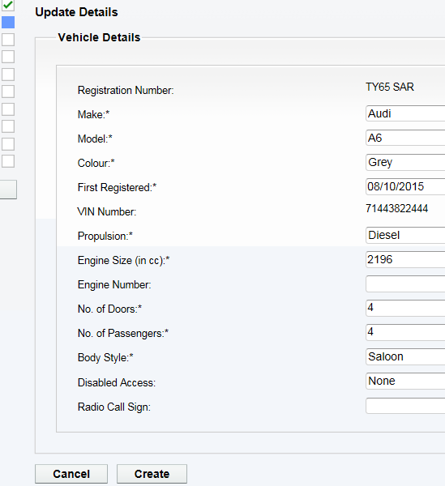
When all the details have been entered, click ‘CREATE’.
13

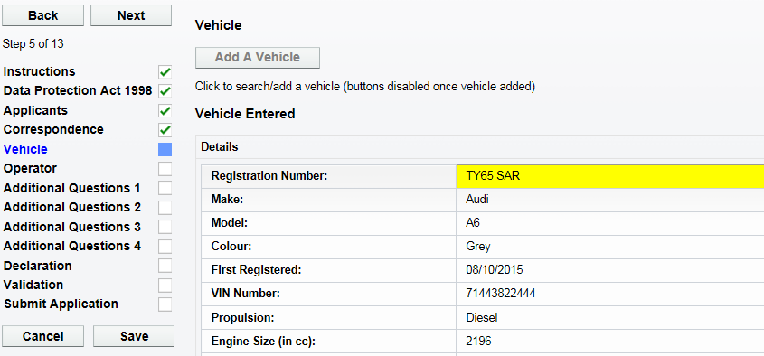
14
You will now be taken back to the vehicle screen and the NEW vehicle will be shown here.
Now click ‘NEXT’ to proceed.

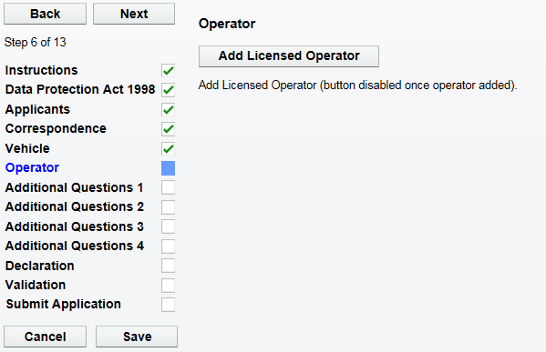
15
Now click ‘ADD LICENSED OPERATOR’.

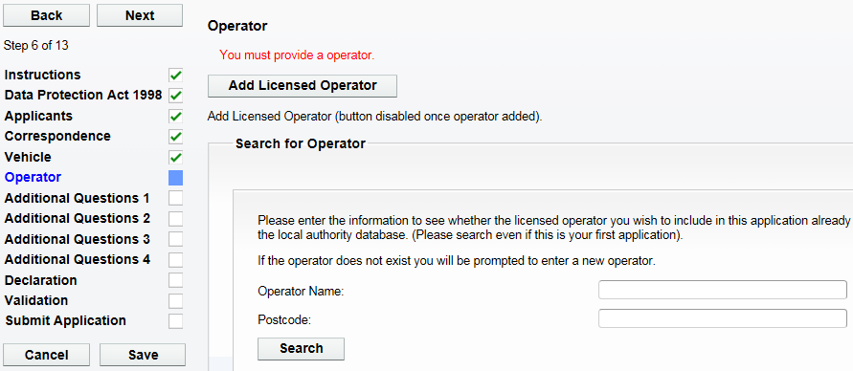
Next, add your FULL NAME and OFF ROAD PARKING POSTCODE in these boxes.
Now click ‘SEARCH’.
16

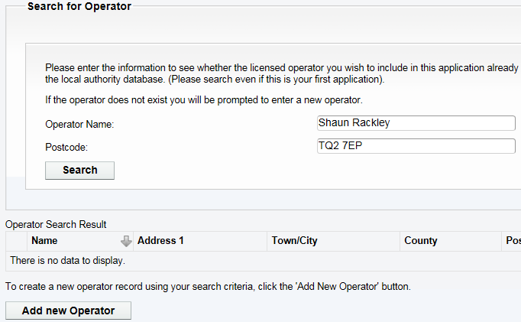
After entering your Full Name and Off Road Parking Postcode, You will either find the address on our database, or have to create a new operators address.
17
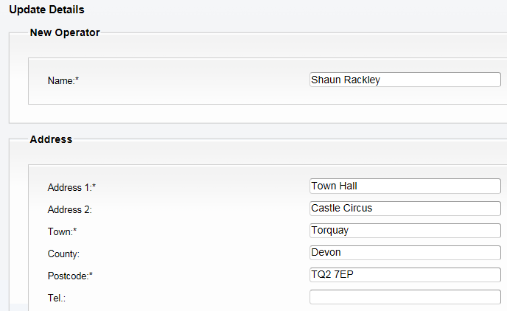
18
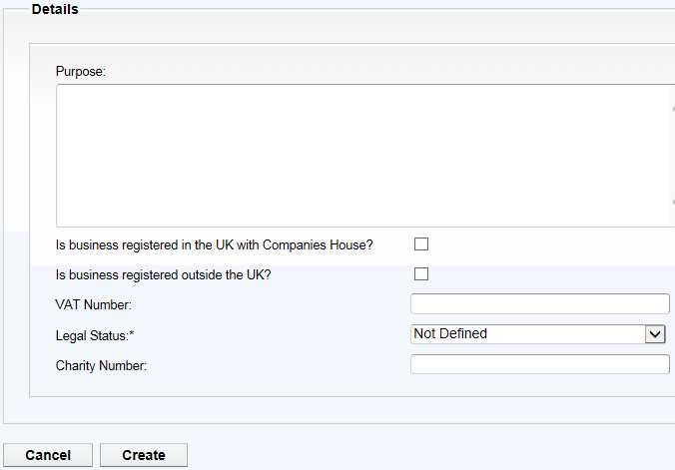
If creating a new operator, enter all of your details and then click ‘CREATE’.

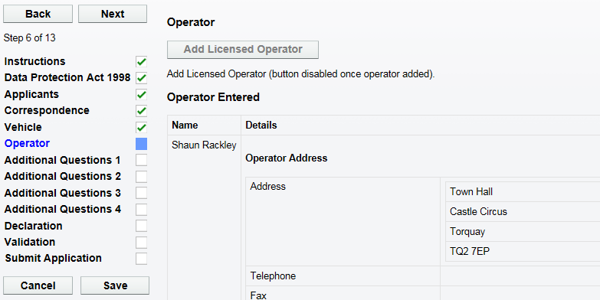
19
You will now be taken back to the operator screen and the NEW operator details will be shown here.
Now click ‘NEXT’ to proceed.
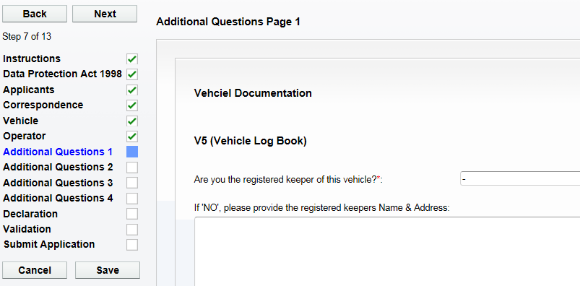
20
Now complete all of the questions on ‘ADDITIONAL QUESTIONS Page 1’.
Now click ‘NEXT’ to proceed.

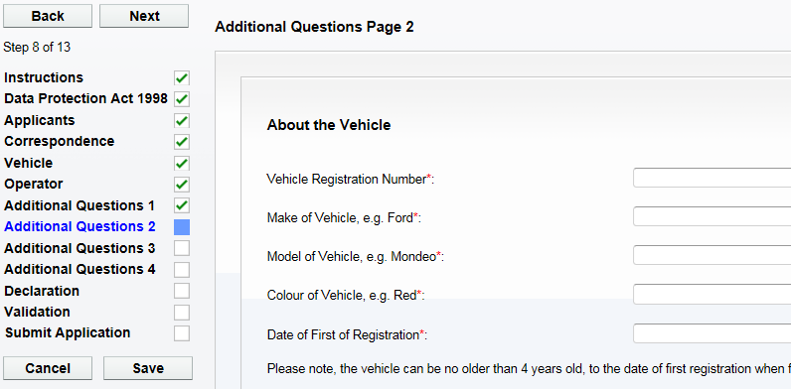
21
Now click ‘NEXT’ to proceed.

Now complete all of the questions on ‘ADDITIONAL QUESTIONS Page 2’.

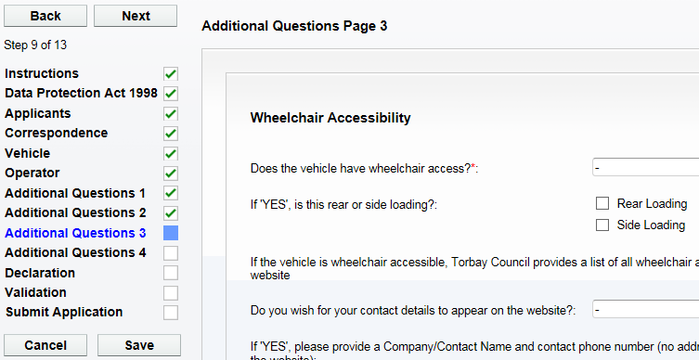
Now click ‘NEXT’ to proceed.

22
Now complete all of the questions on ‘ADDITIONAL QUESTIONS Page 3’.

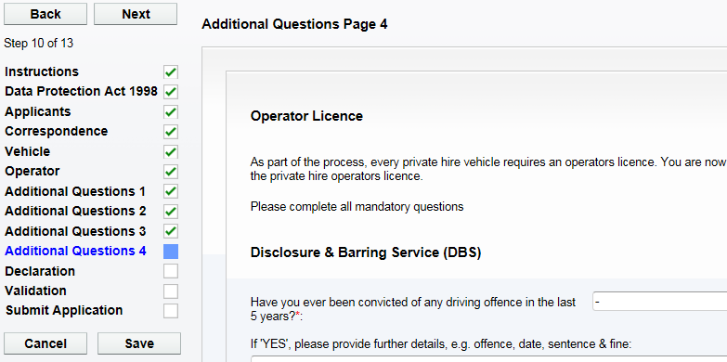
23
Now complete all of the questions on ‘ADDITIONAL QUESTIONS Page 4’.

Now click ‘NEXT’ to proceed.

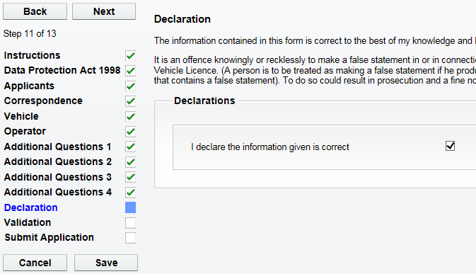
Please tick the declaration to confirm you have entered all the details correctly.
Now click ‘NEXT’ to proceed.

24

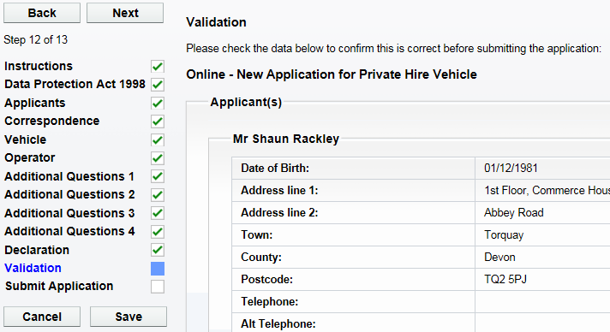
Please check all the personal, vehicle and operator details on this screen are correct.
Now click ‘NEXT’ to proceed.

25
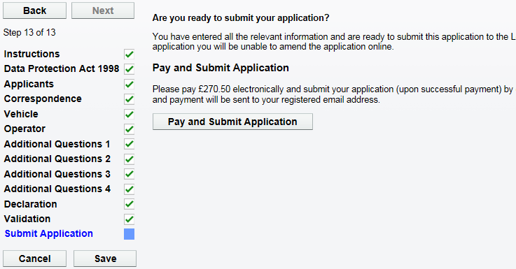
When you are ready to submit the application and make the payment, click on ‘PAY & SUBMIT APPLICATION’. You will then be transferred to Torbay Council’s payment site.
26
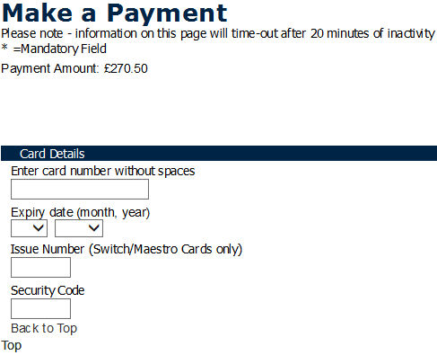
Please now enter your debit/credit card details, including the address details where the card is registered to.
27

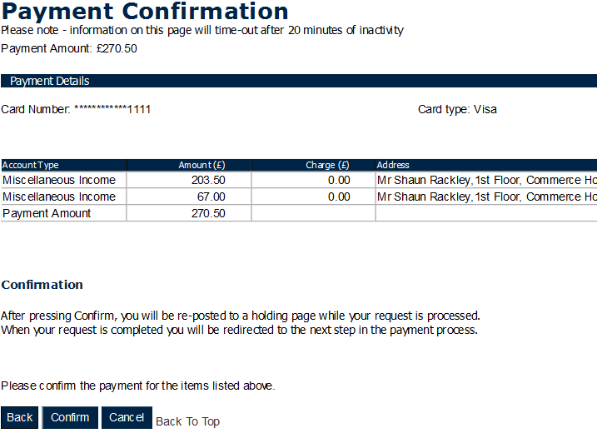
Please now check the amount you are about to pay and click ‘CONFIRM’.
28

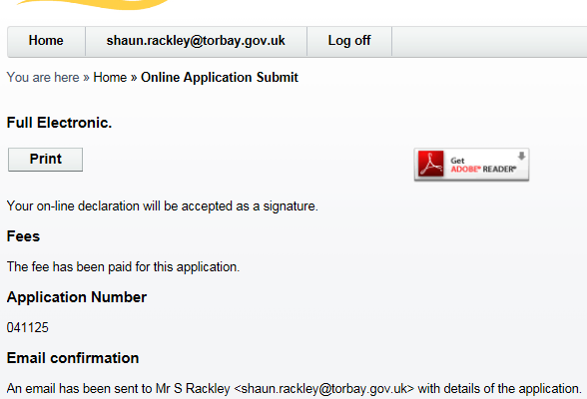
You will now be re-directed and have confirmation that the application has been submitted.
29

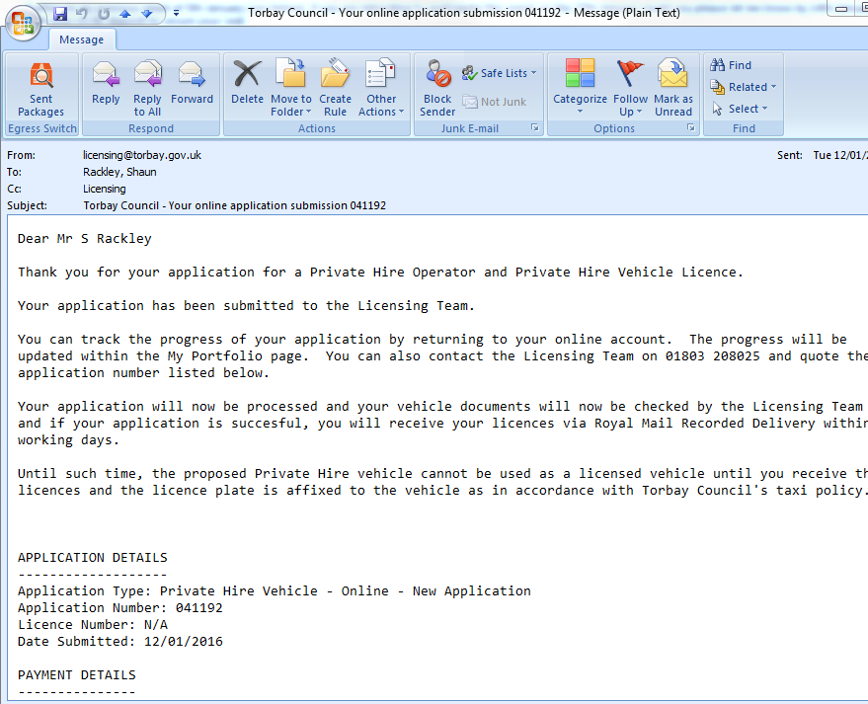
30
You will now receive an email to confirm that the application has been submitted and what happens next. You will also find receipt details within this email.

