How to renew a Private Hire Operators Licence

1
To start, please log onto the web address – www.torbay.gov.uk/taxis then select the ‘Licensing Public Registers’ tab.

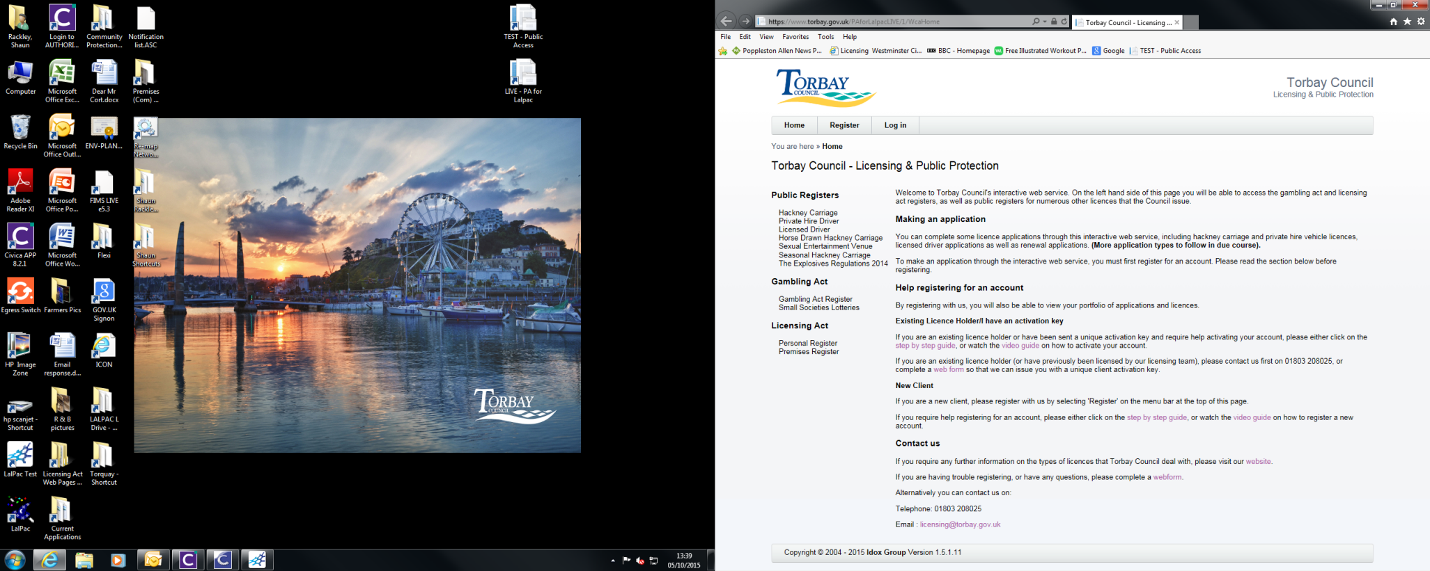
2
Next, Log into your online account using your registered email address and password.

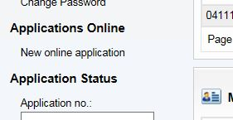
To make an application, click ‘NEW ONLINE APPLICATION’.
3

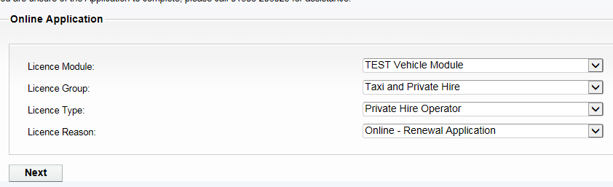
Now select the following options:-
Licence Module = VEHICLE MODULE
Licence Group = TAXI & PRIVATE HIRE
Licence Type = PRIVATE HIRE OPERATOR
Licence Reason = ONLINE-RENEWAL APPLICATION
4


5
Now select the Licence that you wish to renew.

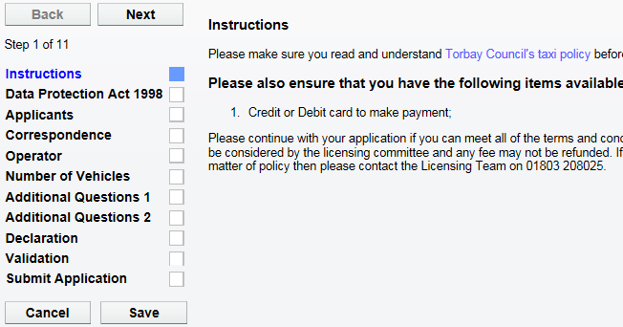
6
When you have the documents ready click ‘NEXT’.
Please read the instructions of what documents are needed to complete this application.

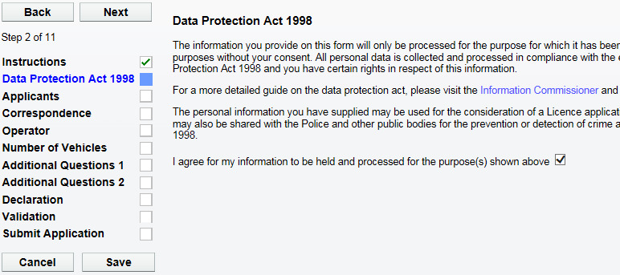
7
Please now agree to the Data Protection agreement by ticking this box.
Now click ‘NEXT’ to proceed.

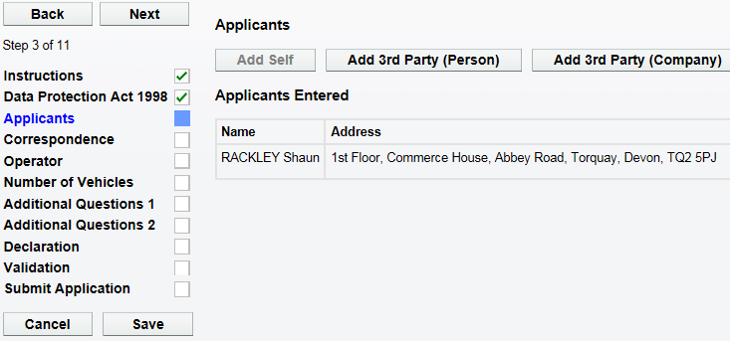
8
Now you will find your personal details. DO NOT change these.
Now click ‘NEXT’ to proceed.

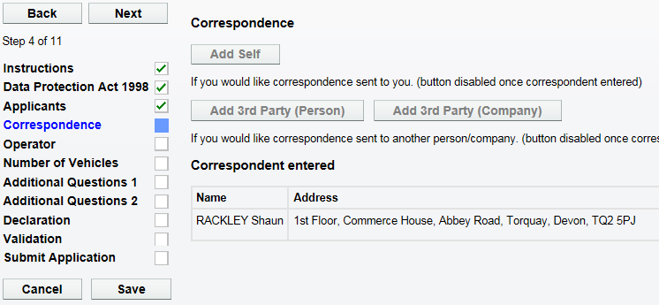
9
Next your correspondence details are shown here. DO NOT change these.
Now click ‘NEXT’ to proceed.

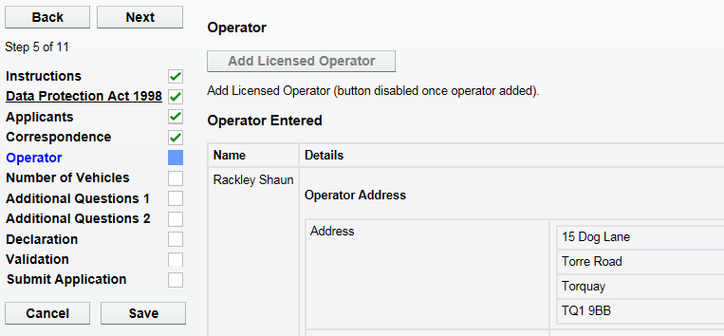
100
Next, check the operator details. These details will show where your off road parking address is. IMPORTANT – If the off road parking address is different to that shown, you will be able to notify us of the new address in the additional questions section.
Now click ‘NEXT’ to proceed.
Now check the amount of Private Hire vehicles you intend to licence. IMPORTANT – Each Private Hire vehicle requires an operator’s licence. If the amount is different to that shown, click ‘EDIT’ and enter the amount of vehicles in this section.

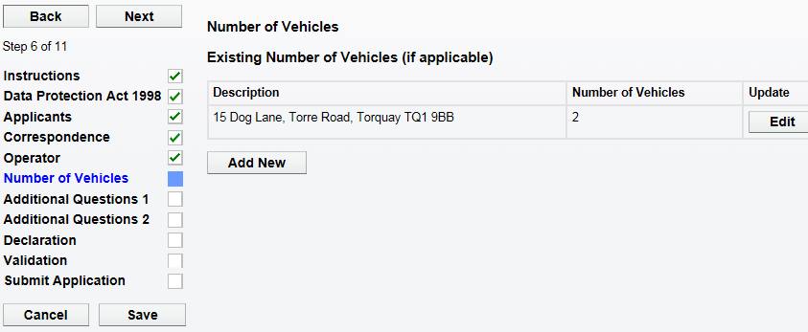
Now click ‘NEXT’ to proceed.
110

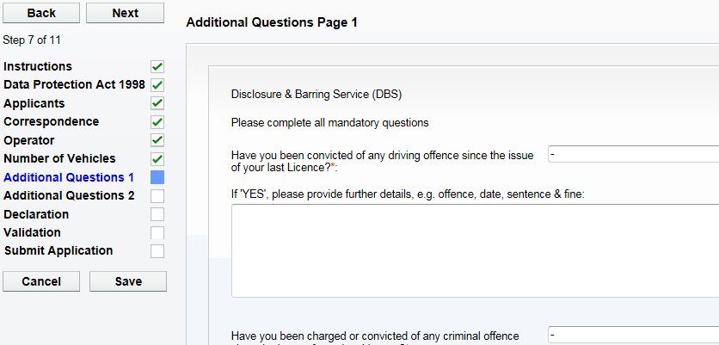
120
Now click ‘NEXT’ to proceed.

Now complete all of the questions on ‘ADDITIONAL QUESTIONS Page 1’.

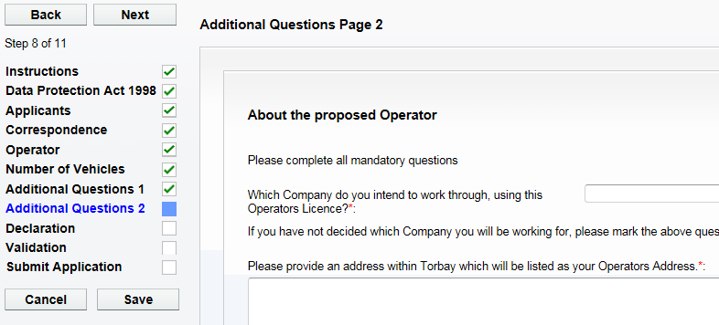
130
Now complete all of the questions on ‘ADDITIONAL QUESTIONS Page 2’.

Now click ‘NEXT’ to proceed.

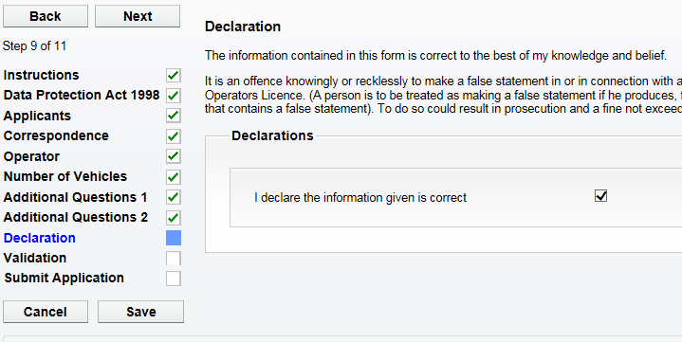
Please tick the declaration to confirm you have entered all the details correctly.
Now click ‘NEXT’ to proceed.

14

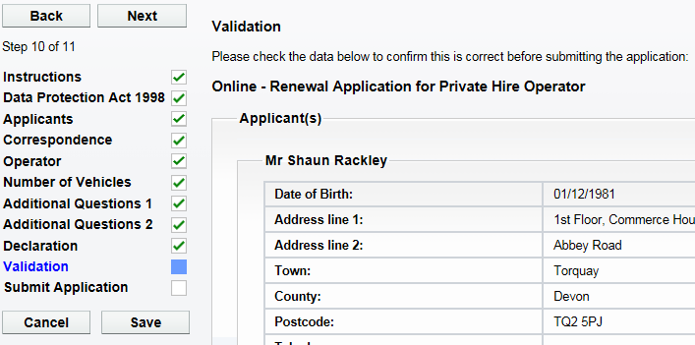
Please check all the personal details on this screen are correct.
Now click ‘NEXT’ to proceed.

15

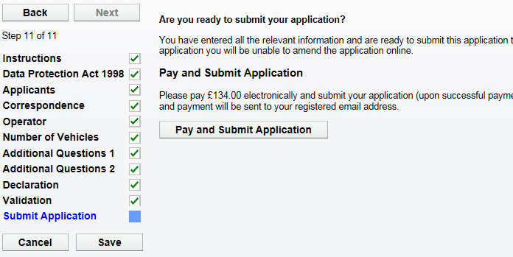
When you are ready to submit the application and make the payment, click on ‘PAY & SUBMIT APPLICATION’. You will then be transferred to Torbay Council’s payment site.
16

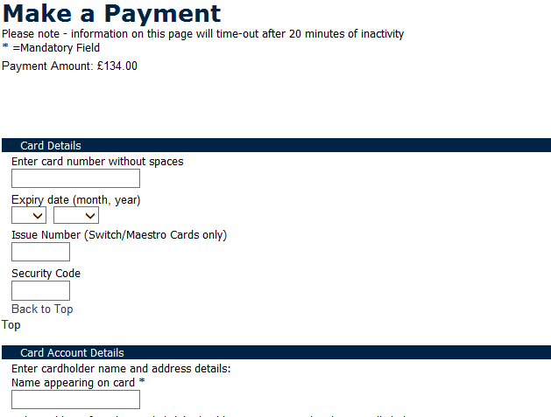
Please now enter your debit/credit card details, including the address details where the card is registered to.
17

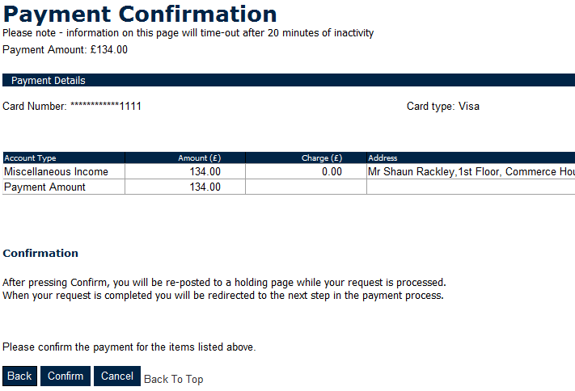
Please now check the amount you are about to pay and click ‘CONFIRM’.
18

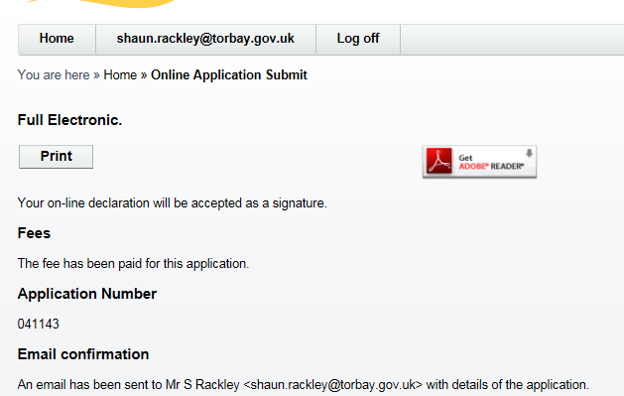
You will now be re-directed and have confirmation that the application has been submitted.
19

20
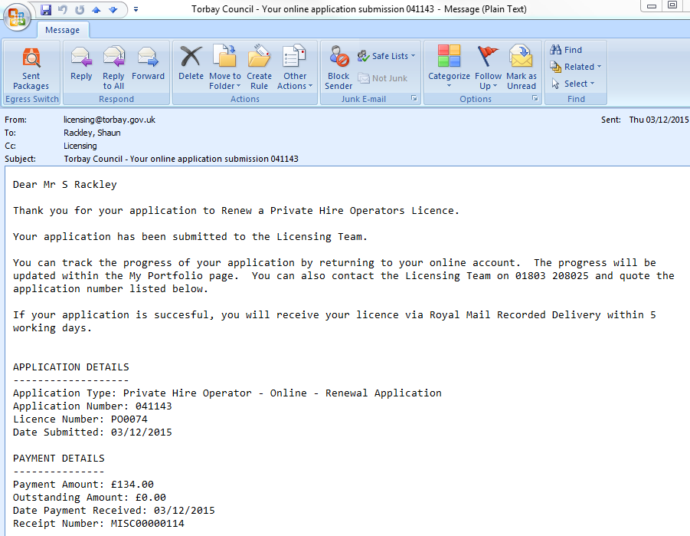
You will now receive an email to confirm that the application has been submitted and what happens next. You will also find receipt details within this email.

