How to apply for a New Licensed Drivers badge

1
To start, please log onto the web address – www.torbay.gov.uk/taxis then select the ‘Licensing Public Registers’ tab.

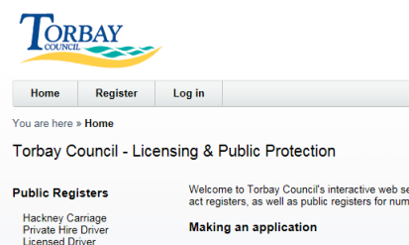
2
Next, Log into your online account using your registered email address and password.

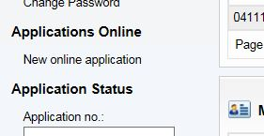
To make an application, click ‘NEW ONLINE APPLICATION’.
3

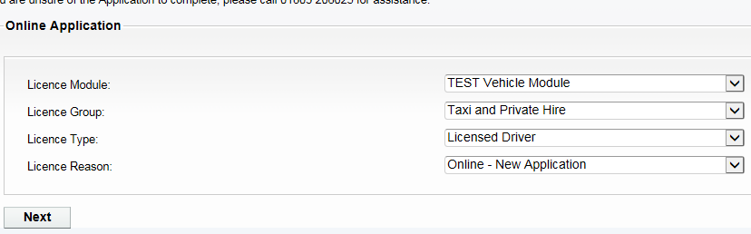
Now select the following options:-
Licence Module = VEHICLE MODULE
Licence Group = TAXI & PRIVATE HIRE
Licence Type = LICENSED DRIVER
Licence Reason = ONLINE – NEW APPLICATION
4

Please read the instructions of what documents are needed to complete this application.
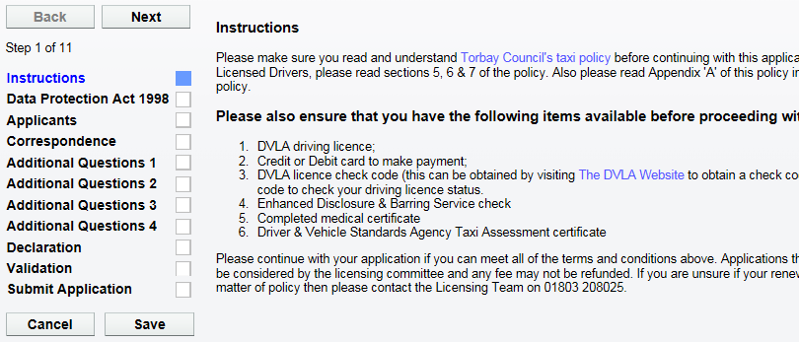
When you have all of the required documents, click ‘NEXT’.
5

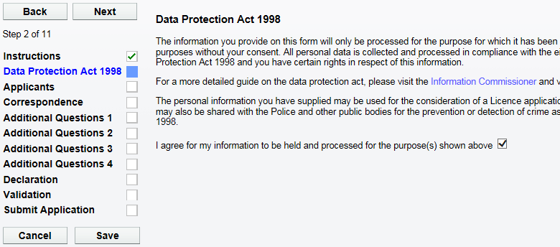
Please now agree to the Data Protection agreement by ticking this box.
6
Now click ‘NEXT’ to proceed.

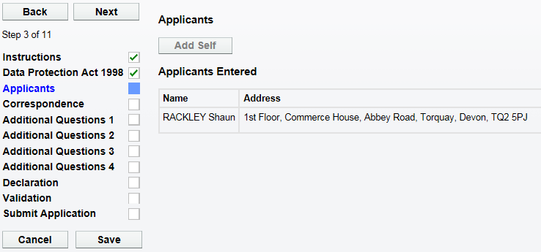
7
Now you will find your personal details. DO NOT change these.
Now click ‘NEXT’ to proceed.

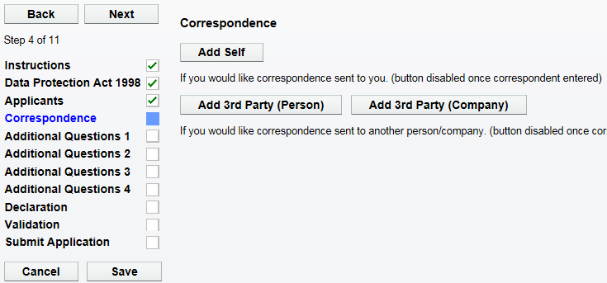
8
Next click ‘ADD SELF’ to add your correspondence details.
Now click ‘NEXT’ to proceed.

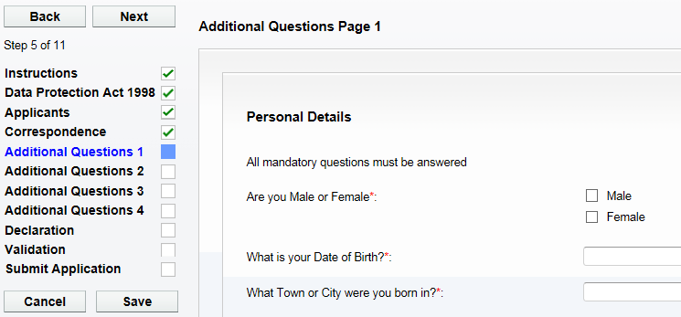
9
Now complete all of the questions on ‘ADDITIONAL QUESTIONS Page 1’.
Now click ‘NEXT’ to proceed.

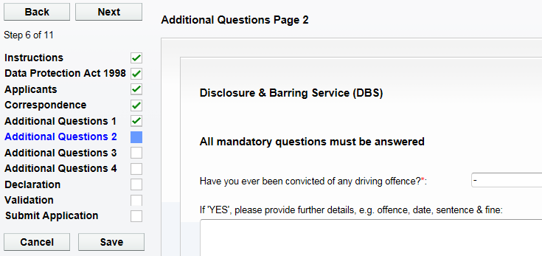
10
Now click ‘NEXT’ to proceed.

Now complete all of the questions on ‘ADDITIONAL QUESTIONS Page 2’.

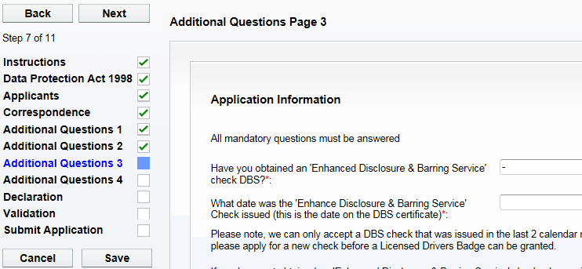
Now complete all of the questions on ‘ADDITIONAL QUESTIONS Page 3’.

Now click ‘NEXT’ to proceed.

11

Now click ‘NEXT’ to proceed.

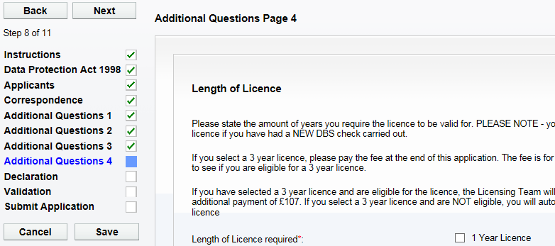
12
Now complete all of the questions on ‘ADDITIONAL QUESTIONS Page 4’.

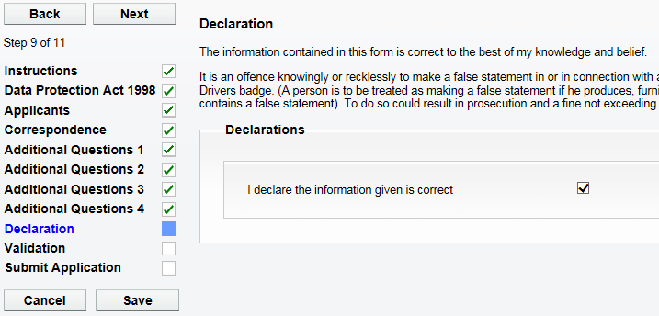
Please tick the declaration to confirm you have entered all the details correctly.
Now click ‘NEXT’ to proceed.

13

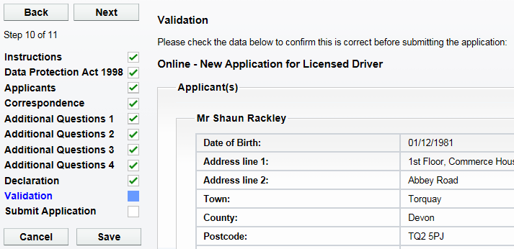
Please check all the personal details on this screen are correct.
Now click ‘NEXT’ to proceed.

14

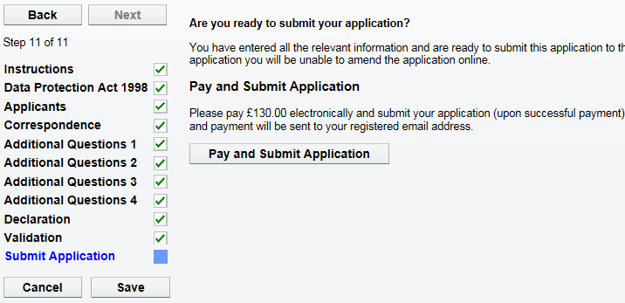
When you are ready to submit the application and make the payment, click on ‘PAY & SUBMIT APPLICATION’. You will then be transferred to Torbay Council’s payment site.
15

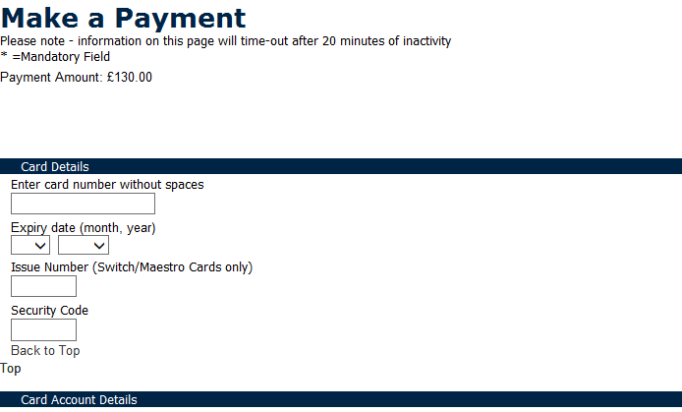
Please now enter your debit/credit card details, including the address details where the card is registered to.
16

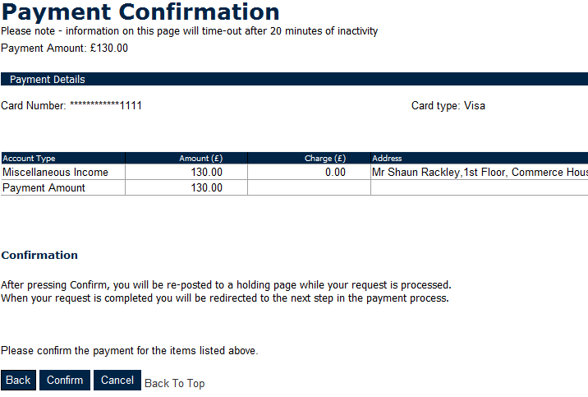
Please now check the amount you are about to pay and click ‘CONFIRM’.
17

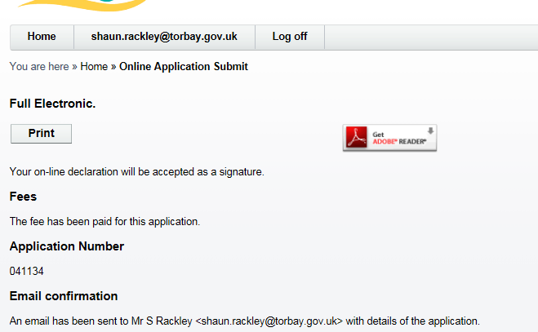
You will now be re-directed and have confirmation that the application has been submitted.
18

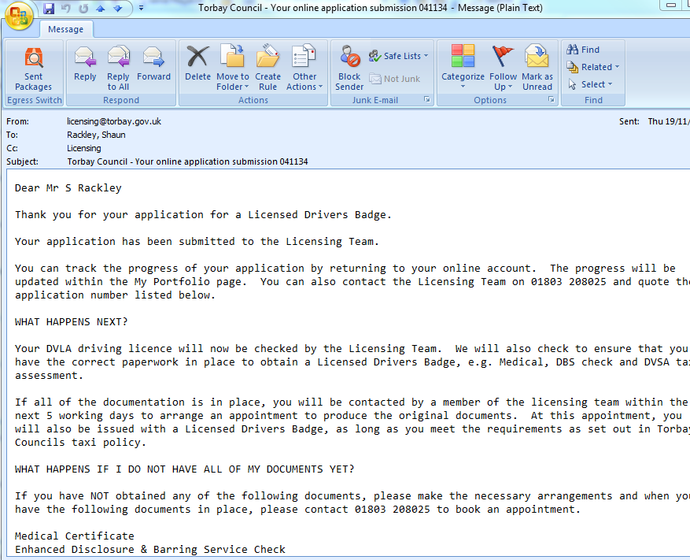
19
You will now receive an email to confirm that the application has been submitted and what happens next. You will also find receipt details within this email.

