How to transfer a Hackney Carriage Licence

1
To start, please log onto the web address – www.torbay.gov.uk/taxis then select the ‘Licensing Public Registers’ tab.

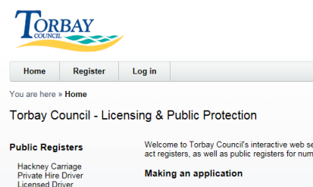
2
Next, Log into your online account using your registered email address and password.

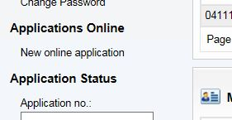
To make an application, click ‘NEW ONLINE APPLICATION’.
3

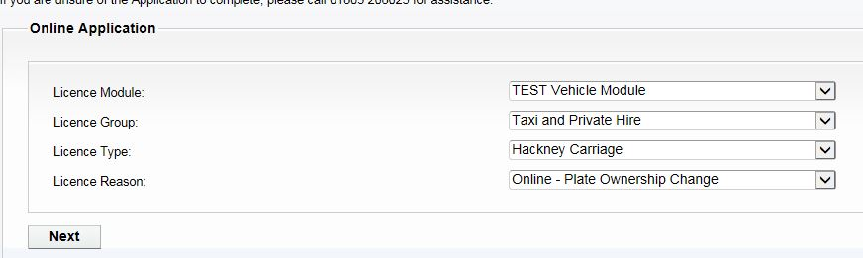
Now select the following options:-
Licence Module = VEHICLE MODULE
Licence Group = TAXI & PRIVATE HIRE
Licence Type = (HACKNEY CARRIAGE)
Licence Reason = ONLINE-PLATE OWNERSHIP CHANGE
4

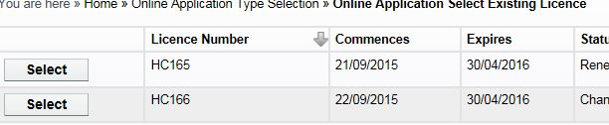
Now select the Licence that you wish to transfer to another person.
5

Please read the instructions of what you will need to complete this application. You also need to download and print the ‘TRANSFER CONSENT FORM’, this can be downloaded by clicking here.
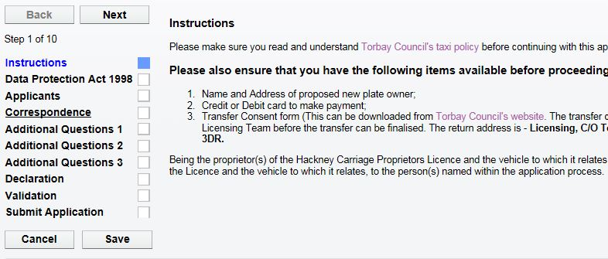
When you have downloaded the form, click ‘NEXT’.
6

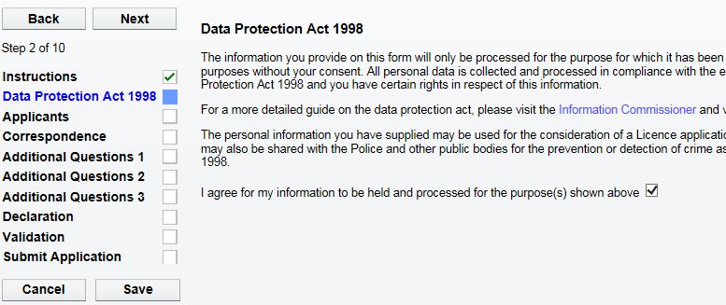
Please now agree to the Data Protection agreement by ticking this box.
Now click ‘NEXT’ to proceed.
7

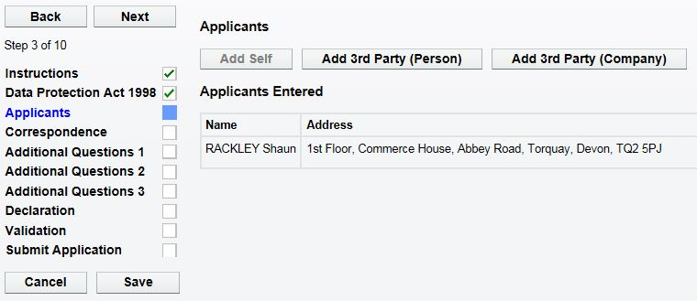
Now you will find your personal details. DO NOT change these.
Now click ‘NEXT’ to proceed.
8

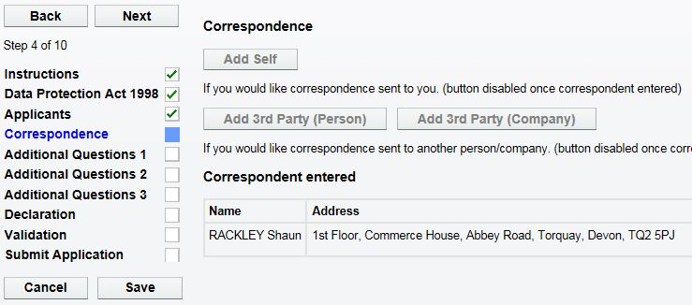
9
Next your correspondence details are shown here. DO NOT change these.
Now click ‘NEXT’ to proceed.
Now click ‘NEXT’ to proceed.
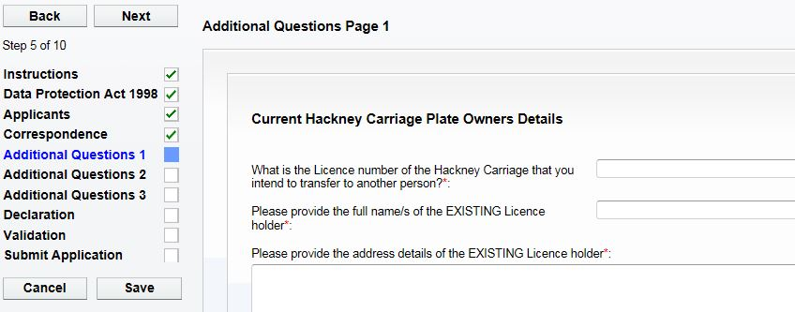
100
Now complete all of the questions on ‘ADDITIONAL QUESTIONS Page 1’.

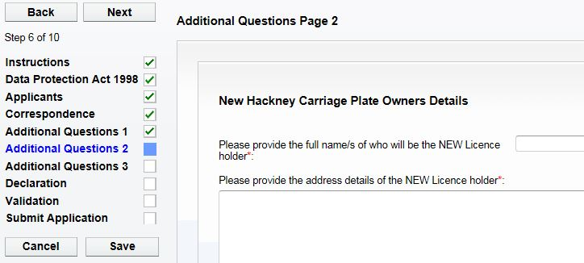
110
Now click ‘NEXT’ to proceed.

Now complete all of the questions on ‘ADDITIONAL QUESTIONS Page 2’.

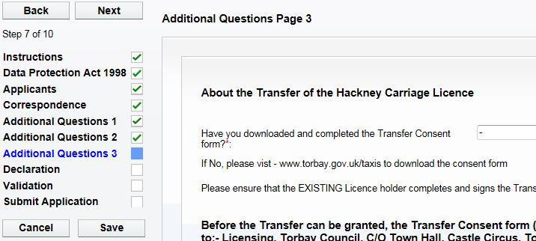
120
Now complete all of the questions on ‘ADDITIONAL QUESTIONS Page 3’.

Now click ‘NEXT’ to proceed.

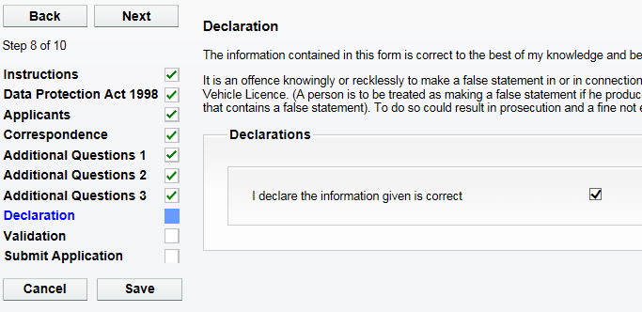
Please tick the declaration to confirm you have entered all the details correctly.
Now click ‘NEXT’ to proceed.

130

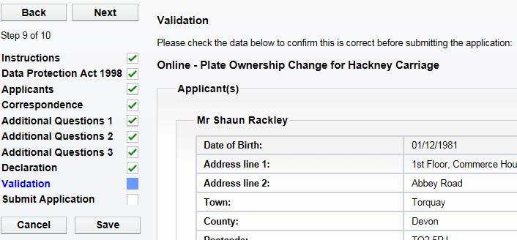
Please check all the personal details on this screen are correct.
Now click ‘NEXT’ to proceed.

140

Next is the PAY & SUBMIT screen, If you have not downloaded and printed the Transfer Consent form yet, please click here.
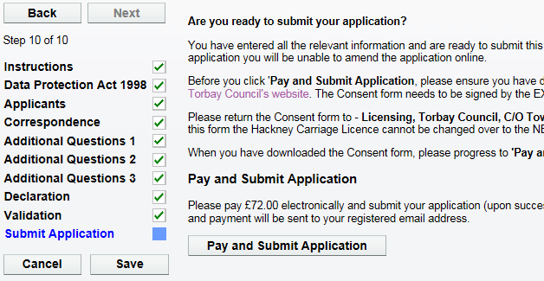
When you are ready to submit the application and make the payment, click on ‘PAY & SUBMIT APPLICATION’. You will then be transferred to Torbay Council’s payment site.
150

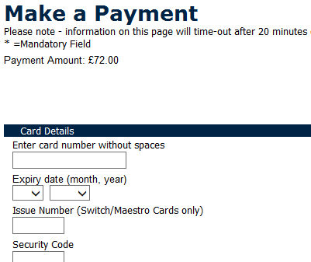
Please now enter your debit/credit card details, including the address details where the card is registered to.
160

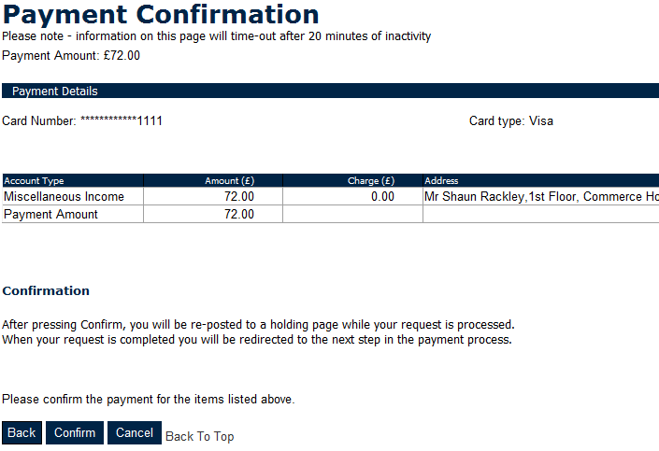
Please now check the amount you are about to pay and click ‘CONFIRM’.
170

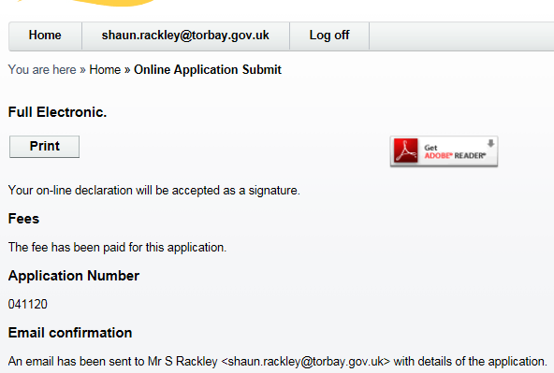
You will now be re-directed and have confirmation that the application has been submitted.
180

19
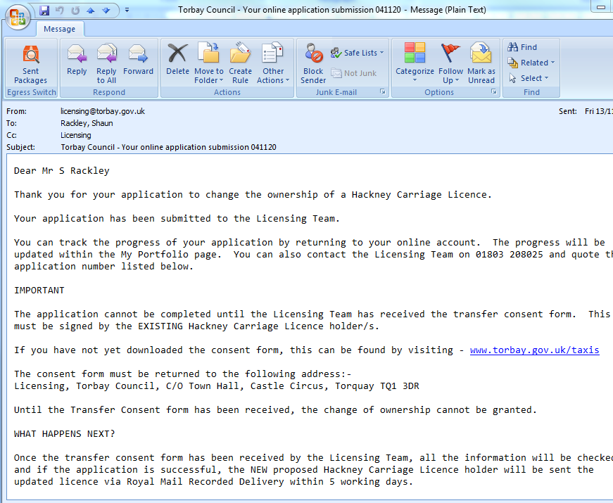
You will now receive an email to confirm that the application has been submitted and what happens next. You will also find receipt details within this email.

To complete this application, the EXISTING Licence holder needs to complete the ‘TRANSFER CONSENT FORM’ and send it to the following address as soon as possible:-
20
Licensing, Torbay Council, C/O Town Hall, Castle Circus, Torquay TQ1 3DR
Without this consent form, the transfer of the licence cannot be granted.
If you have not yet downloaded the form, please visit – www.torbay.gov.uk/taxis and download and print the form.

