July 2016
Communication, Consultation and Engagement Strategy
2016 - 2020

Contents
2 Introduction 3
3 Our stakeholders 3
4 Aims and Objectives 4
4.1 Aim 4
4.2 Objectives 4
5 Definitions of Communication, Consultation and Engagement 5
6 Our duties 6
7 Principles for communication, consultation and engagement 7
8 Action Plan 9
9 Feedback 10

Introduction
Torbay Council is committed to delivering open and effective communication, consultation and engagement. They are fundamental to ensuring our success and underpin the work of the entire council.

Regular and reliable information gives residents and other stakeholders an opportunity to play an active role by influencing decisions, shaping the future of services and helps them to understand the decisions that are taken. It supports the work of councillors, strengthens staff understanding about what is required of them and promotes stronger working relationships with our partners. All of this plays a central role in achieving our Corporate Plan ambition for a prosperous and healthy Torbay.

Torbay Council is committed to using reducing resources to best effect, reducing demand through prevention and innovation and taking a joined up and integrated approach. We need to continue to ensure that our communities and stakeholders are involved in the decision making process and are given the opportunity to help find solutions through high quality consultation and engagement. It is also crucial that we communicate the challenges, decisions and future changes in the most effective, inclusive and timely ways possible.

This strategy will guide how we will communicate, consult and engage with all our stakeholders over the next four years.

Our stakeholders

Torbay Council has to communicate, consult and engage with a wide range of stakeholders:
- Local people – both generally and as users of specific services.
- Partner organisations within the public, private, community and voluntary sectors, including Community Partnerships and the Community Development Trust as a conduit to access the wider community.
- Employees.
- Tourists and visitors.
- National opinion formers including MPs, MEPs, ministers and organisations such as the Local Government Association and central government departments.
- Media organisations, including local, regional, national, digital and specialist.

Aims and Objectives

Aim

Torbay Council is committed to ensuring open and effective communication, consultation and engagement. We want to ensure that people are given the opportunity to play an active role by influencing decisions and shaping the future of services which may affect them.
The aim of this Communication, Consultation and Engagement Strategy is to set out the principles within which Torbay Council will communicate and involve local people across Torbay. This strategy sets out to engage and empower our communities and stakeholders in order to bring about positive change for the good of the whole community.
In engaging with our residents and all stakeholders, we hope to give people a better sense of ownership of the services and activities available to them. Through effective engagement with our communities we also aim to identify any changes which may be required to local services and deliver on our Corporate Plan ambitions of a prosperous and healthy Torbay.

Objectives

In order to meet these aims we will deliver the following objectives:
- Be open and transparent when communicating with all stakeholders.
- Ensure all communication is two way – listen to stakeholders and communicate back the actions we have taken.
- Use a range of communication methods and channels to provide our stakeholders with information about council activities in order to signpost residents and other stakeholders to the right services and, where appropriate, help them to resolve their own issues to reduce demand on council services.
- Engage and communicate with our communities and stakeholders in a timely way so they are informed and are able to have their say on local decision making issues.
- Be realistic about our limitations and the need for the council to use reducing resources to best effect.
- Use an integrated and joined up approach, both within the council and with our partners, to achieve value for money, to avoid consultation fatigue and to ensure messages are consistent.
- Provide good internal communication, consultation and engagement to improve employee morale, increase performance and to enable staff to understand and demonstrate the council’s core values.

Definitions of Communication, Consultation and Engagement

Communication, is generally defined as ‘the imparting or exchanging of information by speaking, writing or using some other medium’ and the ‘successful conveying or sharing of ideas and feelings’.

Torbay Council uses different methods of communication based on target audiences – both internal and external.
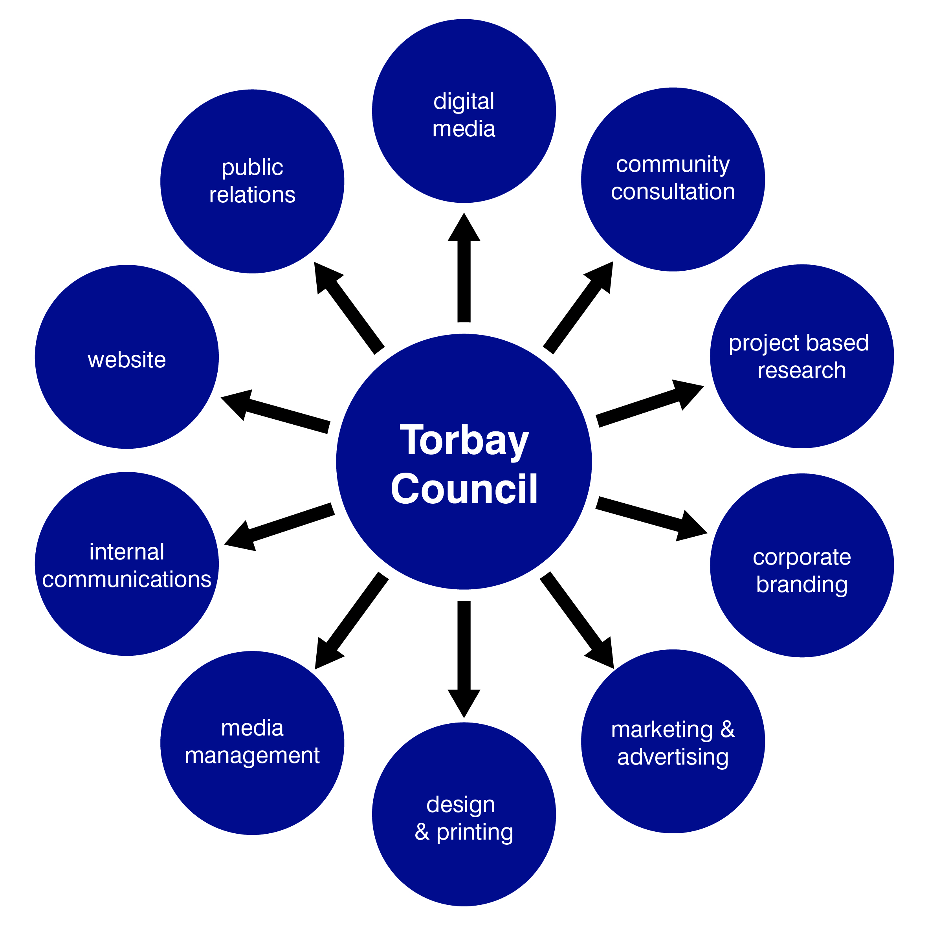

Consultation is defined as the process of ‘dialogue between individuals or groups, based upon a genuine exchange of views, with the objective of influencing decisions, policies or programmes of action’. It can involve:
- Passing information and receiving comments.
- Seeking opinions on options before a decision is reached.
- Seeking to involve local people, communities, businesses, voluntary sector organisations and other organisations in important decisions which have an impact on them.
- Listening and learning from local people, communities and other stakeholders.

Engagement can generally be described as ‘developing and sustaining a relationship between public bodies and community groups to help them both understand and act on the needs or issues that the community and work towards a common vision’. Communities, in this sense, can mean groups of people with similar needs or aspirations such as the users of a particular service.

Our duties

The duty to inform, consult or involve is set out within the Local Government Act 1999 and Local Government and Public Involvement in Health Act 2007.

In exercising the general duty under the Local Government Act 1998, local authorities must ‘make arrangements to secure continuous improvement in the way in which its functions are exercised, having regard to a combination of economy, efficiency and effectiveness’

In deciding how to fulfil the general duty the local authority must have ‘due regard’ for any guidance issued by the Secretary of State and should consult with the following:

- Any person or representatives who are liable to pay any tax, precept or levy in respect of the authority.
- Any person or representatives who are liable to pay non-domestic rates in respect of any area within which the authority carries out functions.
- Any person or representatives who use or are likely to use services provided by the authority.
- Any person or representatives appearing to the authority to have any interest in any area within which the authority carries out functions.

The Government’s Code of Recommended Practice on Local Authority Publicity provides guidance on the content, style, distribution and cost of local authority publicity.

It states that publicity by local authorities should be based on the following seven principles:
- Lawful - comply with the Advertising Standards Authority’s Advertising Codes.
- Cost effective - value for money.
- Objective - politically impartial.
- Even-handed - can address matters of political controversy in a fair manner, but the publicity should not affect support for a single councillor or group.
- Appropriate - refrain from retaining the services of lobbyists. The frequency of council newsletters should be no more than quarterly.
- Have regard to equality and diversity - publicity to positively influence public behaviour and attitudes in relation to issues such as safety and health can be used.
- Issued with care during periods of heightened sensitivity - e.g. elections and referendums.

Principles for communication, consultation and engagement
To ensure Torbay Council meets its duties as well as the aims and objectives within this policy, all communication, consultation and engagement activity will be developed in line with the following guiding principles:

All consultation activity must be agreed by the Corporate Support Team prior to publication to ensure that the consultation meets these principles.

Clear and concise: We will use plain English and avoid jargon and acronyms in all our communications to ensure messages and purposes are clear, understandable and accessible. When consulting we will only ask questions which are necessary and easy to understand.

Purpose: All our activity will have a clear and defined purpose, linked to our Corporate Plan. We will only consult or carry out marketing and public relations activity if there is an identified objective. Consultation and engagement will be used to influence local decision making.

Timely: All communication, consultation and engagement activity will, when possible, be planned in advance so consistent messages can be used at the right time, in the right way with the right people. We will openly inform, engage, discuss and consult with stakeholders at the earliest possible opportunity, ideally when proposals are being developed or when information is confirmed and becomes available. Due consideration will be given on the lead up to any elections or referendums to whether it is appropriate to launch new campaigns and consultation or engagement activity.

Proportionate timescales: The length of time for consultation and engagement activity will be judged against the nature and impact of the proposal / issue being consulted upon. We will ensure that sufficient time is given for respondents to consider any information provided and that there is sufficient time for them to provide an informed response.

Targeted: We will ensure that all our communications and consultations are targeted at the right stakeholder groups so they are effective and use resources in the best possible way. Where proposals, events or services affect specific individuals or groups, these stakeholders will be made aware of the activity so they can find out more, have their say or become involved. Consultation activity, in particular, will be tailored to meet the needs and preferences of different groups of people across Torbay, ensuring accessibility for all.

Relevant information: We will provide enough information, or signpost stakeholders to where they can obtain more information, to ensure that informed choices can be made. This could include how to access a particular service or how to resolve an issue. It could also relate to specific proposals and include information about how the options have been considered and details of any assessments of costs, benefits and impacts which have been carried out.

Feedback: We will ensure that any internal or external feedback will be conscientiously taken into account and will be considered in any final decision making. With regard to consultations, the results will be used to inform the development of relevant impact assessments. We will publish the results of consultation and engagement activity within eight weeks of the activity, stating how many responses were received and how they have been used in formulating the recommendation.

Forward thinking: We will actively explore and assess how we can best use new technology and other new communication channels to reach and engage as many people as possible.

Corporate identity and style guidelines: All communications involving the council will meet our corporate identity guidelines. This is to protect the brand identity, to maintain the council’s professional image and to ensure all council activity is consistent and accountable. This includes use of the Torbay Council logo, images and our house presentation style.

Partnership agreements: As we embrace a stronger integrated and joined up approach it is important that all partners agree in advance how any partnership activity will be carried out and communicated. This is to ensure there are consistent messages and that all communication and engagement protocols and corporate identity guidelines are met.

Responsibility: We acknowledge that communication is a two way process and is the responsibility of everyone. Council employees, elected members and all stakeholders have a role to play in open, timely and effective communication, consultation and engagement with each other.

Monitoring and evaluation: Given the important emphasis on using our resources to best effect, the way in which we communicate, consult and engage should be inclusive and effective. Monitoring and evaluating activity, where possible, will identify if we have met defined goals, areas that need exploring further and activity which can be improved.

Action Plan
 | Action | Responsible Lead | Indicative Timescale | Progress
1. | As outlined within the LGA Corporate Peer Challenge Action Plan - develop and agree a joint protocol for communication, consultation and engagement activity across the Strategic Partnership Forum. | Assistant Director Corporate and Business Services | November 2016
2. | Review how communication, consultation and engagement activity is delivered across the council, to consider if the existing structure and resources will support the council in delivering the aims and objectives of this strategy. | Assistant Director Corporate and Business Services | September 2016
3. | Review the ways in which we currently communicate and engage with our residents and partners to ensure we are making the best use of digital means including our own website and social media. | Communications Manager | December 2016
4. | Identify mechanisms to ensure elected members are informed about communication, consultation and engagement activity across Torbay. Ensuring they are equipped to engage with their communities and encourage their feedback. | Communications Manager / PPR Manager | October 2016
5. | Identify a mechanism through which elected members can feedback to the council issues / matters of concern for their communities ensuring this can be tracked centrally and monitored. | PPR Manager | October 2016
6. | Review the current use and future feasibility of the Council's Viewpoint Panel. | PPR Manager | October 2016
7. | Review the existing policy regarding the communication standards the Council expects from staff when dealing with customers. | Senior Leadership Team | December 2016
8. | Review current training programme for all front facing staff. | Senior Leadership Team | March 2017

Feedback
Torbay Council welcomes your comments and suggestions on our Communication, Consultation and Engagement Strategy, and will use any feedback we receive to help further develop this strategy.

Please emails consultation@torbay.gov.uk or contact us by mail or telephone:

Torbay Council
Corporate Support
Town Hall
Torquay
TQ1 3DR

Telephone: 01803 207227

