
Declaration of count totals

Referendum on the United Kingdom’s membership of the European Union

As Counting Officer for the

Torbay | voting area

at the referendum held on 23 June 2016 under the European Union Referendum Act 2015, and having been authorised to do so by the Regional Counting Officer, I hereby give notice that I have certified the following:

The total number of ballot papers counted was | 75,868
The number of votes cast in favour of REMAIN was | 27,935
The number of votes cast in favour of LEAVE was | 47,889
The number of ballot papers rejected was as follows:
- No official mark | 0
- Both answers voted for | 18
- Writing or mark by which the voter could be identified | 0
- Unmarked or void for uncertainty | 26
The total number of ballot papers rejected was | 44
Signed: 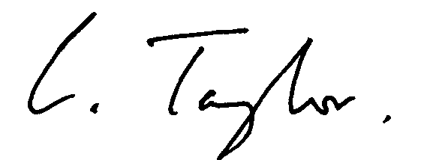

Name: Caroline Taylor | Counting Officer
Dated: 24 June 2016

