TORBAY COUNCIL
TX017

REQUEST BY REGISTERED PROPRIETOR FOR ADVERTISING ON LICENSED VEHICLE

NAME

ADDRESS

CONTACT TELEPHONE NUMBER

PRESENT HACKNEY CARRIAGE

MAKE

MODEL

REGISTRATION NUMBER

I, being the registered proprietor of the above Hackney Carriage vehicle hereby apply for permission to display advertisements on BOTH front doors of the vehicle. I have read the note overleaf and understand the terms and conditions of such permission. In the event that I am unable to comply with any of these conditions, I will cease to display such advertisements. I have detailed below a sample of the intended advertisement.

Signature Date

DETAILS OF PROPOSED ADVERTISEMENT

Please enter in the space below a sketch of the intended display, including detail of dimensions, logos, colours and lettering

CONDITIONS RELATING TO THE DISPLAY OF SIGNS AND ADVERTISEMENTS ON HACKNEY CARRIAGES AND PRIVATE HIRE VEHICLES

Hackney Carriages shall carry and display a roof sign, of a proprietary brand, fitted above the roof, bearing the word TAXI to the front, and either the word TAXI, the proprietors trading name, or telephone number, to the rear. Private Hire Vehicles shall not display such a sign. Additionally, either category of licensed vehicle may carry one sign not larger than 18 inches long and 4 inches wide showing a telephone number and displayed in a position in the front windscreen to be determined in advance by Council Officers. Hackney Carriages may show, in addition, a company logo and name.

Notwithstanding the above, Private Hire Vehicles may display a maximum of two identical signs on the outside of the front doors of the vehicle each within the dimension of 16 inches long by 8 inches wide in addition to a windscreen sign. So as not to cause confusion with hackney Carriages, such door advertisements shall be limited to a telephone number and the words “Private Hire Vehicle”, such information to be provided in black lettering, of an approved font and on a white background (please see below). In addition, there shall be displayed within the vehicle in a prominent position a Notice, to be supplied by the Council, to the effect that the vehicle is licensed for Private Hire use only. Note: The words “Taxi”, “Cab” or “For Hire” shall not appear anywhere on a Private Hire Vehicle. Hackney Carriages may display, fitted to the front doors of the vehicle, advertising signs not larger than 24 inches long and 12 inches wide, subject to the prior approval of the Council as to the advertised subject. The content and layout of all signs shall be approved in advance by Council Officers following written application by the Licensed Operator who will be required to supply full details and any sample considered necessary.

Proprietors are recommended not to order any signs until formal permission in writing has been issued by the Council. Such permission will relate only to the vehicle applied for and not any subsequently licensed vehicle.

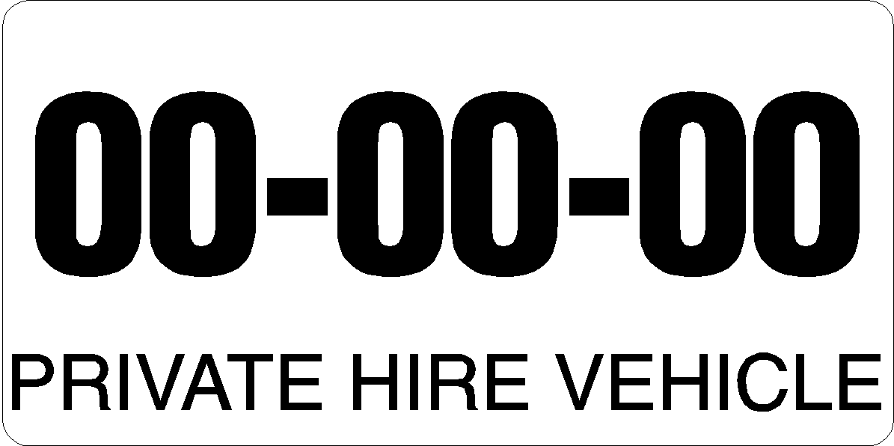
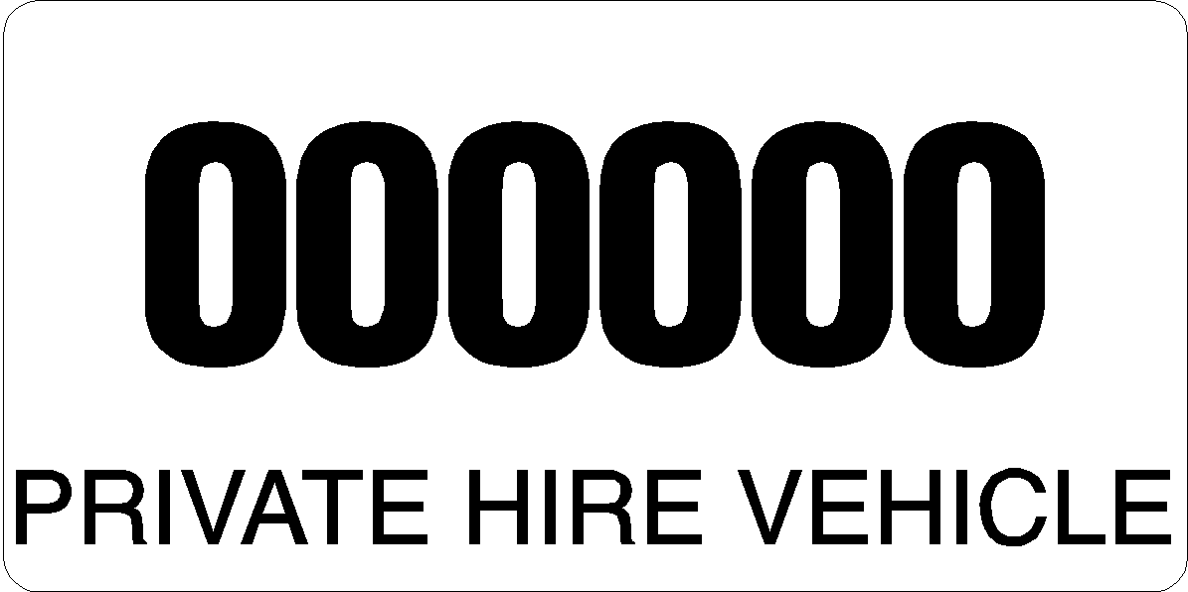
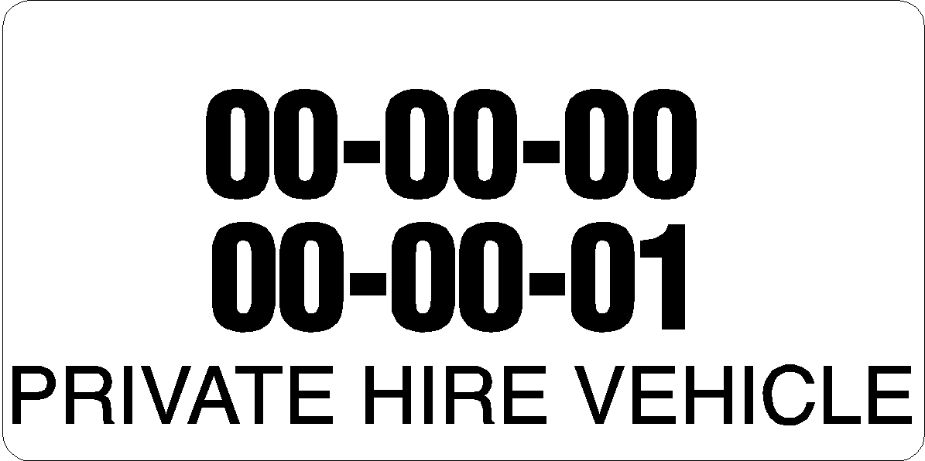Private Hire Vehicles – These are the only acceptable formats – Please note that this is a guide only and the actual display will be the subject of an individual approval

