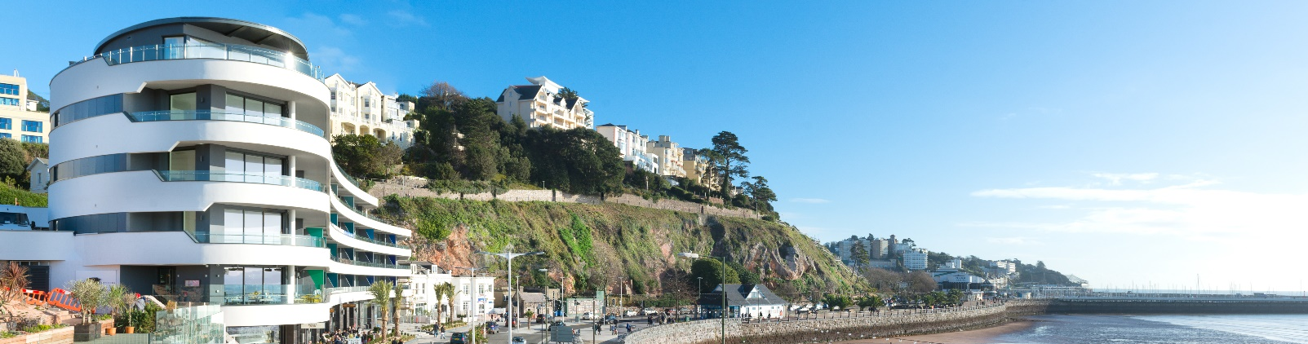
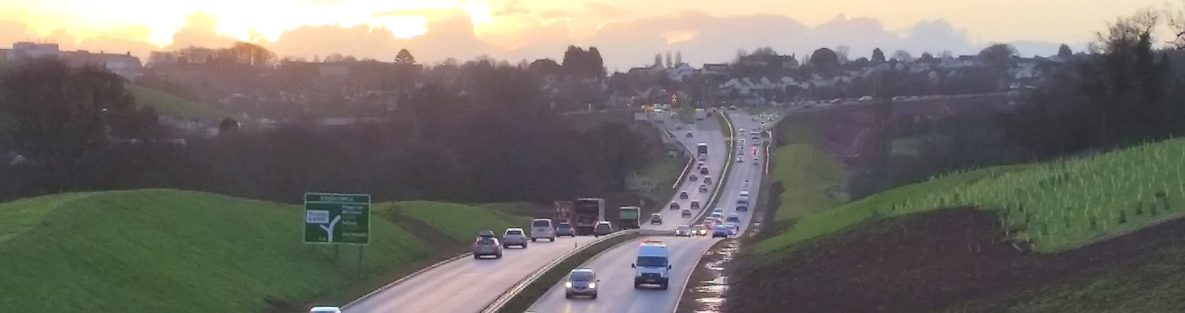
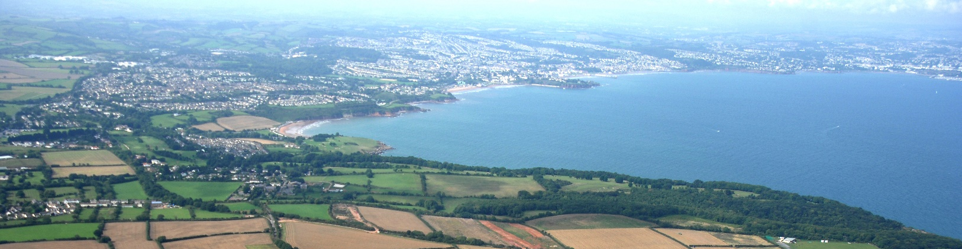

Torbay Local Plan Review
  - Sustainability Appraisal - Developing and Assessing Reasonable Alternatives
March 2021

Contents
Introduction 3
The Local Plan Update 3
Developing Options 4
Methodology 6
Assessment of Reasonable Alternatives 7
Conclusions 10
Next steps 10

This document can be made available in other languages and formats. For more information please contact future.planning@torbay.gov.uk

Introduction
Sustainability Appraisal (SA) is a central tool for ensuring that the Local Plan contributes to the achievement of sustainable development. It provides a way of assessing options and site proposals.

Under Section S19(5) of the Planning and Compulsory Purchase Act 2004 and the Strategic Environmental Assessment (SEA) Regulations which came into force in England and Wales in July 2004, Sustainability Appraisal (SA) and SEA are mandatory for all Local Plans. S39 of the Act requires Local Plans to be prepared with a view to contributing to the achievement of sustainable development. SA is one way of helping fulfil this duty through a structured appraisal of the economic, social and environmental sustainability of the plan. The production of a SA is one of the “tests of soundness” of a Local Plan.

The SA Scoping Report represents the first stage of the SA process. It sets out the context of the SA and provides information on the sustainability framework, sustainability issues in Torbay. The Scoping Report is available to view at the Council website. https://www.torbay.gov.uk/media/15949/sustainability-appraisal-scoping-report.pdf

The current document presents second stage of the sustainability appraisal of the Local Plan Review and update. Its role is to assist with the identification of the most appropriate option, in sustainability terms, to predict implications for sustainable development and put forward recommendations for improvement where necessary. An assessment of ‘reasonable’ alternatives is required to meet the requirements of Regulation 12 of the 2004 SEA Regulations and in doing so, identify and evaluate their sustainability impacts.

The Local Plan Update
The Torbay Local Plan 2012-30 (The Local Plan) reached its fifth anniversary in December 2020. Local Authorities are required to review local plans at least every five years, and update them if necessary. Cabinet considered a review of the Local Plan in November 2020, including an assessment of how far the Plan could be treated as being up to date.

The main issue identified was the shortfall in housing delivery against the Local Plan’s housing requirement (of 578 dwellings over the period 2012-20); and the introduction in national policy of the Standard Method for assessing housing need. The Standard Method (measured at 2020) provides a very similar housing need figure to the Local Plan housing requirement (broadly 586 and 600 dwellings per year respectively – see the Options below).

Cabinet resolved to assess whether the local plan’s housing figure should be updated in line with the most recent standard methodology housing figure. Cabinet further resolved in February 2021 to accept the government’s standard method as a measure of housing need. However “need” does not take into account environmental or other impacts; and the SA process is a way of considering these wider matters.

Accordingly, the purpose of the current SA is to assess whether the option of retaining the current Local Plan’s housing target to 2030 and taking measures to boost housing supply in line with this remains a sustainable option.

Developing Options
The purpose of the Local Plan Review is to assess the future levels of need for new homes (including market, affordable and specialist housing) and other land uses up to 2030 and to provide an appropriate basis for housing and infrastructure provision over this period.

The scale of housing development was assessed in the Local Plan Sustainability Appraisal Report (2015). Three options were assessed 8,000, 10,000 and 15,000 dwellings during the plan period (2012-2030). The scale of employment sites has not been identified to need an update in the Local Plan Review and therefore no assessment of alternative scale of employment provision was undertaken as part of the current SA.

The three options identified in this SA Report are the most recent standard methodology housing figure as required by government, the number of housing achieved in Torbay over the last 12 years period and the core 2018 based Household Projection, which was published in 2020 and at the time of writing is the most recently available demographic projections. These options were identified for the purposes of the sustainability appraisal:
- Option 1: Standard methodology figure (586 per year) or around 5,860 dwellings in 10 years;
- Option 2: "Business as usual" – the number of housing achieved in Torbay since 2012 (363 per year) or around 3,630 dwellings in 10 years;
- Option 3: 2018 based Household Projections 2 year migration rate “core forecast” (700 per year) or 7,000 dwellings in 10 years.

It will be noted that option 1 (Standard Method) is very similar to the existing Local Plan housing target (around 600 dwellings per year, when backlog of undersupply is included). Although the difference is around 14 dwellings per year, this is not considered to be significant when considering options at a broad-brush plan making stage. It will be noted that there is a strong expectation in the NPPF that the standard methodology figure is taken as a starting point for Plan making.

Option 2 “Business as usual”, represents building rates achieved since the beginning of the Local Plan period of 2012. The SEA Directive requires this option to be identified. The housing figure of Option 2 (363 per year) is close to the low growth scenario (400 per year) that was assessed in the Local Plan SA 2015, and therefore will have similar impact on the sustainability objectives.
Option 3 represents a high growth option based on the 2 year migration rate “core” forecast in the 2018 based Sub National Household projections. It is noted that the government has not adopted the 2018 based projections as the starting point for assessing housing need, and the council does not regard it as a statistically robust forecast. But this option is included to test the sustainability implications of higher level of growth scenario.

Options 2 and 3 are likely to require the Plan period to be rolled forward over a longer term plan period in order to comply with paragraphs 22 and 67 of the NPPF. This is also available with Option 1, but would not necessarily be required as the overall growth rate is very similar to the existing Local Plan.

Methodology
The SA of reasonable alternatives involves assessing the performance of each option against the SA framework. The appraisal is a qualitative exercise based on professional judgement taking into account the information gathered in the SA Scoping Report.

The magnitude of the impact of the different options on each objective is defined as significant positive benefit, some positive benefit, neutral or no link, significant negative impact, negative and uncertain impacts (see table 1). The SA should also consider the probability, duration, frequency and reversibility of the effects, including cumulative, secondary and synergistic effects whenever possible.

A significant effect arises as a result of a minor impact on a resource of international and national value or a major impact on a resource of local value. In addition, the accumulation of many non-significant effects on similar local resources may give rise to an overall significant effect. This approach to assessing and assigning significance to an environmental effect relies upon such factors as legislative requirements, guidelines, standards and codes of practice, consideration of the SA/SEA Regulations, the advice and views of statutory consultees and other interested parties and expert judgement.

Table 1: Effects of option on SA objectives
++ | Significantly positive | Option/policy/site would significantly help with achieving objective | Positive effect but consider whether effect can be enhanced
+ | Positive | Option/policy/site would help with achieving objective | Net positive effect but consider whether effect can be enhanced
? | Uncertain | More information needed | Where this will come from – who has it? What will be done about collecting it? When will it be collected?
0 | Neutral | Option/policy/site would neither help nor hinder the achievement of the objective | Option/policy or allocation likely to be acceptable; but would require intervention to realise positive effects
- | Negative | Option/policy/site would be in conflict with the objective. | Will require demonstrable levels of mitigation in order to make the option/policy/site acceptable.
-- | Significantly negative | Option/policy/site would be in conflict with the objective and unlikely to be acceptable. No evidence has been provided on potential mitigation. | Unlikely that adequate mitigation could be provided to make the site acceptable. Delete, reconsider or amend the option/policy or site

Assessment of Reasonable Alternatives
An assessment of the options has been undertaken, with each option assessed against the SA objectives to identify whether they would contribute to, or conflict with, the achievement of the sustainability objectives. Options were also being compared against each other. The outcomes of this appraisal is set out in table 2.

It is important to bear in mind that the options are high-level and include very little information regarding how and where they would be implemented. The appraisal of these options is necessarily high-level and a degree of interpretation was therefore applied to the appraisal.

All options are likely to have a negative impact, sometimes significant, on several SA environmental objectives; most notably in relation to biodiversity, water resources/quality, soil resources, air quality, and climate change. These impacts are associated with loss of land for development, the effects of construction, population increase and increasing demand for resources, and lasting impacts once new development is in use i.e. further environmental disturbance, emissions and energy use. In addition, all options are likely to have a negative effect in relation to waste management as significant new development would place additional pressures on existing waste management facilities.

Conversely, options generally support SA social and economic objectives, particularly those relating to the provision of housing, reducing social deprivation, and promotion of a sustainable and diverse economy. Neutral outcomes may also be realised in relation to the protection of landscape character and heritage assets due to a potential to promote development in areas such as brownfield sites and a focus on high-quality sustainable design as required by the NPPF and promoted by the existing Local Plan.

Table 2: Assessment of Options
Sustainability objective | Option 1 (586 dpa) | Option 2  (363 dpa) | Option 3 (700 dpa) | Comment
1. To reduce and manage the impacts of climate change | - | - | -- | Delivery of housing associated with all options will result in an increase in consumption of energy. The greater the number of housing delivered the higher the potential for negative impact. It is recognised that new developments offer the best opportunity to integrate renewable energy into building design. However, the low growth scenario (Option 2) is unlikely to reach the scale necessary for development of medium and large scale renewable energy schemes, although opportunities may exist for small scale renewable schemes.  The lower growth scenario (option 2) would steer development away from flood risk areas in contrast the high growth option (Option 3) will increase the number of hard surfaces and has the potential to worsen the surface flooding in Torbay. In addition, this option could result in development in locations where services and jobs are less accessible. This could lead to an increase in transport and associated greenhouse gas emissions.
2. To improve water, air, soil quality and minimise noise levels | - | - | -- | Whilst the low level of growth will have the least implications for natural resources, it has been marked as negative because it will contribute to pollution and natural resource depletion to a certain level. It would increase the risk of out commuting for work, further adding to air quality issues.  Local Plan Environmental Resources policies (ER) ensure the negative impacts of new development are avoided or mitigated.
3. To minimise waste and increase the recycling and reuse of waste materials | - | - | -- | The low level of growth will have the least implications for waste generation these have still been marked as negative as there will still be certain requirements in this area.  Local Plan Waste policies ensure the negative impacts of new development are avoided or mitigated.
4. To conserve, protect and enhance habitats  and species, and geodiversity | - | + | -- | The location of development is likely to have more impact on biodiversity than the actual amount delivered. However, as a general principle, the denser the housing development the less opportunities there are for incorporating biodiversity into the design. As explained in the baseline review, Torbay is physically constrained due nature conservation interests and a lack of urban brownfield land opportunities.  Local Plan Biodiversity and Geodiversity Policy (NC1) ensure the negative impacts of new development are avoided or mitigated.
5. To conserve, enhance and enjoy the historic environment. | 0 | 0 | 0/- | The Issues and Options and Call for Evidence document do not have specific geographic boundaries and therefore impacts on the historic environment cannot be assessed at this stage. However, Options 3 could impact more significantly on heritage assets.  Existing Local Plan Historic Environment Policy (HE1) seeks to ensure that new development does not result in an adverse effect on the historic environment.
6. To protect, enhance and manage the character and quality of the landscape, townscape and seascape | 0 | 0 | 0/- | Impacts will depend on quantum of new land take together with the location and design of the proposed growth areas. The Issues and Options and Call for Evidence document do not have specific geographic boundaries and therefore impacts on the landscape, townscape and seascape cannot be fully assessed at this stage. However, Option 3 could require the development of more sites in sensitive landscapes.  Existing Local Plan policies Countryside, Coast and Greenspace seek to ensure that new development does not result in an adverse effect on the landscape and townscape.
7. To reduce the need and desire to travel by car and support sustainable/active modes of travel | + | - | -- | The majority of development is likely to be located within the built up area and therefore will be located in good proximity to local transport and other services. However, development located in the urban fringe would not have good access to local services to meet the needs of the local communities and results in an increase in car ownership and potential journeys made both within the built up area and on the urban fringe.  The low level of growth negative score is due to the increased risk of out commuting for work.
8. To support strong, diverse and sustainable economic growth | + | - | + | The low level of growth could provide minor improvement in viability of local businesses and commercial activities.  The medium growth should lead to an increase in economic activity, through increased employment opportunities arising from development.  The high growth will bring opportunities for in-migration of population who may bring with them new employment opportunities and skills. However, it could displace alternative uses, creating areas of housing with little provision.
9. To reduce poverty and income inequality | + | - | + | The low growth could exacerbate housing inequality and poverty. While the highest level of growth will provide the greatest scope for New Homes Bonus and therefore benefit communities in Torbay. It also raises concerns regarding over-intensive development and loss of cultural assets including space for cultural events.
10. To maximise the use of previously developed land/ buildings and encourage the efficient use of land | - | + | -- | The low growth could provide opportunities to conserve soil by developing brownfield sites and allowing limited development in greenfield sites, in contrast to the high growth could cause permanent loss of bio-productive soil.
11. To promote safe communities and reduce fear of crime | ? | ? | ? | The extent to which crime reduction measures implemented in design depend on individual applications.
12. To provide housing that meets the needs of existing and future residents | + | - | ++ | The highest level of growth would result in the delivery of the greatest amount of affordable housing as required to meet the future demand for housing and therefore has the strongest positive impact on this objective. The low growth options would deliver affordable housing below the assessed level of local housing requirements and it wouldn’t fit well with the long term growth aspirations.
13. To improve health and wellbeing and reduce health inequalities | + | + | + | Access to a decent and affordable housing is one of the wider determinants of health and therefore all options could have positive impacts on health.  Option 2 avoids town cramming and loss of urban open space. However, it reduces the opportunities for regeneration of living environment deprivation.

Conclusions
The current SA has been prepared to support the Torbay Local Plan Update: Issues and Options and Call for Evidence Document. The precise location of new housing is not identified in this stage of plan preparation, therefore offers little scope for assessing cumulative effects. However, the appraisal of the options reveals that each option has sustainable merits and drawbacks. As a preliminary conclusion, Option 1 scores best overall as it would deliver development to enable significant contributions towards economic growth and community infrastructure. The option is likely to reduce the need to travel, poverty and income inequalities as well as health inequalities. It is stressed that this conclusion is preliminary and particular is subject to more detailed consideration of Objectives 5 (historic environment) and 6 (landscape, townscape and seascape).

Next steps

The next step in the development of the SA is to take on board the feedback from this consultation and update this report accordingly. Any significant changes made to the Regulation 18 document will be subject to further SA. The next stage of the Local Plan Update is the Site Allocations Draft Plan (Reg. 19), will be accompanied by a Sustainability Appraisal Report.

