Accessing Housing Benefit payment schedules via MyTorbay
Logging into the portal
To access the MyTorbay portal go to https://www.torbay.gov.uk/request-online-payment-schedule/ and click the ‘Sign in to My Torbay business’

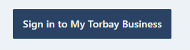

You will be prompted to enter your username and password.

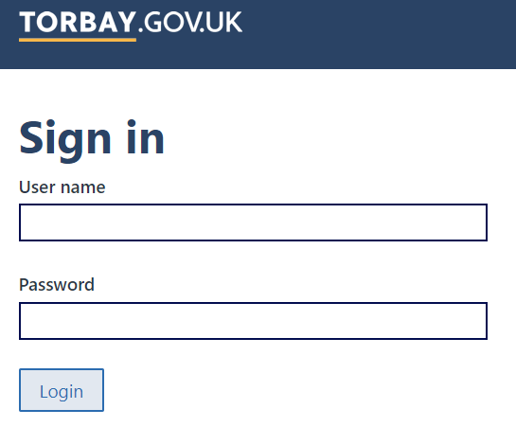
Once logged in you will be presented with a home screen.
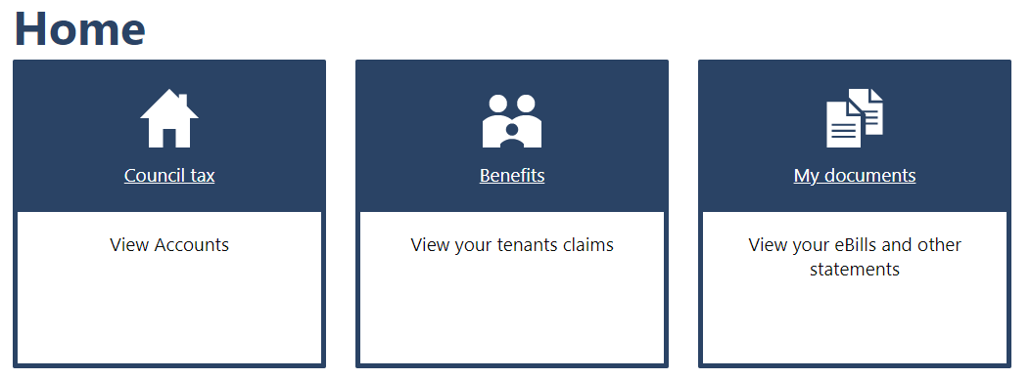
Council Tax and Business Rates account section will show if there is a current or previous liability.
My documents section will appear once signed up to electronic documents and at least one document has been produced. Documentation previously produced prior to portal signup will not be available.

Accessing Housing Benefit Payment Schedules
Click on the ‘Benefits’ section where you will be presented with a summary of your next payment and the last payment made, as well as a list of tenants who have claimed Housing Benefits
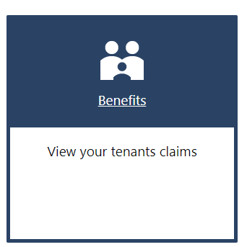
To view a downloadable payment schedule click on ‘View previous payments’ under the Last payment made heading
You will then be presented with a list of payments.
Payment schedule documents for viewing and downloading will only show on your portal account following the first payment run after you signed up. Previous payment schedules will not be accessible but will remain available via the old TorbayDirect site for the time being.
The downloadable payment schedule will be shown by the ‘PDF’ link at the end of the payment line. To display the schedule, click the PDF link. This will open the payment schedule to view and download if required.
When a document is produced you will receive an email notifying you that a new document is available on your account.
Notification Letters
Once you have a portal account setup for Housing Benefits, notification letters will be available in the My documents section. This section will become available once an initial notification letter has been generated.
Unlike the payment schedules, once your portal account is active and notifications are generated electronically a paper version will no longer be sent.
