Menu

Ways of searching for an application

Simple searches (Using the ‘Simple’ search tab)

Advanced searches (Using the ‘Advanced’ search tab)

Weekly/monthly lists of applications (Using the ‘Weekly/Monthly Lists’ tab)

Search the planning history for a range of properties (Using the Property’ tab)

Search the planning history of an area (Using the ‘Map’ tab’)

Retrieving the information you want from a record

Basic Details

Letters of representation (Comments)

The documents and plans

Viewing plans

Measuring plans

Viewing the site area (Maps)

The Registration Service

Registering with Planning Online

Problem getting emails - Anchor

Tracking applications (Be notified of the decision)

Saving a Search

Changing your personal profile details

Managing your account

Delete an account

Accessing Applications Online
Back to menu

Successfully finding information about a planning application is all about using the various search criteria available through ‘Planning Online’ to match up the information that you have with the information held on the database. This guide has been designed to show you how the different search criteria can be used to retrieve the information that you need.

The more specific you make your search criteria the quicker an exact match can be found.

The first step is to visit www.torbay.gov.uk/planningonline then select ‘Search for Planning Applications’.

Using the ‘Simple’ search tab
Back to menu

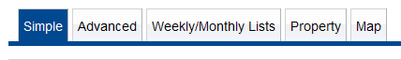

The ‘Simple’ search engine is designed to find a match using either a keyword (which will show all matches with that keyword):


or an application reference (which will bring up only that individual planning application with that reference number):

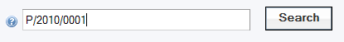
or a postcode (which will bring up all the applications within that postcode zone):



or a single line of the address (that will bring up any applications that match that single line of the address):

Using the ‘Advanced’ search tab
Back to menu

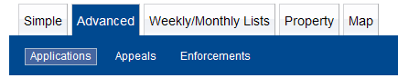

The ‘Advanced’ tab is designed to offer you further ways in order to find a planning application by matching search criteria. You can enter information in several boxes at once and this ‘mix and match’ approach means you can refine your search according to what you know.
For example, you might know that the application you are looking for is for an extension, it’s in the St Marychurch ward and it was refused. Use these facts as your search criteria:

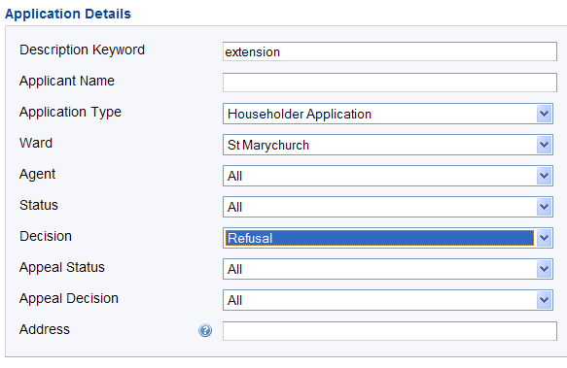
Or you can to choose to search under just one of the criteria such as ‘applicant name’, which will give you all of the planning applications made under that name.

You might want to view applications according to dates such as when we received it or when the decision was made on it and for this you can use the ‘dates’ search engine.

For example, you might want to see all of the applications validated in January of this year:

Using the ‘Weekly/Monthly Lists’ tab
Back to menu

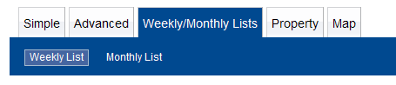
Each week we produce a new batch of applications that have become valid this week and applications that have been decided upon this week. The ‘Weekly/Monthly Lists’ tab enables you to search these lists.

This can be helpful if you are looking for a planning application but you may only know, for example, that we have received it this week. You should be able to find the application that you were looking for by selecting it from the list of results. This is also a handy search method for those people who wish to keep up to date with our applications and decisions on a regular basis.

Select either validated or decided in this week:



Then select which week, search from further backwards in time to include more weeks’ worth of results:

You can choose any or all of these options simultaneously to further refine your search criteria.

For example, if you know its status then refine the status accordingly:

You might know the area, so try refining the ward:

Using the ‘Property’ tab
Back to menu

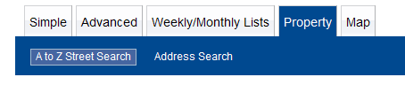

The ‘Property’ tab is a great search method for searching the planning history of a particular property. It is very useful if you want to look at the planning history of a range of properties if, for example, you want to purchase a particular property and would like to see if any nearby houses have been given planning permission for anything. Simply select the road:

For example, to look at the planning history of any house on Marine Drive, Paignton:
Select the letter ‘M’:

Then select which page from the streets list:
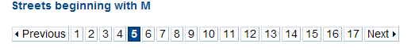

Then select Marine Drive from the list given below by double clicking on it:
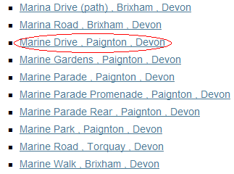

The system will now present you with the all the records containing the word ‘Marine Drive, Paignton’ in the address.

Scroll through the records to find the property/application that you are looking for.

Using the ‘Map’ tab
Back to menu

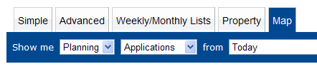
The ‘Map’ tab enables you to look for applications within a given area. This search method is most useful if you are uncertain of any addresses involved but you know the area that you want to look in.

Use the ‘plus’ symbol to zoom in gradually on you search area and use the hand symbol to move around.
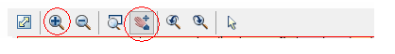
Remember to set the date for the search and if no search results appear then try changing the search date.
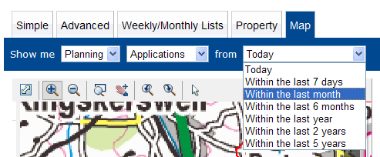

If the system finds any planning applications within that area and timeframe the details will appear to the right of the map.
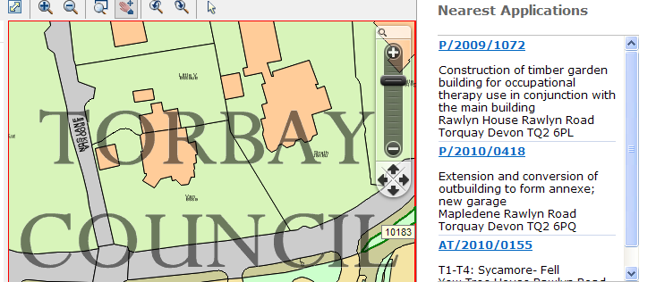

Please note that the ‘Map’ tab may not reveal the entire planning history of a property and is best used in conjunction with the other search mechanisms available on ‘Planning Online’.
Once you have selected an application-retrieving information
Back to menu

This guide has been designed to show you how you can retrieve information once you have opened an individual planning application record.
Basic details
Back to menu

The ‘Details-Summary’ screen holds the most important basic information about an application such as its unique reference number, the site address, the proposal description and the status of the application.

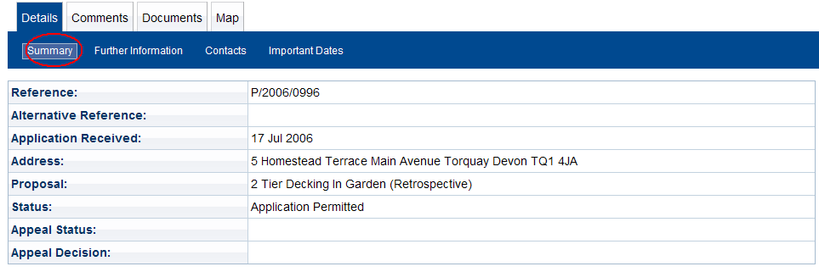

The ‘Further Information’ screen will also give you important facts such as the case officer and the applicant’s name.

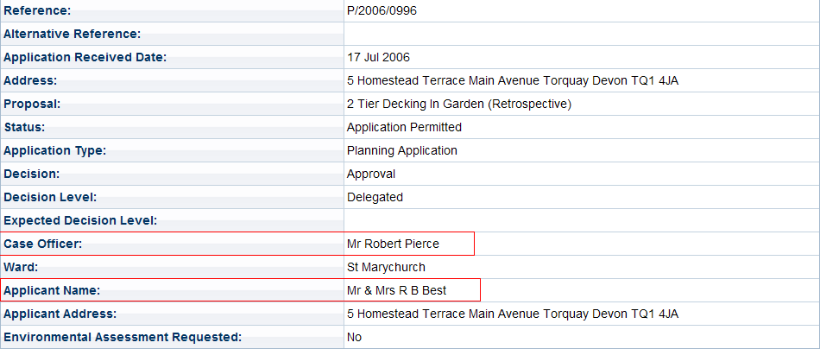

The ‘Contacts’ screen will tell you which ward councillor’s area the application site falls within.


The ‘Important Dates’ screen gives important information such as the date we received an application. One of the most common reasons for looking on the ‘Important Dates’ screen is to establish what date letters of objection or support need to have been submitted to us by. This is the ‘Latest Site Notice Expiry Date’. So, in the example given below, all letters of representation would need to have been submitted by August 18th:
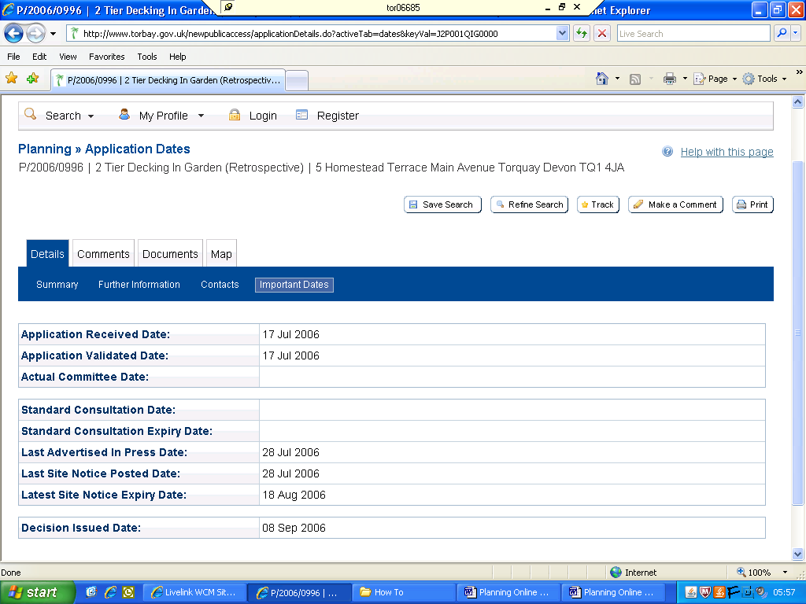

Comments made about an application
Back to menu

The ‘Comments’ page shows you all the comments that have been made by members of the public either to support or to object to the application. Comments listed may have been made electronically or in writing. If the wording states ‘No comment on record’ this means that the comment was made in writing and can be viewed in the ‘Documents’ tab. 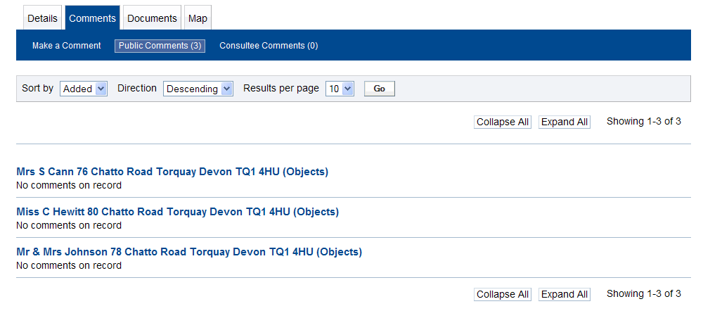
If you wish to submit a comment yourself select the ‘Make a comment’ option which can be found in the blue-coloured options bar near the top.

Viewing Documents
Back to menu

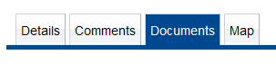
Selecting the ‘Documents’ tab allows you to view all the documents concerning that file that we have received. This includes both what the applicant has submitted and also any letters of objection or support that we have received in writing. Double click on
and then select the item from the list.

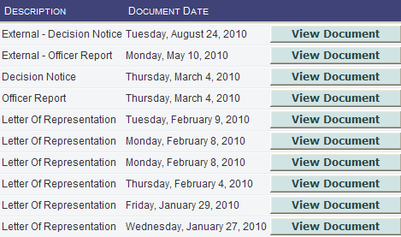
Be aware that there is often more than 1 page of documents listed.


Application form – Gives all the important details about application and is filled in by the applicant or their agent if applicable.
Decision Notice – The legal document granting or refusing planning permission
Officer Report – The report made by the planning officer assigned to that case which details all the important facts about the application.
Existing Elevations/Layout – Illustrates how the site is at the time the application was made.
Proposed Elevations/Layout – Illustrates what the applicant wishes the site to be like.
O.S. Map – The site location plan. If the plan has been scanned in colour the boundaries of the site are denoted by a red line and if the applicant owns any land adjoining the site this will be denoted by a blue line.
Access & Design Statement – Document sometimes required which details the design of the proposed development and gives information about access for disabled persons at the site.
Letter of representation – Comments made by third parties
Additional Information/Supporting Information – Miscellaneous documents.

Viewing the plans
Back to menu

Note the toolbar that appears above the plan.
 = zoom in and out = enter the scale here
 = display whole document = view in larger format
= rotate the image
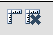 = start and finish measuring

To zoom in on a part of the plan press on the ‘plus’ symbol and then place the cursor on the part of the plan that you want to zoom in on. Now draw a box with your cursor around the area that you want to enlarge. Now go back to the ‘plus’ sign and click on it to zoom in. Use the ‘minus’ symbol to zoom back out at any time.

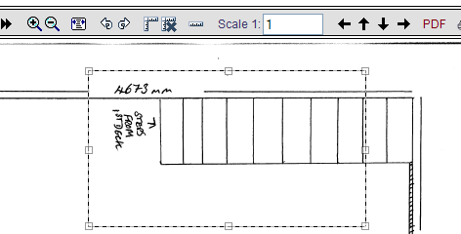

Making measurements
Back to menu

You will first need to find out what scale the drawing has been made to (1:00, 1:50 etc) and this is usually written in the bottom right hand corner of most architects’ plans. You will then need to enter that number in the ‘scale’ box on the toolbar.

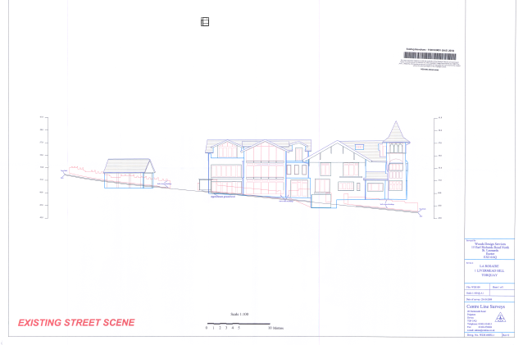

For example, this plan has been drawn to a scale of 1:100.

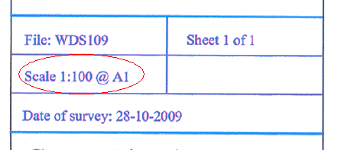

Therefore you must enter ‘100’ into the scale box in order to make accurate measurements:

Now click on the set-square symbol to activate the measuring tool.
Select your starting point using the cursor (a red cross will signify your start point now) and then click on your finish point.

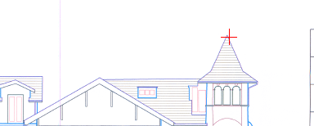

You will now see a red line indicating your measured distance line and the distance from start point to finish point will appear in metric in the grey box.
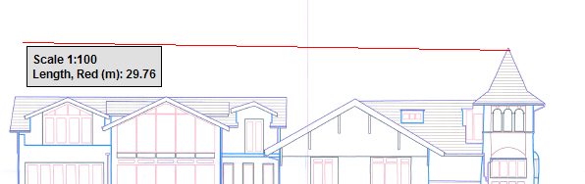

If you wish to remove your ‘measured-distance line’ then click on the symbol of the set square with the cross next to it on the tool bar.

When you wish to finish taking measurements (for example if you need to zoom in or out on the map at any point) you will need to un-highlight the set-square symbol to deactivate the measuring tool.

 Not all plans are drawn to scale and those not drawn to a scale cannot have accurate measurements made from them. However, if the plan has not been drawn to scale the applicant has often given metric measurements written on the plan itself.

‘Maps’ tab-viewing the site area
Back to menu

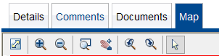
The ‘Map’ tab shows the site area of the application and the boundaries of the site are denoted by the green line. This site is plotted according to the data given to us on the applicant’s site location (Ordnance Survey) plan.
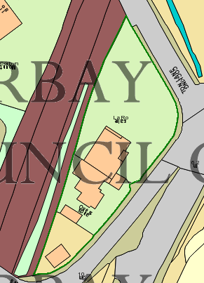
You are able to use the toolbar to move around within the map and to zoom in and out.

Registering with Planning Online
Back to menu

Registering with Planning Online enables you to keep a record of applications that you have viewed as well as updating you by email on the progress of any applications that are of particular interest to you. This is a very useful service if you wish to keep up to date with what planning applications we have received as well as you keeping up to date with any particular application(s) you may be particularly interested in.

To register please visit www.torbay.gov.uk/planningonline, select the ‘register’ option and follow the instructions given onscreen.


You will be sent an email shortly after that asking you to complete your registration and to log in.

Whenever you visit the Planning Online website please login and this will allow you to use all of the services available through Planning Online as well as being able to view and modify your account details at any time.

Not receiving emails?

Please note that any emails from Planning Online may arrive in your email box as spam and you may need to check your spam box for these items. This applies particularly to web-based email accounts.
If you have had problems receiving emails from our system then please note:
If your ‘spam’ settings are set very high it may mean that your email in-box is not allowing emails from our system to arrive with you. Also, if you have a ‘safe-sender’ option you may wish to add planning@torbay.gov.uk to your list, thus allowing any emails from our system to arrive in your mailbox rather than your junk-mail/spam box.

Tracking Applications
Back to menu

If you wish to track the progress of an individual application then simply ‘log in’ before commencing a search. Once you have searched for an application and the application you want is on screen select the ‘Track’ button that appears above the details of the application.
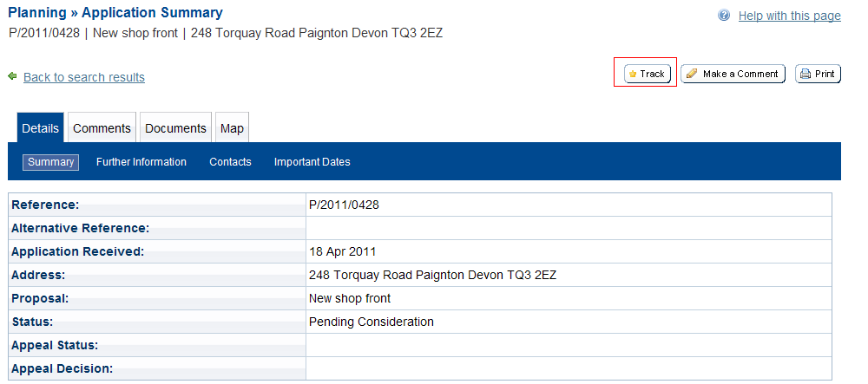
If you have registered with Planning Online then once you have selected to track an application you will automatically receive an email informing you if the ‘status’ of the application has changed, for example if the decision on the application has been made.
You can view your list of tracked applications and request to stop tracking an application by logging in and then selecting ‘Tracked Applications’.
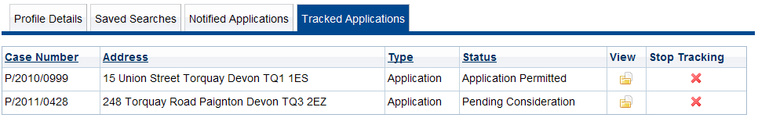

Saving a Search
Back to menu

You may want to be informed about applications that meet certain criteria, such as those within the same postcode area, ward etc.
You will need to ‘log in’ before undertaking a search.
You can use the ‘simple’ or the ‘advance’ search tabs to undertake your search.
For example, if you wanted to receive notification whenever we receive a planning application in the Wellswood area for the next year, you would go to the Advanced Search tab and then:
Select Wellswood as the ward:

‘Status’ would be ‘Pending Consideration’

Date received would need to be set for 1 year:

Once you have set the criteria and pressed ‘search’ please then select the ‘Save Search’ option that appears above the results of your search.
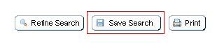

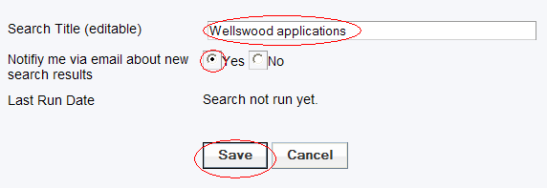

At this stage you can edit the search title to change it to something more meaningful to you. You will be asked whether you wish to be notified via email about new search results or not. If you select ‘yes’ to this option you will be notified by email every time a new application matching this criteria is validated. If you do not wish to be notified by email about new search results you can still view your search results in the ‘Saved Searches’ option whenever you log in.

Although your email notification about an application provides a live link to that application on Planning Online (simply double-click on the item in the email) you can also view your saved searches and tracked applications by logging in when you enter the Planning Online site.

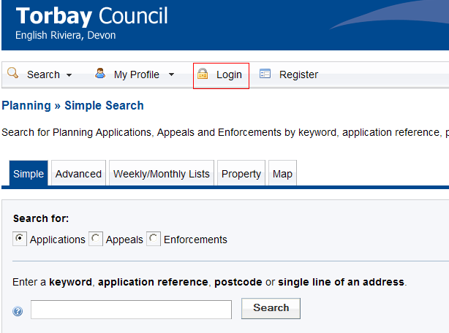

From there please select the ‘My Profile’ option.
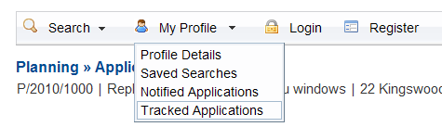

You will automatically be shown a list of each application that you have been notified about and from here you can also access the lists of applications that you have saved and tracked.

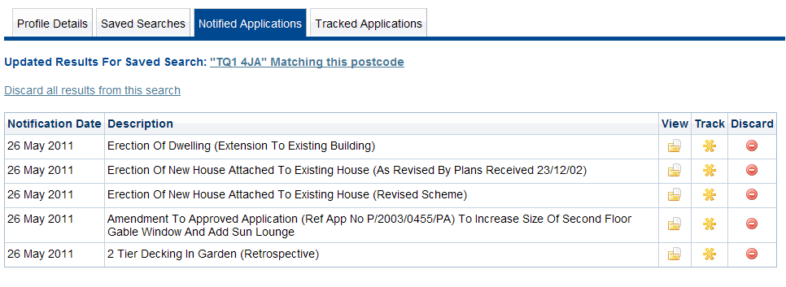

Changing your personal profile details
Back to menu

‘Login’ (enter your email address and then your password)

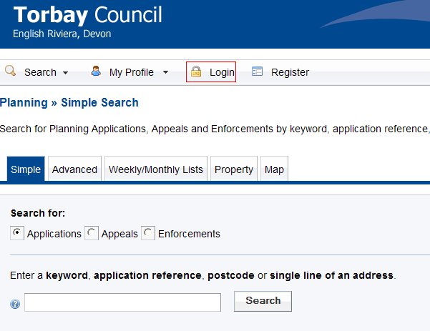

Select the ‘Profile Details’ tab

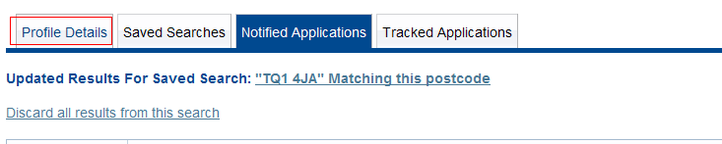

You will see the options available to:

 You can change this to something more meaningful to you
 You can modify your account details
 You can delete the account

To change you password:

Select:

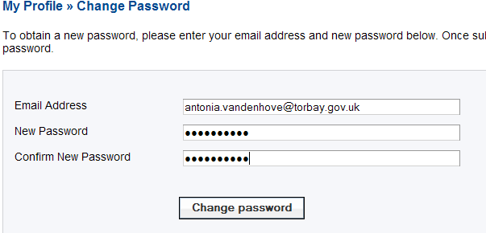

Once you have changed your password you will be sent an email asking you to confirm this change. When you have received the email open it and go back into Planning Online using the link on the email and log in again to change further details if you wish to:

Select the ‘Update Personal details’ tab

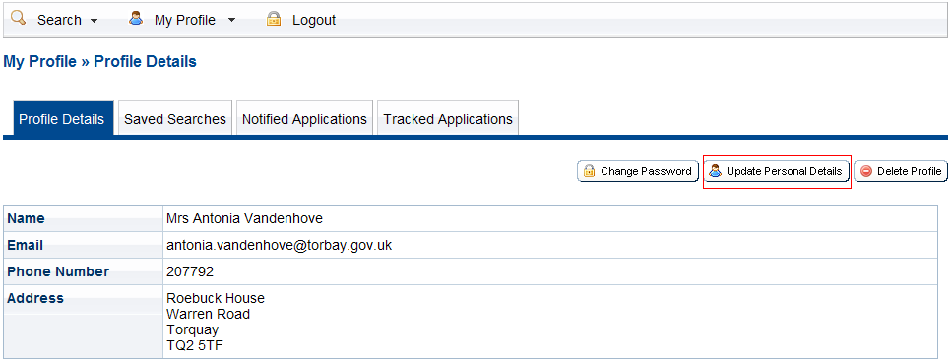

You will now arrive at the ‘Update Personal Details’ page.

From here you can:
- change your title if you need to
- enter a telephone number if you wish to
- change the email address if you wish to have the emails sent to an address other than your work email address (just delete the one that’s currently in there and replace it with another one)

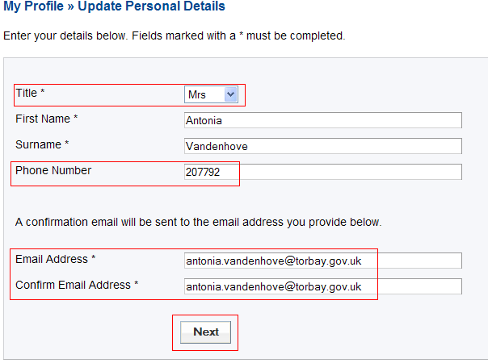

To change the address on your profile:

Delete the current postcode and enter your own home postcode. Select ‘Next’
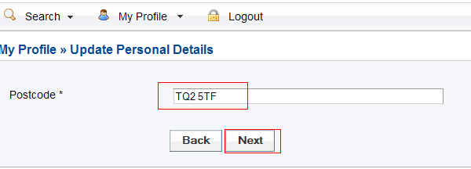

Delete the current postcode and enter your own home postcode. Select ‘Next’

Select your address from the selection available

Click here
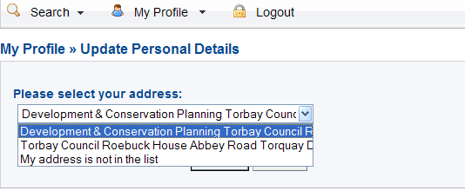

Agree to the Terms and Conditions and Privacy Policy then select ‘Next’

You will now be told that you’re your registration details have been updated.

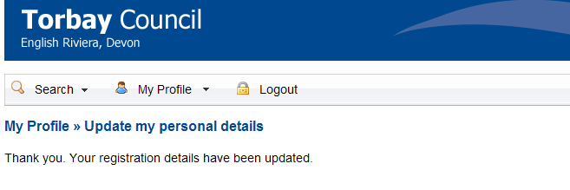
Whenever you visit the Planning Online website please login and this will allow you to use all of the services available through Planning Online as well as being able to view and modify your account details at any time.

Managing Your Account
Back to menu

The ‘Notified Applications’ tab holds the details of all the applications that you have met your ‘saved search’ criteria.
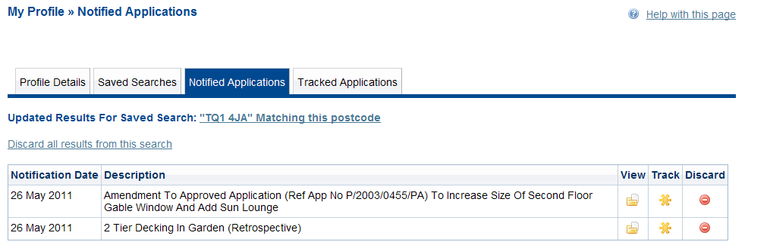

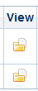
This will open up the individual application for you to view all the details



This will track the application and you will be notified by email when the status of the application changes

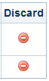
This will delete the individual application from your search results

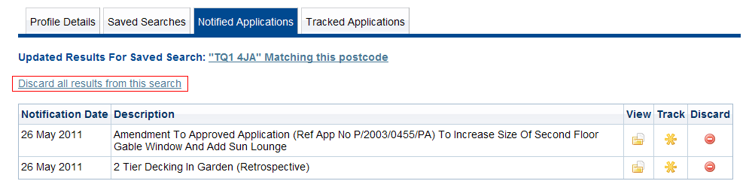
You can clear batches of search results using:
(You will still be notified when any new applications meet this criteria)

The ‘Saved Searches’ tab shows the search criteria that you’ve set.

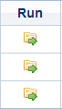


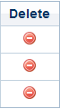
Shows the applications meeting that criteria

To edit your search criteria

To delete that search criteria (email notifications discontinue)

The ‘Tracked Applications’ tab shows the applications that you’re tracking (to be notified of any status changes)

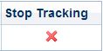

This will open up the individual application for you to view all the details

To stop tracking that application (email notifications discontinue)

Deleting Your Account
Back to menu

Now select

The account with Planning Online will now be deleted.

