Application for a Storage Licence under the
Explosives Regulations 2014

Please read the guidance notes on page 5 before completing this form
- You should not use this form for an application for a licence to store the explosives listed in note 1 (page 5)
- You should only use this form if you want to store no more than 2000kg of explosives
- If there is insufficient room to provide the information requested, please continue on a separate sheet(s) (see note 2)
- Please note that it is an offence under Section 33 of the Health and Safety at Work etc Act 1974 to provide false information. Incomplete or inaccurate information could result in a delay in the processing of your application.
- The information contained in this form may be stored electronically. The information may, where appropriate, be shared with other relevant bodies such as other local licensing authorities or the Health and Safety Executive. You have the right to request a copy of any personal information and to have any inaccuracies corrected.
- Please complete this form using black ink.
The information gathered on this form may constitute personal data as defined in the Data Protection Act 1998. Any personal data will be processed in accordance with the requirements of that Act.

The application is for: [tick the box that applies]

New storage licence Renewal storage licence

If this is a renewal application, please state the date of expiry and any reference number

Expiry Date

Reference No.

Nature of business: [tick the category or categories that apply to this application]

Fireworks – retail Fireworks-import/wholesale Fireworks-display operator

Recreational user Other [please specify)

Are you applying for a licence where the storage will be subject to separation distances? (See note 5)
Yes No

Details of the applicant: [if you are applying on behalf of a company or limited liability partnership (or, in Scotland only, a partnership), please give its name].

Name of applicant:

Companies House No (if applicable)

Date and place of birth [where applicant is an individual]

N.I. no [where applicant is an individual]

Address [including postcode]. If the applicant is a company, please give the registered office

Daytime telephone number:

Mobile number:

Email:

Full address (including postcode) of the place where the explosives will be stored:

Do you have an explosives store at an address different to that above? Yes No

If yes, please provide the full address including postcode of this store

Do you have a licence for this store? Yes No . If yes, please provide the licence number and date of expiry

Licence Number: Date of Expiry:

If the applicant is not the owner/manager of the business, please give the details of the person with management responsibilities for the store.

Name: Position:

Address including postcode [if different from above]

Contact telephone number:

Email:

Out of hours contact details (if different from above) – please give the name and telephone number, including mobile if appropriate, of the person to be contacted in an emergency.

Name of contact:

Telephone No: Mobile No:

Explosives to be kept and quantities

Hazard Type or UN number | Amount (net mass – kg)

[Please tick the box or boxes that apply]

1. Are you intending to store more than 75kg (net) of ammunition or pyrotechnic articles in a building that adjoins domestic premises? Yes No

2. Have you had a previous licence or registration¹ refused or revoked? Yes No

3. Have you been convicted of any offence under legislation on health and safety, (See note 4) Yes No

4. Have you been convicted of any other offences relating to the storage, sale, supply, importation or possession of fireworks and/or any other explosives? (See note 4) Yes No

5. Have you been convicted of any offence under any other legislation including offences against the person, dishonesty offences and offences relating to the supply of controlled drugs? (See note 4)
Yes No

If you have answered “Yes” to any of questions 2-5, please give date(s) and details, including the licensing authority and court where convicted

1 See Regulation 11 of the Manufacture and Storage of Explosives Regulations 2005, SI 2005/1082

Signature of applicant (or applicant’s representative)

By signing this form you agree to the information provided, in relation the explosives stored e.g. the type and quantity, being shared with the emergency services in the event of an incident.

Signed: Date:

Name: Position/Job title:

Organisation [if applicable]

The completed application form, together with the following documents in support of the application, should be sent to:

Licensing and Public Protection, Torbay Council, Town Hall, Castle Circus, Torquay TQ1 3DR

(Please tick the boxes to confirm the following have been submitted)

Application fee: [see note 10] (If you are unsure of the fee, please ask your licensing authority).

Supplementary information sheet (if applicable) [see note 2]
Plan of the site: [see notes 6 & 7]

Floor plan: (if explosives are to be kept on the shop floor or in a building that is to be used for other purposes as well as the storage of explosives) [see note 8]

For licensing authority use only:

Application form completed

Fee enclosed

Site Plan enclosed

Building Floor Plan enclosed (if applicable)

Guidance to applicants

IMPORTANT It is your responsibility to ensure you are aware of, and comply with, the Explosives Regulations 2014.
The licensing authority has the power to prohibit storage of explosives at the site if it believes the site is no longer suitable. It may also take enforcement action if you are not storing safely.

If you are intending to supply fireworks outside the normal permitted period’s e.g. New Year, Chinese New Year, October 15th-November 10th and Diwali, you will also need to make a separate application to your local licensing authority for a licence to comply with the Fireworks Regulations 2004.

General information and notes on completing the application

Note 1 - This form should not be used for an application for a licence to store the explosives listed below:

- relevant explosives

- ammunition the acquisition of which is regulated or prohibited by virtue of the Firearms Acts 1968 to 1997

- smokeless powder or percussion caps

- explosives stored by a person who is registered as a firearms dealer under section 33 of the Firearms Act 1968

If you want to store the explosives listed above, you should use form ER2

You should only use this form if you want to store no more than 2000kg of explosives.
If you want to store more than 2000kg of explosives you should apply to the Health and Safety Executive for a
licence. Further information on licensing can be found at www.hse.gov.uk/explosives/licensing/how-to-apply.htm

Note 2 - If there is insufficient room to provide the information requested, please continue on a separate sheet(s). You should also put your name and address at the top of each sheet before attaching the sheet(s) to your application form.

Note 3 - Please contact Cornwall Fire and Rescue Service admin if you have any questions about your application.
Licensing and Public Protection
Torbay Council
Town Hall, Castle Circus
Torquay
TQ1 3DR
Tel: 01803 208025
Email: Licensing@Torbay.gov.uk

Note 4 - Please note: Any previous convictions you may have may be subject to the Rehabilitation of Offenders Act 1974 and you do not have to include convictions that are ‘spent’ on this application form. Where the application relates to a corporate body or company convictions of all directors should be listed. Where the application relates in Scotland to a partnership, convictions of all partners should be listed. Information on how Licensing Authorities will consider the relevance of previous convictions to an application for a licence can be found at www.hse.gov.uk/explosives/index.htm

Note 5 - Separation distances - please see Regulation 27 of the Explosives Regulation 2014. You will not normally be required to maintain separation distances if you store no more than:

- 250kg HT4

- 25kg HT3 (or combination of HT3 and HT4)

- 0.1kg HT1

- 0.1kg HT2
On one site - If you are unsure whether your store or on places where you will be manufacturing or processing explosives on site are subject to separation distances, contact your local licensing authority

The following documents should be submitted with the application form:

Note 6 - A plan to a scale sufficient to show the location of the site in relation to its surroundings (i.e. named or numbered roads, hamlets, villages or geographical features). Where the site does not have a postal address this should normally be a minimum scale of 1:25000.

Note 7 - If the store is subject to separation distances you will also need to provide an Ordnance Survey Site plan (or similar) map showing the location of the store and distances to any neighbouring buildings. The plan should also show any areas where you intend to process or manufacture explosives where a licence for those activities is not required under regulation 6 of ER2014. The scale will depend on the separation distance. For a distance of up to 200 metres, a 1:1250 would normally be required while greater distance would require a 1:2500 or even a Super Plan. Where this plan clearly identifies the location of the site in relation to its surroundings it can be substituted for the plan referred to in 6 above.

Note 8 - If you intend to store or display more than 12.5kg of fireworks on a shop floor, the licensing authority will require you submit a floor plan of the sales area.

Note 9 - If you intend to store, process or manufacture explosives within a building that is also used for other purposes you should include a floor plan showing the places within the building where you intend storing, processing or manufacturing the explosives.

Note 10 - The fee must also be submitted with the application. Information on fees can be found at www.hse.gov.uk/explosives/licensing/fees.htm, or contact your licensing authority for advice.

Hazard type and quantity

Note 11 - The licensing authority will need to know the hazard type and quantity of the explosives you wish to store to determine whether your store is suitable. The quantity you will be allowed to store will depend on the hazard type of the explosives. Please contact your supplier if you are uncertain about the hazard types of explosive you wish to store.

Note 12 - The “quantity” refers to the ‘net mass’ of the explosives. This means the weight of the explosive contained within an article i.e. less packaging, casings, etc.

Period of validity

Note 13 - Licences for fireworks and other explosives that do not require an explosive certificate may be granted for up to 5 years as the licensing authority determines.

Generic Schedule of Works/Floor Plan

To progress your application you need to provide a schedule of all proposed works you intend to carry out to ensure safe storage and sale of explosives. Include a floor plan of the premises indicating the location and size of both the non-public storage area and the shop floor public area, along with the proposed location of any firework display cabinet(s), emergency escape routes and the location of fire extinguishers.

The plan may be hand-drawn but must include the floor sizes of the two areas, or site, together with a copy of your risk assessment.

If there is domestic/sleeping accommodation above, adjoining or in the vicinity of the premises where you intend to store explosives please advise if it is occupied.

To help we have provided this example generic plan. You can use this as a guide, changing it as necessary to reflect the specific circumstances relating to your proposed activities. Attach any extra information you feel necessary.

Example Schedule of Works

Stock:

- Check order with supplier to confirm hazard type of fireworks to order
- Check that maximum Net Explosive Quantities permitted by licence/registration application for the Hazard Type is not exceeded.

Staff:

- All staff reminded of rules and procedures re storage and sale of fireworks.
- Training records updated.

Storage Area:

- Empty rear store area of highly flammable/combustible material
- Check storage area for damp.
- Blank off access to electrical power outlets. Remove electrical equipment other than light fittings.
- Install wooden shelving to hold up to 250kg Hazard Type 4 fireworks in transit boxes.
- Put up No Entry sign to non-public storage area.
- Put up No Smoking Sign on entry door.
- Display Hazard Warning notice on Entry door.

Public Shop Area

- Display cabinets checked for suitability. No smoking sign placed next to display area.
- Location of display cabinets checked at least 1 metre from any live electrical equipment.
- Fire Extinguishers checked for type and rating (at least two minimum rated 13A) and last service. Replace any not working/out of date.
- Escape route clear. Door(s) unlocked whenever store is occupied.

Example Site Plan

LICENSED PREMISES SITE PLAN WITH SEPERATION DISTANCES

Minor Road

45M

Explosive Store

MINOR ROAD
87M
30M

72M
Barn
House

Public footpath / bridleway

Note: The site plan must include the separation distance of all buildings, footpaths, bridleways, thoroughfares, minor roads, major roads, places of public resort & railway lines within a 90mtr radius of your proposed store.

Example Floor Plan

Include a floor plan for each floor you intend to use to store explosives, ground, first, second floor etc.

Ground Floor
15M
5M
P
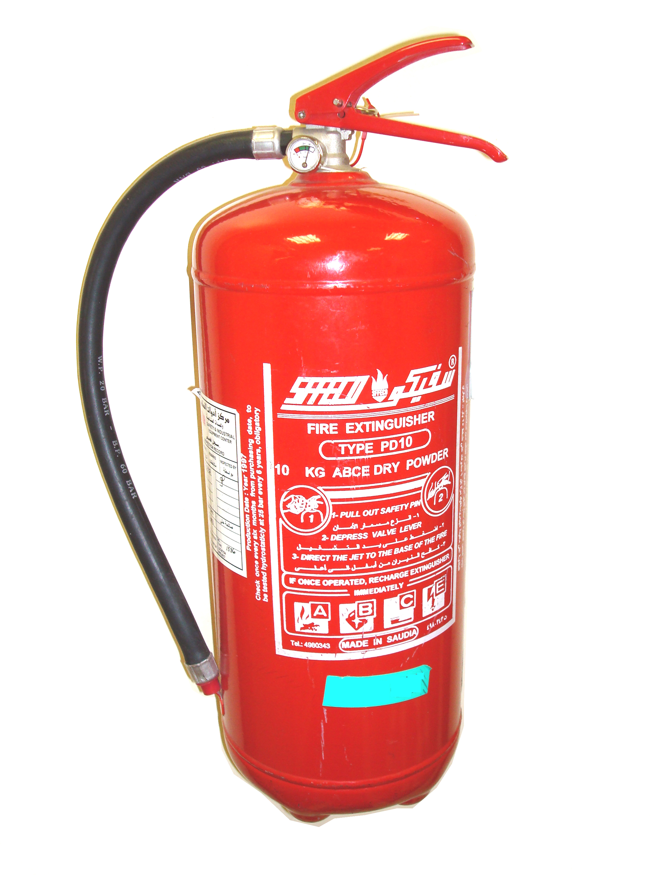
Storage area

5m
Till
5M

Public area display cabinet
15M

Escape Route
10M

Fire Extinguisher =

75m² (length x width)
Size of Explosives Non Public Storage Area site:
225m²
Size of Public Shop Floor Area:
13A Water
Rating/Type of Fire Extinguishers:

Residential accommodation above, adjoining in the vicinity? Yes No

Occupied? Yes No

Note: Fireworks should not be stored in a cellar or basement or in any place that would hinder escape from the premises; for instance in or under a staircase.
Mr A N Other
Completed by (print name):
Owner/Manager
Position:
Acme Company Ltd
Name of Business:

Trading Address that this schedule/plan applies to:
1 The Street, Any Town, Cornwall AA1 BB2

I confirm this is an accurate statement as to the proposed works and floor plan for the attached application.
A N Other
Signed:
1 September 2014
Date:

Site Plan

LICENSED PREMISES SITE PLAN WITH SEPERATION DISTANCES

Note: The site plan must include the separation distance of all buildings, footpaths, bridleways, thoroughfares, minor roads, major roads, places of public resort & railway lines within a 90mtr radius of your proposed store.

Floor Plan

Include a floor plan for each floor you intend to use to store explosives, ground, first, second floor etc.

Size of Explosives Non Public Storage Area site:

Size of Public Shop Floor Area:

Rating/Type of Fire Extinguishers:

Residential accommodation above, adjoining in the vicinity? Yes No

Occupied? Yes No

Note: Fireworks should not be stored in a cellar or basement or in any place that would hinder escape from the premises; for instance in or under a staircase.

Completed by (print name):

Position:

Name of Business:

Trading Address that this schedule/plan applies to:

I confirm this is an accurate statement as to the proposed works and floor plan for the attached application.

Signed:

Date:

