Borough of Torbay
Temporary Parking Restrictions (Hyde Road, Paignton) Revocation Order 2025
Torbay Council made the above Order on 5th September 2025 under the provisions of the Road Traffic Regulation Act 1984, as amended. The effect is to revoke the traffic regulation orders listed in Schedule 1 as follows:
Schedule 1: Orders Revoked
“Borough of Torbay Road Traffic Regulation Act 1984, Section 14(1) – Temporary Parking Restrictions (Hyde Road, Paignton) Order 2025”

Documents giving more detailed particulars of the Order may be inspected between 9:00am and 5:00pm each working day at the Torbay Council Connections Office, Paignton Library and Information Centre, Great Western Road, Paignton, TQ3 3HZ. The documentation may also be viewed online at the following web address: www.torbay.gov.uk/proposedtros

If any person wishes to question the validity of the order or of any of its provisions on the grounds that such is not within the powers conferred by the Act, or that any requirement of the Act or of any instrument made under the Act has not been complied with, that person may within six weeks from the appearance of this advertisement apply to the High Court for this purpose.
Date: 18th September 2025  Anne-Marie Bond  Chief Executive  Torbay Council  Town Hall, Castle Circus  TORQUAY TQ1 3DR | 

DATED 5 September 2025

BOROUGH OF TORBAY
Temporary Parking Restrictions (Hyde Road, Paignton)
Revocation Order 2025

ANNE-MARIE BOND
Chief Executive
Torbay Council
Town Hall
TORQUAY
TQ1 3DR

BOROUGH OF TORBAY
Temporary Parking Restrictions (Hyde Road, Paignton)
Revocation Order 2025

The Council of the Borough of Torbay (“the Council”) in exercise of its powers under Sections 32, 33 and 35 of the Road Traffic Regulation Act 1984 (“the 1984 Act”) as amended by the Parking Act 1989 and the Traffic Management Act 2004 and of all other enabling powers with the consent of the County Council of Devon in accordance with Section 39(3) of the 1984 Act and after consulting with the Chief Officer of Police in accordance with Part III of Schedule 9 to the 1984 Act hereby makes the following Order:-

1. This Order shall come into force on the day of 2025 and may be cited as the “Borough of Torbay Temporary Parking Restrictions (Hyde Road, Paignton) Revocation Order 2025”.

2. Without prejudice to the validity of anything done before or to any liability incurred before the coming into force of this Order, the “Borough of Torbay Road Traffic Regulation Act 1984, Section 14(1) – Temporary Parking Restrictions (Hyde Road, Paignton) Order 2025” is hereby revoked.

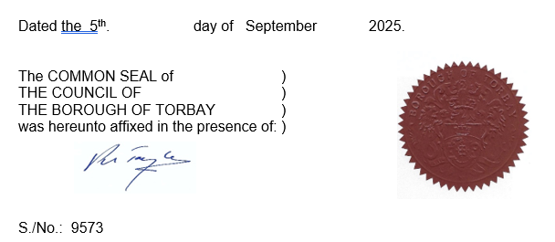

Schedule 1: Revocations

Borough of Torbay Road Traffic Regulation Act 1984, Section 14(1) – Temporary Parking Restrictions (Hyde Road, Paignton) Order 2025

