Heritage Impact Assessment: The Marina Car Park, Torquay
HELAA2021 Ref: | 21T139
Site Address: | The Marina Car Park, Torquay
Site Area (ha): | 0.49
Site Yield: | 40
HIA Assessment

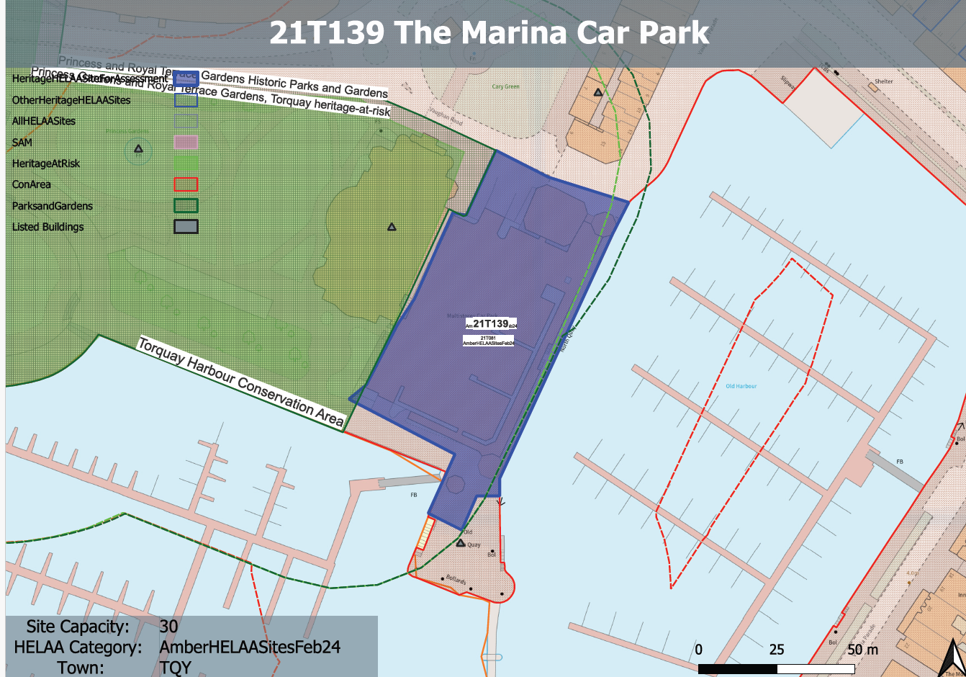
Site overview and heritage context:
MDL car park and offices on the western side of Torquay Inner Harbour.
The site is in a prominent location within the Torquay Harbour Conservation Area and is surrounded by a large number of heritage assets situated around the harbour and the adjacent Grade II listed Torquay Pavilion and the Princess Gardens RPG.

Planning History:
P/2015/0961 – MPA - Change of use and restoration of Pavilion to form hotel reception and spa including restaurant, bars and function rooms. Construction of 4/5 storey 60 bed hotel, 5 and 11 storey block of 43 residential apartments, with ground floor restaurant and retail uses adjacent to harbour. Link between Pavilion and new hotel. Construction of new harbour walkway, provision of 289 car parking places including 69 spaces on Cary Green (42 seasonal; 32 for hotel). Construction of Marina Office and berth holder facilities and erection of Dock masters Office and associated landscaping (proposal revised 5 July 2016) – REFUSED - 12/03/2019
P/2014/0282 - Change of use and restoration of the Pavilion to form hotel reception and spa including restaurant, bars and function rooms. Construction of 4/5 storey 60 bed hotel and 14 storey block of residential apartments, with ground floor restaurant and retail uses adjacent to the harbour. Link between the Pavilion and new hotel. Construction of new harbor walkway, provision of 280 car parking spaces including 65 spaces on Cary Green. Construction of Marina Office, berth holder facilities and landscaping (revised scheme as amended by plans received 16 October 2015) – FINALLY DISPOSED OF – 12/03/2019

Heritage Asset Affected by Allocation | Designation | Contributing Elements to Significance | Impact of Development on Significance | Mitigation Measures for any Identified Harm /Opportunities to Enhance Significance | Impact on Significance with Mitigation in place
Torquay Harbour Conservation Area | Conservation Area | The conservation area evidences the growth of Torquay as  a high-end resort town in the late 18th and 19th centuries with distinctive architecture which illustrates the town’s transition from a small fishing port into a prestigious resort.  The rich mixture of architectural  typologies demonstrates the evolution of architectural fashion from the late 18th to the 20th centuries and lends significant visual interest and historic  character. The site currently makes a detrimental impact on the significance of the conservation area. | If sensitively designed to respect the existing character of the harbourside and the surrounding historic environment, development of the site could have a neutral impact on the significance of the asset | n/a | Neutral
Princess Gardens (W of site) | Grade II Registered Park and Garden | The site in its current form makes a negative contribution to the significance of the asset through the dilution of the quality of the built environment within the immediate surroundings of the asset. | Development of the quantum of unit stated could have in close proximity to the asset could have a detrimental impact on the way in which the asset is experienced, especially from the east, north and south. This would cause less than substantial harm to its significance | If sensitively designed to respect the existing character of the harbourside and the surrounding historic environment and positively address the asset whilst maintaining important views to and from the asset, development of the site could have a neutral impact on the significance of the asset | Neutral
Fountain in Princess Gardens (W of site) | Grade II listed building | Fountain. c1894, contemporary with the laying out of the pleasure grounds. The site in its current form makes a neutral contribution to the significance of the asset. | If sensitively designed to respect the existing character of the harbourside and the surrounding historic environment, development of the site could have a neutral impact on the significance of the asset | n/a | Neutral
Princess Gardens War Memorial (W of site) | Grade II listed building | A group of late C19 seafront public gardens and picturesque terraced cliff walks. The site in its current form makes a negative contribution to the significance of the asset through the dilution of the quality of the built environment within the immediate surroundings of the asset. | If sensitively designed to respect the existing character of the harbourside and the surrounding historic environment, development of the site could have a neutral impact on the significance of the asset | n/a | Neutral
Mallocks Clock Tower (NE of site) | Grade II listed building | Clock tower. 1902. Designed by J Donkin of Bournemouth, carved work by Harry Hems & Sons, contractor EP Bovey. Erected by public subscription to commemorate Richard Mallock, M.P. The site in its current form makes a neutral contribution to the significance of the asset. | If sensitively designed to respect the existing character of the harbourside and the surrounding historic environment, development of the site could have a neutral impact on the significance of the asset | n/a | Neutral
Torquay Pavilion (W of site) | Grade II listed building | Pavilion. 1911 by HA Garrett, Borough Surveyor, based on 1897 designs by Edward Richards, architect to the Haldon estate; contractor RE Narracott of Stoke Gabriel. The site in its current form makes a negative contribution to the significance of the asset through the dilution of the quality of the built environment within the immediate surroundings of the asset. | Development of the quantum of unit stated could have in close proximity to the asset could have a detrimental impact on the way in which the asset is experienced, especially from the east, north and south. This would cause less than substantial harm to its significance | If sensitively designed to respect the existing character of the harbourside and the surrounding historic environment and positively address the asset whilst maintaining important views to and from the asset, development of the site could have a neutral impact on the significance of the asset | Neutral
3 – 15 Vaughan Parade (N of site) | Grade II listed building | Terrace of 7 houses. 1831, to the designs of Jacob Harvey. Thorough renovation, replanning and rear additions of 1991. The site in its current form makes a negative contribution to the significance of the asset through the dilution of the quality of the built environment within the immediate surroundings of the asset. | If sensitively designed to respect the existing character of the harbourside and the surrounding historic environment, development of the site could have a neutral to positive impact on the significance of the asset. | An appropriately designed and sensitive development which raises the quality of the built environment could enhance the significance of the asset and the way in which it is experienced. | Neutral/enhancement
Cary Estate Office (N of site) | Grade II listed building | Office of the Cary Estate. Probably 1859 when the building became the Devon and Cornwall Bank (Ellis, p.276). Became the Cary Estate Office in 1908. The site in its current form makes a neutral contribution to the significance of the asset. | If sensitively designed to respect the existing character of the harbourside and the surrounding historic environment, development of the site could have a neutral impact on the significance of the asset | n/a | Neutral
1 Palk Street (N of site) | Grade II listed building | No.1 PALK STREET. Library, billiard and public rooms, now in use as offices. 1831 by Jacob Harvey, contemporary with the rest of Vaughan Parade. The site in its current form makes a neutral contribution to the significance of the asset. | If sensitively designed to respect the existing character of the harbourside and the surrounding historic environment, development of the site could have a neutral impact on the significance of the asset. | n/a | Neutral
Lloyds Bank, Palk Street (N of site) | Grade II listed building | Bank. c1900. Fine sandstone ashlar on a local grey rock-faced limestone plinth; roof concealed behind balustraded parapet. The site makes a limited contribution to the setting of the asset. | If sensitively designed to respect the existing character of the harbourside and the surrounding historic environment, development of the site could have a neutral impact on the significance of the asset. | n/a | Neutral
Royal Bank of Scotland, The Strand (NE of site) | Grade II listed building | Bank. 1893, by C R Grittle, chief architect at National Provincial Bank. The site falls within the urban and harbourside setting of the asset. The site in its current form makes a neutral contribution to the significance of the asset. | If sensitively designed to respect the existing character of the harbourside and the surrounding historic environment, development of the site could have a neutral impact on the significance of the asset. | n/a | Neutral

