Heritage Impact Assessment: Triangle West of Bascombe Rd, N of disused railway, Brixham
HELAA2021 Ref: | 21B055
Site Address: | Triangle West of Bascombe Rd, N of disused railway, Brixham
Site Area (ha): | 1.45
Site Yield: | 15
HIA Assessment

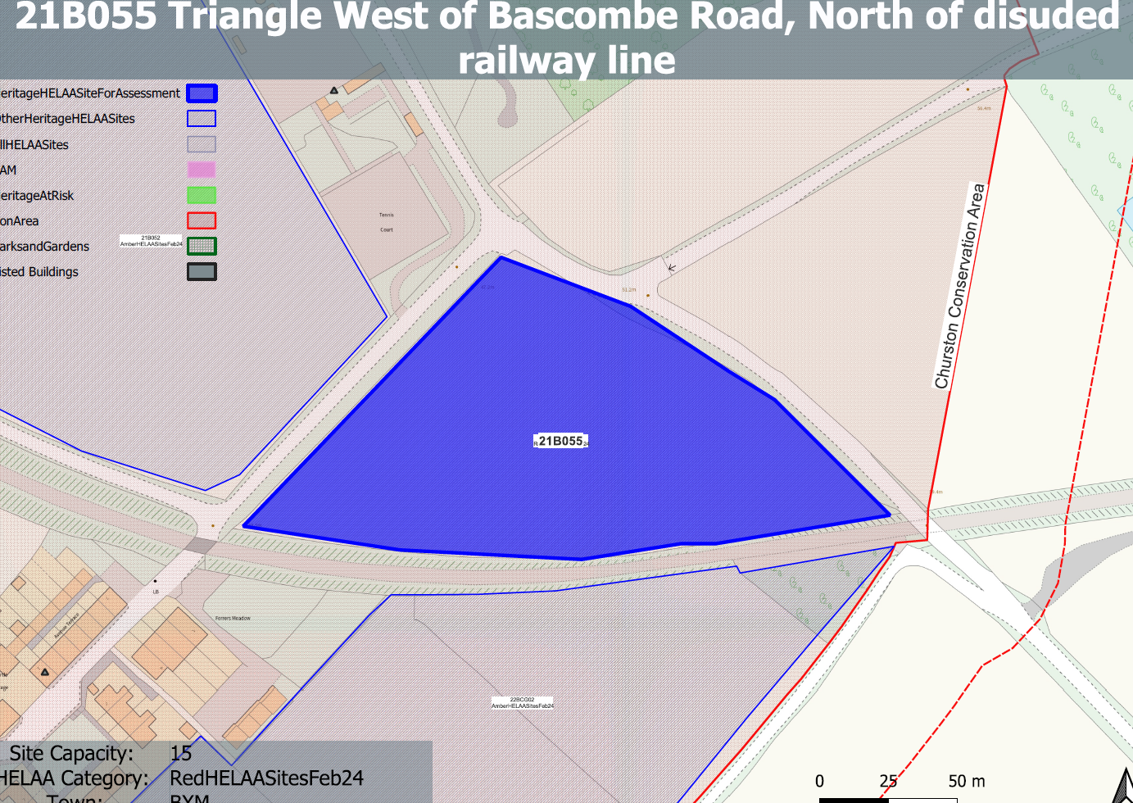
Site overview and heritage context:
Triangular area to the east of Bascombe Road and north of the discussed railway line. The site is relatively flat. It lies outside of but is disconnected from Churston Ferrers.
The site has historically remained undeveloped with the exception of the construction of the railway line on its southern border which dates from the late 19th century.
The site is within the Churston Ferrers Conservation Area and is nearby to a number of other designated heritage assets

Planning History:
No relevant planning history

Heritage Asset Affected by Allocation | Designation | Contributing Elements to Significance | Impact of Development on Significance | Mitigation Measures for any Identified Harm /Opportunities to Enhance Significance | Impact on Significance with Mitigation in place
Churston Ferrers Conservation Area | Conservation Area | The conservation area has a ‘traditional English Village’ character set within a distinct rural setting in-between the settlements of Galmpton and Brixham. It contains a high concentration of listed buildings for a small settlement.  The site in its undeveloped form makes a clear positive contribution to the rural characteristics of the conservation area. | The development of the site to the quantum stated would have a demonstrable impact on the open, rural character of the site and the wider conservation area. This would cause ‘less than substantial’ harm to its significance. | Any built development on the site would have a demonstrable impact on the open, rural character of the site and the wider conservation area. This would cause ‘less than substantial’ harm to its significance. This is unlikely to be mitigated to the point where harm can be removed. | Less than substantial harm.
Walls, including gate piers and folly, enclosing the courtyard and (former) gardens to the south and west of Churston Court (N of site) | Grade II listed building | A series of early to mid C19, or possibly earlier, walls, including gate piers and a folly, situated to the west and south of Churston Court. The site forms part of the setting of the asset and makes a minor positive contribution to its significance. | The development of the site to the quantum stated would have a demonstrable impact on the open, rural character of the site and the wider conservation area. This would have a detrimental on the rural setting of the asset and would cause a minor degree of ‘less than substantial’ harm to its significance. | Any built development on the site would have a demonstrable impact on the open, rural character of the site and the wider area. However, impact on this individual asset could be limited by a reduction in quantum of development, the siting of any infrastructure away from the asset and the retention of a suitable landscape buffer to maintain the immediate rural setting to the asset. This could result in a neutral impact to its significance. | Neutral
Avenue Terrace 1-7, Churston Road (SW of site) | Grade II listed building | A row of mid 19th century estate cottages. The site forms part of the wider rural setting of the asset, but is visually and physically separated from the site by the railway line and a band of large mature planting. The site makes a limited contribution to the significance of the asset. | The development of the site would have limited impact on the significance of this asset. | n/a | Neutral
Myrtle Cottage (SW of site) | Grade II listed building | Mid 19th century cottage. The site forms part of the wider rural setting of the asset, but is visually and physically separated from the site by the railway line and a band of large mature planting. The site makes a limited contribution to the significance of the asset. | The development of the site would have limited impact on the significance of this asset. | n/a | Neutral
Church of St Mary the Virgin | Grade II* listed building | 15th century parish church restored in the mid-19th century. The site forms part of the rural setting of the church with views of the church tower being visible in context from surrounding lanes. The site makes a minor positive impact on the significance of the asset. | The development of the site to the quantum stated would have a demonstrable impact on the open, rural character of the site and may impact on the way in which views of the tower are experienced. This would cause a minor degree of ‘less than substantial’ harm to its significance. | Any built development on the site would have a demonstrable impact on the open, rural character of the site and the wider area. However, impact on this individual asset could be limited by a reduction in quantum of development, the siting of any infrastructure away from identified sightlines and the retention of a suitable landscape buffer to boundaries to maintain the immediate rural to its edges. This could result in a neutral impact to its significance. | Neutral

