Heritage Impact Assessment: Torbay Industrial Estate Part 2, Brixham
HELAA2021 Ref: | 21B054
Site Address: | Torbay Industrial Estate Part 2, Brixham
Site Area (ha): | 0.08
Site Yield: | 20
HIA Assessment

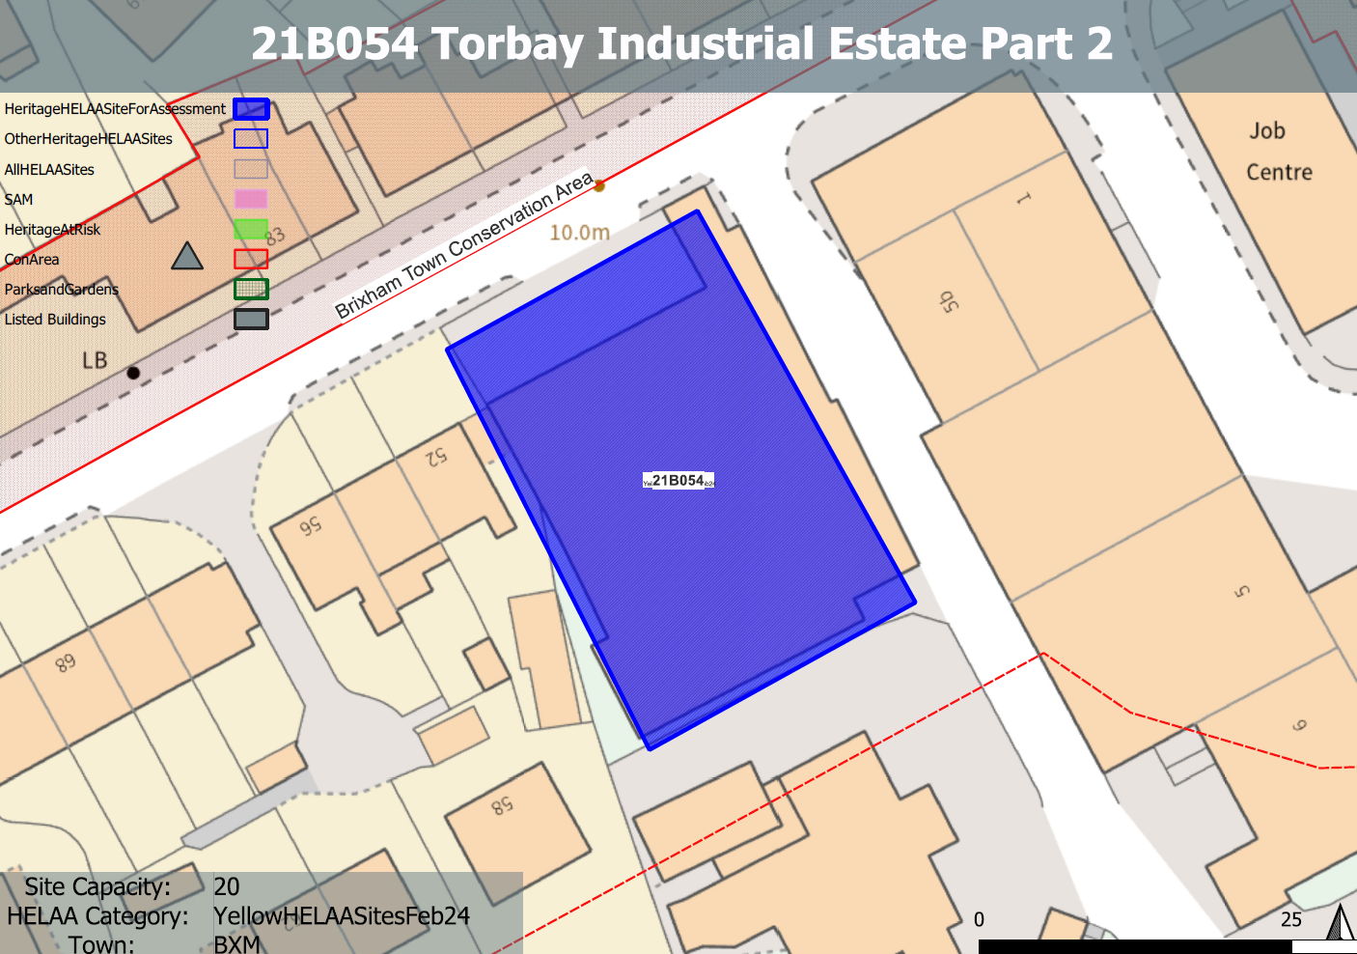
Site overview and heritage context:
The site comprises land to the south of New Road Brixham which is part of the Torbay Trading Estate. The area comprises the former paintworks factory. The site has been in use since the late 19th century with the current building dating from the 1950s. It is currently in use as a vehicle mechanics workshop.
The topography of the site rises to the south with existing built development stepping up to follow the contours of the site.
The building presents a strong art deco inspired façade to New Road along with a large blank wall on its eastern boundary which is currently used for advertising.
The site sits outside, but adjacent to the boundary of the Brixham Town Conservation Area which can be found to the north and a Grade II listed building which is in close proximity to the northwest.

Planning History:
P/2024/0311 – Redevelopment of the former Jewson site consisting of demolition of existing commercial building and erection of new three and four storey residential building to comprise 17 two-bedroom flats – PENDING CONSIDERATION

Heritage Asset Affected by Allocation | Designation | Contributing Elements to Significance | Impact of Development on Significance | Mitigation Measures for any Identified Harm /Opportunities to Enhance Significance | Impact on Significance with Mitigation in place
Brixham Town Conservation Area (N of site) | Conservation Area | The conservation area evidences the origins of Brixham Town as a  small fishing port and naval supply station, and its rapid growth in the 19th century. It is notable for the number of surviving 18th, 19th and early 20th-century terraces. There are many other  attractive historic buildings which tell the story of Brixham’s industrial past and its evolution over the course of the 19th century.  The site sits outside, but adjacent to, the conservation area and makes a minor contribution to its significance. | The development of the site to the quantum stated could be achieved whilst utilizing an urban grain, scale and overall design approach which responds to the history of the site, and which sensitively relates to the surrounding townscape.  This would have a neutral to minor positive impact to the significance of the conservation area. | n/a | Neutral to minor positive
85 and 85A New Road, including front garden wall (NW of site) | Grade II listed building | House and boundary treatment dating from the early 19th century. The site sits within the urban setting of the asset and currently presents a visually unappealing face to it, resulting in a minor negative impact to its significance. | The development of the site to the quantum stated could be achieved whilst utilizing an urban grain, scale and overall design approach which responds to the history of the site, and which sensitively relates to the surrounding townscape, including this asset. This would have a minor positive impact to its significance. | n/a | Minor positive

