Heritage Impact Assessment: Torbay Industrial Estate Part 1, Brixham
HELAA2021 Ref: | 21B053
Site Address: | Torbay Industrial Estate Part 1, Brixham
Site Area (ha): | 0.32
Site Yield: | 15
HIA Assessment

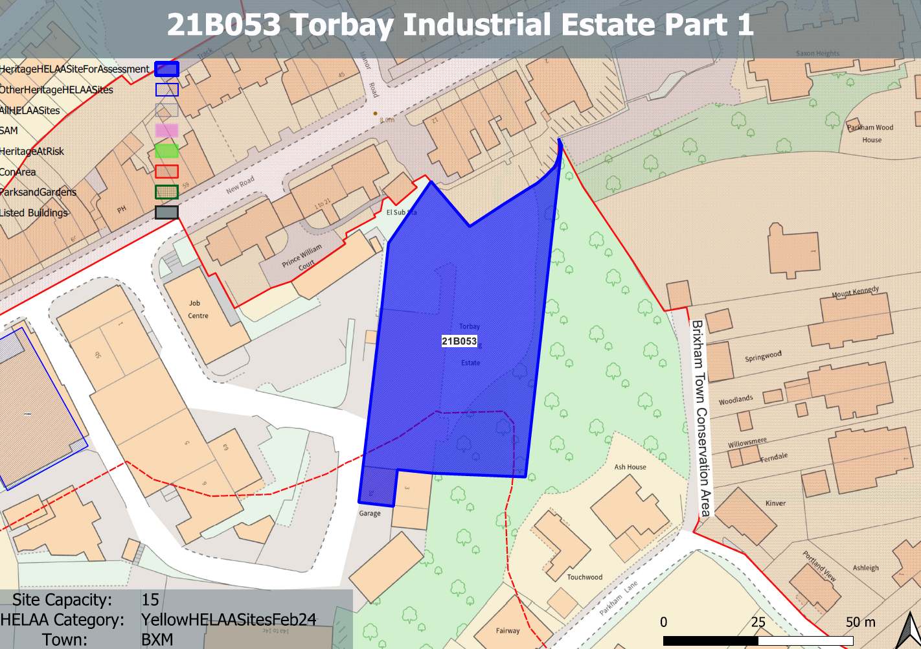
Site overview and heritage context:
The site comprises land to the south of New Road Brixham which is part of the Torbay Trading Estate. The area is largely open and is used for informal parking and storage.
The site itself is relatively level but sits on an elevated position rising above New Road to the North.
There is little evidence of historic development on the site which is bounded to the east by rising wooded ground, existing residential development to the north and industrial buildings to the south and west
The site sits outside of the Brixham Town Conservation Area but is immediately adjacent to its boundary to the north, east and west.

Planning History:
Various relating to its industrial use.

Heritage Asset Affected by Allocation | Designation | Contributing Elements to Significance | Impact of Development on Significance | Mitigation Measures for any Identified Harm /Opportunities to Enhance Significance | Impact on Significance with Mitigation in place
Brixham Town Conservation Area | Conservation Area | The conservation area evidences the origins of Brixham Town as a  small fishing port and naval supply station, and its rapid growth in the 19th century. It is notable for the number of surviving 18th, 19th and early 20th-century terraces. There are many other  attractive historic buildings which tell the story of Brixham’s industrial past and its evolution over the course of the 19th century.  The site sits outside, but adjacent to, the conservation area and makes a limited contribution to its significance. | The development of the site to the quantum stated could be achieved whilst utilizing an urban grain and scale which sensitively relates to the surrounding townscape.  This would have a neutral impact to the significance of the conservation area. | n/a | Neutral

