Heritage Impact Assessment: Land at Green Lane/Bascombe Road, Brixham
HELAA2021 Ref: | 21B052
Site Address: | Land at Green Lane/Bascombe Road, Brixham
Site Area (ha): | 3.43
Site Yield: | 15
HIA Assessment

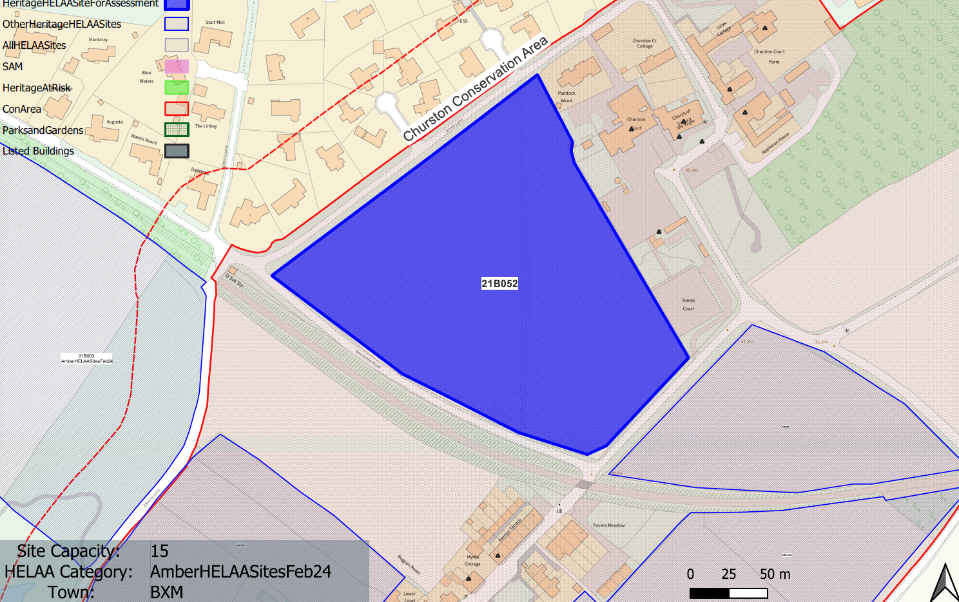
Site overview and heritage context:
Field east of Green Lane and north of Bascombe Road. Located to the northeast of Brokenbury Quarry wastewater treatment works
The site is within the Churston Ferrers Conservation Area and is nearby to a number of other designated heritage assets
The site has high archaeological potential due to its proximity to a known prehistoric settlement site.

Planning History:
No relevant planning history

Heritage Asset Affected by Allocation | Designation | Contributing Elements to Significance | Impact of Development on Significance | Mitigation Measures for any Identified Harm /Opportunities to Enhance Significance | Impact on Significance with Mitigation in place
Churston Ferrers Conservation Area | Conservation Area | The conservation area has a ‘traditional English Village’ character set within a distinct rural setting in-between the settlements of Galmpton and Brixham. It contains a high concentration of listed buildings for a small settlement.  The site in its undeveloped form makes a clear positive contribution to the rural and special landscape characteristics of the conservation area and its evolution as an historic settlement. | The development of the site to the quantum stated would have a demonstrable impact on the open, rural character of the site and the wider conservation area. This would cause ‘less than substantial’ harm to its significance. | Any built development on the site would have a demonstrable impact on the open, rural character of the site and the wider conservation area. This would cause ‘less than substantial’ harm to its significance. This is unlikely to be mitigated to the point where harm can be removed. | Less than substantial harm.
Walls, including gate piers and folly, enclosing the courtyard and (former) gardens to the south and west of Churston Court (E of site) | Grade II listed building | A series of early to mid C19, or possibly earlier, walls, including gate piers and a folly, situated to the west and south of Churston Court. The site forms part of the setting of the asset and makes a minor positive contribution to its significance. | The development of the site to the quantum stated would have a demonstrable impact on the open, rural character of the site and the wider area. This would have a detrimental on the rural setting of the asset and would cause a minor degree of ‘less than substantial’ harm to its significance. | Any built development on the site would have a demonstrable impact on the open, rural character of the site and the wider area and the way in which this asset would be experienced. This would cause ‘less than substantial’ harm to its significance. This is unlikely to be mitigated to the point where harm can be completely removed. | Less than substantial harm
Church of St Mary the Virgin (E of site) | Grade II* listed building | 15th century parish church restored in the mid-19th century. The site forms part of the rural setting of the church with views of the church tower being visible in context from the site. The site makes a minor positive impact on the significance of the asset. | The development of the site to the quantum stated would have a demonstrable impact on the open, rural character of the site and may impact on the way in which the asset is experienced. This would cause a minor degree of ‘less than substantial’ harm to its significance. | Any built development on the site would have a demonstrable impact on the open, rural character of the site and the wider area and the way in which this asset would be experienced. This would cause ‘less than substantial’ harm to its significance. This is unlikely to be mitigated to the point where harm can be completely removed. | Less than substantial harm
Avenue Terrace 1-7, Churston Road (S of site) | Grade II listed building | A row of mid 19th century estate cottages. The site forms part of the wider rural setting of the asset, but is visually and physically separated from the site by the railway line and a band of large mature planting. The site makes a limited contribution to the significance of the asset. | The development of the site would have limited impact on the significance of this asset. | n/a | Neutral
Churston Court (E of site) | Grade II* listed building | Large house, now hotel. Probably mid or late C16, remodelled early C17 and late C17. C18 and C19 additions with large addition of 1985-7 at rear. Basic fabric may be late medieval. The site appears to have possibly had a historic relationship with the asset and currently forms part of its immediate rural setting. It makes a positive contribution to its significance. | The development of the site to the quantum stated would have a demonstrable impact on the open, rural character of the site and would have a detrimental impact on the way in which the asset is experienced and its historical relationship with the site. This would cause ‘less than substantial’ harm to its significance. | Any built development on the site would have a demonstrable impact on the open, rural character of the site and would have a detrimental impact on the way in which the asset is experienced and its historical relationship with the site. This would cause ‘less than substantial’ harm to its significance. | Less than substantial harm
Cross shaft adjoining east wall of the south porch of Church of St Mary the Virgin (E of site) | Grade II listed building | Cross shaft. Late medieval. The site is not considered to contribute to the significance of the asset whose setting is limited to the churchyard. | The development of the site would have limited impact on the significance of this asset. | n/a | Neutral
Churchyard wall and gates on south and east sides of Church of St Mary the Virgin (E of site) | Grade II listed building | Curtilage wall and gates. Probably contemporary with the restoration of the church in 1864-6. The site is not considered to contribute to the significance of the asset whose setting is limited to the churchyard and immediate surroundings. | The development of the site would have limited impact on the significance of this asset. | n/a | Neutral
Barn and cattle yard approx. 30m south of Churston Court farmhouse including piers and wall (E of site) | Grade II listed building | Threshing barn, cattle yard, and storehouse. Mid C19. The site is not considered to contribute to the significance of the asset. | The development of the site would have limited impact on the significance of this asset. | n/a | Neutral
Farm building SW of Churston Court Farmhouse, including gate piers and wall (E of site) | Grade II listed building | Enclosed courtyard containing shippons, stables, root house, granary, pound house and cart shed, mid C19. The site is not considered to contribute to the significance of the asset. | The development of the site would have limited impact on the significance of this asset. | n/a | Neutral
Churston Court farmhouse including courtyard of service buildings and garden walls (E of site) | Grade II listed building | Farmhouse. Mid C19. The site is not considered to contribute to the significance of the asset. | The development of the site would have limited impact on the significance of this asset. | n/a | Neutral

