Heritage Impact Assessment: Land at Greenway Road/Greenway Park, Brixham
HELAA2021 Ref: | 21B049a
Site Address: | Land at Greenway Road, Brixham
Site Area (ha): | 4.95
Site Yield: | 50
HIA Assessment

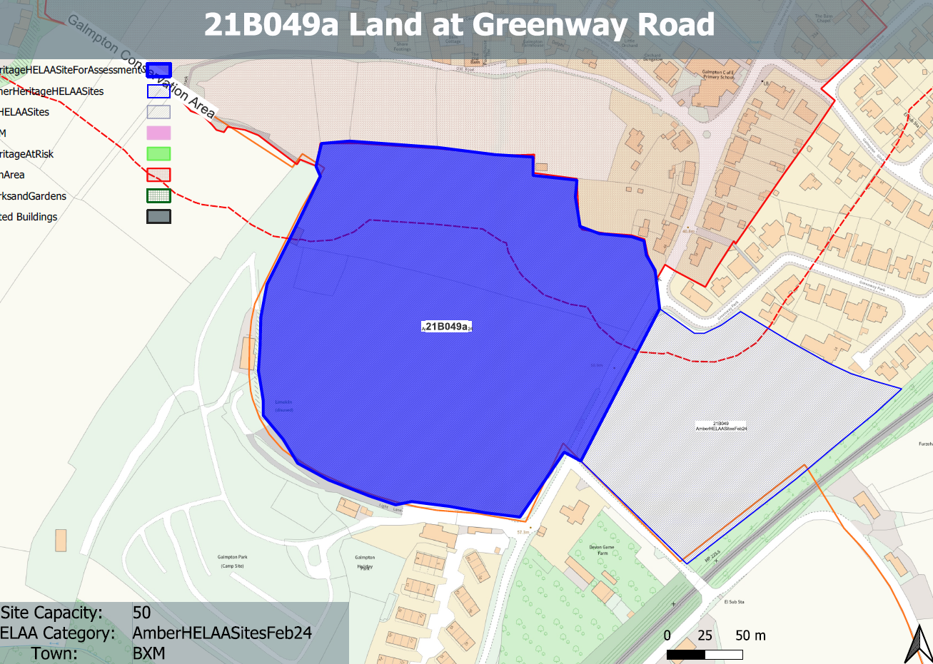
Site overview and heritage context:
An open cultivated field with hedgerow boundaries on land within the area between Greenway Road to the east and Light Lane to the south.
The boundary to the Galmpton Conservation Area is located immediately to the north of the site.

Planning History:
None

Heritage Asset Affected by Allocation | Designation | Contributing Elements to Significance | Impact of Development on Significance | Mitigation Measures for any Identified Harm /Opportunities to Enhance Significance | Impact on Significance with Mitigation in place
Galmpton Conservation Area (N of site) |  | The significance of the conservation area comprises its surviving historic built form, its landscape setting which is a dominant feature of the southern and western half of the area, and the relationship between the two.  The site in its undeveloped form makes a positive contribution to the rural characteristics and setting of the conservation area. | The development of the site to the quantum proposed would have a demonstrable impact on the open, rural character of the site and the adjacent conservation area. The elevated position of the site would result in built form being visible from within the conservation area.  The presence of built form within the rural setting of the conservation area would dilute the landscape value of the site and would cause ‘less than substantial’ harm to its significance. | A significantly reduced quantum of development limited to the southern boundary of the site and accessed from Light Lane with a substantial landscape buffer may reduce the visibility of the proposed development from the conservation area. This coupled with a very low-density development possibly using an agricultural aesthetic may reduce the level of harm to a neutral impact if very sensitively designed | Neutral

