Heritage Impact Assessment: Land at Greenway Road/Greenway Park, Brixham
HELAA2021 Ref: | 21B049
Site Address: | Land at Greenway Road/Greenway Park, Brixham
Site Area (ha): | 1.9
Site Yield: | 20
HIA Assessment

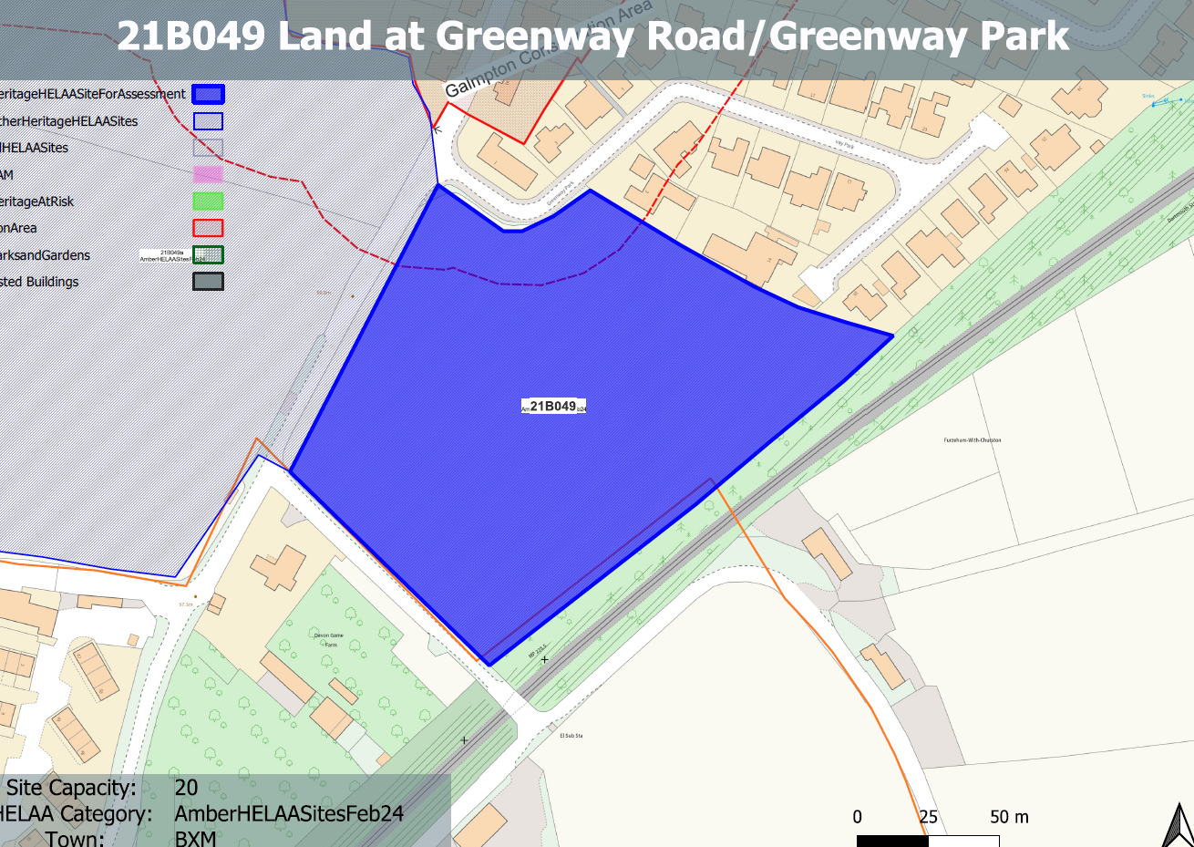
Site overview and heritage context:
An open cultivated field with hedgerow boundaries on land within the area between Greenway Road to the west, the railway line serving Churston station to the east.
The Galmpton Conservation Area is located to the north of the site.

Planning History:
None

Heritage Asset Affected by Allocation | Designation | Contributing Elements to Significance | Impact of Development on Significance | Mitigation Measures for any Identified Harm /Opportunities to Enhance Significance | Impact on Significance with Mitigation in place
Galmpton Conservation Area (N of site) |  | The significance of the conservation area comprises its surviving historic built form, its landscape setting which is a dominant feature of the southern and western half of the area, and the relationship between the two.  The site in its undeveloped form makes a positive contribution to the rural characteristics and setting of the conservation area. | The development of the site to the quantum proposed would have a demonstrable impact on the open, rural character of the site and the adjacent conservation area and would be visible from Greenway Road when looking out from the boundaries of the conservation area. The presence of built form within the rural setting of the conservation area would dilute the landscape value of the site and would cause ‘less than substantial’ harm to its significance. | A reduced quantum of development limited to the south-eastern boundary of the site which would allow the northern and south western sections of the site to remain undeveloped may  reduce the level of harm to its significance so as to have a neutral impact. | Neutral

