Heritage Impact Assessment: Land at Broadsands, Brixham
HELAA2021 Ref: | 21B048
Site Address: | Land at Broadsands, Brixham
Site Area (ha): | 4.3
Site Yield: | 80
HIA Assessment

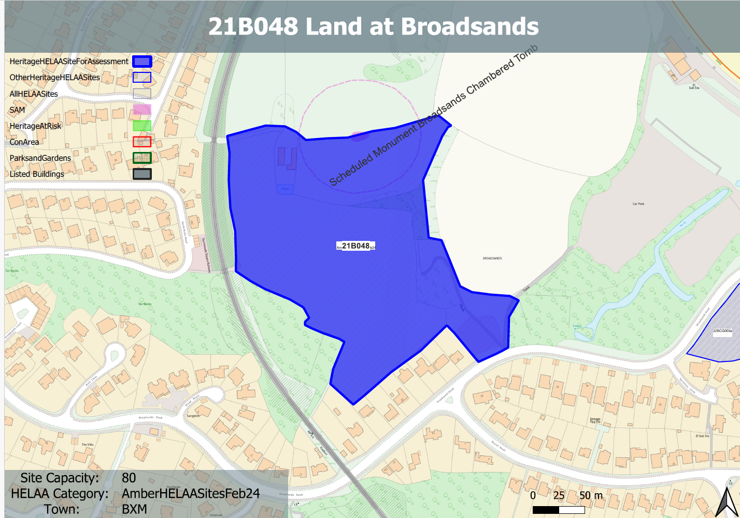
Site overview and heritage context:
Fields to the north of Broadsands Road and south of Broadsands Barrow.
The site includes two agricultural buildings and parcels of land laid to pasture and separated by hedgerow. Access to the site is from Broadsands Road through an area of hardstanding.
The site includes Neolithic Chambered Tomb which is highly sensitive from an archaeological and a landscape perspective.

Planning History:
No relevant planning history

Heritage Asset Affected by Allocation | Designation | Contributing Elements to Significance | Impact of Development on Significance | Mitigation Measures for any Identified Harm /Opportunities to Enhance Significance | Impact on Significance with Mitigation in place
Chambered tomb, 630m NW of Elberry Farm | Scheduled Monument | The monument includes a Neolithic chambered tomb located on the southern slope of hilly ground overlooking the Torbay coast at Broadsands. The tomb, which was incorporated into a hedge bank in antiquity, takes the form of a megalithic chamber which was found during excavation to contain human remains.  The site boundary includes the asset, however, the site as a whole contributes to the rural setting of the asset and its position within the landscape. | The development of the site to the quantum stated would have a demonstrable impact on the open, rural character of the site and the surrounding landscape of the asset. This would cause substantial harm to its significance. | Any built development on the site would have a demonstrable impact on the open, rural character of the site and the landscape setting of the asset. A significant reduction in the quantum of development and its siting to the existing area of hardstanding within the SE corner of the site may reduce some of the harm, however, this would still encroach upon the open nature of the site and a possible route to the asset and therefore the way in which it is experienced. This could result in a degree of less than substantial harm to the significance of the asset. | Less than substantial harm.

