Heritage Impact Assessment: The Piggery, Elberry Lane
HELAA2021 Ref: | 21B042
Site Address: | The Piggery, Elberry Lane
Site Area (ha): | 1.26
Site Yield: | 10
HIA Assessment

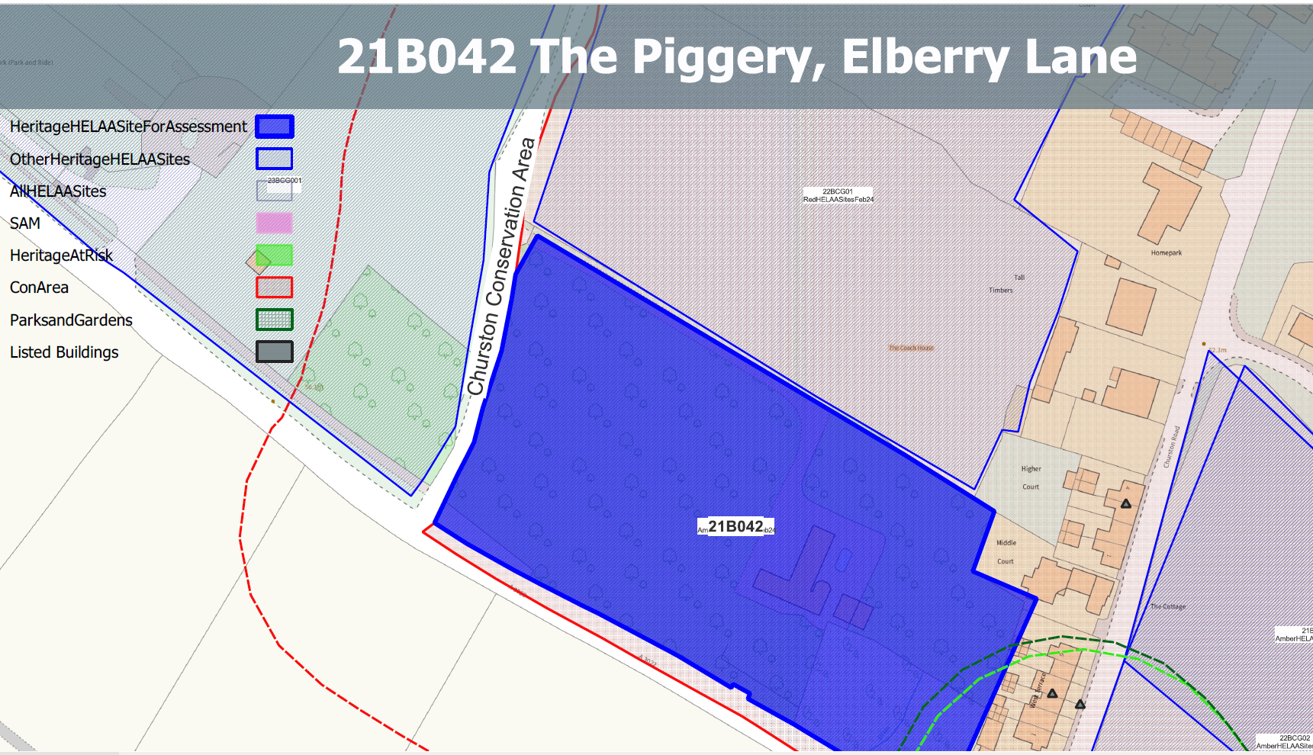
A Site overview and heritage context:
House and grounds NE side of Brixham Road, adjacent to Churston Cross. The site is currently serving as an orchard and a paddock.
The site appears to have historically been in use as an orchard and is accessed from Elberry Lane to the West.
The site is within the Churston Ferrers Conservation Area and is nearby to a number of other designated heritage assets

Planning History:
P/1990/0313 - Erection Of Covered Swimming Pool (In Outline) – Approved 30/04/1990

Heritage Asset Affected by Allocation | Designation | Contributing Elements to Significance | Impact of Development on Significance | Mitigation Measures for any Identified Harm /Opportunities to Enhance Significance | Impact on Significance with Mitigation in place
Churston Ferrers Conservation Area | Conservation Area | The conservation area has a ‘traditional English Village’ character set within a distinct rural setting in-between the settlements of Galmpton and Brixham. It contains a high concentration of listed buildings for a small settlement.  The site maintains its historical use as an orchard and makes a clear contribution to the historical value of the conservation area as well as its rural characteristics. | The development of the site to the quantum stated would have a demonstrable impact on the open, rural character of the site and would remove its historic use as an orchard. This would cause ‘less than substantial’ harm to its significance. | Any built development on the site would have a demonstrable impact on the open, rural character of the site and the readability of the historic uses of the area, unless the proposed quantum of development was significantly reduced and sited wholly within the existing built area. This would likely cause ‘less than substantial’ harm to its significance, but could result in a neutral impact if very sensitively designed. | Neutral
Higher Court (Terrace) including gate piers at No 1 (E of site) | Grade II listed building | Terrace of 4 estate cottages. Mid C19. Subsidiary features: at left-hand end of terrace the entrance to No.1 has 2 stone and rubble gate piers with caps built of stones on edge. The site forms part of the immediate setting of the asset and is a physical reminder of historical uses of the area. It makes a positive contribution to its significance | The development of the site to the quantum stated would have a demonstrable impact on the open, rural character of the site and would significantly dilute the readability of the historic uses of the area. This would cause ‘less than substantial’ harm to the significance of the asset | Any built development on the site would have a demonstrable impact on the open, rural character of the site and the readability of the historic uses of the area, unless the proposed quantum of development was significantly reduced and sited wholly within the existing built area. This would likely cause ‘less than substantial’ harm to its significance, but could result in a neutral impact if very sensitively designed. | Neutral
West Terrace (E of site) | Grade II listed building | Terrace of 6 estate cottages. Mid/late C19. The site forms part of the immediate setting of the asset and is a physical reminder of historical uses of the area. It makes a positive contribution to its significance | The development of the site to the quantum stated would have a demonstrable impact on the open, rural character of the site and would significantly dilute the readability of the historic uses of the area. This would cause ‘less than substantial’ harm to the significance of the asset | Any built development on the site would have a demonstrable impact on the open, rural character of the site and the readability of the historic uses of the area, unless the proposed quantum of development was significantly reduced and sited wholly within the existing built area. This would likely cause ‘less than substantial’ harm to its significance, but could result in a neutral impact if very sensitively designed. | Neutral
1-6 West Terrace front gardens, walls, gates, gate piers and railings (E of site) | Grade II listed building | 6 sets of red-brick gate piers with a single pier at the right-hand end. Mid C19, has group value with principal building. The setting of the asset is confined to its immediate surroundings and relationship with the principal building. The site makes a limited contribution to the asset’s significance. | The development of the site would have a neutral impact on the asset’s significance. | n/a | Neutral
Nos 1 and 2 including gate piers and garden wall facing Brixham Road (SE of site) | Grade II listed building | Pair of cottages built as a single range. Probably C18/C19 remodelling of an earlier building. The building occupies an important corner site, relating to groups of listed buildings in both Brixham and Churston Roads. It is shown as a single house on the Churston Ferrers tithe map of 1839. The site forms part of the immediate setting of the asset and is a physical reminder of historical uses of the area. It makes a positive contribution to its significance | The development of the site to the quantum stated would have a demonstrable impact on the open, rural character of the site and would significantly dilute the readability of the historic uses of the area. This would cause ‘less than substantial’ harm to the significance of the asset | Any built development on the site would have a demonstrable impact on the open, rural character of the site and the readability of the historic uses of the area, unless the proposed quantum of development was significantly reduced and sited wholly within the existing built area. This would likely cause ‘less than substantial’ harm to its significance, but could result in a neutral impact if very sensitively designed. | Neutral
The Old Smithy including front garden wall, railing, gate and gate piers (S of site) | Grade II listed building | Smith's house, now a private dwelling. Dated 1870. The site forms part of the immediate setting of the asset and is a physical reminder of historical uses of the area. It makes a positive contribution to its significance | The development of the site to the quantum stated would have a demonstrable impact on the open, rural character of the site and would significantly dilute the readability of the historic uses of the area. This would cause ‘less than substantial’ harm to the significance of the asset | Any built development on the site would have a demonstrable impact on the open, rural character of the site and the readability of the historic uses of the area, unless the proposed quantum of development was significantly reduced and sited wholly within the existing built area. This would likely cause ‘less than substantial’ harm to its significance, but could result in a neutral impact if very sensitively designed. | Neutral
Crossways Cottage, Orchard Cottage (SE of site) | Grade II listed building | Pair of semi-detached houses, possibly a single farmhouse extended and sub-divided. Possibly C17, altered C18/C19. The site forms part of the immediate setting of the asset and is a physical reminder of historical uses of the area. It makes a positive contribution to its significance | The development of the site to the quantum stated would have a demonstrable impact on the open, rural character of the site and would significantly dilute the readability of the historic uses of the area. This would cause ‘less than substantial’ harm to the significance of the asset | Any built development on the site would have a demonstrable impact on the open, rural character of the site and the readability of the historic uses of the area, unless the proposed quantum of development was significantly reduced and sited wholly within the existing built area. This would likely cause ‘less than substantial’ harm to its significance, but could result in a neutral impact if very sensitively designed. | Neutral
Ye Old Forge (S of site) | Grade II listed building | Forge, stable and cart shed, now a house. Probably c1870. The setting of the asset is largely confined to its immediate surroundings and relationship with surrounding assets. The site makes a limited contribution to the asset’s significance. | The development of the site would have a neutral impact on the asset’s significance. | n/a | Neutral
The Old School House (SE of site) | Grade II listed building | School and schoolmaster's house, now 2 houses. Dated 1864. The site makes a limited contribution to the asset’s significance. | The development of the site would have a neutral impact on the asset’s significance. | n/a | Neutral
Front garden walls, gate, gate piers and railings at the Old School House (SE of site) | Grade II listed building | Garden walls, gate, gate piers, and railings. 1864. The setting of the asset is confined to its immediate surroundings and relationship with the principal building. The site makes a limited contribution to the asset’s significance. | The development of the site would have a neutral impact on the asset’s significance. | n/a | Neutral
Lupton Park (SE of site) | Grade II* Historic Park and Garden | A late C18 parkland landscape and mid C19 formal gardens associated with a late C18 mansion remodelled in the mid C19. A mid C20 country house designed by Oswald Milne is set in mid C20 formal gardens within the park. The site forms part of the wider setting of the asset which makes a minor positive contribution to its significance. | The development of the site to the quantum stated would have a demonstrable impact on the open, rural character of the site which could cause a degree of ‘less than substantial’ harm to the significance of the asset. | A significant reduction in the quantum of development and the siting of any built form within the existing built area may reduce the level of harm to the asset to the point where it would have a neutral impact. | Neutral

