**Heritage Impact Assessment:** Alston Lane, Brixham

|  |  |
| --- | --- |
| **HELAA2021 Ref:** | 21B036 |
| **Site Address:** | Alston Lane, Brixham |
| **Site Area (ha):** | 0.55 |
| **Site Yield:** | 10 |
| **HIA Assessment** |  |

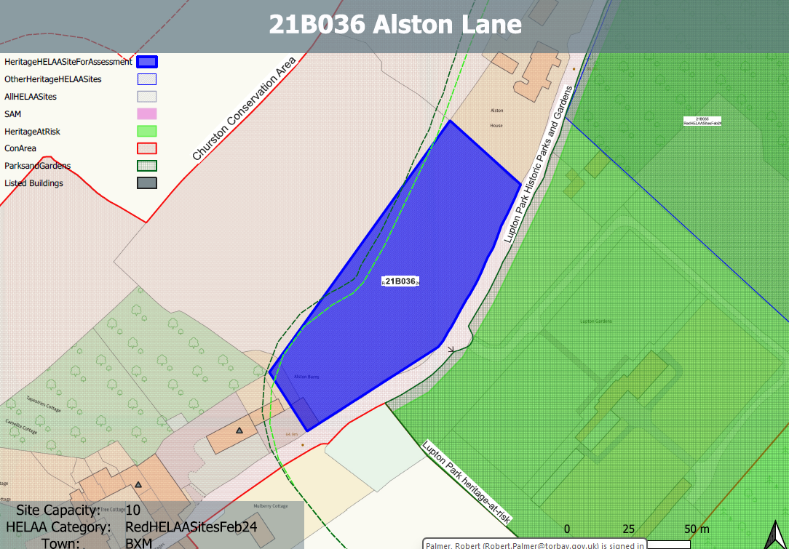 **Site overview and heritage context:**

Portion of a large field to the west of Alston Lane. The site is relatively flat and is currently accessed from the rural lane by a small entrance attached to an existing agricultural outbuilding which is likely to be curtilage listed. It is bounded by mature hedgerow and fencing to a residential property on the northern boundary.

The site sits within the Churston Ferrers Conservation Area, is adjacent to the Lupton Park RPG and is in close proximity to Grade II listed buildings to the south.

**Planning History:**

No planning history.

|  |  |  |  |  |  |
| --- | --- | --- | --- | --- | --- |
| **Heritage Asset Affected by Allocation** | **Designation** | **Contributing Elements to Significance** | **Impact of Development on Significance** | **Mitigation Measures for any Identified Harm /Opportunities to Enhance Significance** | **Impact on Significance with Mitigation in place** |
| Lupton Park (E of site)  Churston Ferrers Conservation Area  Cattle Yard and Building approx. 80m NE of Alston Farmhouse, Alston Lane (partly within and immediately SW of the site)  Courtyard of farm buildings immediately NE of Alston Farmhouse (SW of site)  Alston Farmhouse, including front garden wall and gate | Grade II* Registered Park and Garden  Conservation Area  Grade II listed building    Grade II listed building  Grade II listed building | A late C18 parkland landscape and mid C19 formal gardens associated with a late C18 mansion remodelled in the mid C19. A mid C20 country house designed by Oswald Milne is set in mid C20 formal gardens within the park.  The undeveloped nature of the site contributes to the rural setting of the park and the walled garden which is located immediately to the east.  The conservation area has a ‘traditional English Village’ character set within a distinct rural setting in-between the settlements of Galmpton and Brixham. It contains a high concentration of listed buildings for a small settlement.  The site in its undeveloped form makes a positive contribution to the rural character of the conservation area.  Cattle yard and buildings. Mid and late C19. Together with Alston Farmhouse and its main yard this makes a good farmyard group.  Part of the building falls within the site and is located at the existing entrance to it. The site has a clear physical and historical relationship with the asset and makes a positive contribution to its significance.  Farm buildings, now office, garage and storage. Probably early C19, with mid/late C19 modifications. Group value with Alston Farmhouse and associated agricultural buildings. The site has a clear historical relationship with the asset and makes a positive contribution to its significance.  Farmhouse. Early C19. Group value with associated agricultural buildings and yards. The site has a clear historical relationship with the asset and makes a positive contribution to its significance. | Introduction of built form would erode rural setting causing less than substantial harm to the significance of the asset.  The development of the site to the quantum stated would have a demonstrable impact on the open, rural character of the site and the wider conservation area. This would cause less than substantial harm to its significance.  The development of the site to the quantum stated would have a demonstrable impact on the open, rural character of the site and the rural setting of the farmyard. This would cause less than substantial harm to its significance.  The development of the site to the quantum stated would have a demonstrable impact on the open, rural character of the site and the rural setting of the farmyard. This would cause less than substantial harm to its significance.  The development of the site to the quantum stated would have a demonstrable impact on the open, rural character of the site and the rural setting of the farmhouse. This would cause less than substantial harm to its significance. | Any built development on the site would have a demonstrable impact on the open, rural character of the site and the setting of Lupton Park. This would cause ‘less than substantial’ harm to its significance. This is unlikely to be mitigated to the point where harm can be removed.  Any built development on the site would have a demonstrable impact on the open, rural character of the site and the wider conservation area. This would cause ‘less than substantial’ harm to its significance. This is unlikely to be mitigated to the point where harm can be removed.  Any built development on the site would have a demonstrable impact on the open, rural character of the site and rural setting and relationship with the asset. This would cause ‘less than substantial’ harm to its significance. This is unlikely to be mitigated to the point where harm can be removed.  Any built development on the site would have a demonstrable impact on the open, rural character of the site and rural setting and relationship with the asset. This would cause ‘less than substantial’ harm to its significance. This is unlikely to be mitigated to the point where harm can be removed.  Any built development on the site would have a demonstrable impact on the open, rural character of the site and rural setting and relationship with the asset. This would cause ‘less than substantial’ harm to its significance. This is unlikely to be mitigated to the point where harm can be removed. | Less than substantial harm  Less than substantial harm  Less than substantial harm  Less than substantial harm  Less than substantial harm |