Heritage Impact Assessment: Land at Laywell Rd/Mathill Rd, Brixham
HELAA2021 Ref: | 21B033
Site Address: | Land at Laywell Rd/Mathill Rd, Brixham
Site Area (ha): | 1.44
Site Yield: | 15
HIA Assessment

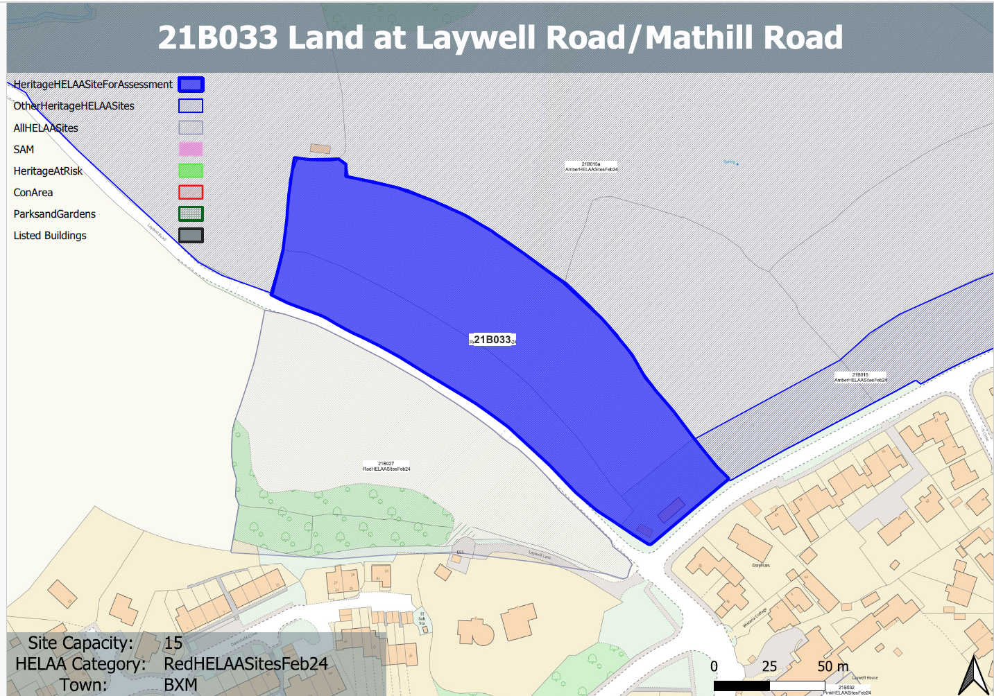
Site overview and heritage context:
Fields on the outskirts of Brixham bounded by Mathill Rd to the south and Laywell Rd to the west. The site rises to a ridge to the south at Mathill Rd. It includes some single storey outbuildings on the southern boundary which form a paddock. The area is enclosed by bands of mature vegetation but is highly visible in views from the north.
The Higher Brixham Conservation Area and a number of listed buildings are located to the east.
The site may have been part of a medieval field system and therefore may have some archaeological potential.

Planning History:
P/1987/1498 – Residential development (in outline) - Land South Laywell Road Nr Junc Of Mathill Road And Summer Lane Brixham – Refused 23/10/1987

Heritage Asset Affected by Allocation | Designation | Contributing Elements to Significance | Impact of Development on Significance | Mitigation Measures for any Identified Harm /Opportunities to Enhance Significance | Impact on Significance with Mitigation in place
Higher Brixham Conservation Area (E of site) | Conservation Area | The conservation area retains a village character to its western half and a more urban character to the eastern and northern parts related to the outward expansion of Lower Brixham in the later 19th century. The site sits outside, but adjacent to, the conservation area. The large site forms part of the historic edge of the settlement and its semi-rural setting. It makes a minor positive contribution to its significance. | The development of the site and all associated infrastructure would dilute the rural/edge of settlement setting of the asset which makes a positive contribution to its significance. This would cause a minor degree of ‘less than substantial’ harm. | A significantly reduced quantum of development limited to the southern elements of the site which would be read as part of the existing townscape of Mathill Rd rather than an incursion into the rural setting of the asset could reduce the level of harm to a neutral impact. | Neutral
Milepost Plaque | Grade II listed building | Milepost. Probably early C19. The site forms part of the wider rural setting of the milepost which denotes the historic edge of the settlement of Brixham, it makes a minor positive contribution to its significance. | The development of the site and all associated infrastructure would dilute the rural/edge of settlement setting of the asset which makes a positive contribution to its significance. This would cause a minor degree of ‘less than substantial’ harm. | A significantly reduced quantum of development limited to the southern elements of the site which would be read as part of the existing townscape of Mathill Rd rather than an incursion into the rural setting of the asset could reduce the level of harm to a neutral impact. | Neutral

