Heritage Impact Assessment: Argos ‘Block’, Union Street, Torquay
HELAA2021 Ref: | 21T052
Site Address: | Argos ‘Block’, Union Street, Torquay
Site Area (ha): | 0.12
Site Yield: | 40
HIA Assessment

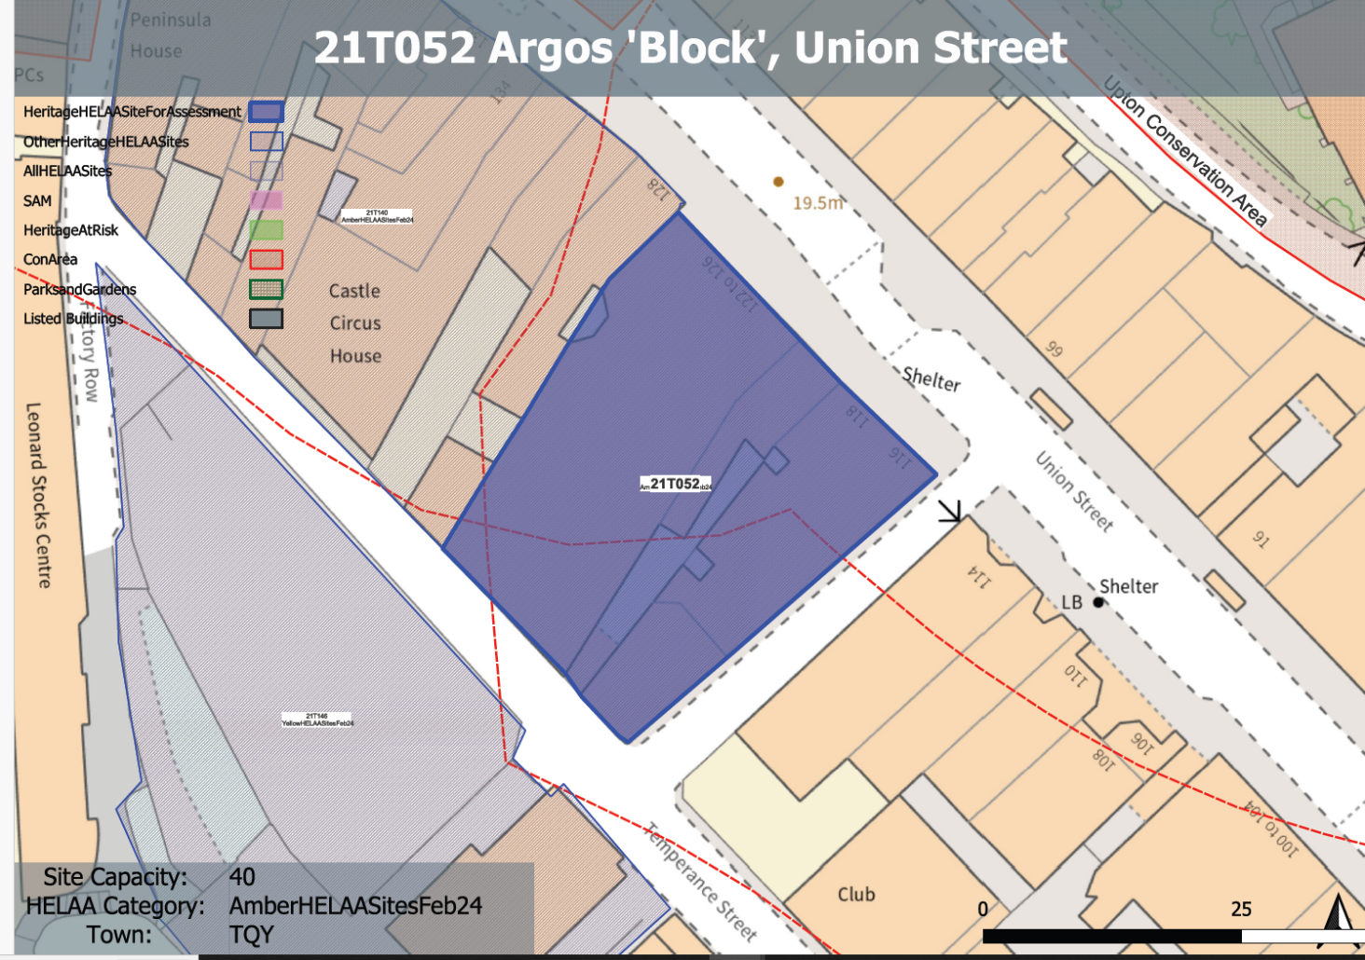
Site overview and heritage context:
The site can be found on the western side of Union Street. The existing buildings on the site appear to date from the late 19th century and have undergone 20th century alterations to facilitate their current retail use.
The buildings present a 2/3 storey frontage to Union Street with modern shopfronts on the ground floor. Built development extends over the majority of the site with only a small enclosed courtyard accessed from Temperance Street from the rear remaining undeveloped.
The site retains some traditional form and character, however, the majority have been lost through alteration and replacement.
The site is not within a designated conservation area, however, the boundary to the Abbey Road Conservation Area can be found nearby to the west and the boundary to the Upton Conservation Area to the north.

Planning History:
Various applications relating to the retail use of the site.

Heritage Asset Affected by Allocation | Designation | Contributing Elements to Significance | Impact of Development on Significance | Mitigation Measures for any Identified Harm /Opportunities to Enhance Significance | Impact on Significance with Mitigation in place
Abbey Road Conservation Area (W of site)  Upton Conservation Area (N and E of site) | Conservation Area  Conservation Area | The site forms part of the urban setting of the conservation area. The historic form of the late 19th century development on the site can still be read from the conservation area, although much of its traditional character has been lost. The site makes a neutral contribution to the asset.  The site forms part of the urban setting of the conservation area. The historic form of the late 19th century development on the site can still be read from the conservation area, although much of its traditional character has been lost. The site makes a neutral contribution to the asset. | Conversion to residential use with limited external alterations would have a neutral impact on the significance of the asset.  Conversion to residential use with limited external alterations would have a neutral impact on the significance of the asset. | The improvement of the architectural treatment and visual appearance of the building including the reinstatement of traditional detail where appropriate would improve the general condition of the historic environment within the area and would have a minor positive impact on the significance of the nearby conservation area.  The improvement of the architectural treatment and visual appearance of the building including the reinstatement of traditional detail where appropriate would improve the general condition of the historic environment within the area and would have a minor positive impact on the significance of the nearby conservation area. | Minor positive  Minor positive

