Heritage Impact Assessment: Land adjacent to Broadley Drive, Livermead
HELAA2021 Ref: | 21T050a
Site Address: | Wider land at Broadley Drive, Livermead
Site Area (ha): | 13.49
Site Yield: | 200
HIA Assessment

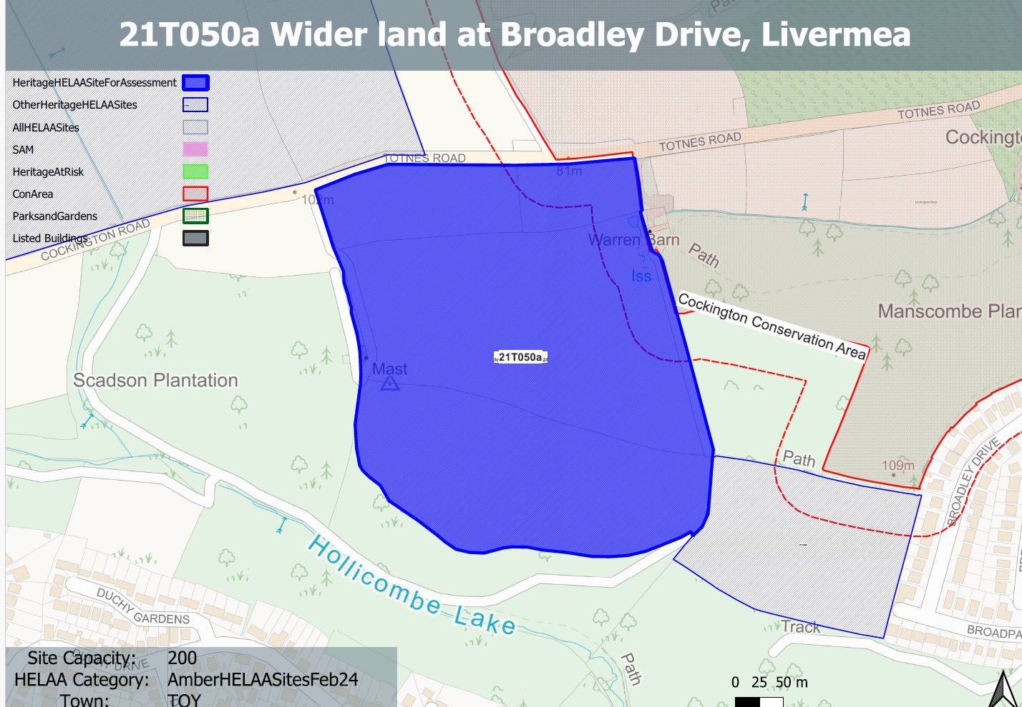
Site overview and heritage context:
An area of 4 fields laid to pasture and separated by hedgerows. The ground slopes steeply to the south to form a ridge and plateau. Manscombe woods can be found to the east of the site and Totnes Rd to the north.
The boundary of the Cockington Conservation Area can be found to the east of the site incorporating Manscombe Wood. A Grade II listed building, Warren Barn, is located immediately to the east of the site.

Planning History:
No relevant planning history

Heritage Asset Affected by Allocation | Designation | Contributing Elements to Significance | Impact of Development on Significance | Mitigation Measures for any Identified Harm /Opportunities to Enhance Significance | Impact on Significance with Mitigation in place
Cockington Conservation Area (E of site) | Conservation Area | The conservation area is defined by the estate village of Cockington and extensive designed parkland which surround Cockington Court and the Parish Church. The area retains a sense of isolation and rural tranquility. A large part of the conservation area lies away from the village and  outside the park, it consists of a network of hedged, or walled, fields; enclosed copses; or mixed woodland and scrub.  The site in its undeveloped form makes a positive contribution to the rural characteristics and setting of the conservation area. | The development of the site to the quantum proposed would have a demonstrable impact on the open, rural character of the site and the adjacent conservation area. This would cause ‘less than substantial’ harm to its significance. | Any quantum of proposed development with its associated infrastructure would have a demonstrable impact on the open, rural character of the site and the approaches and setting of the adjacent conservation area. This would continue to cause ‘less than substantial’ harm to its significance | Less than substantial harm
Warren Barn (immediately E of site) | Grade II listed building | Fomer linhay dating from the mid C19. Forms part of an outfarm complex with stream running through north end of yard and a walled yard.  The site forms the direct rural backdrop to the asset and makes a considerable contribution to its rural setting which is an important element of its significance. | The development of the site to the quantum proposed would have a significant impact on the open rural character of the site and the rural setting of the asset.  This would cause a high level of ‘less than substantial’ harm to its significance. | Any quantum of proposed development with its associated infrastructure and access from Totnes Rd would have a demonstrable impact and encroachment upon the open, rural character of the site and the rural setting of the asset. This would continue to cause a degree of ‘less than substantial’ harm to its significance | Less than substantial harm

