Heritage Impact Assessment: Land adjacent to Broadley Drive, Livermead
HELAA2021 Ref: | 21T050
Site Address: | Land adjacent to Broadley Drive, Livermead
Site Area (ha): | 3.2
Site Yield: | 50
HIA Assessment

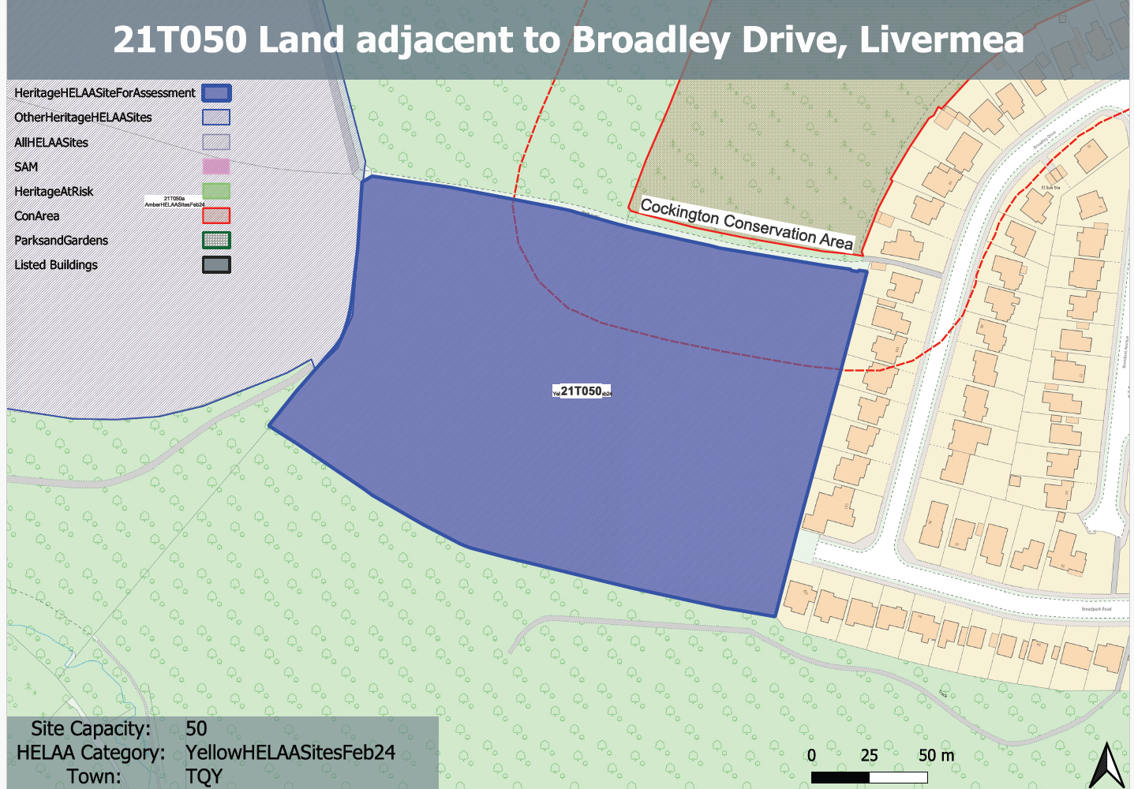
Site overview and heritage context:
Agricultural field at the edge of the settlement to the rear of Nos. 99-113 Broadley at the top of Livermead, with Manscombe Wood to the north, Scadson Woods to the south, and an agricultural field to the west beyond a footpath which runs along the western boundary of the site. The western half of the site slopes fairly gently downhill towards the west, with the gradient becoming steeper towards the southwestern corner of the site.
The boundary of the Cockington Conservation Area can be found to the north of the site incorporating Manscombe Wood.

Planning History:
No relevant planning history

Heritage Asset Affected by Allocation | Designation | Contributing Elements to Significance | Impact of Development on Significance | Mitigation Measures for any Identified Harm /Opportunities to Enhance Significance | Impact on Significance with Mitigation in place
Cockington Conservation Area (N of site) | Conservation Area | The conservation area is defined by the estate village of Cockington and extensive designed parkland which surround Cockington Court and the Parish Church. The area retains a sense of isolation and rural tranquility. A large part of the conservation area lies away from the village and  outside the park, it consists of a network of hedged, or walled, fields; enclosed copses; or mixed woodland and scrub.  The site in its undeveloped form makes a positive contribution to the rural characteristics and setting of the conservation area. | The development of the site to the quantum proposed would have a demonstrable impact on the open, rural character of the site and the adjacent conservation area. This would cause ‘less than substantial’ harm to its significance. | A significantly reduced quantum of development limited to the SE boundary of the site with a significant landscape buffer between the development and the conservation area and the surrounding rural landscape may reduce the level of harm to its significance so as to have a neutral impact. | Neutral

