**Heritage Impact Assessment:** Fleet Walk shopping centre, Torquay

|  |  |
| --- | --- |
| **HELAA2021 Ref:** | 21T047 |
| **Site Address:** | Fleet Walk shopping centre, Torquay |
| **Site Area (ha):** | 0.81 |
| **Site Yield:** | 25 |
| **HIA Assessment** |  |

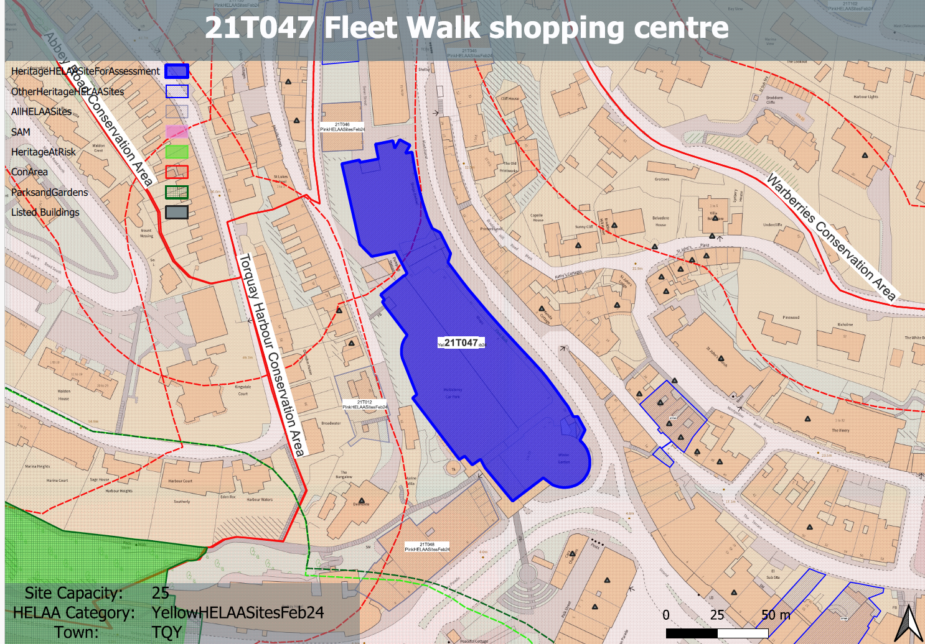

**Site overview and heritage context:**

Fleet Street is one of the major shopping and commercial streets of the town; it links the harbour with Union Street. Its original early 19th century form was altered in 1865 when it was remade and doubled in size. The site comprises the Fleet Walk complex which was constructed in the late 1980s removing the narrow historic street pattern in this area. It is designed as a is a modern interpretation of a historic Victorian style shopping arcade and includes modest sized shopfronts along with a consistent pattern of the location of shop doors, the height of windows and in most cases the use of materials.

The two-storeyed northern end of the building with its arched openings was built to emulate the original frontage, the remainder is more contemporary with a first-floor pedestrian arcade and, at its junction with Cary Parade, a circular copper-roofed rotunda named the Winter Garden.

The site is within the Torquay Harbour Conservation Area and is surrounded by a large number of listed buildings.

**Planning History**

Various relating to its ongoing commercial use.

|  |  |  |  |  |  |
| --- | --- | --- | --- | --- | --- |
| **Heritage Asset Affected by Allocation** | **Designation** | **Contributing Elements to Significance** | **Impact of Development on Significance** | **Mitigation Measures for any Identified Harm /Opportunities to Enhance Significance** | **Impact on Significance with Mitigation in place** |
| Torquay Harbour Conservation Area  Nos 49, 51 and 53 attached Garden Walls and Gate Piers, Rock Road (W of site)  55, 57 and 57a Rock Road (W of site)  6, 7 and 8 Fleet Street (E of site)  28-34 The Terrace (E of site)  Parish Church of St John the Evangelist (E of site)  Cary Estate Office (S of site)  Lloyds Bank (S of site)  Delmonte (W of site) | Conservation Area  Grade II listed building  Grade II listed building    Grade II listed building  Grade II listed buildings (4 entries)  Grade I listed building  Grade II listed building  Grade II listed building  Grade II listed building | The northern element of the site comprising a terrace ground floor shopfronts, glazed canopy and arched windows on the first floor is identified as a key building and building group of architectural importance or which makes a significant contribution to the townscape. The remainder of the site is less refined in its architectural treatment but has a neutral impact on the significance of the conservation area.  Terrace of 3 houses including low garden walls and gate piers, constructed in the mid-19th century. The site forms part of the urban setting of the asset and makes a limited contribution to its significance.  House. Late 1860s/early 1870s. The site forms part of the urban setting of the asset and makes a limited contribution to its significance.    Constructed in 1889 as the Devon and Exeter Savings Bank. The site is in close proximity to the asset and forms part of its immediate urban setting, sitting relatively neatly within the surrounding historic environment within this part of Torquay, although the original historic layout of the area has been lost. The site therefore only currently makes a neutral contribution to its significance.  A series of four listed building entries, forming a terrace constructed in the 1830s. The site, in particular the circular copper-roofed rotunda forms part of the wider urban setting of the asset but makes a limited contribution to its significance.  Parish church. 1861-73 to the designs of GE Street, west tower completed 1884-85. The site forms part of the wider urban setting of the asset but makes a limited contribution to its significance.  Constructed in mid-19th century, likely as a bank before becoming the Cary Estat Office in 1908. The southern element of the site sits opposite the asset and forms part of its urban setting. The site currently makes a neutral contribution to its significance.  Constructed in 1900 as a bank. The southern element of the site sits opposite the asset and forms part of its urban setting. The site currently makes a neutral contribution to its significance.  Villa constructed in the 1840s. now dived into flats. The site forms part of the urban setting of the asset and makes a limited contribution to its significance. | A mixed-use development which retained the commercial frontage and architectural language of the existing structure and involved the sensitive redevelopment of the carpark to the rear of the site would have a neutral impact on the significance of this asset.  Conversion to residential use to accommodate 25 units would have a negligible neutral impact on the significance of the asset.  Conversion to residential use to accommodate 25 units would have a negligible neutral impact on the significance of the asset.  A mixed-use development which retained the commercial frontage and architectural language of the existing structure and involved the sensitive redevelopment of the carpark to the rear of the site would have a neutral impact on the significance of this asset.  Conversion to residential use to accommodate 25 units would have a negligible neutral impact on the significance of the asset.  Conversion to residential use to accommodate 25 units would have a negligible neutral impact on the significance of the asset.  A mixed-use development which focused residential uses within the sensitive redevelopment of the carpark to the rear of the site and retained the commercial frontage and architectural language of the existing structure to the south would have a neutral impact on the significance of this asset.  A mixed-use development which focused residential uses within the sensitive redevelopment of the carpark to the rear of the site and retained the commercial frontage and architectural language of the existing structure to the south would have a neutral impact on the significance of this asset.  Conversion to residential use to accommodate 25 units would have a negligible neutral impact on the significance of the asset. | Improvements to the southern elevation could have a minor positive impact on the significance of the asset.  Improvements to the roofscape of the car park to the rear of the site could result in a development more in-keeping with the quality of the surrounding historic environment which would have a minor positive impact on the significance of the asset.  Improvements to the roofscape of the car park to the rear of the site could result in a development more in-keeping with the quality of the surrounding historic environment which would have a minor positive impact on the significance of the asset.  n/a  n/a  n/a  n/a  n/a  Improvements to the roofscape of the car park to the rear of the site could result in a development more in-keeping with the quality of the surrounding historic environment which would have a minor positive impact on the significance of the asset. | Minor positive  Minor positive  Minor positive  Neutral  Neutral  Neutral  Neutral  Neutral  Minor positive |