Heritage Impact Assessment: Adjacent to Abbey Hall, Rock Road, Torquay
HELAA2021 Ref: | 21T043
Site Address: | Adjacent to Abbey Hall, Rock Road, Torquay
Site Area (ha): | 0.1
Site Yield: | 15
HIA Assessment

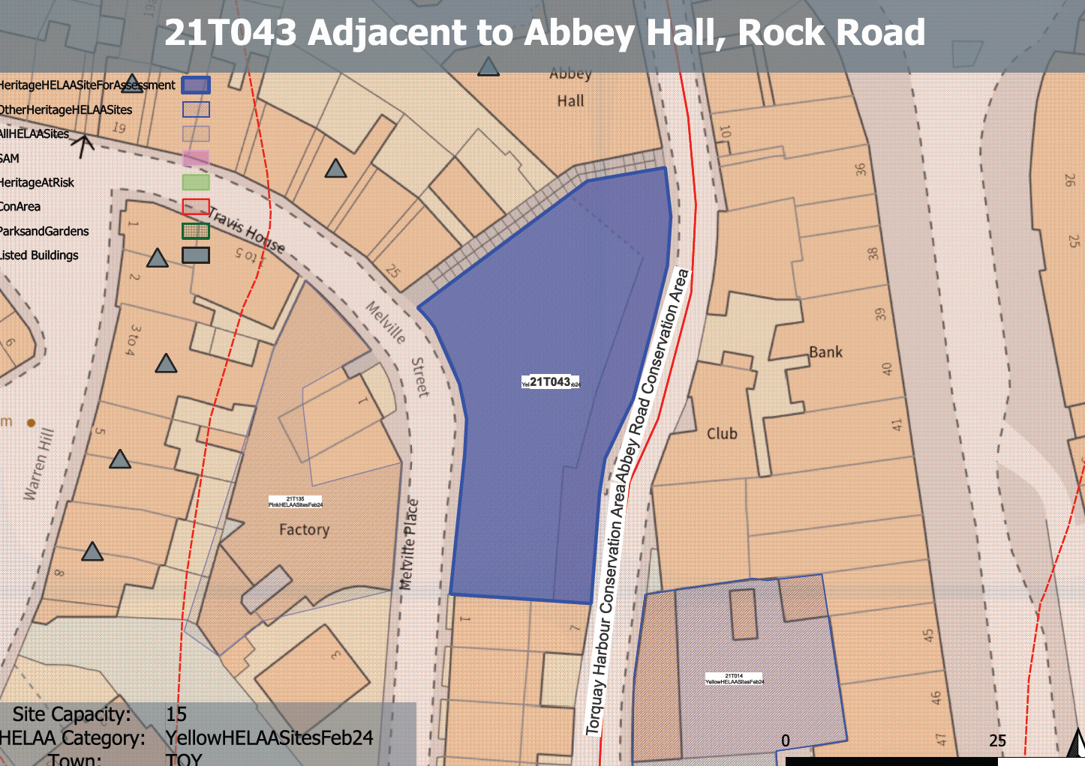
Site overview and heritage context:
The site is located close to Torquay High Street and bounded to the east by Rock Road and to the west by a terrace of residential buildings. A combination of commercial, residential, educational and retail properties surround the site. The west of the site is bounded by a limestone wall that rises approximately 8m to Melville Street. The north side of the site is bounded by a stepped passageway with a limestone wall.
A Methodist church occupied the site in the 1800s. Up until the early 1960s the site was a laundry, it was then demolished and made way in the 1980s and 1990s for car valet operations. The area comprises concrete hard-standing surfacing over bedrock used to raise ground levels and provide a level surface
The site is within the Abbey Road Conservation Area and adjacent to the Torquay Harbour Conservation Area to the east. A number of listed buildings can be found around the site to the north and west.

Planning History:
P/1986/2635 Residential Development 29 Flats Sheltered Housing - Approved 20/02/87
P/1998/1891 Erection Of 29 Housing Units (In Outline) - Approved 22/01/99
P/2015/0270 - The proposed use of land for the purposes of recreation or instruction and the erection or placing of tents on the land – Approved 19/05/2015

Heritage Asset Affected by Allocation | Designation | Contributing Elements to Significance | Impact of Development on Significance | Mitigation Measures for any Identified Harm /Opportunities to Enhance Significance | Impact on Significance with Mitigation in place
Abbey Road Conservation Area  Torquay Harbour Conservation Area (immediately E of site)  Abbey Hall (immediately N of site)  19-25 Melville Street (immediately N of site)  1 to 8 Warren Hill (W of site) | Conservation Area  Conservation Area  Grade II listed building  Grade II listed building  Grade II listed building (4 entries) | The site of a former Methodist chapel – one of a number of ecclesiastical establishments present in the 19th century.  The site is characteristic of the area demonstrating a considerable difference in levels which allows it to be viewed from many different angles. It also incorporates surviving extensive boundary walls using local limestone rubble. The site has long been derelict but abut an important pedestrian link and forms the backdrop to important views from Melville St to the east. The site currently makes a neutral contribution to the significance of the conservation area.  The site forms part of the urban setting of the conservation area. It currently makes a neutral contribution to the historic environment within the area and to its significance.  Built as the British School for Boys and Girls in 1853 in the Italianate style The asset is indicative of the growth of a large and diverse population of various confessions in these areas during the mid-Victorian period.  The site forms part of the direct setting of the asset and although any historical relationship between the two sites has been lost as a result of the demolition and clearance of the site. The surviving built remains and extensive boundary walls make a positive contribution to its significance.  A terrace of seven houses, set in crescentic concave form, of the mid-1840s. The site forms part of the immediate urban setting of these assets, particularly No. 25. It currently makes a neutral impact to their significance.  A terrace of eight houses dated from their leases to 1847 which ascend the hill in a slight crescent. The site forms part of the urban setting of the assets but makes a limited contribution to their significance. | The development of 15 units in this constrained site may potentially result in the loss existing boundary walls to Rock Rd and may impact on established views to the east from Melville St as identified within the conservation area appraisal. This would cause a degree of less than substantial harm to the significance of the asset  The development of 15 units in this constrained site may potentially result in the loss existing boundary walls to Rock Rd and may have an overbearing impact on properties within the conservation area along Rocks Rd. This would cause a minor degree of less than substantial harm to the significance of the asset.  The development of 15 units in this constrained site may potentially result in the loss existing boundary walls to Rock Rd and may have an overbearing impact on the asset. This would cause less than substantial harm to its significance.  The development of 15 units in this constrained site may potentially result in an insensitive overdevelopment of the site which would impact on the how the asset (particularly No.25 is experienced from the surrounding area. This would cause less than substantial harm to its significance.  Development of the site would have a neutral impact on the significance of these assets. | A reduced quantum of development which embraces the constraints of the site and respects the character and local distinctiveness of the conservation area and retains existing boundary walls whilst achieving safe access would enhance the significance of the conservation area.  A reduced quantum of development which embraces the constraints of the site and respects the character and local distinctiveness of the area and retains existing boundary walls whilst achieving safe access would be a minor enhancement to the significance of the conservation area.  A reduced quantum of development which embraces the constraints of the site and respects the character and local distinctiveness of the area and retains existing boundary walls whilst achieving safe access would result in a neutral impact to the asset’s significance.  A reduced quantum of development which embraces the constraints of the site and respects the character and local distinctiveness of the area and retains existing boundary walls whilst achieving safe access would result in a neutral impact to the asset’s significance.  n/a | Enhancement  Enhancement  Neutral  Neutral  Neutral

