Heritage Impact Assessment: Pimlico, Torquay
HELAA2021 Ref: | 21T041
Site Address: | Pimlico, Torquay
Site Area (ha): | 0.06
Site Yield: | 50
HIA Assessment

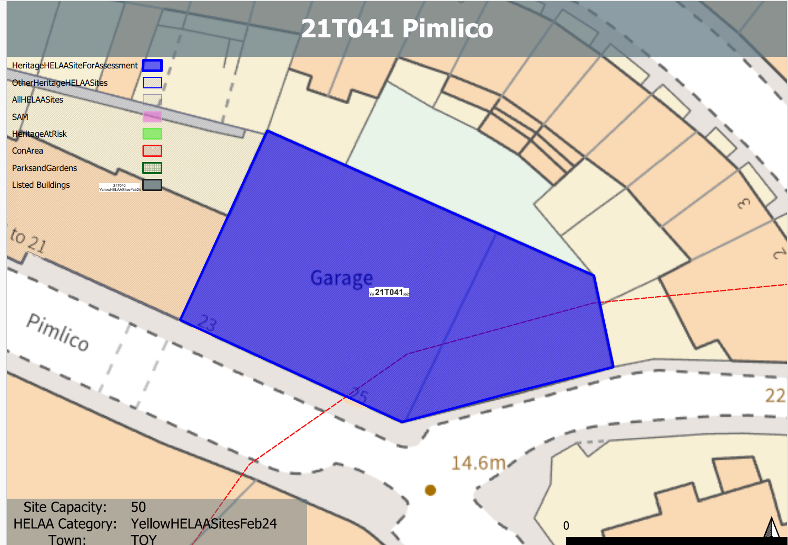
Site overview and heritage context:
The site can be found on the northern side of Pimlico on the corner with Stentiford Hill Road. The site is in use as a garage and associated commercial space and is located on a prominent corner site. Ground levels on the site rise to the east with the site sitting below neighbouring development to the east. Levels fall away slightly to the south as the Pimlico heads down towards Torquay harbour.
The existing buildings on the site appear to possibly date from the mid 20th century with late 20th century alterations.
The site is not within a designated conservation area, however, the boundary to the Torquay Harbour Conservation Area can be found nearby to the south.

Planning History:
None

Heritage Asset Affected by Allocation | Designation | Contributing Elements to Significance | Impact of Development on Significance | Mitigation Measures for any Identified Harm /Opportunities to Enhance Significance | Impact on Significance with Mitigation in place
Torquay Harbour Conservation Area (S of site) | Conservation Area | The site forms part of the urban setting of the conservation area. The site makes a neutral contribution to the asset. | Conversion to residential use with limited external alterations would have a neutral impact on the significance of the asset. | The improvement of the architectural treatment and visual appearance of the building including would improve the general condition of the built environment within the area and would have a very limited minor positive impact on the significance of the nearby conservation area. | Limited Minor positive

