Heritage Impact Assessment: Roebuck House, Abbey Road, Torquay
HELAA2021 Ref: | 21T038
Site Address: | Roebuck House, Abbey Road, Torquay
Site Area (ha): | 0.059
Site Yield: | 49
HIA Assessment

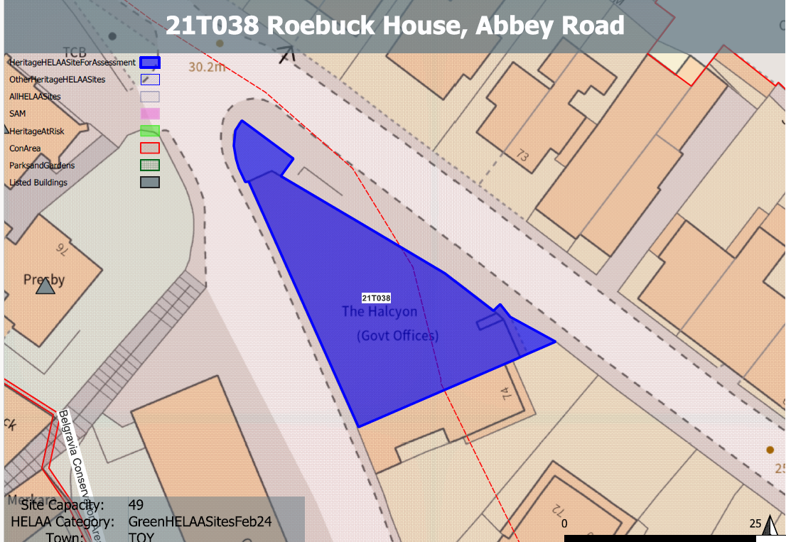
Site overview and heritage context:
The site comprises a freestanding office block with six floors of office space and a lower ground floor that provided car parking and bin storage. The building has not been used since approximately 2012 and is believed to be currently vacant.
The site lies within the Abbey Road Conservation Area and is surrounded by a number of listed buildings. The height of the building results in it also being visible from the nearby Belgravia Conservation Area.

Planning History
P/2021 – Change of use from offices to residential development (C3) – Prior Approval Granted 16 August 2021.

Heritage Asset Affected by Allocation | Designation | Contributing Elements to Significance | Impact of Development on Significance | Mitigation Measures for any Identified Harm /Opportunities to Enhance Significance | Impact on Significance with Mitigation in place
Abbey Road Conservation Area  Belgravia Conservation Area (W of site)  70 and 72 Abbey Road (SE of site)  85 Abbey Road (N of site)  Church of the Assumption of Our Lady (W of site)  Presbytery adjoining the Church of the Assumption of Our Lady (W of site)  School associated with the Church of the Assumption of Our Lady (W of site) | Conservation Area  Conservation Area  Grade II listed building  Grade II listed building  Grade II listed building  Grade II listed building  Grade II listed building | The existing building is 7 storeys high and a prominent feature within the townscape. It is identified as a modern intrusion but a significant landmark within the conservation area  The existing building is 7 storeys high and a prominent feature within the townscape. It is visible within the setting of the conservation area as a modern intrusion.  Early to mid C19 pair of semi-detached houses within an urban setting. The site currently makes a negative contribution to the significance of the asset.  Mid C19 detached house. Now hotel within an urban setting. The site currently makes a negative contribution to the significance of the asset.  Roman Catholic church. 1853, by J Hansom, aisle and Lady Chapel added 1858, group value with associated buildings. Set within its own landscaped grounds within a wider urban setting. The site currently makes a negative contribution to the significance of the asset.  Presbytery. 1857, by J Hansom, who was the architect of the church, group value with church and school set within its own landscaped grounds within a wider urban setting. The site currently makes a negative contribution to the significance of the asset.  School constructed in 1857 to the designs of J Hansom, group value with church and presbytery set within its own landscaped grounds within a wider urban setting. The site currently makes a minor negative contribution to the significance of the asset due to distance and intervening buildings between the site and the asset. | The proposed yield of 49 could be achieved through the sensitive conversion of the site which would result in a neutral or positive impact to the significance of this asset.  The proposed yield of 49 could be achieved through the sensitive conversion of the site which would result in a neutral or positive impact to the significance of this asset.  The proposed yield of 49 could be achieved through the sensitive conversion of the site which would result in a neutral or positive impact to the significance of this asset.  The proposed yield of 49 could be achieved through the sensitive conversion of the site which would result in a neutral or positive impact to the significance of this asset.  The proposed yield of 49 could be achieved through the sensitive conversion of the site which would result in a neutral or positive impact to the significance of this asset.  The proposed yield of 49 could be achieved through the sensitive conversion of the site which would result in a neutral or positive impact to the significance of this asset.  The proposed yield of 49 could be achieved through the sensitive conversion of the site which would result in a neutral or positive impact to the significance of this asset. | Opportunity to enhance significance through sensitive conversion of the site and improvement of external appearance.  Opportunity to enhance significance through sensitive conversion of the site and improvement of external appearance.  Opportunity to enhance significance through sensitive conversion of the site and improvement of external appearance.  Opportunity to enhance significance through sensitive conversion of the site and improvement of external appearance.  Opportunity to enhance significance through sensitive conversion of the site and improvement of external appearance.  Opportunity to enhance significance through sensitive conversion of the site and improvement of external appearance.  Opportunity to enhance significance through sensitive conversion of the site and improvement of external appearance. | Positive  Positive  Positive  Positive  Positive  Positive  Positive

